Supplemental Information File
Supplemental Figures

Figure S1. In vitro stability of ^{99m}Tc-ICG-HSA NPs in fetal bovine serum.

Figure S2. Longitudinal planar and SPECT/CT images after injection of ^{99m}Tc-ICG-HSA NPs in left rear pad of a SD rat and the SPECT/CT fusion image of ^{99m}Tc-ICG-HSA NPs after plantar injection for 1 h.

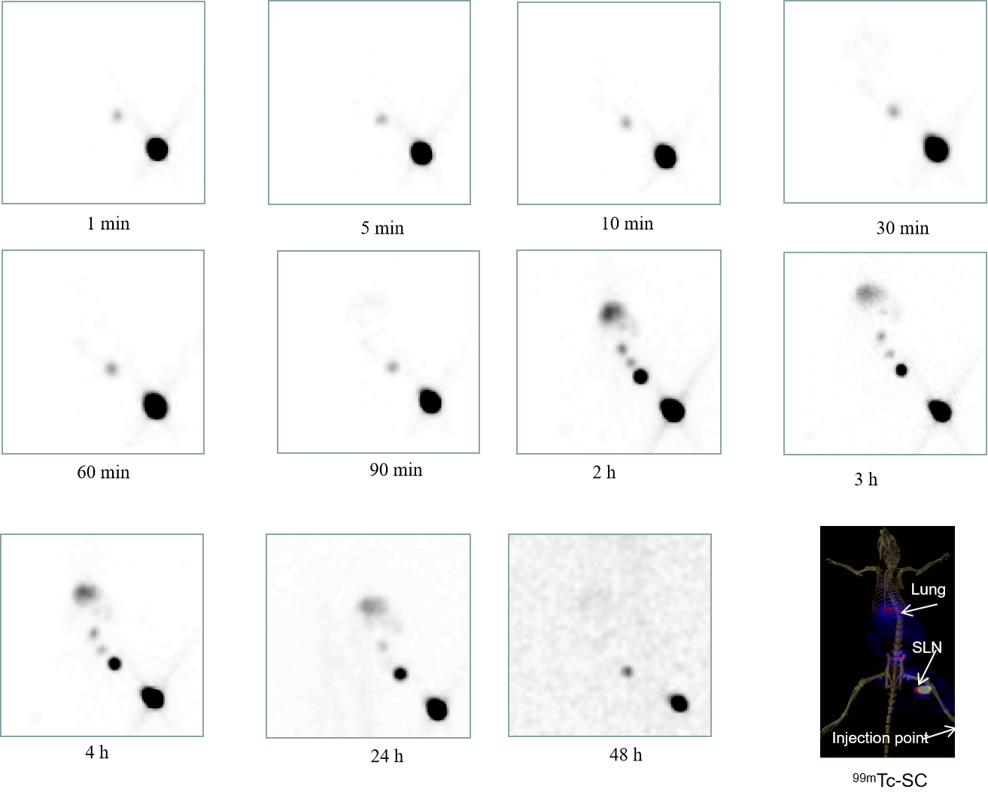
Figure S3. Longitudinal planar and SPECT/CT images after injection of ^{99m}Tc-SC in left rear pad of a SD rat and the SPECT/CT fusion image of ^{99m}Tc-SC NPs after plantar injection for 1 h.

Figure S4. Biodistribution of ^{99m}Tc-SC in major organs and tissues of rats. N = 3 in each group.

Table S1. Organ observed doses and whole-body effective doses
Target organ | Absorbed Dose (mGy/MBq, Mean ± SD)
Adrenals | 8.50E-03 | 5.47E-04
Brain | 4.53E-03 | 1.32E-04
Breasts | 3.61E-03 | 7.32E-05
Gallbladder Wall | 8.56E-03 | 5.25E-04
LLI Wall | 5.68E-03 | 1.88E-04
Small Intestine | 6.41E-03 | 1.30E-04
Stomach Wall | 6.27E-03 | 6.38E-05
ULI Wall | 8.95E-03 | 9.00E-04
Heart Wall | 5.66E-03 | 1.04E-04
Kidneys | 3.94E-02 | 8.12E-03
Liver | 1.25E-02 | 1.72E-03
Lungs | 6.15E-03 | 3.30E-04
Muscle | 3.69E-03 | 2.28E-04
Ovaries | 5.97E-03 | 1.25E-04
Pancreas | 7.99E-03 | 3.01E-04
Red Marrow | 4.85E-03 | 2.87E-05
Osteogenic Cells | 1.28E-02 | 2.16E-04
Skin | 2.20E-03 | 9.48E-04
Spleen | 9.27E-03 | 2.12E-04
Thymus | 4.73E-03 | 1.51E-04
Thyroid | 3.98E-03 | 1.72E-04
Urinary Bladder Wall | 5.36E-03 | 2.41E-04
Uterus | 5.74E-03 | 1.59E-04
Total Body | 5.39E-03 | 1.25E-05
Effective Dose (mSv/MBq) | 6.51E-03 | 2.41E-04

