Supplementary Material 1:

Establishment of the subcutaneous tuberculous granuloma model in mice
The BCG-induced subcutaneous tuberculous granuloma in mice was caused by the subcutaneous injection of the BCG bacterial suspension method. Briefly, each mouse was injected intraperitoneally with a dose of 1.0 mg/kg of dexamethasone for three consecutive days to create an immunosuppressive environment before the inoculation. After that, BCG bacterial suspensions (containing 2×10⁸ colony-forming units (CFU)/mL) were subcutaneously injected into the right buttock tissue of a mouse. The constructed tuberculous granuloma model in BCG-infected mice after 12 days of continuous injection of BCG solution into the subcutaneous tissue was observed by H&E staining and immunohistochemical staining of granulomatous tissue, as shown in Figure S1. H&E staining revealed a typical granulomatous structure on the 12th day of BCG inoculation, which mainly showed extensive necrosis in the central area, surrounded by fibrous cuffs at the edges (Figures S1A, B, and C). Meanwhile, immunohistochemical staining for pimonidazole confirmed the presence of severe hypoxia in the constructed subcutaneous tuberculous granuloma model (Figure S1D). Other studies have also demonstrated that tuberculous granulomas in mouse models have key features of human tuberculosis (necrosis, hypoxia, and vascular structure abnormalities).^{1,2}

Supplementary Material 2:

In vivo biodistribution of LEV@CAT-NPs
To detect the in vivo accumulation and distribution of LEV@CAT-NPs composite nanoparticles in granuloma tissues, the DiR-labeled LEV@CAT-NPs solution was injected into the mice subcutaneously infected with BCG via the tail vein. The fluorescence images were acquired, and fluorescence signal intensity was detected by the live animal imaging system at different time points. As shown in Figures S2A and B, the fluorescence intensity of the infected lesions showed an increasing and then decreasing trend as time increased following LEV@CAT-NPs injection and reached a peak at 24 hours post-injection, which implied that the largest amount of nanoparticles accumulated in granulomatous tissue at the time point of 24 hours post-injection. Afterward, a significant amount of nanoparticles with red fluorescence were found in the granulomatous tissue 24 hours following the injection of DIR-labeled nanoparticles, according to CLSM (Figure S2C), further demonstrating the ability of the LEV@CAT-NPs nanoparticles to efficiently aggregate at the site of granulomatous lesions. To further evaluate the ex vivo distribution of LEV@CAT-NPs nanoparticles, major organs (heart, liver, spleen, lung, and kidney) and granuloma tissues of mice were collected 48 h post-injection and subjected to ex vivo fluorescence imaging. The results revealed that the accumulation of DiR-labeled LEV@CAT-NPs was higher in the liver and spleen (Figures S2D and E), which might be due to the uptake of nanoparticles by the reticuloendothelial system. The above results demonstrated that the LEV@CAT-NPs nanoparticles could effectively accumulate at the granuloma site, which lays the foundation for subsequent in vivo treatment of granulomas.

Supplementary Material 3:

Selected ultrasonic irradiation parameters
The ultrasonic instrument was developed by Chongqing Ronghai Engineering Research Center of Ultrasound Medicine Co., Ltd., China. It has a circular plane transducer with a diameter of 3.0 cm, a center frequency of 1.0 MHz, and an adjustable sound intensity output of 0.1-10.0 W/cm². The safety of ultrasonication during percutaneous irradiation in mice was confirmed by pathological observation of mouse skin after ultrasound exposure. Figure S3 depicts the pathological structural alterations in granulomatous tissue following ultrasound-only subcutaneous irradiation at various ultrasonic intensities and exposure times. After ultrasonic irradiation alone for 5 minutes, the tissue mucosa suffered damage, including an incomplete mucosa (red arrow). Similar mucosal-damaging results were seen after 7 minutes of ultrasound exposure. However, no significant damages were observed under ultrasonic irradiation at 0.5 W/cm², 0.7 W/cm², 1.0 W/cm², and 1.2 W/cm² for 3 minutes. Therefore, the safety threshold dosage at an intensity of 1.2 W/cm² for 3 minutes was chosen as the ultrasonic irradiation parameter to treat the animals in this study.

Supplementary Material 4:

Hemolysis assay of LEV@CAT-NPs in vitro
Hemolysis assays are also crucial for carrying out the biosafety test for LEV@CAT-NPs in vivo since the nanoparticles must be given through blood. As displayed in Figure S4A, red blood cell suspensions were incubated with LEV@CAT-NPs at different concentrations (the concentration gradients of equal LEV and CAT were 0.06, 0.12, 0.25, 0.50, 1.00, 2.00, and 4.00 mg/mL), and no obvious hemolysis phenomenon was observed. Even at the highest concentration of LEV and CAT (4.00 mg/mL) in LEV@CAT-NPs suspension, the hemolysis rate was only 2.76% (Figure S4A). The hemolysis is less than 5%, which is considered non-toxic according to the ASTM F-756–08 standard.³

Supplementary Material 5:

Cytotoxicity assay of LEV@CAT-NPs in vitro
The cytotoxicity of LEV@CAT-NPs relative to free LEV and CAT against normal macrophages RAW264.7 in vitro was examined, as shown in Figure S4B. The activity of macrophages decreased with the increase in LEV concentration, and the activity was significantly decreased to 74% compared to the controls at the concentration of 32.0 μg/mL, while the cell activity in the LEV@CAT-NPs group was significantly higher than that of free LEV at the same drug concentration, and that was still about 81% at the concentration of 64 μg/mL (Figure S4B). Similarly, the macrophage activity of the free CAT group was significantly lower than that of the LEV@CAT-NPs at the same concentration, with only 73% cellular activity at 64 μg/mL (Figure S4B).

Supplementary Material 6:

The levels of ROS generation following treatment
Ultrasound can activate sonosensitizers to produce highly cytotoxic ROS, which has antibacterial activity against planktonic bacteria and biofilms.⁴ In the present study, higher levels of BCG intracellular ROS were detected after 5 hours of ultrasound-mediated nanodrug (containing LEV) therapy. CLSM observation revealed that intracellular ROS levels were significantly increased following treatment with US-mediated free LEV, LEV-NPs, and LEV@CAT-NPs compared to the other experimental groups without ultrasound (which only exhibited a small amount of green fluorescence), and the US+LEV@CAT-NPs group showed the highest green fluorescence intensity (Figure S5A). Several subtypes of ROS, including singlet oxygen (¹O₂), hydrogen peroxide (H₂O₂), and hydroxyl radicals (•OH), can be generated during SDT treatment, as shown in Figures S5B, C, and D. The fluorescence intensity of the ultrasound and LEV@CAT-NPs combined treatment group was notably higher than that of other experimental groups. The results suggested that LEV@CAT-NPs have the potential to achieve effective ROS production in the lesion area under ultrasound triggering to enhance the antibacterial effect.

Supplementary Material 7:

Biosafety analysis
Furthermore, the biosafety of ultrasound-mediated LEV@CAT-NPs in vivo was assessed. At 14 days after treatment with ultrasound-mediated LEV@CAT-NPs, the serum analysis revealed that the levels of biochemical indicators in the US+LEV@CAT-NPs group fluctuated within the normal range, including liver function indicators (e.g., ALT, AST, TBIL) and renal function indicators (e.g., BUN, CREA), compared to those in the saline control group, as shown in Figure S6A. Meanwhile, H&E pathological assessment revealed no pathological damage in major organs, including the heart, liver, spleen, lung, and kidney, at 14 days post-treatment of US+LEV@CAT-NPs, as shown in Figure S6B. The findings reaffirm the biosafety of synergistic therapy in vivo for biomedical applications.

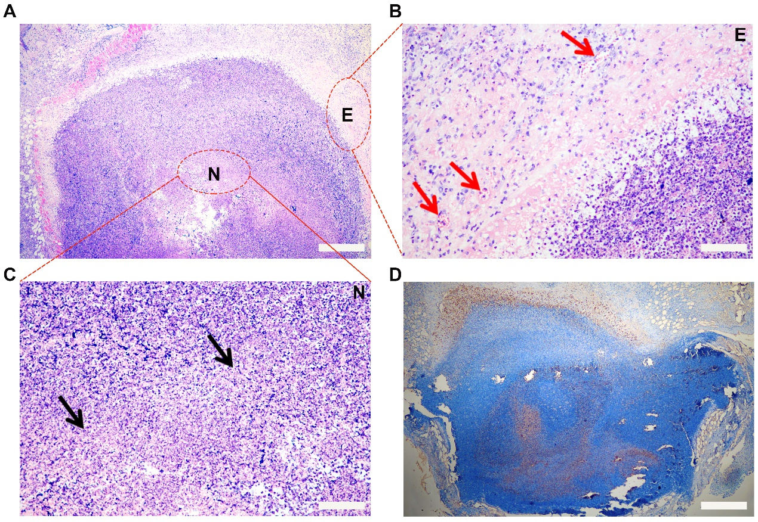
Figures:
Figure S1 Histological analysis of granulomatous tissue on the 12th day after BCG infection. (A) H&E staining of granulomatous tissue. (B and C) Shown are enlarged views of the red oval areas E (B) and N (C) in Figure A (the red arrow represents the blood vessel and the black arrow represents the localized necrosis). (D) Immunohistochemical staining of pimonidazole from granulomatous tissue. Scale bars are 100 μm.

Figure S2 Distribution of LEV@CAT-NPs in vivo. (A) Fluorescence intensity images of BCG-infected BALB/c mice after being intravenously injected with DiR-labeled nanoparticles at pre-i.v., 3 h, 9 h, 12 h, 24 h, and 48 h. (B) Average fluorescence intensity of granulomatous tissue at different time points. (C) A frozen section of granulomatous tissue at 24 h post-injection of DiR-labeled nanoparticles (red fluorescence) was observed with CLSM. The scale bar is 1000 μm. (D) Biodistribution of DiR-labeled nanoparticles in granulomas and major organs extracted from mice at 48 h post-i.v. (E) Average fluorescence intensity histogram of granulomas and major organs isolated at 48 h post-i.v. The data represent the mean ± SD of three independent experiments.

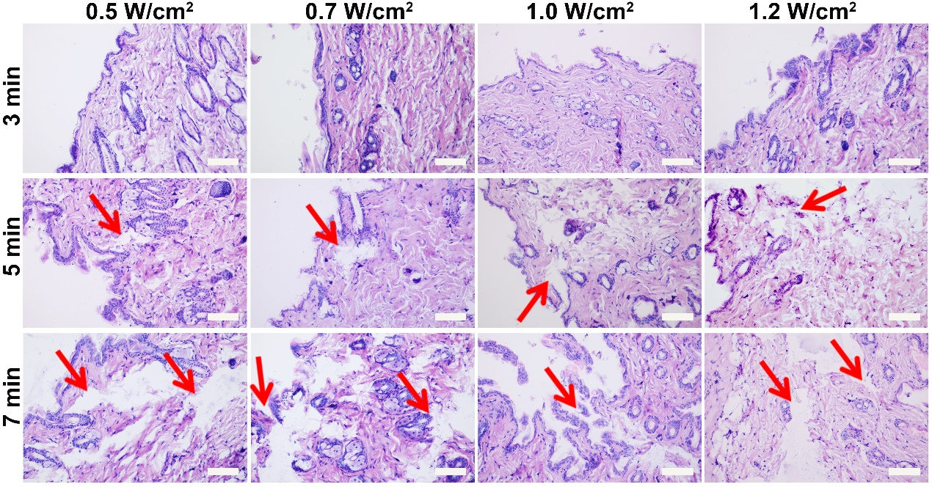
Figure S3 H&E staining images of hip skin from mice after ultrasonic irradiation (red arrows indicate incomplete mucosa). Scale bars are 100 μm.
Figure S4 In vitro biosafety analysis of the LEV@CAT-NPs. (A) Quantitative results showed hemolytic activity of the LEV@CAT-NPs with different drug concentrations. (B) The comparison of macrophage viability treated with free LEV, free CAT, and LEV@CAT-NPs at different concentrations of LEV and CAT from 4 to 64 μg/mL. The data represent the mean ± SD of three independent experiments. *p < 0.05, **p < 0.01, ***p < 0.001, ns, not significant.

Figure S5 Detection of ROS and ROS subspecies generation. (A) The production of ROS (green) in BCG was observed by CLSM following treatment with different modalities. The scale bar is 50 μm. (B-D) ¹O₂ (B), H₂O₂ (C), and •OH (D) generation of free LEV, LEV-NPs, and LEV@CAT-NPs in the presence and absence of ultrasound irradiation. The data represent the mean ± SD of three independent experiments. ***p < 0.001.

Figure S6 In vivo biosafety evaluation. (A) Mice serum biochemistry analysis. (B) H&E staining images of major organs of BALB/c mice. The scale bar is 100 μm. The data represent the mean ± SD of three independent experiments.
References
1. Barna BP, Malur A, Thomassen MJ. Studies in a murine granuloma model of instilled carbon nanotubes: relevance to sarcoidosis. Int J Mol Sci. 2021;22(7):3705.
2. Dutta NK, Illei PB, Jain SK, Karakousis PC. Characterization of a novel necrotic granuloma model of latent tuberculosis infection and reactivation in mice. Am J Pathol. 2014;184(7):2045-2055.
3. Orme IM, Basaraba RJ. The formation of the granuloma in tuberculosis infection. Semin Immunol. 2014;26(6):601–609.
4. Nakonechny F., Nisnevitch M. Different aspects of using ultrasound to combat microorganisms. Adv Funct Mater. 2021;31(44):1–24.

