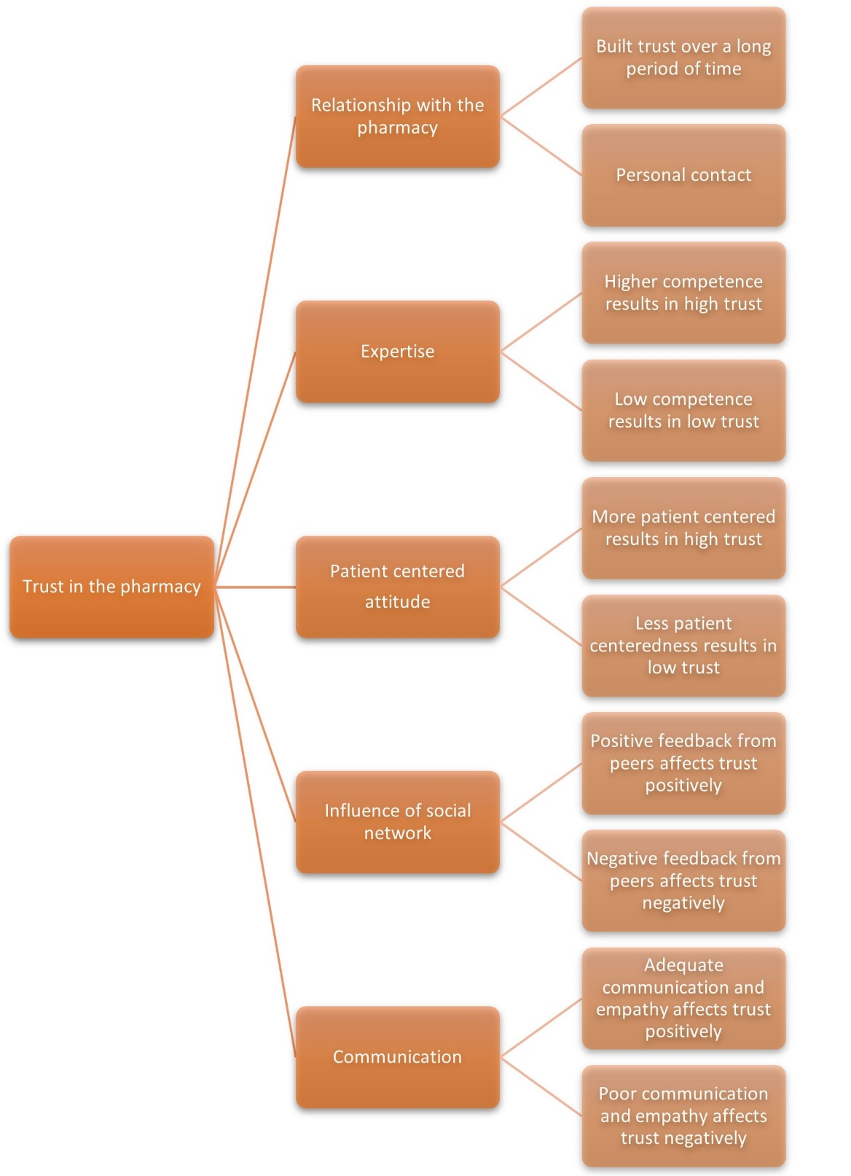
Supplementary Figure 1: Coding tree for analysing focus group data

Supplementary Table 1: Items of the questionnaire clustered in the ‘expertise’ domain
Expertise | Factor loading
If I have questions about my respiratory medication, I ask someone from the pharmacy team first | 0.3950
The pharmacy team would indicate when an error has been made | 0.6132
The pharmacy team provides me with medications of the highest quality | 0.6401
The team in the pharmacy are experts in respiratory medication | 0.7453
I always follow the advice of the pharmacy team | 0.6147
The pharmacy team can resolve issues with my respiratory medication | 0.6413

Supplementary Table 2: Items of the questionnaire clustered in the ‘patient attention’ domain
Patient oriented: attention | Factor loading
I appreciate it when the pharmacy team calls me to ensure clarity regarding the medications | 0.6864
I appreciate it when the pharmacy team calls me to check on my well-being, beyond my medication usage | 0.7111
Feeling welcomed in the pharmacy has a positive impact on my trust | 0.4794
Having the option to discuss personal matters (e.g., in a separate room) gives me a sense of comfort and satisfaction | 0.4262

Supplementary Table 3: Items of the questionnaire clustered in the ‘patient engagement’ domain
Patient oriented: Engagement | Factor loading
The pharmacy team cares about my health | 0.8767
The pharmacy team has my best interests at heart | 0.9103
The pharmacy team gives me the opportunity to ask questions | 0.7703
The pharmacy team pays attention to my issues | 0.8624
I can tell the pharmacy team everything | 0.7524
My trust in the pharmacy team is strengthened when the team is friendly | 0.4682

Supplementary Table 4: Items of the questionnaire clustered in the ‘information and communication’ domain
Information and communication | Factor loading
Due to the busyness in the pharmacy, I often struggle to express myself adequately | 0.3806
The pharmacy team is willing to discuss options with me and answer my questions | 0.7293
The pharmacy team prioritizes my health over medication costs | 0.5649
I am open to receiving information from the pharmacy team | 0.4577
The pharmacy team explains well how to use my medications | 0.7400
I understand when the pharmacy team explains to me how to use medication | 0.6474
My trust in the pharmacy team is strengthened when they communicate well with me | 0.3620

Supplementary Table 5: Items of the questionnaire clustered in the ‘personal relationship with the pharmacy’ domain
Personal relationship with the pharmacy | Factor loading
My trust in the pharmacy team is strengthened when the team is knowledgeable | 0.3573
The pharmacy team knows who I am | 0.4363
If the pharmacy team wears name tags, it creates a more personal relationship | 0.3943
A more personal relationship with the pharmacy team strengthens my trust in the team | 0.5330
I prefer staying with the same pharmacy for a long time because it allows me to build a better bond with the pharmacy team | 0.8818
A long-term relationship with a pharmacy strengthens my trust in the pharmacy team | 0.8882

Supplementary Table 6: Items of the questionnaire clustered in the ‘opinions of peers’ domain
Opinions of peers | Factor loading
If someone I know well says good things about the pharmacy, I gain more trust in the pharmacy | 0.7779
If someone I don't know well says good things about the pharmacy, I gain more trust in the pharmacy | 0.7779

