Survival prediction model for patients with hepatocellular carcinoma and extrahepatic metastasis
based on XGBoost algorithm

Short title: Survival prediction of advanced HCC patients

Authors: Jihye Lim¹, Hyeon-Gi Jeon², Yeonjoo Seo¹, Moonjin Kim³, Ja Un Moon⁴, and Se Hyun Cho¹

Table of contents
- Supplementary Figure 1. Survival probability of hepatocellular carcinoma (HCC) patients with extrahepatic metastasis.
- Supplementary Figure 2. Decision trees for (A) 3-, (B) 6-, and (C) 12- months survival prediction model.

Supplementary Figure 1. Survival probability of hepatocellular carcinoma (HCC) patients with extrahepatic metastasis.
(A) Child-Pugh class, (B) number of tumors, (C) size of tumor, (D) vascular or bile duct invasion, (E) metastatic site, and (F) primary anti-HCC treatment
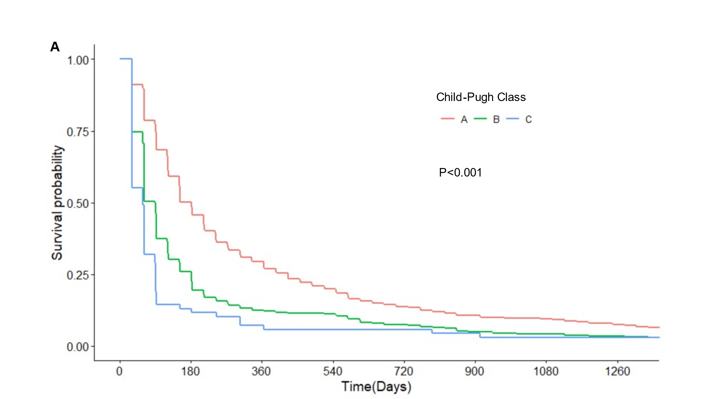
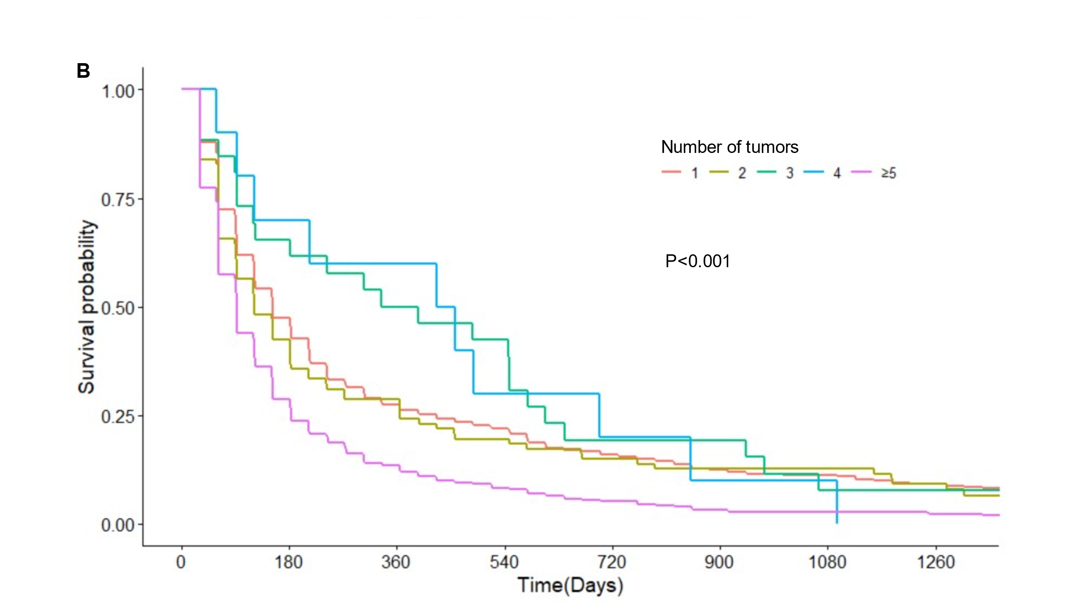
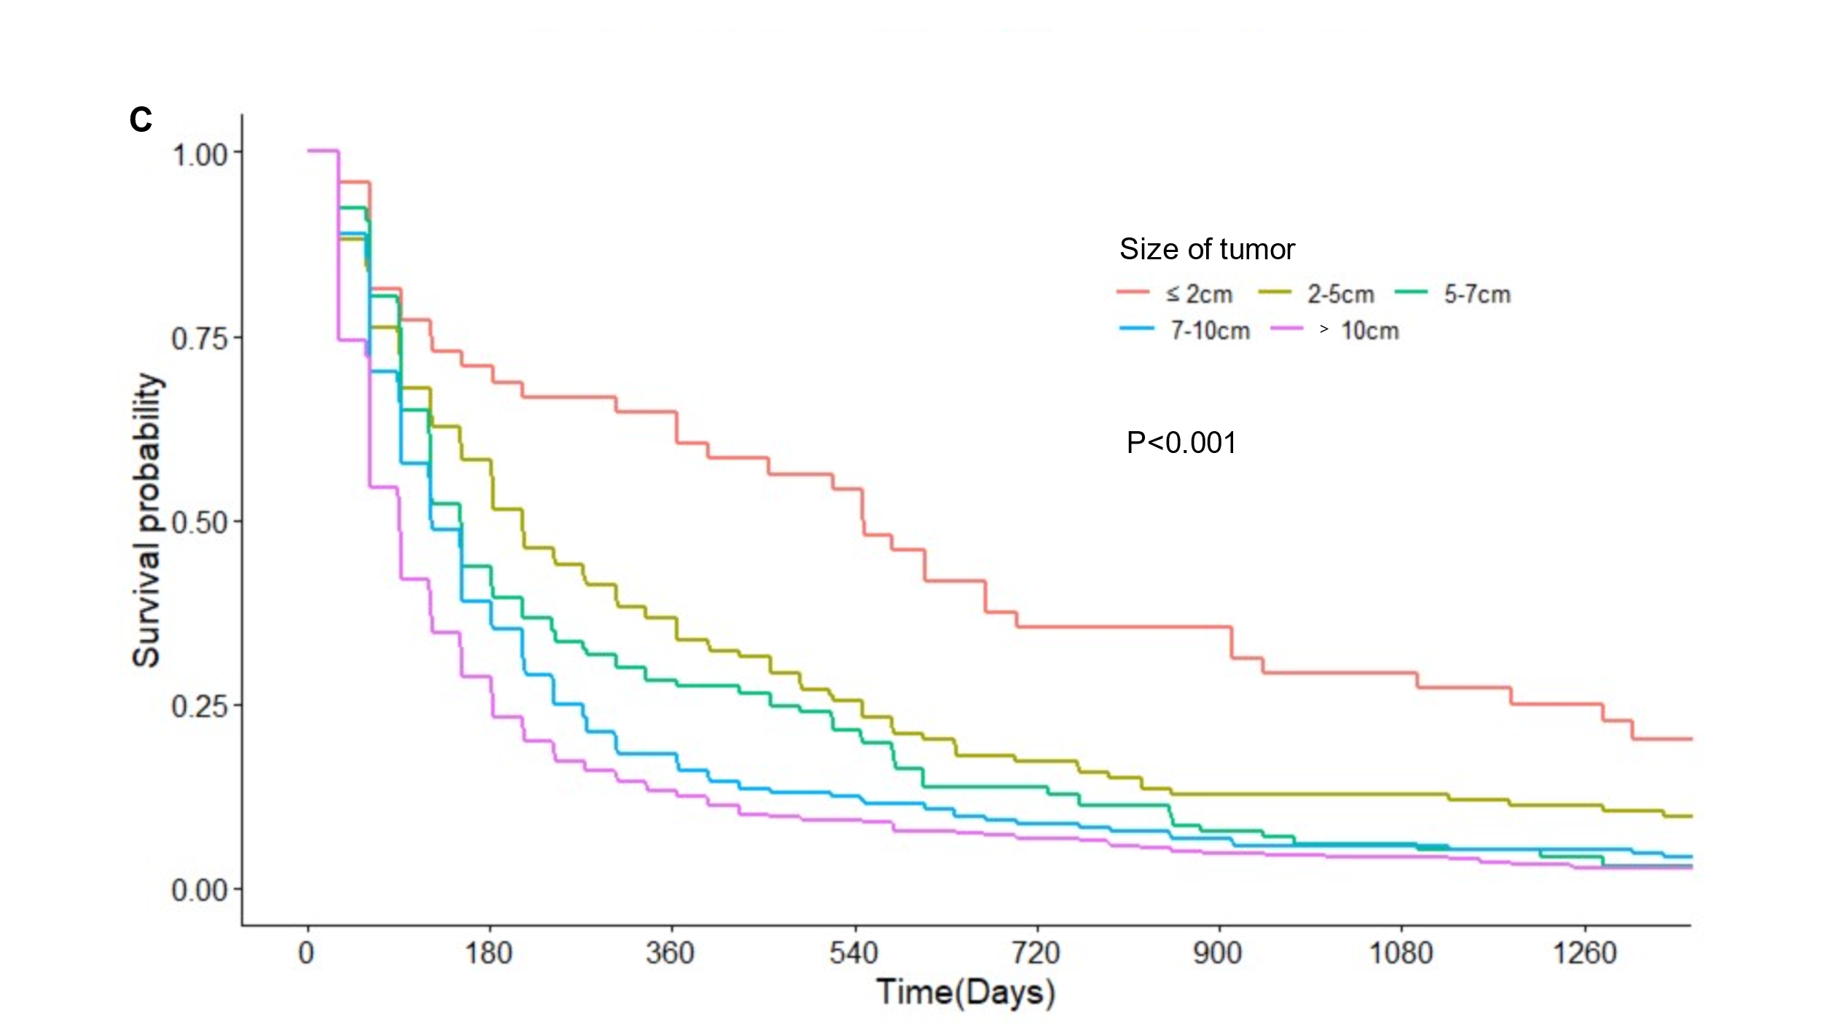
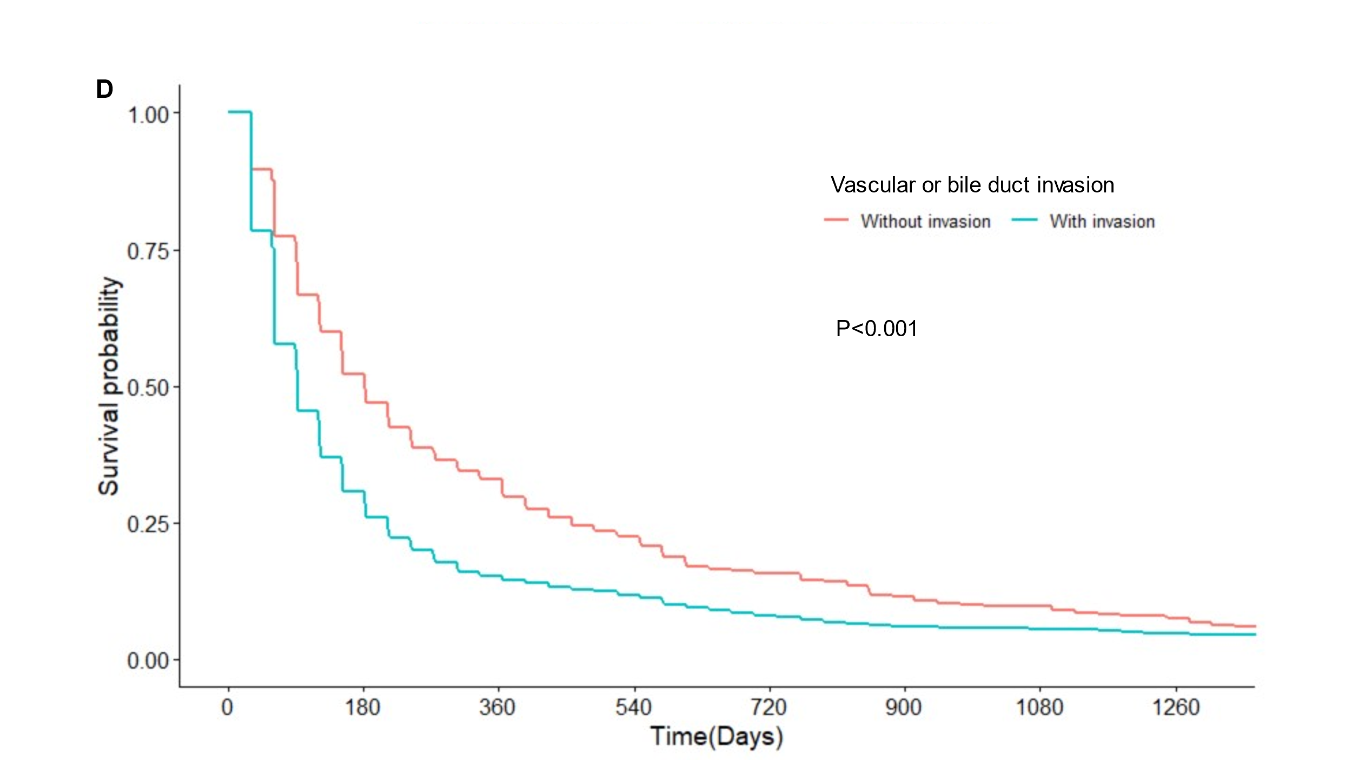
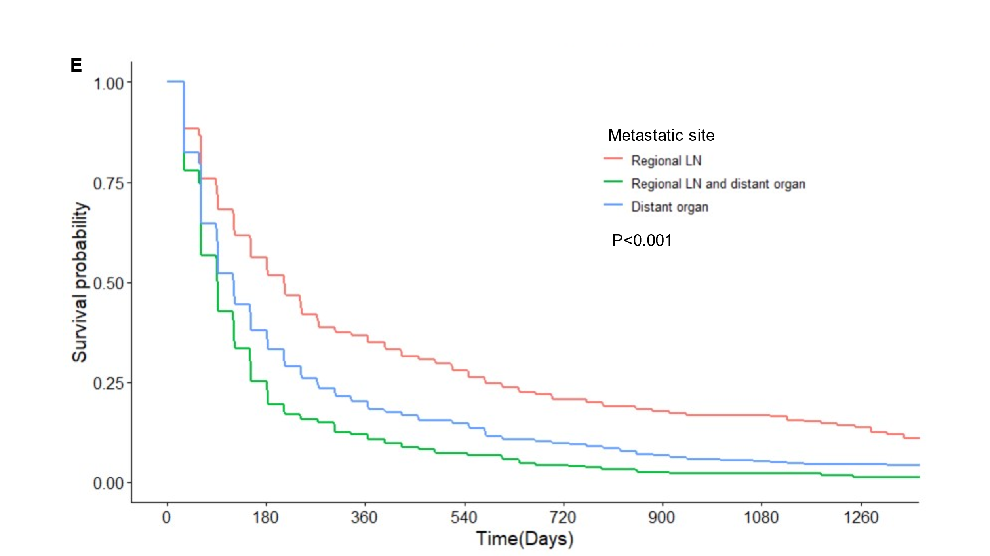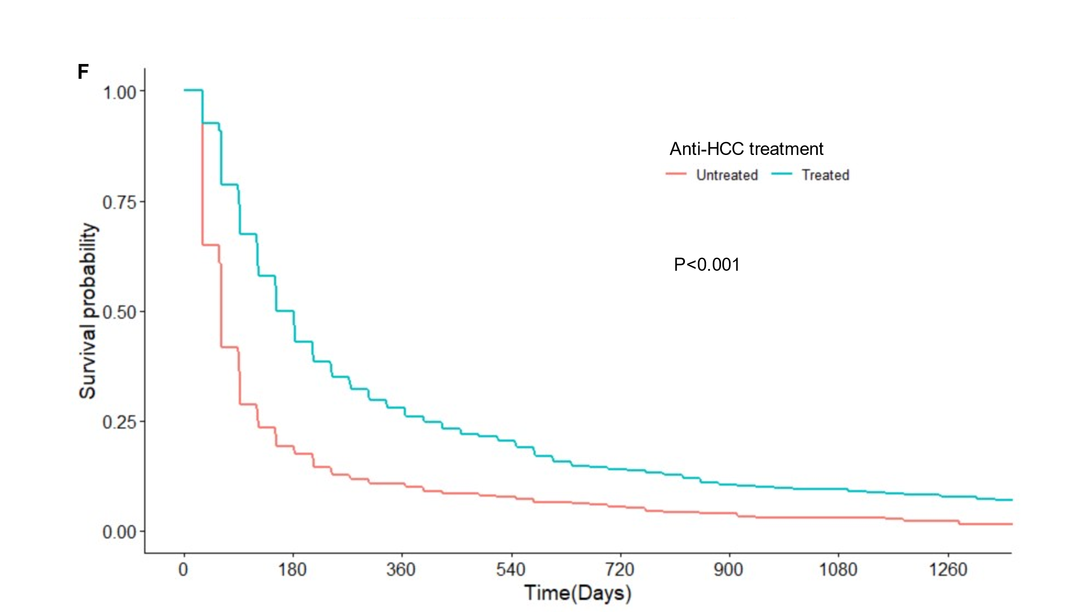
Abbreviations: LN, lymph node

Supplementary Figure 2. Decision trees for (A) 3-, (B) 6-, and (C) 12- months survival prediction model.
