Development of high-loading Trastuzumab PLGA nanoparticles: a powerful tool against HER2 positive breast cancer cells
Tania Mariastella Caputo,¹† Giovannina Barisciano,²† Chiara Mulè,¹ Angela Maria Cusano,³ Anna Aliberti,*¹ Livio Muccillo,² Vittorio Colantuoni,² Lina Sabatino,*²Andrea Cusano^{1,3}
1. Optoelectronics Group, Department of Engineering, University of Sannio, Benevento, Italy.
2. Department of Sciences and Technologies, University of Sannio, Benevento, Italy
3. CeRICTscrl Regional Center Information Communication Technology, Benevento, Italy
SUPPORTING INFORMATION
Figure S1
A
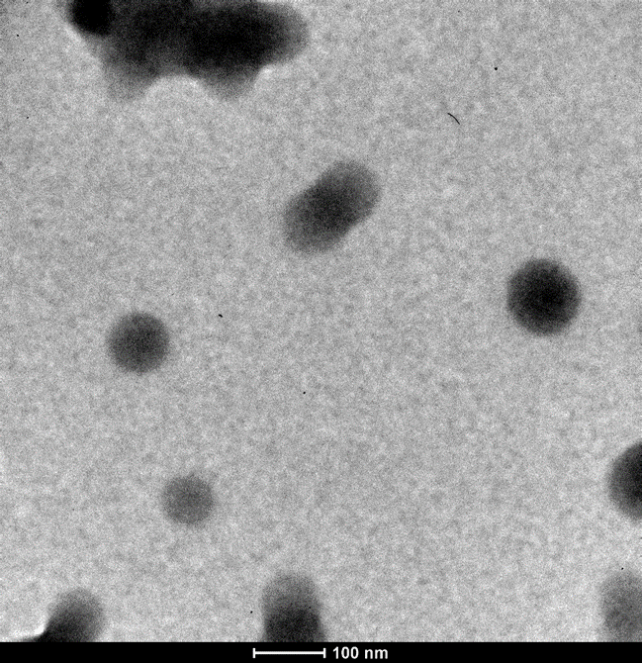

Figure S1 A: Transmission electron microscopy (TEM) images were acquired by depositing 5 µl of nanoparticles on TEM copper grids with a carbon coated Formvar film. After evaporation of the solution, the grid was washed with deionized water and analysed by TEM Tecnai G2 Spirit TWIN (FEI, Hillsboro, OR, USA).

B

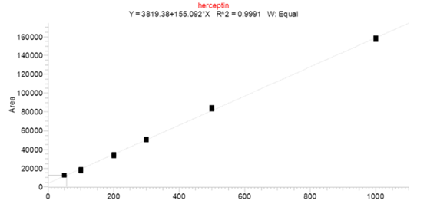
TZ concentration (ng/mL)

Figure S1 B: Trastuzumab calibration curve

Figure S2
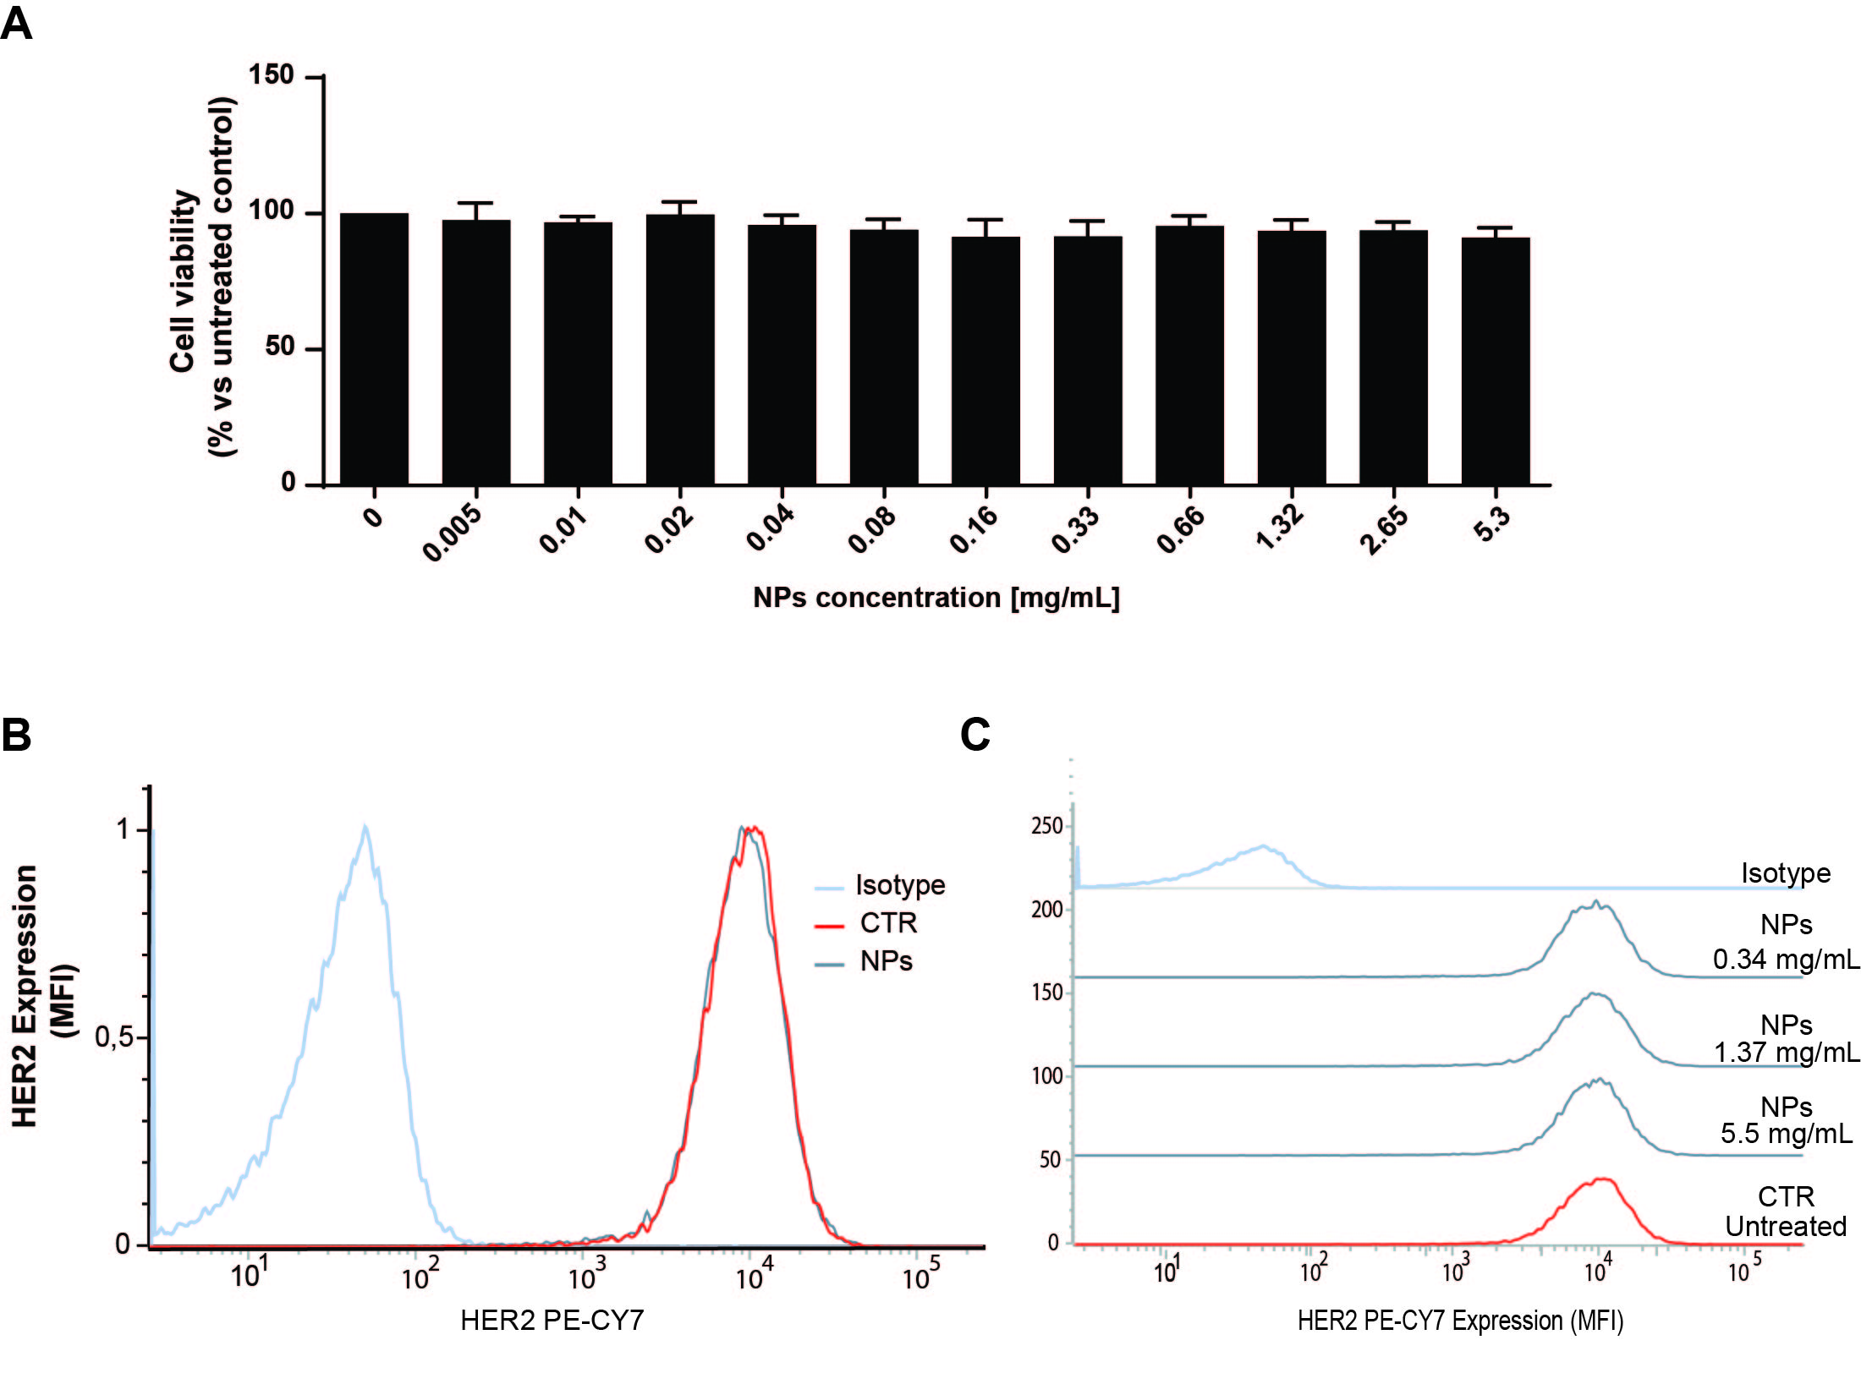
Figure S2: Evaluation of the effects of NPs on SKBR3 cells.
A) The histograms show the percentage of viable SKBR3 cells before or after exposure to increasing concentrations of NPs; B) The overlapping one-dimensional cytograms of untreated or NP treated SKBR3 cells indicate that cell size, shape, and complexity are not affected as determined by flow cytometry; C) HER2 surface expression in untreated or treated SKBR3 cells by using a PE -Cy7-labelled specific anti-HER2 antibody in flow cytometry. The peaks corresponding to HER2 in B) and C) are expressed as mean fluorescence intensity (MFI). Data are expressed as mean ± SEM of independent experiments performed at least in triplicate; the mean values from untreated or treated cells were compared by applying the t- test. Statistical significance was considered when * p < 0.05, ** p < 0.01, *** p < 0.001. **** p < 0.0001

Figure S3: Confocal Z-stack images
Confocal Z-stack images of SKBR3 labelled with: DAPI and PE -CY7 secondary antibody to stain the nucleus (I - blue channel) and the tubulin (II- red channel) and treated with FITC-bound TZ (III - green channel), either in its free form, F-TZ (A – B) or encapsulated in PLGA particles, F-TZP (C - D). IV) Merge of II and III channels and V) all channels.

F-TZ
A) SKBR after 30 minutes of incubation with F-Tz
III
I
II
IV
V

B) SKBR after 3 hours of incubation with F-TZ
I
III
II
IV
V

C) SKBR after 30 minuts of incubation with F-TZP
I
III
II
IV
V

D) SKBR after 3 hours of incubation with F-TZP
III
II
I
V
IV

Figure S4
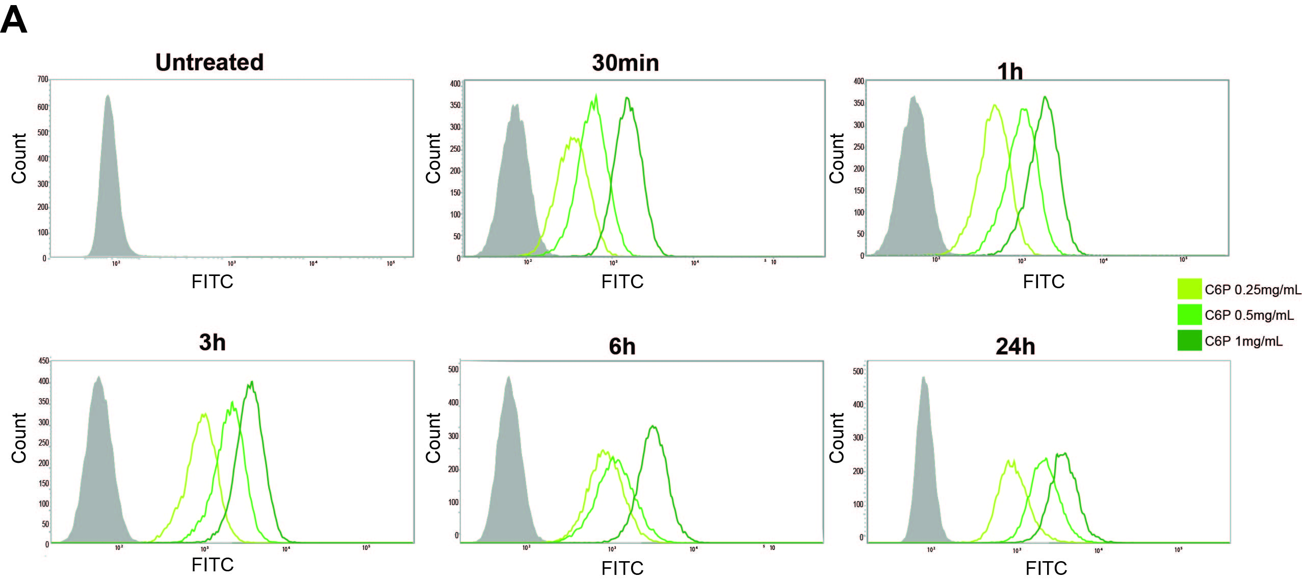
Figure S4 A) Flow cytometry analysis of coumarin 6-loaded particles (C6P) uptake by SKBR3 cells. The curves illustrated in the panels refer to the levels of cellular Fluorescence Intensity after treatment with increasing concentrations of C6P (0.25 - 0.5 - 1 mg) for 30 min, 1 - 3- 6 - 24 h.

Figure S5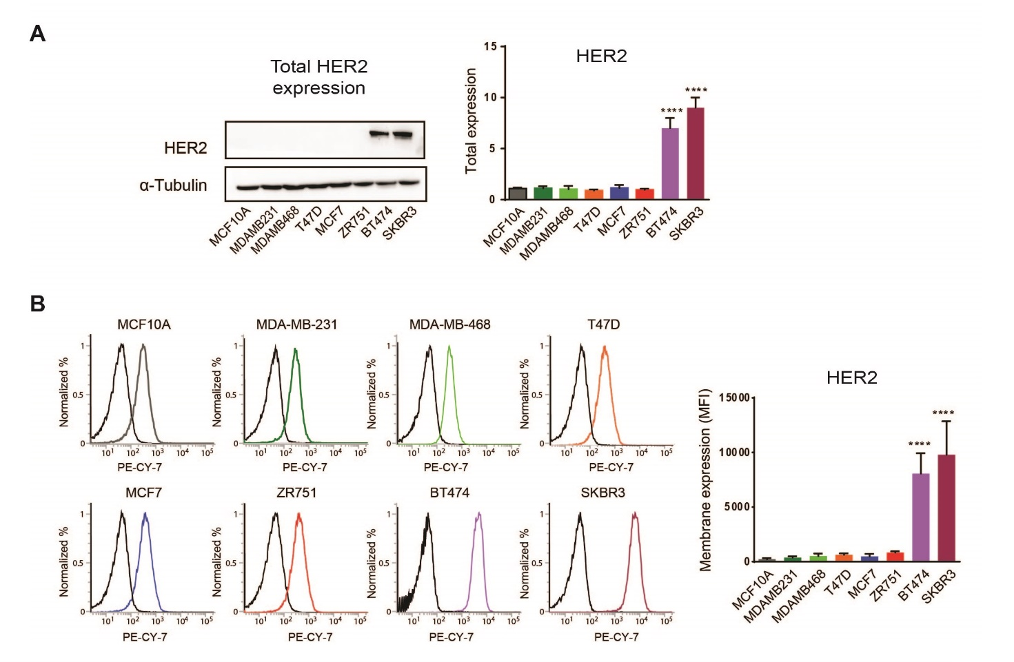
Figure S5 HER2 expression and cell surface exposure in breast cancer derived cell lines. A) Western blot analysis of HER2 expression in the indicated cell lines representative of the different breast cancer subtypes and normal epithelium (MCF10A) with an anti-HER2 specific antibody. The histogram on the right illustrates the relative quantification after normalization to α-Tubulin used as control of equivalent protein loading in each lane. B) Flow cytometry analysis of HER2 membrane exposure in the same cell lines using a PE-CY7 labelled anti-HER2 antibody. The histogram reports the relative quantification as mean fluorescence intensity (MFI).

