Materials
Cetrimonium bromide (CTAB), tetraethyl orthosilicate (TEOS), 3-aminopropyltriethoxysilane (APTES) were bought from the Sigma-Aldrich Co. Other chemical reagents were obtained from China National Pharmaceutical Group Corporation. Fetal bovine serum (FBS), RPMI-1640 medium, Dulbecco's modified Eagle's medium and Iscove's Modified Dulbecco medium were purchased from GIBCO. Diagnostic kits for complex IV activity assay including Alkaline phosphatase (ALP), alanine transaminase (ALT), aspartate transaminase (AST), blood urea nitrogen (BUN), and creatinine (CRE) were bought from Nanjing Sheng Gong Bioengineering Company.

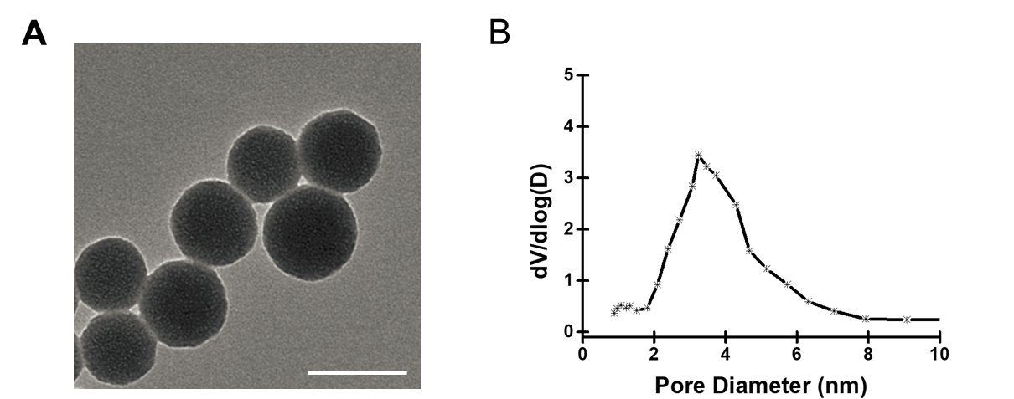
Figure S1. Characterization of MSNs@RA/GA. (A) TEM image of MSNs@RA/GA, the scale bar = 100 nm. (B) Pore size distribution of MSNs@RA/GA.

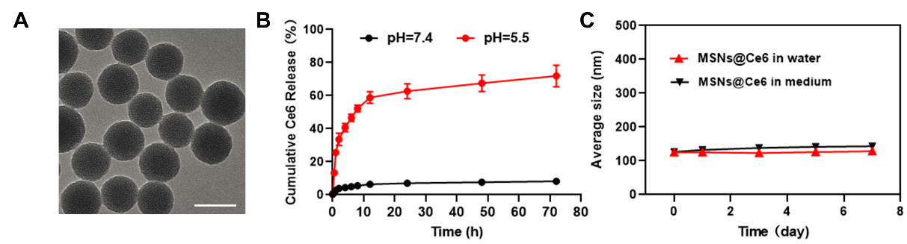
Figure S2. Characterization and drug release of MSNs@Ce6. (A) TEM image of MSNs@Ce6, the scale bar = 100 nm. (B) Release profiles of MSNs@Ce6 at different pH, n = 3. Data are presented as mean ± SD. (C) Average size of MSNs@Ce6 after stockage in deionized water and RPMI-1640 medium for 1, 3, 5 and 7 days, n = 3. Data are presented as mean ± SD.

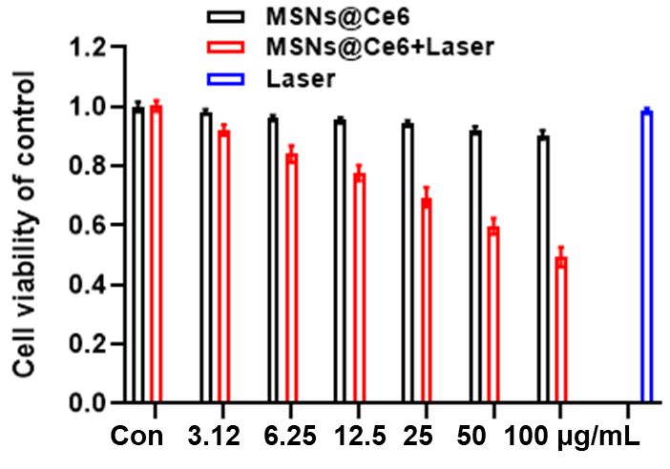
Figure S3. Cytotoxicity of MSNs@Ce6 at various concentration towards H22 cells at the absence of presence of the 660 nm laser irradiation, n = 4. All the data are presented as mean ± SD.

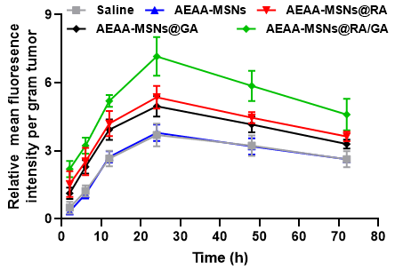
Figure S4. The tumor accumulation of MSNs@Ce6 at predetermined time points in the mice pretreated with various formulations, n = 3. All the data are presented as mean ± SD.

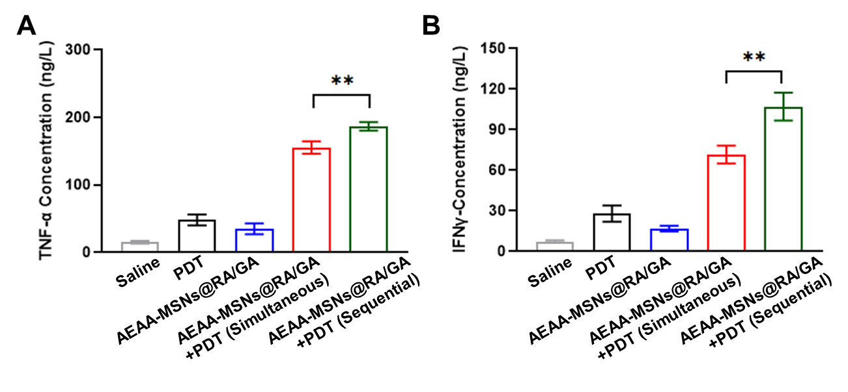
Figure S5. Secretion of (A) TNF-α and (B) IFN-γ in the serum after various treatments, n = 3. All the data are presented as mean ± SD. **P < 0.01.

