Appendix A. Semi-structured Interview Question Prompts
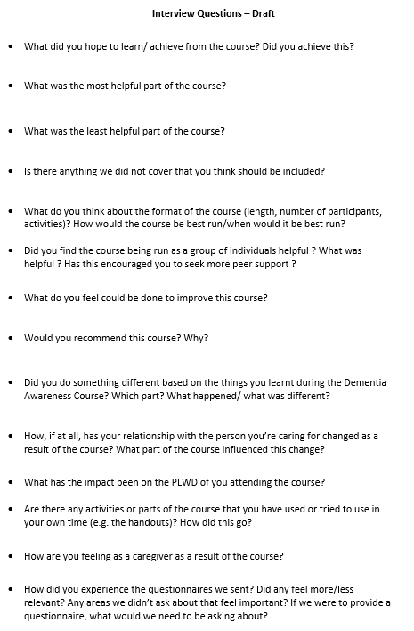
Notes: PLWD, Person Living With Dementia

Appendix B. Example Coding Table
Sample Transcript | Codes | Sub-Theme | Sub-Theme | Main Theme
“It is hard to stay on the ball for four hours” | Course too Long | Length of Course | Course Format | Acceptability of Course
“I learned a lot. And actually, the time went so quickly, I couldn't believe it was over” | Course Length Okay | Length of Course | Course Format | Acceptability of Course
“You know that you’re not alone or you’re not the only person getting frustrated. So, whilst other people’s experiences aren’t always going to be the same, I learned loads and kind of felt a lot of support from the group” | Reflection of Group Format | Group Format | Course Format | Acceptability of Course
“Actually, it was quite nice” | Reflection on Number of Participants | Group Format | Course Format | Acceptability of Course
“it's much easier to do it on the screen than face to face. It makes it easier for people to attend because they don’t have to worry about travelling” | Online Format of Course | Online Format | Course Format | Acceptability of Course
“Some of the like myth busting, I think that was quite helpful because, certainly it's been quite difficult with relatives and things, but also just for my own knowledge, knowing what’s true and not” | Course Content | Content, Group Activities and Handouts | Course Content | Acceptability of Course
“The activities that made us think and share after a bit of information was given, that was for me was the best thing” | Course Activities | Content, Group Activities and Handouts | Course Content | Acceptability of Course
“There was nothing about new technology…we use technology, quite a lot, so it would’ve been nice to hear a bit more about that and how we can use it” | Missing Content from Group | Missing Content | Course Content | Acceptability of Course
“Most people end up just fumbling their way through because there isn’t much out there” | Lack of Support at Diagnosis | Experience of Support at Diagnosis | Point of Delivery of Course | Acceptability of Course
“Would really help to have this at the start of someone’s journey so they know what skills to use and what’s to come” | Point of Delivery of Course | Delivery of Course | Point of Delivery of Course | Acceptability of Course
“It was really helpful, and I found it so interesting and thought-provoking” | Overall View of Course | Reflections of Course | Views of Course | Acceptability of Course
“I feel glad that I got offered this course, because I’ve learned so much” | Reflection on Being Offered Course | Reflections of Course | Views of Course | Acceptability of Course
“You know, sometimes as carers, you don't have time to read a great big book on dementia, and you wouldn't understand it half the time. A lot of people who were carers might not have the capacity to be able to do that kind of learning. So having this course shown to them is really valuable, I’d definitely recommend it” | Recommend Course to Others | Recommend Course to Others | Views of Course | Acceptability of Course

