Supporting Information
Mn-doped nano-hydroxyapatites as theranostic agents with tumor pH-amplified MRI-signal capabilities for guiding photothermal therapy
Chengyu Li¹, Ziyou Ding¹, Yingchao Han¹
¹State Key Laboratory of Advanced Technology for Materials Synthesis and Processing, Biomedical Materials and Engineering Research Center of Hubei Province, Wuhan University of Technology, Wuhan 430070, China
Correspondence: Yingchao Han, Email hanyingchao@whut.com
Supplementary experimental methods
Material properties
Characterization. The crystal phase purity of obtained materials was checked by the X-ray diffraction (XRD) technique using a D8 ADVANCE (Bruker, Karlsruhe, Germany) diffractometer using Cu Kα radiation (λ = 1.54178 Å) generated at 40 kV and 40 mA, a counting time of 0.5 s, and a step size of 0.02° 2θ. The particle size and morphology of pure nHAP and nHAPMn were observed and measured by scanning electron microscope (SEM, ZEISS Sigma 300) equipped with an energy-dispersive X-ray spectrometer (EDAX Genesis XM4) and transmission electron microscopy (TEM, JEOL JEM F200). Dynamic light scattering (Nano ZS, Malvern) was used to record the hydrodynamic size distribution. The UV−visible absorption spectrum and OD980 were measured using a Cary 50 spectrophotometer (Varian). The XPS measurements were performed using a PHI-5000 CESCA system (PerkinElmer) with radiation from an Al Kα (1486.6 eV) X-ray source. Fourier transform infrared (FT-IR) spectra were recorded on a Nicolet NEXUS870 spectrometer (Nicolet Instruments Inc., Madison, WI, USA). Magnetic measurements were performed using a vibrating sample magnetometer (VSM) attached to the evercool physical property measurement system (from Quantum Design). Magnetization measurements were carried out at room temperature and with applied DC magnetic fields of up to 1 Tesla.
Photothermal Performance. The photothermal performance of nHAP and nHAPMn was detected with an infrared thermal imager. Briefly, 0.5 mL materials were exposed to 808 nm laser at different Mn ions doping concentrations (nHAP, nHAPMn1, nHAPMn3, nHAPMn5, nHAPMn10) or different laser power densities (0.5, 1, 1.5, 2 W/cm²). During laser irradiation for 15 min, the temperature of the solution was recorded by a thermal imager. The photothermal conversion efficiency (η) of materials was measured according to the literature protocols[1, 2]. To evaluate photostability, nHAPMn5 suspension were exposed to 808 nm laser (1 W/cm²) for 10 min (laser ON), followed by cooling to room temperature without irradiation for 10 min (laser OFF). A thermal imager was used to record the temperature of the solution during five ON/OFF cycles.
MRI study. To evaluate the magnetic resonance (MR) contrast enhancement effect, 200 μL of nHAPMn5 with various concentrations (0.05, 0.25, 0.5, 1.25 and 2.5 mM) in aqueous solutions were imaged by using a clinical 7.0 T MR clinical scanner (Micro-MRI Bruker, Germany) with a wrist surface coil (diameter 11 cm). T1-Weight images (T1WI) were obtained using a sequence with the following parameters: field of view (FOV), 90 × 60 mm²; slice thickness, 1.5 mm; spacing, 0.5 mm; base matrix resolution, 256 × 256; repetition time (TR), 500 ms; and effective echo time (TE), 20 ms. The r1values were calculated from the slope of the curve-fitting result of 1/T₁ (s⁻¹) versus the metal ion concentration (mM).
ICP-AES Analysis.
The element concentrations in each sample were quantified by ICP-AES (Prodigy-Teledyne Instruments Leeman Lab). ICP-AES was calibrated by standard solutions for elements interested and samples were prepared by dissolving 40 mg powder in 250 ml 1 wt.% HNO₃.
The as-prepared nHAPMn5 powder without PAA treatment were dispersed in buffer with different pH (7.4, 6.5, and 5.5). The sample vials were kept on a horizontal shaker with constant temperature of 37 °C. At predetermined time intervals, the nHAPMn5 suspension were obtained to test photothermal efficiency, ICP-AES was also used to evaluate the release of Mn ions.
In vitro experiments
Cell Culture. Two types of cells, MC3T3-E1 and MG63 cells (ATCC) were used for cell studies and cultured in α-MEM and MEM (Gibco), respectively, supplemented with 10% (v/v) fetal bovine serum and 0.1mg/mL streptomycin and 100 U/mL penicillin at 37 °C in an atmosphere of 5% CO₂.
Cytotoxicity assay. The MC3T3-E1 cells were seeded into 96 well plates at a density of 5 × 10³ cells per well for 24h, and then it was incubated with a series of Mn ions doped-nHAP (nHAP, nHAPMn1, nHAPMn3, nHAPMn5, nHAPMn10) at 100 μg/mL for 1-3 days, 10 μL of CCK-8 was added to each well with 90 μL of cultured medium in a 96-well cell culture plate, and absorbance at 450 nm was recorded by ELIASA 1 h later. To demonstrate the biological safety of PAA, CCK-8 experiments were also conducted on the PAA group without added materials.
Hemolysis Assay. Mouse red blood cells (RBCs) obtained from BALB/C mice (Wuhan Center for Disease Control & Prevention, China.) were diluted with a certain amount of PBS, and then RBCs were separated from the serum using centrifugation at 2000 rpm for 10 min. After being washed at least four times, the RBCs were then diluted with 10 mL of PBS. Subsequently, 200 μL of the diluted RBC suspension was mixed with 1 mL of PBS (negative control), deionized water (positive control), or nHAPMn NPs at different concentrations (100-1000mg/L). After incubation for 2 h at 37 °C, the mixtures were centrifuged at 12000 rpm for 10 min. All of the obtained supernatants were added to a 96-well plate, and their absorbance at 570 nm was measured using a multifunction microplate reader (Infinite M200 Pro, Switzerland). Finally, the percentage hemolysis of the RBCs was calculated according to the following formula: hemolysis ratio (%) = (A_{sample, 570 nm}-A_{negative, 570 nm})/ (mean value of A_{positive, 570 nm} −A_{negative,570nm})×100%.
Live/Dead Cell Staining Assay. After different treatments, MC3T3-E1 cells were incubated with Calcein-AM (5 μM) and propidium iodide (10 μM) for 30 min. After being washed by PBS, MC3T3-E1 cells were stained with calcein AM and PI for 20 min and imaged to distinguish the live cells (green color) and dead cells (red color) using a fluorescence microscope (OLYMPUS, IX73).
Cell photothermal experiments. The in vitro photothermal ablation effect of materials on cancer cells was further evaluated with the MG63 cells. MG63 cells were seeded onto a 96 well plate at a density of 5 × 10³ cells per well, a day before the experiment. After incubation with materials, cells were then exposed to the NIR laser (808 nm, 1 W/cm²) for 10 min and either stained with calcein AM and PI for 20 min and imaged to verify the photothermal effect on cancer cells (OLYMPUS, IX73).
In Vivo Animal Studies.
For tumor propagation, 6-week-old female BALB/C mice were injected with MG63 cells subcutaneously into the flank region (1×10⁷ cells in 0.1 mL of PBS). The mice bearing MG63 tumors were treated after the tumor volume reached 50-70 mm³.
MRI study. Mice bearing MG63 tumors were anesthetized via intraperitoneal injection of 1% pentobarbital sodium (40 mg/kg), followed by collecting the axial MR as the data of pre-injection. Afterward, the mice (n=3) were intravenously injected with nHAPMn5 (5mg/mL, 200 μL). The images of the tumor location were collected at special time intervals of 0 h, 2 h, 4 h, 6 h, 12h and 24 h using a 9.4 T Bruker Pharma Scan Micro-MRI instrument. ImageJ software was used to measure signal intensities of tumor area.
PTT study. The BALB/C mice bearing MG63 tumors were randomly divided into four groups with three mice per group: (1) PBS, (2) PBS+NIR (808 nm laser), (3) nHAPMn5, and (4) nHAPMn5+NIR (808 nm laser). Briefly, nHAPMn5 (100μL, 5 mg/mL) was intravenously injected, and the control group was injected with the same volume of PBS solution. After injection for 12 h, the mice were irradiated at a power density of 1 W/cm² for 10 min. Tumor volumes and body weight were measured every 2 days after the treatment. Tumor volumes were calculated by the formula:V =width²*length/2. The relative tumor volume was normalized to their initial tumor volume.
Histological staining. For the histology and blood analysis, organs (heart, liver, spleen, lung and kidney), tumors and whole blood samples from the four groups were collected at 14 days after treatment. The harvested tissues were fixed in 10% formalin solution and stored at room temperature. Hematoxylin and eosin (H&E) staining sections (Histoserv, Germantown, MD, USA) were examined by a BX41 bright field microscopy (Olympus, Tokyo, Japan). Blood cells, red blood cells etc. of the mice were collected in heparinized tubes and analyzed with VetScan HM5 (Abaxis, Inc.)
Statistical Analysis
The results were reported as the mean ± standard deviation of three different studies. ANOVA analysis was carried out to determine statistical significance (*P < 0.05, **P < 0.01, ***P < 0.001, ****P <0.0001) of the experimental data.

Supplementary experimental results
Table. S1. The atomic ratios for Mn ion doped HA from ICP-AES result.
 | nHAP | nHAPMn1 | nHAPMn3 | nHAPMn5 | nHAPMn10
Mn/(Mn+Ca)*100% | 0 | 0.98% | 2.87% | 4.62% | 8.21%

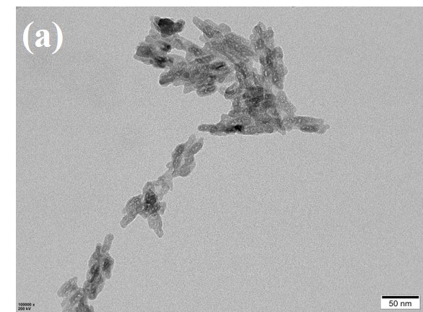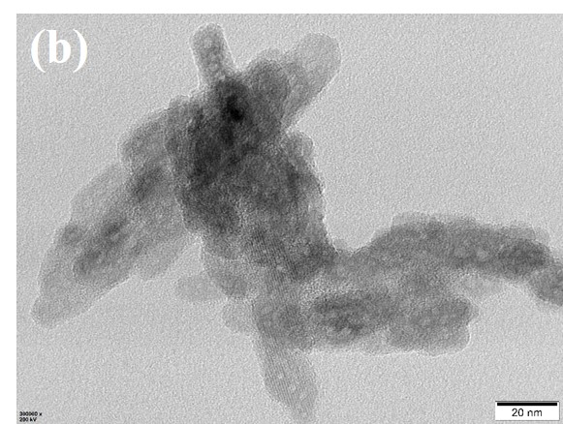
Figure S1 (a-b) Transmission electron microscopy (TEM) of nHAPMn5 after PBS (pH=6.5) treatment for 3 days.
Figure S2 Mn ions release profiles of nHAPMn5 without PAA treatment under physiological conditions at different pH (5.5, 6.5 and 7.4).
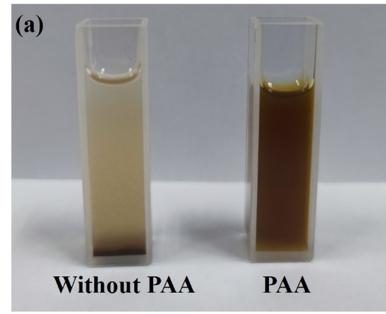
Figure S3 (a) Optical images of nHAPMn5 samples in the absence and presence of PAA (in the absence of PAA, the nHAPMn5 aggregates immediately in 1 hour). (b-d) Dynamic light scattering of nHAPMn5 samples in the presence of PAA within 7 days respectively using water, PBS and serum as the medium (inset: the corresponding optical images).
Figure S4 UV−vis-NIR absorption spectra of nHAPMn5 prepared in pH=10 or 12 conditions (inset: the corresponding optical images).
Figure S5 Magnetization curves of nHAPMn5 prepared in different preparation temperatures measured at room temperature.
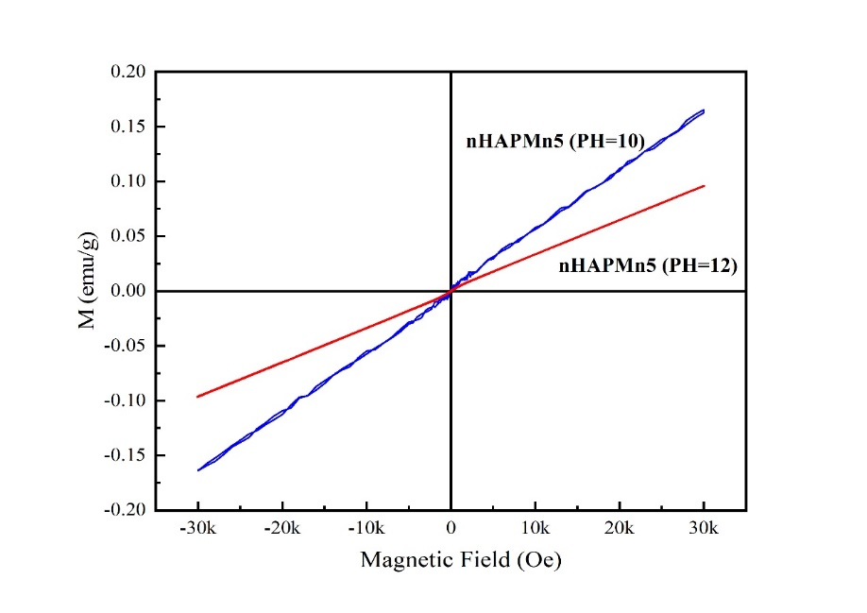
Figure S6 Magnetization curves of nHAPMn5 prepared in pH=10 or 12 conditions measured at room temperature.
Figure S7 Heating properties of nHAPMn5 solutions prepared in pH=10 or 12 conditions during irradiation with an 808 nm laser.

Figure S8 Heating properties of nHAPMn5 solutions treated with various PBS conditions (pH=5.5, 6.5 and 7.4) after 7 days.
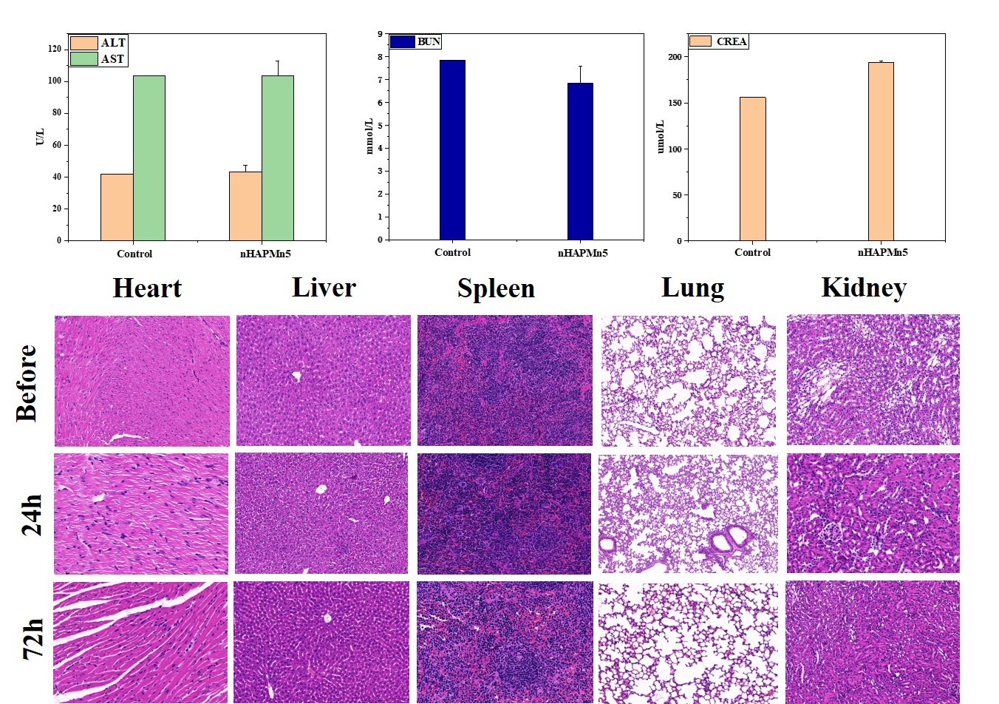
Figure S9 Liver function (ALT, AST) and kidney function (CREA and BUN) of tumor-bearing mice. Tissue slices of mice (heart, liver, spleen, lung, and kidney) after intravenous injection with nHAPMn5 and treatment for 24h and 72h (scale bar, 100 µm).
References
[1] C. Qi, J. Lin, L.H. Fu, P. Huang, Calcium-based biomaterials for diagnosis, treatment, and theranostics, Chem Soc Rev 47(2) (2018) 357-403.
[2] Z. Liu, S. Zhang, H. Lin, M. Zhao, H. Yao, L. Zhang, W. Peng, Y. Chen, Theranostic 2D ultrathin MnO2 nanosheets with fast responsibility to endogenous tumor microenvironment and exogenous NIR irradiation, Biomaterials 155 (2018) 54-63.

Highlights
- The magnetic resonance imaging signals could be amplified at the acidic tumor microenvironment by the degradation of nHAPMn and the release of Mn ions, which shows nHAPMn has good pH-responsive magnetic resonance imaging capacity in solid tumors
- This effect can be ascribed to a reduction of the crystalline domain size because of the presence of doping Mn ions as substitutes for Ca ions, as observed in previous works
- The in vivo MRI results indicated that the nanoparticles began to diffuse after injection and extended in the whole tumor region in 12 h
- nHAPMn can act as photothermal agents with high photothermal conversion efficiency thanks to their strong photoabsorption in the NIR range

