Appendix 1: Detailed Steps of Linkage Method A
- Identified all females ages 12–55 between January 2005 and March 2022 with any code from the active pregnancy code list. Restriction to those with female gender was done in an attempt to identify the population with uteri who can become pregnant. This population is not necessarily restricted to cisgender females and we recognize this binary gender classification to be suboptimal.
  - For each female, started from the first date of the pregnancy code and set as the first pregnancy start date.
  - Continued checking if the next pregnancy code date was within 294 days (estimated maximum end date); if not, set the date as a new pregnancy episode start date.
  - Repeated step 1i–ii, created a table for each female with each pregnancy episode start and end date.
  - Matched step 1iii table to infants (dependent members whose enrollment start month/year is the same as their birth month/year) with same family identification code. Required infant date of birth (set as 15th day of birth month) to be within pregnant episode start date and end date. A single pregnancy episode may have had multiple births and therefore a single mother may have had multiple infant pair matches (e.g., twins).
- Identified all females ages 12–55 with any code from the delivery code list.
  - For each female, started from the first date of the delivery code and set as the delivery date (pregnancy end date).
  - Continued checking if the next delivery code date is within 168 days; if not, set the date as a new delivery episode date.
  - Repeated step 2i–ii, created a table for each female with each delivery episode date.
  - Matched step 2iii table to infants (dependent members whose enrollment start month/year is the same as their birth month/year) with same family identification code. Required infant date of birth (set as 15th day of birth month) to be within ±60 days of the delivery date. A single pregnancy episode may have had multiple births and therefore multiple pairs (e.g., twins).
- Of the family identification code pairs created in steps 1iv and 2iv, classified into mutually exclusive groups:
  - Pairs identified in both 1iv and 2iv.
  - Pairs identified in only 1iv (and not 2iv).
  - Pairs identified in only 2iv (and not 1iv).

Appendix 2: Detailed Steps of Linkage Method B
  - Identified all females ages 12–55 between January 2005 and March 2022 who had a matching family identification code to an infant (dependent member whose enrollment start month/year is the same as their birth month/year). Allowed females to match to multiple unique infants (e.g., siblings, multiples).
  - Set delivery date as the 15th day of the infant birth month.
  - Of the family identification code pairs identified, determined how many would have been identified based on presence of the following code types:
    - Active pregnancy code(s). Maternal records included at least one code from the active pregnancy code list within the 294 days before the delivery date.
    - Completed pregnancy outcome code(s). Maternal records included at least one code from the delivery-related code list in ±60 days from the delivery date.
  - Of those classified in 3i and 3ii, classified into mutually exclusive groups:
    - Pairs who met both 3i and 3ii.
    - Pairs who met only 3i (and not 3ii).
    - Pairs who met only 3ii (and not 3i).
    - Pairs who met neither 3i nor 3ii.

Supplemental Table 1. Claims-based definitions for active pregnancy and live birth delivery episodes
Category | ICD-10 Diagnosis Codes
Active Pregnancy | O100–O104, O11, O120–O121, O13–O16, O20, O210–O212, O22 (not O228), O23 (not O233), O24 (not O243, O248), O25, O26 (not O269), O29 (not O294, O295, O298), O30 (not O308), O310 (not O313), O32, O33 (not O334, O338), O34 (not O345, O347), O350, O351, O353, O358, O359, O36, (not O367, O369), O40, O41, O42, O43, O441, O450, O459, O469, O47, O48, P07, Z33, Z349
Live Birth Delivery | O601, O603, O611, O619, O62 (not O628), O630, O631, O639, O64 (not O645, O649), O651, O654, O655, O66 (not O664–O668), O679, O68, O68, O69 (not O691), O70 (not O704), O71 (not O718), O72, O73, O742, O743, O744, O749, O75 (not O754, O759), O80 (not O808), O81 (not O812), O820, O821, O829, O830, O831, O839, O840, O842, O849, O85, O86 (not O868), O87, O88 (not O888), Z380–Z383
Abbreviations: ICD-10: International Classification of Diseases, Tenth Revision

Supplemental Table 2. Claims-based definitions for maternal medical conditions and infant major congenital malformations
Category | ICD-10 Diagnosis Codes
Female Medical Conditions
Alcohol use disorders | E244, F100– F107, G312, G621, R780
Anxiety disorders | F40 (not F408), F41 (not F413), F420, F421, F429, F43 (not F438), F440 (not F443), F930
Asthma | J45, J46
Breast cancer | C50, Z123
Cervical cancer | C53
Diabetes | E10 (not E102, E108), E11 (not E112, E118), E12, E13 (not E132, E138), E14 (not E142, E147, E148), R730, R739
Epilepsy | G40, G41 (not G418)
Major depressive disorder | F32, F33 (not F338)
Migraine | G430
Substance use disorders | E244, F100– F107, F112, F120, F122, F127, F130, F131, F132, F140, F142, F150, F151, F152, F155, F157, F160, F161, F162, F170, F172, F180, F181, F182, F19 (not F194, F198), G312, G621, P961, R780, R782, R786, R787
Infant Major Congenital Malformations
Congenital heart anomalies | Q20 (not Q209), Q21, Q22 (not Q229), Q23 (not Q239), Q24, Q25, Q26, Q27, Q28 (not Q289)
Congenital musculoskeletal and limb anomalies | Q650, Q651, Q652, Q658, Q659, Q660, Q661, Q680, Q681, Q682, Q688, Q69, Q70, Q711, Q713, Q714, Q715, Q716, Q719, Q721, Q723, Q724, Q727, Q729, Q730, Q731, Q738, Q740, Q741, Q742, Q743, Q749, Q750, Q755, Q759, Q761, Q762, Q764, Q769, Q77, Q78, Q798, Q799
Digestive congenital anomalies | Q380, Q383, Q384, Q386, Q387, Q388, Q39, Q400–Q403, Q410 (not Q418), Q421, Q423, Q429, Q43 (not Q431), Q44, Q450–Q458, Q790–Q795
Down syndrome | Q90
Klinefelter syndrome | Q980, Q981, Q984
Neural tube defects | Q00, Q01, Q054–Q059, Q070
Orofacial clefts | Q35, Q36, Q37, Q37
Other chromosomal abnormalities | Q748, Q751, Q754, Q758, Q796, Q87, Q91, Q922, Q923, Q926, Q928, Q929, Q932–Q935, Q938, Q939, Q970, Q971, Q99
Other congenital birth defects | G712, Q02, Q03, Q04, Q06 (not Q063), Q07, Q10, Q11, Q12, Q13, Q14, Q15, Q17, Q18 (not Q187), Q270, Q30, Q31, Q32, Q33 (not Q335), Q34, Q381, Q382, Q385, Q430, Q459, Q662–Q668, Q680, Q683, Q684, Q685, Q740, Q752, Q753, Q760, Q765, Q766, Q767, Q80, Q810, Q811, Q812, Q523, Q525, Q53, Q552, Q633, Q653–Q656, Q818, Q819, Q82, Q83 (not Q830), Q84, Q85, Q860, Q890–Q898
Turner syndrome | Q960, Q963, Q964, Q969
Urogenital congenital anomalies | P960, Q50, Q51 (not Q515–Q517), Q520–Q522, Q524, Q526, Q527, Q529, Q54 (not Q544), Q55 (not Q558), Q560–Q562, Q640, Q641
Delivery Characteristics
Preterm birth | P072, P073
Notes: Algorithms from the Global Burden of Disease study.^{39, 40}
Abbreviations: ICD-10: International Classification of Diseases, Tenth Revision

Supplemental Table 3. Claims-based definitions for maternal medication exposures
Category | WHO ATC Code
ACE-Is | C09AA, C09AA01, C09AA02, C09AA03, C09AA04, C09AA06, C09AA07, C09AA08, C09AA10, C09AA12, C09AA14, C09AA16
Anticonvulsants | B05XA05, N02BG11, N03AA03, N03AB01, N03AB02, N03AB05, N03AB52, N03AC02, N03AD01, N03AE, N03AE01, N03AF01, N03AF03, N03AG01, N03AG04, N03AX03, N03AX09, N03AX11, N03AX12, N03AX13, N03AX14, N03AX15, N03AX16, N03AX17, N03AX18, N03AX22, N05BA01, N05BA06, N05BA09
Anti-diabetics | A10AB01, A10AB04, A10AB05, A10AB06, A10AC01, A10AC04, A10AD01, A10AD04, A10AD05, A10AD06, A10AE01, A10AE04, A10AE05, A10AE06, A10AE54, A10AE56, A10BA02, A10BA03, A10BB, A10BB01, A10BB02, A10BB03, A10BB09, A10BB12, A10BB31, A10BD, A10BD05, A10BD06, A10BD08, A10BD09, A10BD13, A10BD19, A10BF01, A10BF02, A10BF03, A10BG03, A10BH, A10BH01, A10BH02, A10BH03, A10BH04, A10BH05, A10BH08, A10BJ01, A10BJ02, A10BJ03, A10BJ05, A10BJ06, A10BK, A10BK01, A10BK02, A10BK03, A10BK05, A10BK07, A10BX, A10BX02, A10BX03, A10BX08, A10XA
Methotrexate | L04AX03
Mycophenolate | L04AA06
Ribavirin | J05AP01
SSRIs | N06AB05, N06AB06, N06AB08, N06AB10
Statins | C10AA01, C10AA03, C10AA04, C10AA05, C10AA07, C10AA08
Warfarin | B01AA03
Abbreviations: WHO ACT: World Health Organization Anatomical Therapeutic Chemical

Supplemental Table 4. Expected events of infant major congenital malformations among linked mother–infant pairs in the Japan Medical Data Center (JMDC) claims database
Outcome | All Valid Pairs  (N = 385,295)  N | Valid Pairs with Codes  (N = 275,352)  N
Congenital heart anomalies | 10,934 | 8,333
Congenital musculoskeletal and limb anomalies | 6,462 | 4,794
Digestive congenital anomalies | 1,799 | 1,373
Down syndrome | 628 | 456
Klinefelter syndrome | 9 | 8
Neural tube defects | 747 | 567
Orofacial clefts | 706 | 528
Other chromosomal abnormalities | 556 | 408
Other congenital birth defects | 23,954 | 17,404
Turner syndrome | 13 | 12
Urogenital congenital anomalies | 1,291 | 966
Any major congenital malformationª | 41,438 | 30,571
Notes:
ªDoes not equate to a simple sum of the individual major congenital malformation categories due to some infants possessing >1 major congenital malformation.

Supplemental Table 5. Expected distribution of prescription medication exposure among linked mother–infant pairs in the Japan Medical Data Center (JMDC) claims database
Prescription Medication | All Valid Pairs  (N = 385,295) | Valid Pairs with Codes  (N = 275,352)
ACE-Is | 35 | 35
Anti-diabetics | 3,395 | 3,366
Anticonvulsants | 1,567 | 1,429
Methotrexate | 15 | 13
Mycophenolate | 5 | 4
SSRIs | 1,511 | 1,399
Statins | 155 | 141
Warfarin | 46 | 44
Abbreviations: ACE-Is: Angiotensin-converting enzyme inhibitors. SSRIs: Selective serotonin reuptake inhibitors.

Supplemental Table 6. Mapping of ICD-9 gestational age algorithm to the Japan Medical Data Center (JMDC) ICD-10 availability
 | MarketScan Linkage Algorithm |  |  | ICD-10 Mapping |  | JMDC Availability
Step | ICD-9 Code | Description | Estimated Gestational Age (Days) | ICD-10 Code | Description | ICD-10 Code | Description
1 | 765.21 | <24 completed weeks | 168 | P07.21 | Extreme immaturity of newborn, <23 completed weeks | P07.2 | Extreme immaturity (<28 weeks)
 |  |  |  | P07.22 | Extreme immaturity of newborn, 23 completed weeks | P07.2 | Extreme immaturity (<28 weeks)
2 | 765.22 | 24 completed weeks | 168 | P07.23 | Extreme immaturity of newborn, 24 completed weeks | P07.2 | Extreme immaturity (<28 weeks)
3 | 765.23 | 25–26 completed weeks | 182 | P07.24 | Extreme immaturity of newborn, 25 completed weeks | P07.2 | Extreme immaturity (<28 weeks)
 |  |  |  | P07.25 | Extreme immaturity of newborn, 26 completed weeks | P07.2 | Extreme immaturity (<28 weeks)
4 | 765.24 | 27–28 completed weeks | 196 | P07.26 | Extreme immaturity of newborn, 27 completed weeks | P07.2 | Extreme immaturity (<28 weeks)
 |  |  |  | P07.31 | Preterm newborn, 28 completed weeks | P07.3 | Other preterm infants (after 28 weeks)
5 | 765.0–765.09 | Extreme immaturity | 196 | P07.0–P07.03 | Extremely low birth weight newborn | P07.0 | Extremely low birth weight
 |  |  |  | P07.1–P07.18 | Other low birth weight newborn | P07.1 | Other low birth weight
 |  |  |  | P07.30 | Preterm newborn, unspecified weeks | P07.3 | Other preterm infants (after 28 weeks)
6 | 765.25 | 29–30 completed weeks | 210 | P07.32 | Preterm newborn, 29 completed weeks | P07.3 | Other preterm infants (after 28 weeks)
 |  |  |  | P07.33 | Preterm newborn, 30 completed weeks | P07.3 | Other preterm infants (after 28 weeks)
7 | 765.26 | 31–32 completed weeks | 224 | P07.34 | Preterm newborn, 31 completed weeks | P07.3 | Other preterm infants (after 28 weeks)
 |  |  |  | P07.35 | Preterm newborn, 32 completed weeks | P07.3 | Other preterm infants (after 28 weeks)
8 | 765.27 | 33–34 completed weeks | 238 | P07.36 | Preterm newborn, 33 completed weeks | P07.3 | Other preterm infants (after 28 weeks)
 |  |  |  | P07.37 | Preterm newborn, 34 completed weeks | P07.3 | Other preterm infants (after 28 weeks)
9 | 765.28 | 35–36 completed weeks | 252 | P07.38 | Preterm newborn, 35 completed weeks | P07.3 | Other preterm infants (after 28 weeks)
 |  |  |  | P07.39 | Preterm newborn, 36 completed weeks | P07.3 | Other preterm infants (after 28 weeks)
10 | 765.1–765.19 | Other preterm infants | 245 | P07.0–P07.03 | Extremely low birth weight newborn | P07.0 | Extremely low birth weight
 |  |  |  | P07.1–P07.18 | Other low birth weight newborn | P07.1 | Other low birth weight
 |  |  |  | P07.30 | Preterm newborn, unspecified weeks | P07.3 | Other preterm infants (after 28 weeks)
11 | 765.20 | Preterm with unspecified weeks | 245 | P07.20 | Extreme immaturity of newborn, unspecified weeks | P07.2 | Extreme immaturity (<28 weeks)
 |  |  |  | P07.30 | Preterm newborn, unspecified weeks | P07.3 | Other preterm infants (after 28 weeks)
12 | 644.21 | Onset of delivery before 37 completed weeks | 245 | O60.12X0 | Preterm labor second trimester with preterm delivery second trimester, not applicable or unspecified | O60.1 | Preterm spontaneous labor with preterm delivery
 |  |  |  | O60.13X0 | Preterm labor second trimester with preterm delivery third trimester, not applicable or unspecified | O60.1 | Preterm spontaneous labor with preterm delivery
 |  |  |  | O60.14X0 | Preterm labor third trimester with preterm delivery third trimester, not applicable or unspecified | O60.1 | Preterm spontaneous labor with preterm delivery
13 | 645.1x | Post-term pregnancy, delivered, with or without mention of antepartum condition (>40 to 42 completed weeks) | 287 | O48.0 | Post-term pregnancy | O48- | Prolonged pregnancy
14 | 766.21 | Post-term infant (>40 to 42 completed weeks) | 287 | P08.21 | Post-term newborn | P08.2 | Post-term infant, not heavy for gestational age
15 | 645.2x | Prolonged pregnancy, delivered (>42 completed weeks) | 294 | O48.1 | Prolonged pregnancy | O48- | Prolonged pregnancy
16 | 766.22 | Prolonged gestation (>42 completed weeks) | 294 | P08.22 | Prolonged gestation of newborn | P08.2 | Post-term infant, not heavy for gestational age
17 | NA | Without any of the codes for pre-term or post-term | 273 | NA | Without any of the codes for pre-term or post-term | NA | Without any of the codes for pre-term or post-term

Supplemental Table 7. Duke-Margolis framework for data fitness for purpose applied to the Japan Medical Data Center (JMDC) claims database mother–infant linked cohort
Data Element | Considerations | Findings
Data Relevancy
Availability of Key Data | Whether critical data fields required to address the research question are available: the exposure (maternal medication exposure), the outcome (infant major congenital malformations), potential covariates of interest, and data fields permitting accurate patient-level mother–infant linkage. | - Data fields for exposure, outcome, and potential covariates of interest were used to generate descriptive statistics and were expected to be complete.  - Data fields for patient-level mother–infant linkage were used in Linkage Methods A and B.
Representativeness | Whether the patients in the linked mother–infant JMDC population are expected to be representative of the population of interest (i.e., pregnant people in Japan and their liveborn infants). | - Comparison to publicly available data from Japan suggested preterm births were under-recorded in this population (3.6% versus 5.6%).  - Total congenital malformations were over-represented in this population compared with the general Japan population (10.8% versus 5.3%), but the prevalence of each specific subtype was mostly consistent.  - Maternal characteristics appeared mostly consistent with the population of same-aged females in Japan.
Sufficient Subjects | Whether the linked population of mothers and infants is expected to be sufficiently large, with sufficient outcome events among the infants. | - 385,295 total valid mother–infant pairs were identified, representing about 2% of live births in Japan during the study period.  - About 41,000 total infant congenital malformations were observed among these pairs.  - The prevalence of specific maternal medication exposures and infant congenital malformations varied widely, suggesting sufficient populations may be available to precisely estimate some, but not all, exposure–outcome associations.
Longitudinality | Whether the mothers are continuously enrolled for the entire pregnancy and the infants are under follow-up for a sufficient timeframe to observe outcomes. | - 57% of mothers from valid pairs were continuously enrolled during pregnancy.  - 86% of infants form valid pairs had at least a year of follow-up.  - 49% of valid pairs met both pregnancy and follow-up continuous enrollment.
Data Quality (Mother–Infant Matches)
Completeness | Whether the mother–infant linkage process is expected to identify the complete set of mothers and infants in the JMDC. | - The linkage rate was 56% for pregnancy episodes that had codes indicating a live birth delivery.  - Of the annual live births captured in the JMDC, we found that 54% were able to be linked to a mother.  - These linkage rates align with expectations of the proportion of infants who would be covered under their mother’s, versus other parent’s, health insurance plan.
Accuracy | Validity: Whether the family identification variable is a valid indicator of family relation. | - Family identification codes are generated and used for billing purposes and therefore expected to correctly indicate correspondence between insured individuals and their dependents.
Accuracy | Conformance: Whether the family identification variable is congruent with standardized types, sizes, and formats. | - Family identification codes are always assigned, regardless of the presence or number of dependents corresponding to an insured individual, and are never missing.  - The creation and maintenance of the claims database itself does not disrupt family identification information.
Accuracy | Logical Plausibility: Whether the “mothers” and “infants” who have been linked together are plausible mother–infant pairs. | - Cross-tabulation of values indicated for the relationship of the “mother” and “infant” to the insurance holder allowed for confirmation of assumed mother–infant relationships in 90% of pairs.  - Exclusion of invalid and indeterminate matches strengthened our confidence in the validity of mother–infant pairings.
Accuracy | Consistency: Whether the data fields used for creation of the mother–infant pairs (i.e., family identification codes) are expected to be consistently used across the dataset. | - There was a lack of detailed documentation from the JMDC regarding the creation and use of the family identification variable.
Transparency of Data Processing | Whether the mother–infant pairs may be created via transparent data processing. | - Full transparency of the linkage algorithm is achievable.
Provenance | Whether processes of the data collection and database creation may impact the quality of the mother–infant matches. | - The JMDC does not perform any transformations to the family identification variable after receiving the data from payers.
Data Quality (Gestational Period Estimation)
Completeness | Whether information on the gestational period is expected to be available for the complete linked population. | - The JMDC reports only month and year of birth, removing the day to avoid the possibility of re-identification.  - 60% of valid pairs lacked a delivery code, meaning that delivery date/infant date of birth would need to be imputed.  - 41% of valid pairs did not have any codes indicating an active pregnancy, which would hinder the ability to estimate gestational age.
Accuracy | Validity: Whether the estimated gestational period is expected to reflect the true gestational period for each mother–infant pair. | - Estimations of delivery date and gestational age are expected to result in misclassification of the exposure window, the degree of which varies by preterm versus term status.
Accuracy | Conformance: Whether information that will be used to estimate gestational period (i.e., codes) is congruent with standardized types, sizes, and formats. | - The JMDC does not support the fifth level digit of the ICD-10 codes (where gestational week information would have been available), which is inconsistent with the standard availability in other claims databases and would limit the ability to finely estimate gestational age.
Accuracy | Logical Plausibility: Whether the estimated gestational period reflects a logically plausible gestational period for all mother–infant pairs. | - Methods from the literature could be used to insert an estimated gestational age for each mother–infant pair, which would guarantee that there are no gestational ages greater than post-term or less than the length of a viable live birth.
Accuracy | Consistency: Whether the information that will be used to estimate gestational period (i.e., codes) is consistently used across all individuals. | - Pregnancy and delivery coding are expected to be consistent across all mothers in the linked cohort as the current ICD-10 coding scheme has been in use in Japan since 1990.
Transparency of Data Processing | Whether the gestational period may be estimated via transparent data processing. | - Full transparency of the gestational age algorithm is achievable.
Provenance | Whether processes of data collection and database creation and preparation may impact the quality of the data elements involved in gestational age estimation. | - The way in which the JMDC standardizes diagnosis data from standard disease names to ICD-10 limits the maximum unit of ICD-10 information to the fourth level.

Supplemental Figure 1. Maternal and infant characteristics and assessment windows
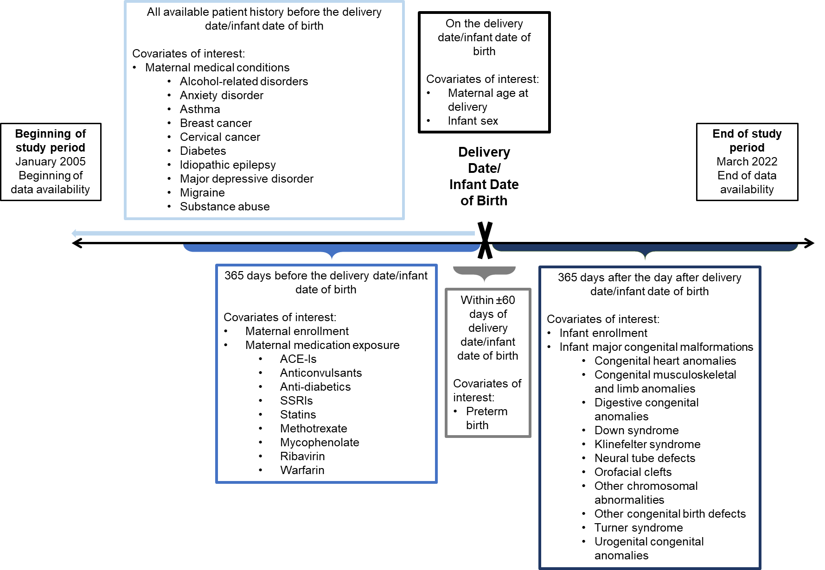
Abbreviations: ACE-Is: Angiotensin-converting enzyme inhibitors. SSRIs: Selective serotonin reuptake inhibitors.

Supplemental Figure 2. Value of variable indicating relationship to insurance holder for linked pairs of females of childbearing age with members enrolled at birth who share family identification codes, restricted to those with pregnancy or delivery codes
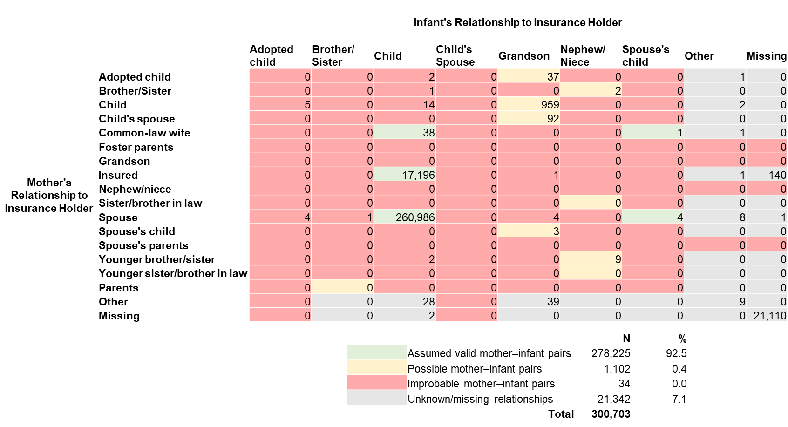
Notes: Mother–infant pairs assumed to be valid pairs were those in which the mother was the insured individual or the spouse of the insured individual and the infant was indicated to be the child. Possible mother–infant pairs were those in which a mother–child relationship was possible but not confirmable without additional family tree information (e.g., aunt and nephew/niece, child and grandchild). Improbable mother–infant pairs were those in which, assuming incestuous relationships to be improbable, an alternative familial relationship was more likely (e.g., siblings, grandparent and grandchild). Although some of the "adopted child" infant relationships could be valid relationships between mother and child, these are not valid mother–infant pairs for the purposes of studying in utero exposures.

Supplemental Figure 3. Comparison of true first trimester exposure window with that estimated in the JMDC under various scenarios according to the availability of pregnancy and delivery codes
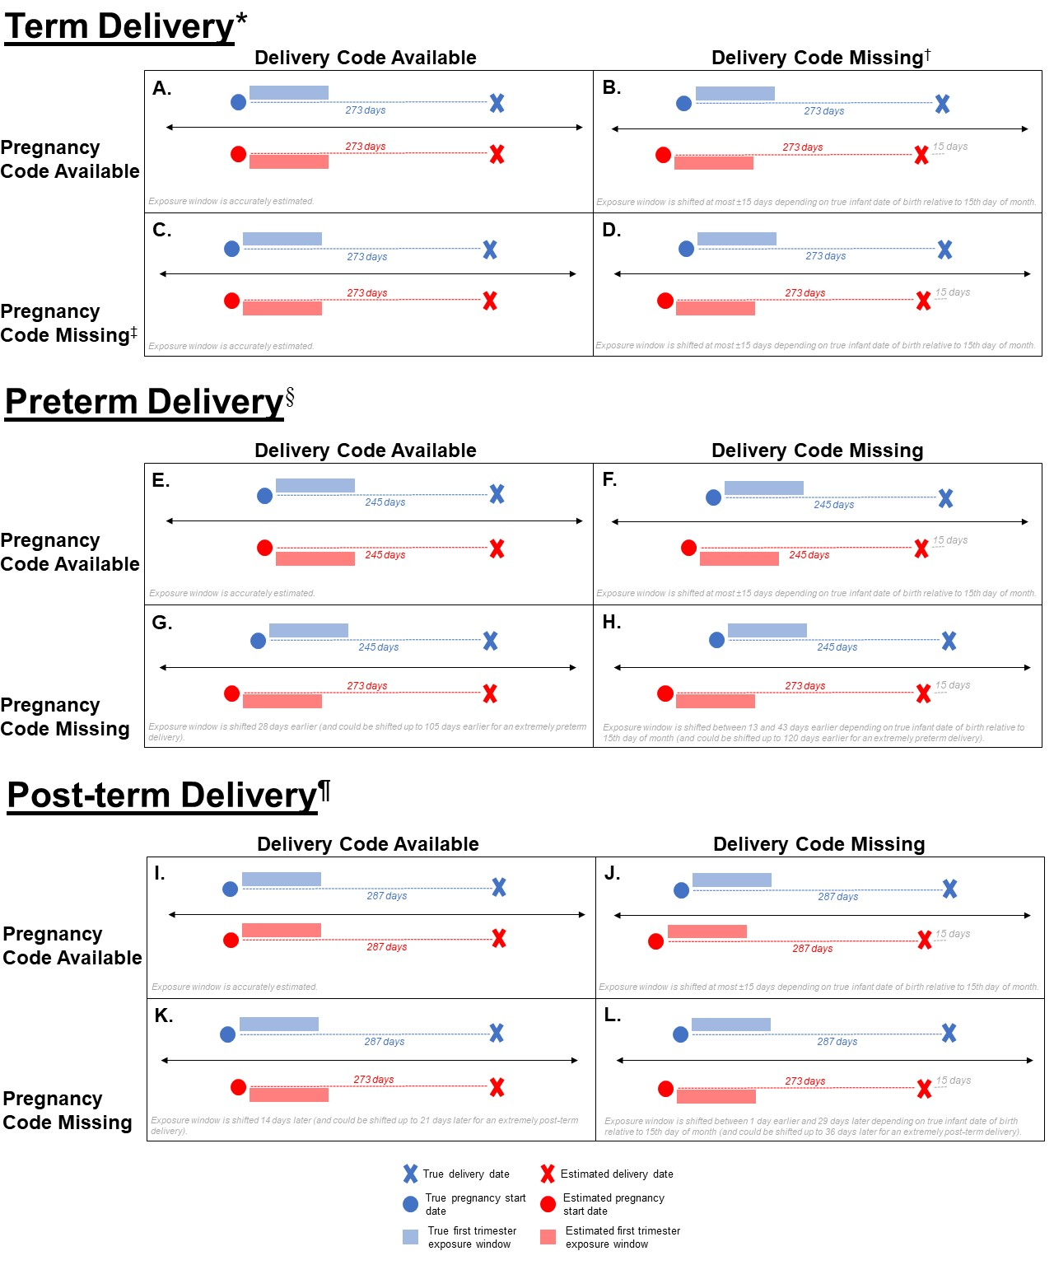
Notes: Figure displays the estimated first trimester exposure window, relative to the true first trimester exposure window, for term (A–D), preterm (E–H), and post-term (I–L) deliveries when pregnancy and/or delivery codes are available or missing. For each set of subfigures, the upper-left box (A, E, I) displays the scenario in which both pregnancy and delivery codes are available. The upper-right box (B, F, J) displays the scenario in which pregnancy codes are available, but delivery codes are missing. The lower-left box (C, G, K) displays the scenario in which pregnancy codes are missing, but delivery codes are available. The lower-right box (D, H, L) displays the scenario in which both pregnancy and delivering codes are missing.

* Term delivery is defined here as 273 completed gestational days.
† When delivery code is missing, delivery date/infant date of birth is imputed as the fifteenth day of the infant birth month.
‡ When pregnancy code is missing, gestational age is imputed as the length of a term birth (273 days).
§ Preterm delivery is defined here as 245 completed gestational days, but could be as short as 168 days.
¶ Post-term delivery is defined here as 287 completed gestational days, but could be a long as 294 days.

