SUPPORTIVE INFORMATION

Title: Development and Validation of a Patient-Reported Outcome Measure for Fingernail and Toenail Conditions: the NAIL-Q

Authors:
Anne F Klassen¹, Charlene Rae¹, Maureen O’Malley², Trisia Breitkopf¹, Leah Algu¹, Jasmine Mansouri³, Claire R Brown⁴, Yi Wang⁵, Shari R. Lipner⁴
¹Department of Pediatrics, McMaster University
² Division of Dermatology, Department of Medicine, McMaster University
³Schulich School of Medicine and Dentistry, Western University
⁴Department of Dermatology, Weill Cornell Medicine
⁵Department of Health Research Methods, Evidence, and Impact, McMaster University
Corresponding Author: Anne F Klassen, McMaster University, 3N27, 1200 Main Street W, Hamilton, ON, Canada, L8N 3Z5, aklass@mcmaster.ca

Table S1: Semi-structured interview guide

NAIL CONDITION
- Can you describe your nail condition to me?
- How long have you had this condition?
- What kinds of treatments have you had/will you have in the future for your nail condition?
- How happy/satisfied have you been with each treatment(s)?
SYMPTOMS/FUNCTION
- Can you describe any symptoms and sensations you experience with your nail condition? Probe as needed: pain, swelling, numbness, itch, odor etc. For each symptom/sensation, how bad is it (eg, intensity/severity/frequency). For each symptom/sensation, how does it interfere in your daily life?
- Can you describe any functional problems you have using your hands/feet? Probe: activities of daily living, self-care, walk, exercise, range of motion etc.
- Do you use any accommodations such as special footwear, gloves, etc?
- What issues do you experience with regards to taking care of your nails?
APPEARANCE
- How would you describe how your nails looks? Probe: before and after treatment for contour, colour, shape, scenarios, size, shape, qualitative, surrounding skin, symmetry, visibility.
- How have your toenails affected what kind of shoes you wear?
- What do you like/dislike about the appearance of your nails?
- What would you like to change about the appearance of your nails?
PSYCHOLOGICAL
- Can you describe if/how your nails (how it looks and feels) affects you emotionally? Probe as needed: negative (distress, feel down, irritation) and positive (happy, vibrant) emotions; negative (self-conscious, embarrassed) and positive (confident, attractive) body image concerns; concealment behaviours (gloves, shoes, makeup, polish).
- For any nail treatments you have had, can you describe any changes in your psychological wellbeing and how you feel about yourself? Probe as needed: for positive (feel better, happier, more confident, attractive) and negative (feel worse, self-conscious, unattractive)
- How big were these changes and how long did they last?
SOCIAL
- Thinking about your nails (how it looks/feels), can you describe any impacts on social interactions with people? Probe as needed: positive (more confident, go out more, making friends, recreation, shake hands, dating) and negative (isolation, stay in, stigmatized, avoidance)
- Do people stare or notice your nails?
- How have you felt supported or not supported by people in your life?
- Does your nail condition (how it looks/feels) have any impact on your work life? Please describe these.
GENERAL
- Can you describe any other concerns or issues you experienced that we have not already covered?
- Thinking back over what you have talked about in this interview, what would you say are the most/least important concerns in relation to your nail condition?

Figure S1 REDCap survey images to aid participants in identifying nail condition
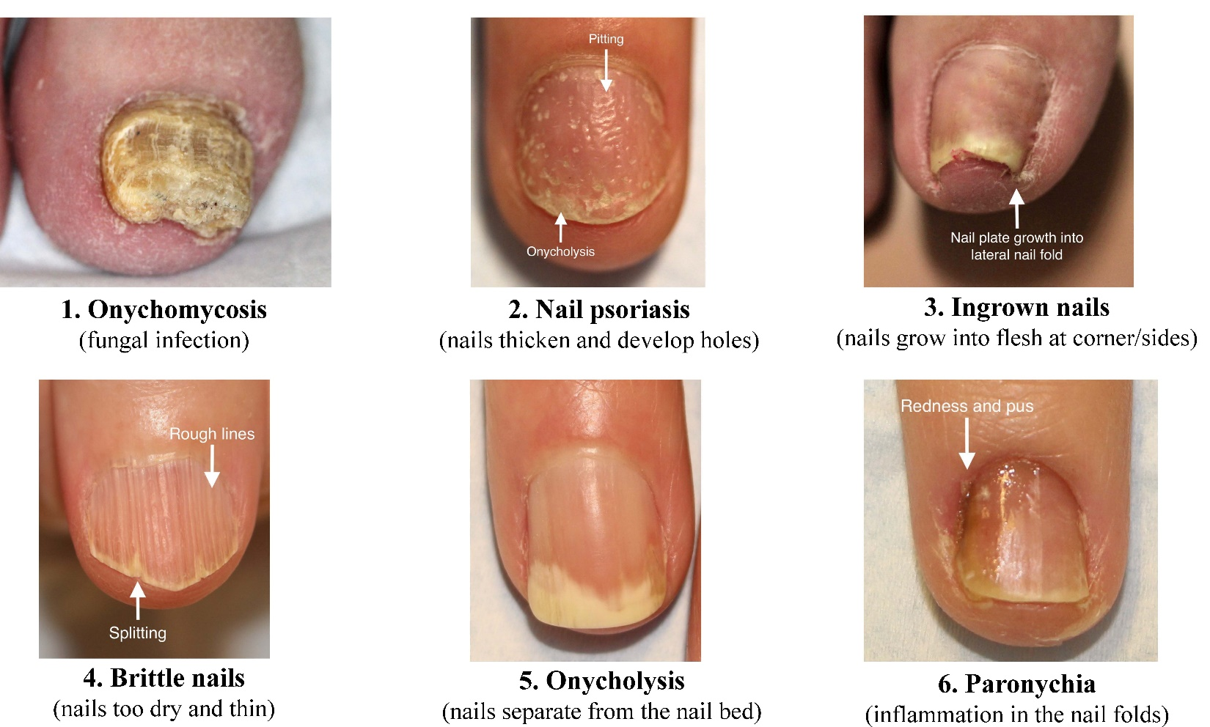

Table S2: Sample characteristics for phase 1 qualitative study
 |  | Number
COUNTRY | Canada | 5
COUNTRY | USA | 18
AGE | <49 | 6
AGE | 50-59 | 3
AGE | 60-69 | 6
AGE | >70 | 8
GENDER | Woman | 19
GENDER | Man | 4
RACE | White | 16
RACE | Black / African American | 2
RACE | Hispanic / Latino1 | 4
RACE | Other | 1
CONDITION | Brittle nails | 4
CONDITION | Dystrophy | 1
CONDITION | Ingrown toenails | 1
CONDITION | Lichen Planus | 3
CONDITION | Onychomycosis | 8
CONDITION | Onychopapilloma | 1
CONDITION | Onychophagia | 1
CONDITION | Onychorrhexis | 1
CONDITION | Psoriasis | 3
CONDITION | Trachyonychia | 1
CONDITION | Trauma | 1
SEVERITY BEFORE TREATMENT | Mild | 6
SEVERITY BEFORE TREATMENT | Moderate | 8
SEVERITY BEFORE TREATMENT | Severe | 11
TIME SINCE DIAGNOSIS, YEARS* | <1 | 2
TIME SINCE DIAGNOSIS, YEARS* | 1-5 | 13
TIME SINCE DIAGNOSIS, YEARS* | >5 | 10
NAILS AFFECTED | Fingernails | 21
NAILS AFFECTED | Toenails | 9
NAILS AFFECTED | Both | 7
NUMBER FINGERNAILS AFFECTED* | One | 5
NUMBER FINGERNAILS AFFECTED* | Some | 7
NUMBER FINGERNAILS AFFECTED* | All | 8
NUMBER TOENAILS AFFECTED* | One | 0
NUMBER TOENAILS AFFECTED* | Some | 6
NUMBER TOENAILS AFFECTED* | All | 2
Note: 2 participants had 2 nail conditions; * data missing for 1 participant

Table S3: Item revision during each round

ROUND 1 | Decision | ROUND 2 | Decision | ROUND 3 | Decision | FIELD-TEST | FINAL
APPEARANCE
How smooth the surface of your nails look (no ridges, indents or pits)? | retain |  | retain |  | retain |  | retain
The thickness of your nails? | retain |  | retain |  | retain |  | retain
How even the surface of the nails looks? | retain |  | retain |  | retain |  | retain
How your nails look up close? | retain |  | retain |  | retain |  | retain
How clear your nails look (no spots or stripes)? | retain |  | retain |  | retain |  | retain
How strong your nails are? | retain |  | retain |  | retain |  | retain
How hard your nails are? | retain |  | retain |  | retain |  | retain
How normal your nails look? | retain |  | retain |  | retain |  | retain
How healthy your nails are? | retain |  | retain |  | retain |  | retain
The color of your nails? | retain |  | retain |  | retain |  | drop
How even colored your nails look? | retain |  | retain |  | retain |  | drop
How your nails look under a bright light? | retain |  | retain |  | retain |  | drop
How your nails look when you are using your hands (eg, eating, playing cards)? | retain |  | retain |  | retain |  | drop
How attractive your nails look? | retain |  | retain |  | retain |  | drop
How fast your nails grow? | retain |  | retain |  | retain |  | drop
How your nails look if you rest your palms on a table? | retain |  | retain |  | retain |  | drop
The length of your nails? | retain |  | retain |  | retain |  | drop
How your nails look compared with other people? | revise | How your nails look compared with other people’s nails? | retain |  | retain |  | retain
How securely attached your nails are to the nailbed? | revise | How tightly attached your nail(s) are to the nailbed? | retain |  | retain |  | drop
How the cuticle/skin around your nails looks? | retain |  | revise | How the skin around your nails looks? | retain |  | drop
How clean your nail condition makes your nails look? | drop
The shape of your nails? | drop
The size of your nails? | drop
How well your nails match each other? | drop
How your nails look when you hold a glass? | drop
 |  |  | add | How your nails look in photos? | retain
 |  |  | add | How your cuticles look (ie, the skin at the bottom edge of your nails)? | retain | How your cuticles look?
NAIL DISTRESS
I get upset about my nail condition. | retain |  | retain |  | retain |  | retain
I dislike when people look at my nails. | retain |  | retain |  | retain |  | retain
I dislike how my nails look. | retain |  | retain |  | retain |  | retain
I am self-conscious of my nail condition. | retain |  | retain |  | retain |  | retain
I am embarrassed about my nail condition. | retain |  | retain |  | retain |  | drop
My nail condition interferes with my ability to enjoy life. | retain |  | retain |  | retain |  | drop
I worry about having to greet people (eg, shake hands or wave). | retain |  | retain |  | retain |  | drop
I worry people might think my nail condition is contagious. | retain |  | retain |  | retain |  | drop
I avoid having my nails done (eg, manicure, pedicure). | retain |  | retain |  | retain |  | drop
I hide my nails when I am with other people (eg, gloves, keep hands in pocket). | revise | I hide my nails when I am with other people (eg, gloves, shoes, keep hands in pocket). | retain |  | retain |  | drop
I am conscious of my nail condition when I am with other people (eg, restaurant, beach). | revise | I am aware of my nail condition when I am with other people (eg, restaurant, beach). | retain |  | retain |  | retain
I cover my nails when I go out (eg, nail polish, artificial nails). | drop
I dislike when people ask about my nails. | drop
I avoid some activities that show my nails. | drop
 |  |  | add | I avoid having photos taken that show my nails. | retain |  | retain
 |  |  |  |  | add | My nail condition makes me feel frustrated. | retain
NAIL SYMPTOMS
Nails that break? | retain |  | retain |  | retain |  | retain
Nails that peel (layers)? | retain |  | retain |  | retain |  | retain
Nails that split? | retain |  | retain |  | retain |  | retain
Nails that chip? | revise | Nails that chip (ie, little pieces come off)? | retain |  | retain |  | retain
Skin around the nails that looks swollen? | retain |  | retain |  | retain |  | retain
Skin around the nails that bleeds? | retain |  | retain |  | retain |  | retain
Nails that cause pain? | retain |  | retain |  | retain |  | retain
Nails that come off? | retain |  | retain |  | retain |  | drop
Nails and surrounding skin that are infected? | retain |  | retain |  | retain |  | drop
Nails that are loose or lifted from the nailbed? | retain |  | retain |  | retain |  | drop
Nails that smell? | retain |  | retain |  | retain |  | drop
Nails that crack? | drop
Skin around the nails that looks inflamed? | drop
Nails that are dry? | drop
Nails that cause sensitivity? | drop
 |  |  | add | Nails that throb? | retain |  | retain
 |  |  | add | Skin around the nails that look red? | retain |  | retain
 |  |  | add | Nails that cause pain in the tips of your fingers or toes? | retain |  | retain
 |  |  | add | Nails that do not grow as fast as you would like? | retain |  | drop
PHYSICAL: FINGERNAILS
Buttoning a shirt or coat? | retain |  | retain |  | retain |  | retain
Putting on or taking off clothes? | retain |  | retain |  | retain |  | retain
Personal grooming (eg, shaving, putting on make-up)? | retain |  | retain |  | retain |  | retain
Typing? | retain |  | retain |  | retain |  | retain
Preparing food (eg, peeling, cutting)? | retain |  | retain |  | retain |  | drop
Gripping handles (eg, tennis racket, golf club, broom)? | retain |  | retain |  | retain |  | drop
Writing with a pen or pencil? | retain |  | retain |  | retain |  | drop
Scratching an itch? | revise | Using your nails to scratch an itch? | retain |  | retain |  | drop
Picking up a coin? | revise | Picking up a small item (eg, coin, pill, button)? | retain |  | retain |  | drop
Clipping your fingernails? | revise | Looking after your nails (eg, clip, clean)? | retain |  | retain |  | drop
Eating with cutlery (eg, fork, spoon, knife)? | drop
Opening a jar? | drop
Turning a key in a lock? | drop
 | add | Doing chores around the house? | retain |  | retain |  | retain
 | add | Being able to get your hands wet (eg, do dishes, wash hands)? | retain |  | retain |  | drop
 |  |  | add | Doing your usual daily activities (eg, work, school)? | retain |  | retain
PHYSICAL: TOENAILS
Being physically active? | retain |  | retain |  | retain |  | retain
Your ability to be independent? | retain |  | retain |  | retain |  | retain
Putting on or taking off socks? | retain |  | retain |  | retain |  | drop
Your ability to move around? | revise | Your ability to walk or move around? | retain |  | retain |  | retain
Your ability to do your usual activities (eg, work, school)? | revise | Doing your usual daily activities (eg, work, school)? | retain |  | retain |  | retain
Being able to wear shoes you like? | revise | Being able to wear shoes that cover your toes? | retain |  | retain |  | drop
Your ability to do chores around the house? | revise | Doing chores around the house? | retain |  | retain |  | drop
Doing activities you enjoy? | revise | Doing activities that you enjoy? | retain |  | retain |  | retain
Your ability to clean your nails? | revise | Looking after your nails (eg, clip, clean)? | retain |  | retain |  | drop
Putting on or taking off clothes (eg, nails catch or snag)? | drop
Your ability to enjoy life? | drop
Your social life? | drop
Your self-confidence? | drop
Your ability to clip your nails? | drop
TREATMENT OUTCOME
I wish I had the nail treatment sooner. | retain |  | retain |  | retain |  | drop
The results of the nail treatment are great. | retain |  | retain |  | retain |  | drop
My nail condition has improved with treatment. | retain |  | retain |  | retain |  | drop
I am pleased with the results of the nail treatment. | retain |  | retain |  | retain |  | retain
It was worthwhile having the nail treatment. | retain |  | retain |  | retain |  | retain
The results of the nail treatment are better than I expected. | retain |  | retain |  | retain |  | retain
I am happy with the nail treatment. | revise | I am happy with the result of the nail treatment. | revise | I am glad I had the nail treatment. | retain |  | retain
My nails are much better than before the nail treatment. | revise | My nails are better than before the nail treatment. | drop |  |  |  | drop
 |  |  | add | The treatment worked for my nail condition. | retain |  | retain
 |  |  | add | The treatment was worth the time and effort. | retain |  | retain
 |  |  | add | I am happy with how fast the nail treatment worked. | retain |  | drop
 |  |  | add | I would have the nail treatment again if I needed to. | retain |  | drop
 |  |  | add | I would recommend the nail treatment to other people with my condition. | retain |  | retain

Table S4: Item revision during 3 rounds of participant and expert input

Scales | Decisions | Round 1 – participants | Round 2 - experts | Round 3 - participants | Field-test version
NAIL APPEARANCE |  | n=25 | n =20 | n=22 | n=22
NAIL APPEARANCE | Retain | 18 | 19 | 21
NAIL APPEARANCE | Revise | 2 | 1 | 1
NAIL APPEARANCE | Drop | 5 | 0 | 0
NAIL APPEARANCE | Add | 0 | 2 | 0
NAIL DISTRESS |  | n =14 | n=11 | n=12 | n=13
NAIL DISTRESS | Retain | 9 | 11 | 12
NAIL DISTRESS | Revise | 2 | 0 | 0
NAIL DISTRESS | Drop | 3 | 0 | 0
NAIL DISTRESS | Add | 0 | 1 | 1
NAIL SYMPTOMS |  | n=15 | n=11 | n=15 | n=15
NAIL SYMPTOMS | Retain | 10 | 11 | 15
NAIL SYMPTOMS | Revise | 1 | 0 | 0
NAIL SYMPTOMS | Drop | 4 | 0 | 0
NAIL SYMPTOMS | Add | 0 | 4 | 0
PHYSICAL: FINGERNAILS |  | n =13 | n=12 | n=13 | n=13
PHYSICAL: FINGERNAILS | Retain | 7 | 12 | 13
PHYSICAL: FINGERNAILS | Revise | 3 | 0 | 0
PHYSICAL: FINGERNAILS | Drop | 3 | 0 | 0
PHYSICAL: FINGERNAILS | Add | 2 | 1 | 0
PHYSICAL: TOENAILS |  | n =14 | n=9 | n=9 | n=9
PHYSICAL: TOENAILS | Retain | 3 | 9 | 9
PHYSICAL: TOENAILS | Revise | 6 | 0 | 0
PHYSICAL: TOENAILS | Drop | 5 | 0 | 0
PHYSICAL: TOENAILS | Add | 0 | 0 | 0
TREATMENT OUTCOME |  | n=8 | n=8 | n=12 | n=12
TREATMENT OUTCOME | Retain | 6 | 6 | 12
TREATMENT OUTCOME | Revise | 2 | 1 | 0
TREATMENT OUTCOME | Drop | 0 | 1 | 0
TREATMENT OUTCOME | Add | 0 | 5 | 0
TOTAL |  | 89 | 71 | 83 | 84

Table S5: RMT item level fit statistics and differential item function results

Scales | Item Fit Statistics |  |  |  |  |  |  | Differential Item Function*
Item | Location | SE | Fit Residual | DF | χ² | DF | p-value | Country | Age | Gender | Education | Location
NAIL APPEARANCE
Clear | -0.47 | 0.05 | 4.89 | 529.4 | 15.0 | 9 | 0.09 | no | no | 1,2,3 | no | 1,2
Hard | -0.42 | 0.05 | 1.90 | 520.4 | 12.9 | 9 | 0.17 | no | no | no | no | 1,2,3
Strong | -0.41 | 0.05 | 3.42 | 530.3 | 14.8 | 9 | 0.10 | no | no | no | no | 1,2,3
Thickness | -0.14 | 0.05 | 0.41 | 531.2 | 8.6 | 9 | 0.47 | no | no | 1,3 | no | no
Smooth | -0.10 | 0.05 | 0.43 | 532.0 | 5.1 | 9 | 0.83 | no | no | no | no | no
Even surface | -0.03 | 0.05 | -1.05 | 530.3 | 10.3 | 9 | 0.33 | no | no | no | no | no
Normal | 0.11 | 0.05 | -1.80 | 531.2 | 8.8 | 9 | 0.45 | no | no | no | no | 1,2,3
Healthy | 0.29 | 0.06 | -3.48 | 532.9 | 15.4 | 9 | 0.08 | no | no | no | no | no
Compared | 0.50 | 0.05 | 0.98 | 531.2 | 3.4 | 9 | 0.95 | no | no | no | no | no
Up close | 0.66 | 0.05 | -0.96 | 530.3 | 13.8 | 9 | 0.13 | no | no | no | no | 3
NAIL DISTRESS
Aware with others | -0.61 | 0.05 | 3.60 | 498.0 | 17.4 | 8 | 0.03 | no | no | 1,2,3 | no | no
Avoid photos | -0.49 | 0.05 | -0.20 | 497.1 | 9.7 | 8 | 0.29 | no | 1 | no | no | 1,2,3
Upset | -0.28 | 0.06 | 1.74 | 496.3 | 5.1 | 8 | 0.75 | 1,2,3 | no | no | no | 3
Frustrated | -0.23 | 0.05 | -1.11 | 499.7 | 15.9 | 8 | 0.04 | no | no | no | no | no
People look | 0.28 | 0.05 | -1.40 | 496.3 | 16.6 | 8 | 0.03 | no | no | no | no | 2
Self-conscious | 0.65 | 0.06 | 0.13 | 498.8 | 4.8 | 8 | 0.78 | no | no | no | no | no
Dislike | 0.69 | 0.06 | -0.39 | 498.8 | 10.5 | 8 | 0.23 | 1,2,3 | 1,2,3 | no | no | no
NAIL SYMPTOMS
Skin bleeds | -0.41 | 0.06 | -0.88 | 421.4 | 12.3 | 7 | 0.09 | no | 1,2, | no | no | 1,2,3
Nails throb | -0.35 | 0.06 | 2.90 | 419.8 | 7.0 | 7 | 0.42 | no | 1,2,3 | no | no | no
Skin red | -0.09 | 0.06 | -0.63 | 423.9 | 12.2 | 7 | 0.09 | no | no | no | no | no
Skin swollen | 0.04 | 0.06 | -0.79 | 423.1 | 7.0 | 7 | 0.43 | no | no | no | no | no
Pain in tips | 0.17 | 0.05 | -0.01 | 423.1 | 6.4 | 7 | 0.49 | no | no | no | no | no
Nails cause pain | 0.64 | 0.06 | 0.22 | 423.9 | 8.1 | 7 | 0.32 | no | no | no | no
STRENGTH: FINGERNAILS
Peel | -0.05 | 0.10 | 2.99 | 116.6 | 7.6 | 2 | 0.02 | N/A | no | N/A | N/A | N/A
Split | -0.03 | 0.11 | -0.84 | 118.8 | 5.4 | 2 | 0.07 | N/A | no | N/A | N/A | N/A
Chip | 0.00 | 0.10 | 0.66 | 120.2 | 0.7 | 2 | 0.71 | N/A | no | N/A | N/A | N/A
Break | 0.08 | 0.10 | -1.67 | 119.5 | 4.8 | 2 | 0.09 | N/A | no | N/A | N/A | N/A
PHYSICAL: FINGERNAILS
Button | -0.30 | 0.12 | -0.72 | 112.7 | 3.0 | 2 | 0.23 | N/A | no | N/A | N/A | N/A
Groom | -0.23 | 0.12 | 0.68 | 111.1 | 2.2 | 2 | 0.33 | N/A | no | N/A | N/A | N/A
Type | -0.07 | 0.12 | 0.74 | 111.1 | 1.3 | 2 | 0.53 | N/A | no | N/A | N/A | N/A
Daily activities | 0.12 | 0.12 | -0.90 | 112.7 | 1.4 | 2 | 0.49 | N/A | no | N/A | N/A | N/A
Chores | 0.18 | 0.11 | 0.63 | 111.9 | 0.9 | 2 | 0.64 | N/A | no | N/A | N/A | N/A
Clothes | 0.30 | 0.11 | 1.76 | 112.7 | 0.4 | 2 | 0.83 | N/A | no | N/A | N/A | N/A
PHYSICAL: TOENAILS
Independent | -0.85 | 0.09 | 0.34 | 231.8 | 4.1 | 3 | 0.25 | no | no | no | no | N/A
Daily activities | -0.40 | 0.08 | -2.53 | 231.0 | 10.7 | 3 | 0.01 | no | no | no | no | N/A
Walk or move | 0.10 | 0.08 | -0.85 | 232.6 | 3.3 | 3 | 0.35 | no | no | no | no | N/A
Activities enjoy | 0.49 | 0.08 | 0.86 | 228.7 | 1.5 | 3 | 0.67 | no | no | no | no | N/A
Physically active | 0.67 | 0.08 | 2.15 | 231.8 | 3.3 | 3 | 0.34 | no | no | no | no | N/A
TREATMENT OUTCOME
Glad had it | -0.85 | 0.08 | -0.09 | 319.9 | 5.8 | 5 | 0.32 | no | no | 1,2 | N/A | N/A
Would recommend | -0.59 | 0.07 | 1.34 | 319.9 | 2.5 | 5 | 0.78 | no | no | no | N/A | N/A
Worthwhile | -0.35 | 0.08 | -0.60 | 320.8 | 2.9 | 5 | 0.72 | no | no | no | N/A | N/A
Time and effort | -0.15 | 0.08 | -1.82 | 318.2 | 2.5 | 5 | 0.77 | no | no | no | N/A | N/A
Treatment worked | 0.35 | 0.08 | -2.30 | 319.9 | 8.5 | 5 | 0.13 | no | no | no | N/A | N/A
Pleased | 0.54 | 0.08 | -1.15 | 317.4 | 1.5 | 5 | 0.92 | no | no | no | N/A | N/A
Better than expected | 1.04 | 0.08 | 3.24 | 320.8 | 6.6 | 5 | 0.26 | no | no | no | N/A | N/A
*In DIF analysis, 1 = random sample 1 was significant; 2 = random sample 2 was significant; 3 = random sample 3 was significant

Figure S2: Person-item threshold distributions for each NAIL-Q scale from RMT analysis

NAIL APPEARANCE | 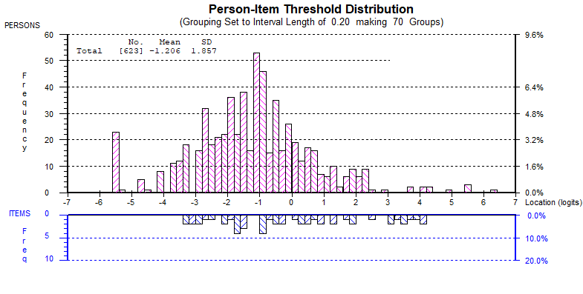
NAIL DISTRESS | 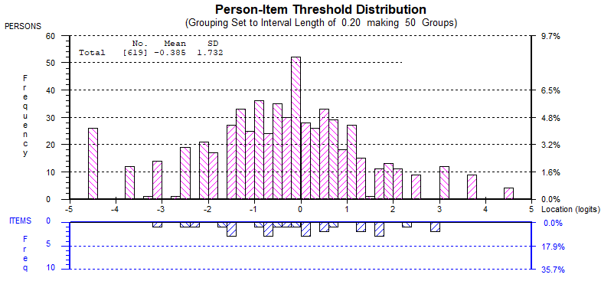
NAIL SYMPTOMS | 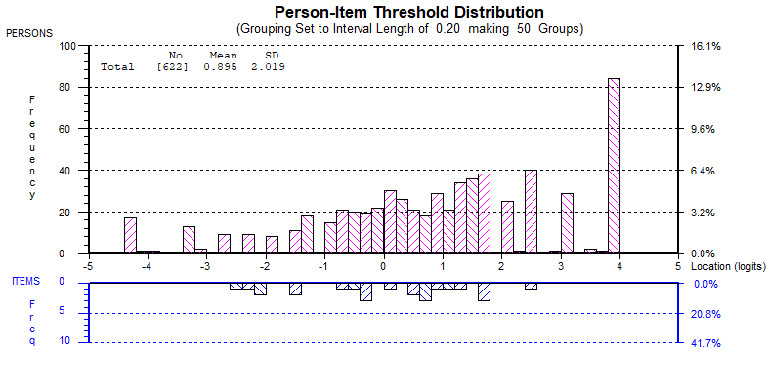
STRENGTH: FINGERNAILS | 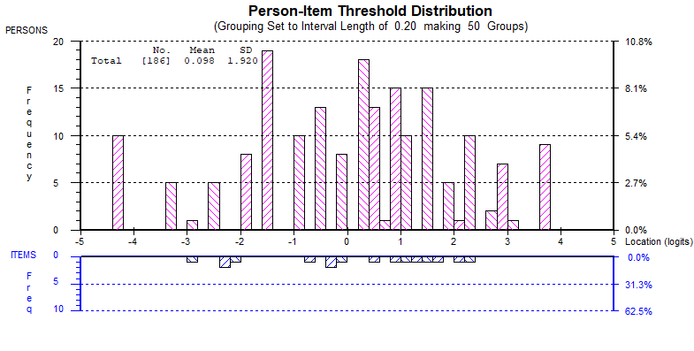
PHYSICAL: FINGERNAILS | 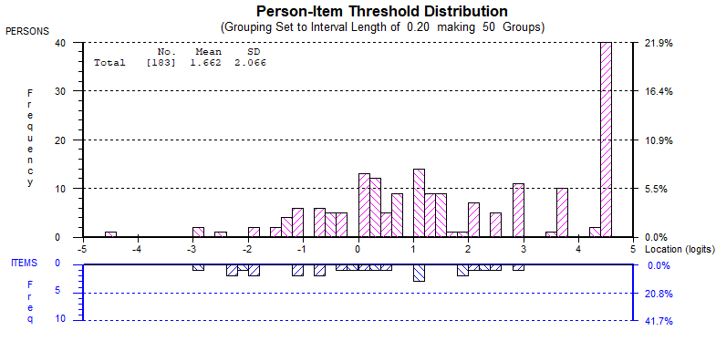
PHYSICAL: TOENAILS | 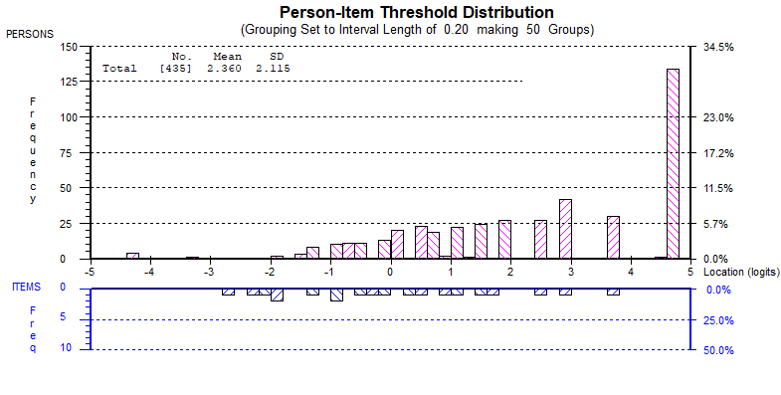
TREATMENT OUTCOME | 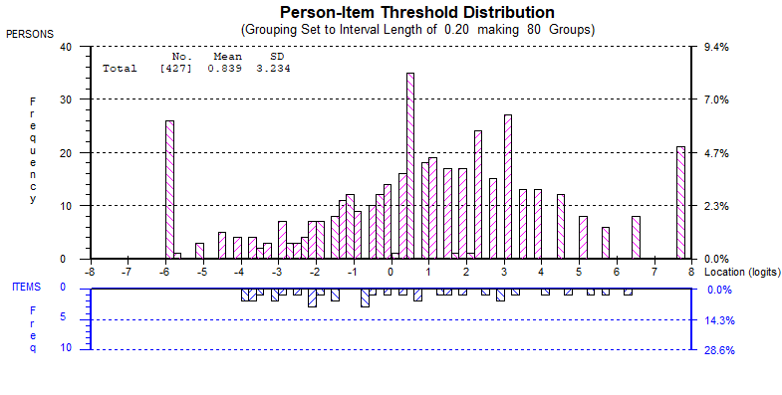

Table S6: How would you describe the SEVERITY of your nail condition?

Scale |  | Mean | SD | 95% CI |  | N | P-value
 |  |  |  | Lower Bound | Upper Bound | N | P-value
APPEARANCE | Mild | 46 | 12 | 44 | 47 | 228 | p<0.001
APPEARANCE | Moderate | 39 | 15 | 37 | 41 | 339 | p<0.001
APPEARANCE | Severe/Very severe | 26 | 16 | 22 | 30 | 56 | p<0.001
DISTRESS | Mild | 55 | 17 | 53 | 57 | 227 | p<0.001
DISTRESS | Moderate | 43 | 17 | 41 | 44 | 336 | p<0.001
DISTRESS | Severe/Very severe | 27 | 17 | 23 | 31 | 56 | p<0.001
SYMPTOMS | Mild | 71 | 23 | 68 | 74 | 228 | p<0.001
SYMPTOMS | Moderate | 58 | 24 | 55 | 60 | 338 | p<0.001
SYMPTOMS | Severe/Very severe | 47 | 28 | 39 | 54 | 56 | p<0.001
STRENTH: FINGERNAILS | Mild | 57 | 24 | 52 | 63 | 72 | P=0.045
STRENTH: FINGERNAILS | Moderate | 49 | 26 | 44 | 54 | 101 | P=0.045
STRENTH: FINGERNAILS | Severe/Very severe | 43 | 28 | 26 | 59 | 13 | P=0.045
PHYSICAL: FINGERNAIL | Mild | 78 | 21 | 73 | 83 | 72 | p<0.001
PHYSICAL: FINGERNAIL | Moderate | 64 | 21 | 60 | 68 | 98 | p<0.001
PHYSICAL: FINGERNAIL | Severe/Very severe | 47 | 27 | 30 | 63 | 13 | p<0.001
PHYSICAL: TOENAILS | Mild | 84 | 19 | 81 | 87 | 155 | p<0.001
PHYSICAL: TOENAILS | Moderate | 71 | 21 | 68 | 74 | 237 | p<0.001
PHYSICAL: TOENAILS | Severe/Very severe | 60 | 27 | 52 | 69 | 43 | p<0.001

Table S7: What side is your nail condition on?

Scale |  | Mean | Std. Deviation | N | P-value
APPEARANCE | one side | 43 | 14 | 272 | p<0.001
APPEARANCE | both sides | 38 | 16 | 351 | p<0.001
DISTRESS | one side | 48 | 17 | 269 | p=0.027
DISTRESS | both sides | 44 | 21 | 350 | p=0.027

Table S8: How PAINFUL is your nail condition?

Scale | Response Options | Mean | Std. Deviation | 95% CI |  | N | P-value
SYMPTOMS | Response Options | Mean | Std. Deviation | Lower Bound | Upper Bound | N | P-value
SYMPTOMS | No pain | 77 | 24 | 74 | 80 | 227 | p<0.001
SYMPTOMS | Mild | 59 | 20 | 56 | 61 | 234 | p<0.001
SYMPTOMS | Moderate | 46 | 20 | 43 | 49 | 139 | p<0.001
SYMPTOMS | Severe/Very severe | 29 | 26 | 18 | 41 | 22 | p<0.001

Table S9: How EMBARRASSING is your nail condition?

Scale | Response Options | Mean | Std. Deviation | 95% CI |  | N | P-value
 |  |  |  | Lower Bound | Upper Bound | N | P-value
APPEARANCE | Not at all | 51 | 14 | 48 | 53 | 116 | p<0.001
APPEARANCE | A little | 42 | 12 | 41 | 44 | 276 | p<0.001
APPEARANCE | Moderately | 37 | 15 | 34 | 39 | 146 | p<0.001
APPEARANCE | Extremely | 25 | 15 | 22 | 29 | 85 | p<0.001
DISTRESS | Not at all | 64 | 16 | 61 | 67 | 115 | p<0.001
DISTRESS | A little | 50 | 14 | 48 | 51 | 274 | p<0.001
DISTRESS | Moderately | 38 | 13 | 35 | 40 | 145 | p<0.001
DISTRESS | Extremely | 22 | 15 | 19 | 25 | 85 | p<0.001
SYMPTOMS | Not at all | 70 | 23 | 65 | 74 | 116 | p<0.001
SYMPTOMS | A little | 64 | 24 | 61 | 67 | 275 | p<0.001
SYMPTOMS | Moderately | 57 | 24 | 53 | 61 | 146 | p<0.001
SYMPTOMS | Extremely | 50 | 29 | 44 | 57 | 85 | p<0.001

Table S10: How much does your NAIL condition INTERFERE with doing your usual daily activities?

Scale | Response Options | Mean | Std. Deviation | 95% CI |  | N | P-value
 |  |  |  | Lower Bound | Upper Bound | N | P-value
DISTRESS | Not at all | 53 | 19 | 50 | 55 | 231 | p<0.001
DISTRESS | Little bit | 45 | 17 | 43 | 47 | 316 | p<0.001
DISTRESS | Quite a bit/ Very much | 28 | 17 | 24 | 32 | 72 | p<0.001
SYMPTOMS | Not at all | 75 | 24 | 72 | 78 | 232 | p<0.001
SYMPTOMS | Little bit | 58 | 21 | 55 | 60 | 317 | p<0.001
SYMPTOMS | Quite a bit/ Very much | 35 | 25 | 30 | 41 | 73 | p<0.001
PHYSICAL: FINGERNAILS | Not at all | 89 | 15 | 86 | 93 | 61 | p<0.001
PHYSICAL: FINGERNAILS | Little bit | 62 | 18 | 58 | 65 | 100 | p<0.001
PHYSICAL: FINGERNAILS | Quite a bit/ Very much | 42 | 15 | 36 | 49 | 22 | p<0.001
STRENGTH: FINGERNAILS | Not at all | 66 | 22 | 60 | 71 | 62 | p<0.001
STRENGTH: FINGERNAILS | Little bit | 46 | 24 | 41 | 50 | 101 | p<0.001
STRENGTH: FINGERNAILS | Quite a bit/ Very much | 43 | 29 | 30 | 55 | 23 | p<0.001
PHYSICAL: TOENAILS | Not at all | 91 | 14 | 89 | 93 | 169 | p<0.001
PHYSICAL: TOENAILS | Little bit | 68 | 19 | 66 | 71 | 216 | p<0.001
PHYSICAL: TOENAILS | Quite a bit/ Very much | 46 | 18 | 41 | 52 | 50 | p<0.001

Table S11: How much worse or better is your NAIL condition now compared with before you had the treatment?

Scale | Response Options | Mean | Std. Deviation | 95% CI |  | N | P-value
 |  |  |  | Lower Bound | Upper Bound | N | P-value
OUTCOME | A lot / A little worse | 28 | 22 | 18 | 38 | 21 | p<0.001
OUTCOME | Same | 36 | 21 | 32 | 40 | 134 | p<0.001
OUTCOME | A little better | 58 | 13 | 56 | 60 | 222 | p<0.001
OUTCOME | A lot better | 77 | 16 | 74 | 80 | 103 | p<0.001

