Case | 1 | 2 | 3 | 4 | 5 | 6 | 7 | 8 | 9
Age | 68 | 41 | 85 | 86 | 53 | 76 | 43 | 70 | 37
Gender | Male | Male | Male | Male | Male | Female | Male | Female | Male
NAYA | III | III | IV | IV | III | III | IV | III | II
6MW | 392.3 | 400.3 | 274.5 | 293.2 | 372.6 | 315.8 | 224.5 | 412.2 | 424.6
EF | 39 | 34 | 33 | 38 | 30 | 39 | 36 | 35 | 35
IVSD | 9 | 9 | 9 | 9 | 11 | 9 | 11 | 8 | 11
LVDd | 54 | 66 | 68 | 61 | 55 | 68 | 66 | 50 | 70
LVDs | 43 | 55 | 57 | 49 | 46 | 58 | 53 | 41 | 58
BNP | 141.74 | 200.23 | 161.2 | 953.27 | 151.51 | 340.62 | 120.18 | 857.7 | 80.74
TG | 1.25 | 1.24 | 0.94 | 0.89 | 4.28 | 1.17 | 0.66 | 1.78 | 2.19
TC | 5.68 | 4.27 | 3.96 | 2.53 | 4.74 | 4.38 | 6.51 | 5.39 | 4.75
LDL | 3.14 | 2.73 | 2.36 | 1.51 | 2.64 | 2.42 | 4.11 | 3.58 | 2.56
Cr | 62.6 | 92.1 | 75.6 | 90.8 | 83.8 | 63 | 90.3 | 87 | 69.5
Smoking | No | No | Yes | Yes | Yes | No | Yes | No | No
Hypertension | No | Yes | Yes | No | Yes | No | Yes | No | Yes
Coronary Artery Disease | Yes | Yes | Yes | No | Yes | No | Yes | Yes | No
Supplementary Table 1. Before treatment group raw data

Supplementary Table 2. After 2months of treament group raw data
Case | 6MWT | EF | IVSD | LVDd | LVDs
1 | 436.7 | 44 | 10 | 53 | 42
2 | 452.4 | 37 | 11 | 57 | 47
3 | 346 | 43 | 9 | 61 | 48
4 | 464.2 | 41 | 9 | 59 | 47
5 | 463.3 | 32 | 11 | 55 | 45
6 | 315.9 | 37 | 9 | 68 | 57
7 | 234.7 | 38 | 13 | 62 | 51
8 | 436.6 | 33 | 9 | 56 | 45
9 | 429 | 38 | 10 | 68 | 53

Supplementary Table 3. After 6months of treament group raw data
Case | 6MWT | EF | IVSD | LVDd | LVDs
1 | 363.8 | 46 | 10 | 50 | 37
2 | 419.5 | 40 | 11 | 55 | 44
3 | 480.4 | 48 | 8 | 51 | 35
4 | 474.8 | 41 | 9 | 55 | 43
5 | 429.4 | 34 | 11 | 52 | 42
6 | 232.4 | 41 | 9 | 61 | 50
7 | 469.9 | 55 | 13 | 52 | 37
8 | 593.6 | 40 | 9 | 51 | 41
9 | 505.7 | 44 | 9 | 62 | 48
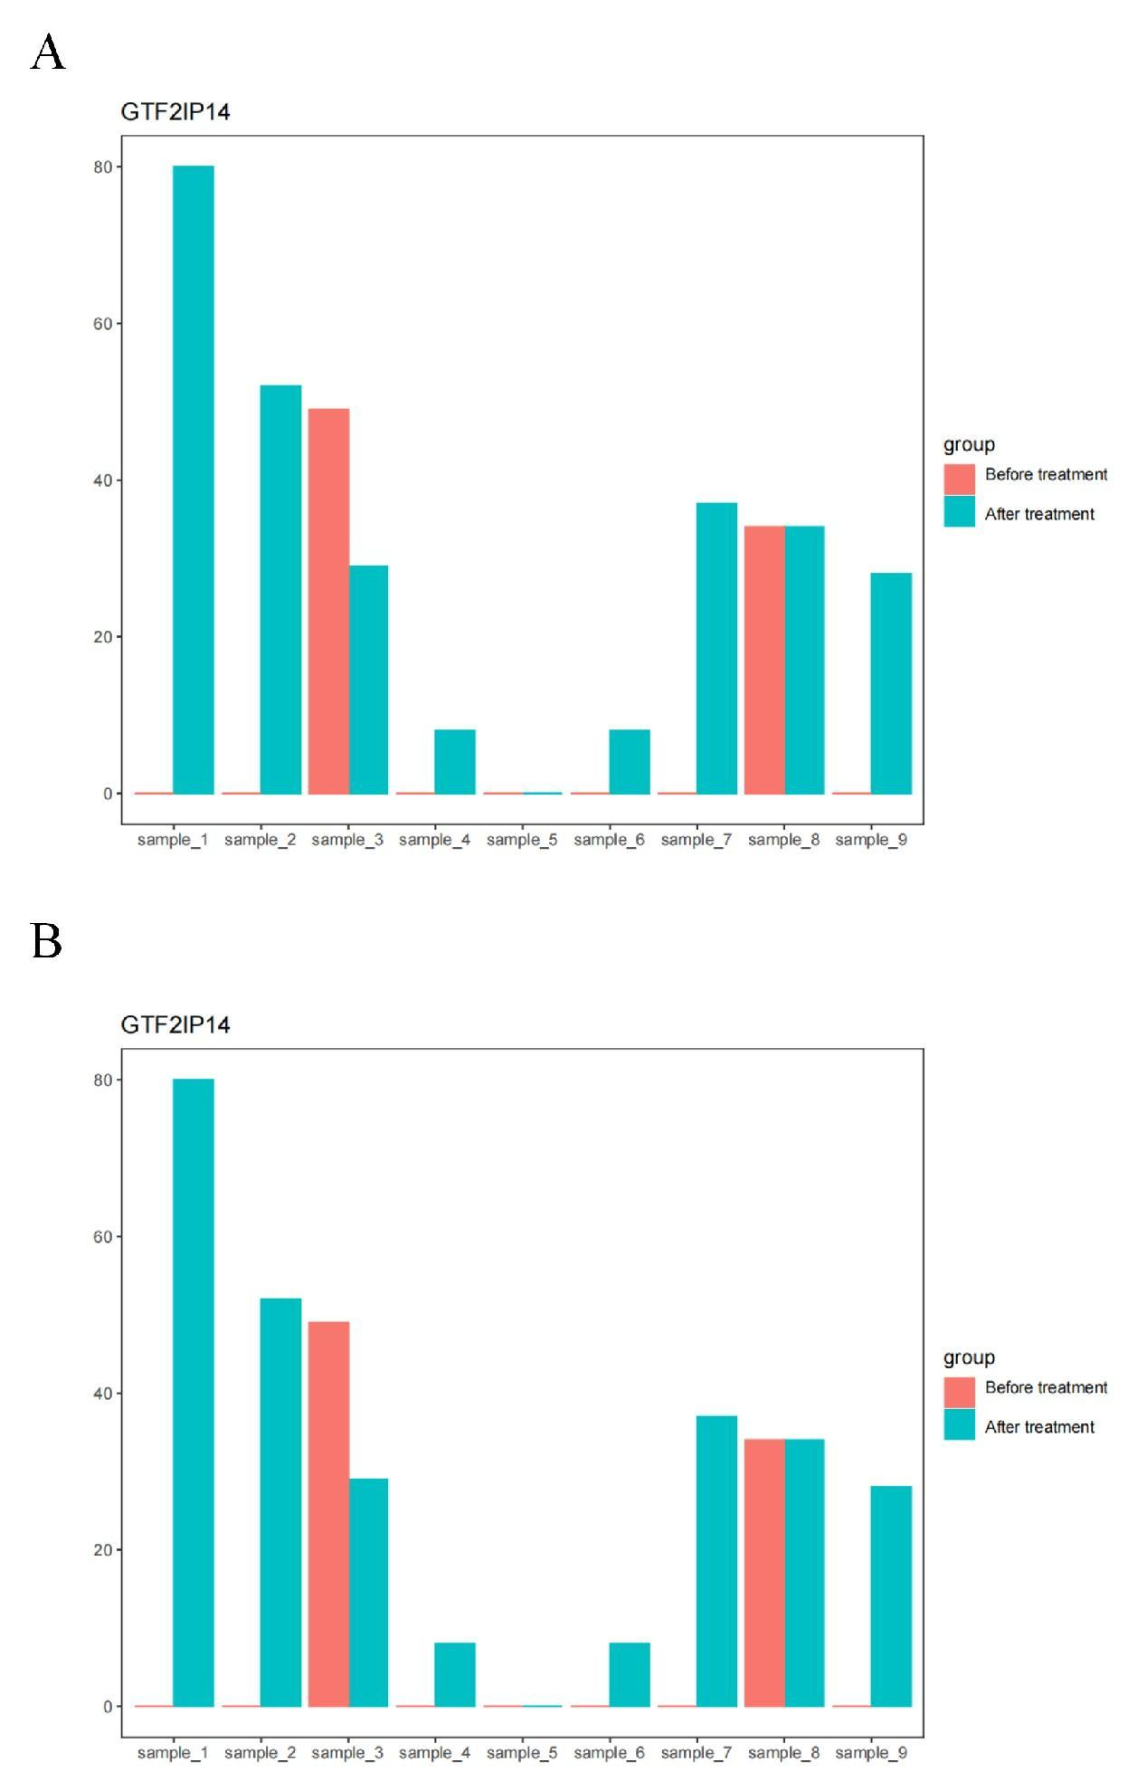
Supplementary Figure 1. GTF2IP14 and MTLN expression in each patient before and after treatments. A. GTF2IP14 expression in each patient before treatment; B. MTLN expression in each patient before treatment.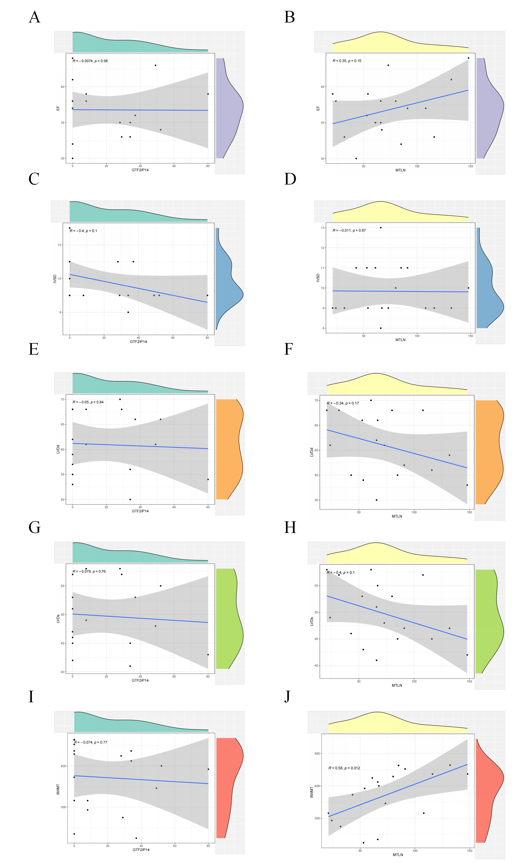
Supplementary Figure 2. Correlation analysis of echocardiography and hub genes (GTF2IP14 and MTLN). A、C、E、G: Scatter plot of correlation between GTF2IP14 and cardiac ultrasound indices; B、D、F、H: Scatter plot of correlation between MTLN and cardiac ultrasound indices; I. Scatter plot of the correlation between GTF2IP14 and 6MWT; J.Scatter plot of the correlation between MTLN and 6MWT.

