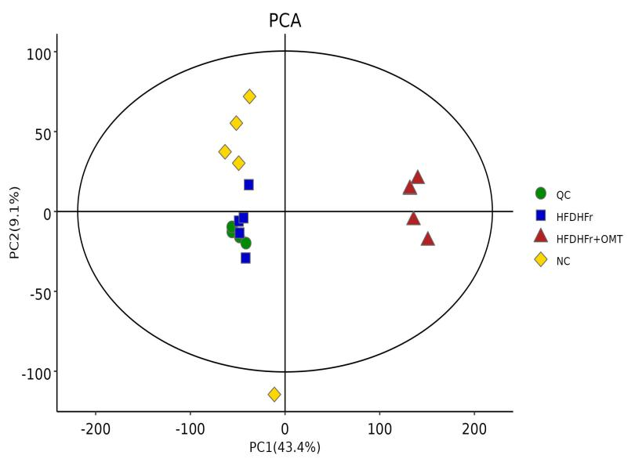
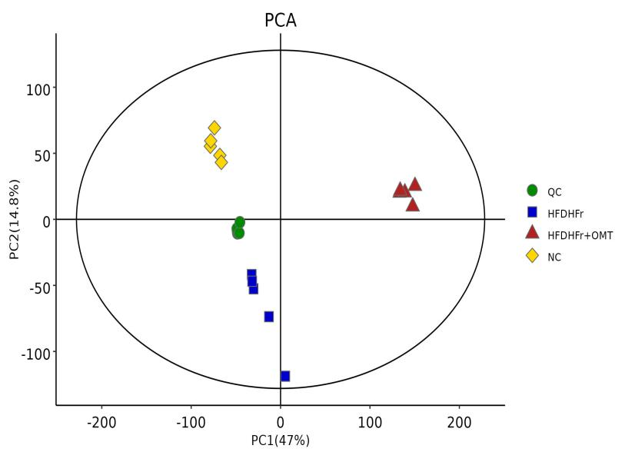
Supplemental Figure 1. The PCA of samples in serum(a) and liver(b).
a
b

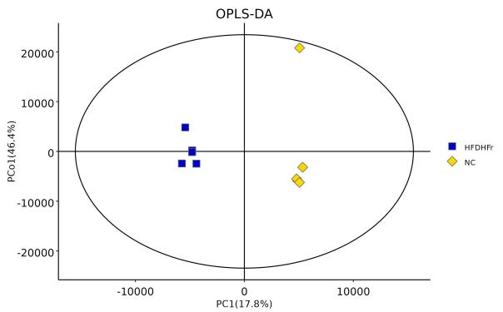
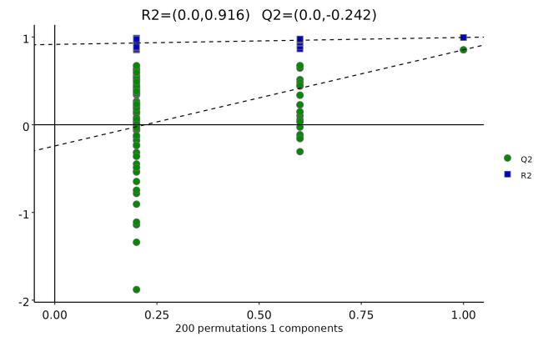
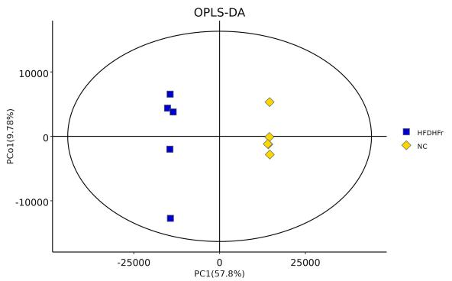
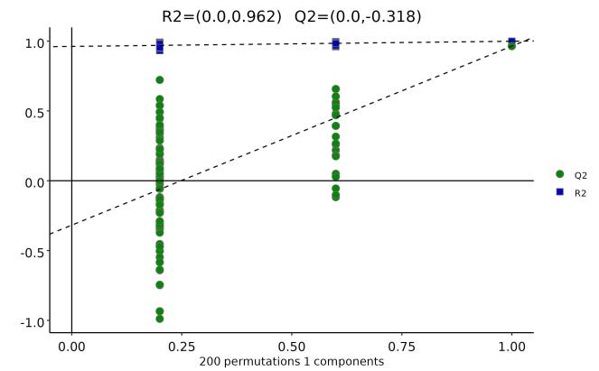
a
b
c
d
Supplemental Figure 2. The OPLS-DA(a) and Permutation(b) of samples in serum, the OPLS-DA(c) and Permutation(d) of samples in liver between HFDHFr group and NC group.

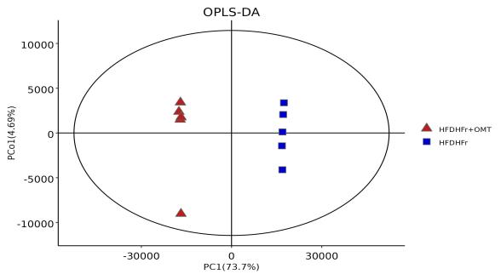
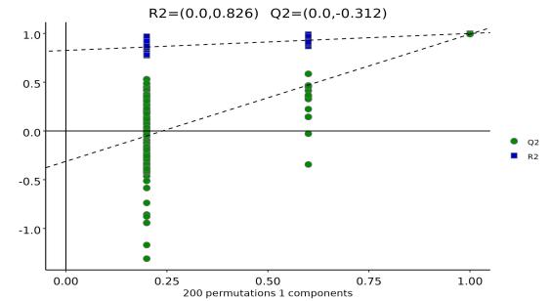
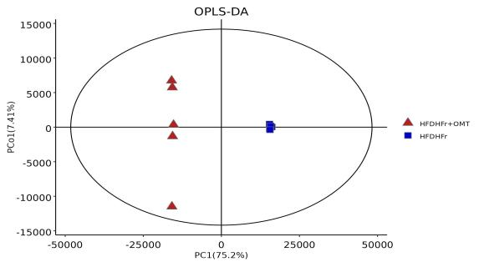
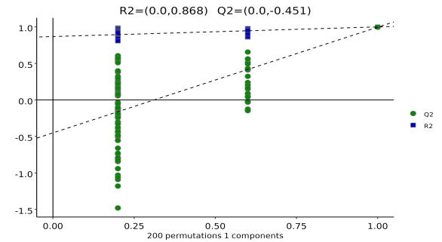
Supplemental Figure 3. The OPLS-DA(a) and Permutation(b) of samples in serum, the OPLS-DA(c) and Permutation(d) of samples in liver between HFDHFr+OMT group and HFDHFr group.
a
b
c
d

Supplemental Table 1. The number of different metabolites in each comparison group in serum and liver.

Group | Number of different metabolites in serum | Number of different metabolites in liver
HFDHFr vs NC | 163 | 352
HFDHFr+OMT vs HFDHFr | 424 | 534
HFDHFr+OMT vs HFDHFr vs NC | 414 | 565

