Glucose-regulated protein 78 targeting ICG and DOX loaded hollow Fe₃O₄ nanoparticles for hepatocellular carcinoma diagnosis and therapy
Yushen Jinª, Zhongquan Cheng^{b}, Zhu Yuan^{b}, Yang Du^{c}, Jie Tian^{c*}, Bing Shao^{a,d*}
ªBeijing Key Laboratory of Diagnostic and Traceability Technologies for Food Poisoning, Beijing Centre for Disease Prevention and Control, Beijing 100013, China
^{b} Department of General Surgery, Capital Medical University, Beijing Friendship Hospital, Beijing, 100050, China
^{c} CAS Key Laboratory of Molecular Imaging, Key Laboratory of Molecular Imaging, Institute of Automation, Chinese Academy of Sciences, Beijing, 100190, China
^{d}College of Veterinary Medicine, China Agricultural University, Beijing 100193, China
*Correspondence: Email: shaobingch@sina.com (Bing Shao); jietian@ia.ac.cn (Jie Tian)

Calculation of the photothermal conversion efficiency of the SP94-Fe₃O₄@ICG&DOX nanoparticles
The thermal profile of the SP94-Fe₃O₄@ICG&DOX nanoparticles with concentration of 50 µg/mL was shown in Figure S3a. The photothermal conversion efficiency (η) was calculated using eqn (1):
$η=\frac{hS\left(T_{Max}-T_{Surr}\right)-Q_{Dis}}{I\left(1-{10}^{-A_{808}}\right)}$ (1)
where h is the heat transfer coefficient, S is the surface area of the container, T_{Max} is the equilibrium temperature, T_{Surr} is ambient temperature of the surrounding, and (T_{Max} - T_{Surr}) is 25.9 °C according to Figure S3a. Q_{Dis} expresses the rate of heat input due to light absorption by the solvent, which was measured independently containing pure water without microspheres and found to be 28.77. I is the laser power (300 mW) and A808 is the absorbance (1.25) of 50 µg/mL at an excitation wavelength of 808 nm. The value of hS is derived according to eqn (2):
$τ_{s}=\frac{m_{D}C_{p}}{hS}$ (2)
where τ_{s} is the sample system time constant, mD and Cp are the mass (0.500g) and heat capacity (4.2 J/g) of water, respectively. The time constant for heat transfer of the system is determined to be τ_{s} = 407.9 as shown in Figure S3b according to the plot of cooling time versus negative natural logarithm of the temperature driving force obtained from the cooling stage. Thus the 808 nm laser photothermal conversion efficiency of SP94-Fe₃O₄@ICG&DOX nanoparticles is 36.9%.
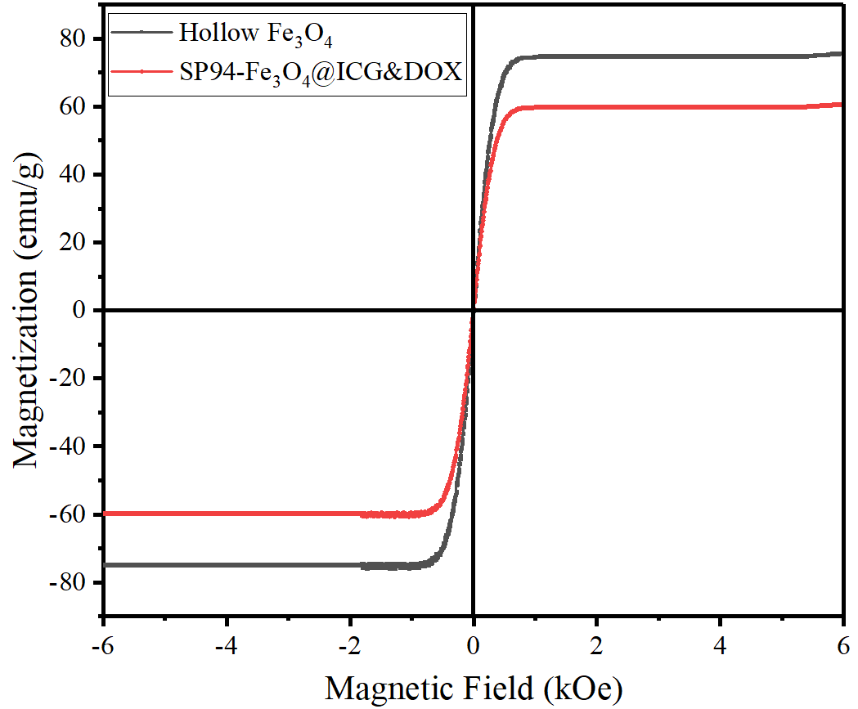
Fig S1. Magnetic hysteresis loops of hollow Fe₃O₄ nanoparticles and SP94-Fe₃O₄@ICG&DOX nanoparticles
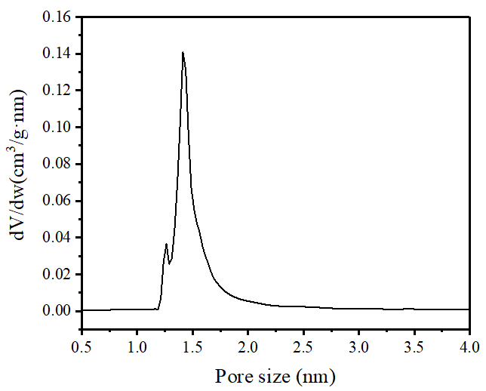
Fig S2. Pore size distributions of the hollow Fe₃O₄ nanoparticles
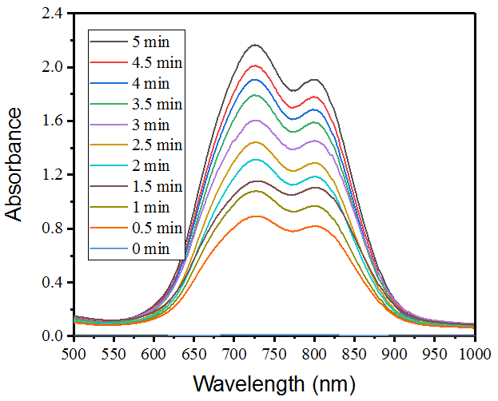
Fig S3. UV-Vis-NIR spectra of ICG in the supernatant after laser irradiation at different time (808 nm, 0.2W/cm², 0-5 min)

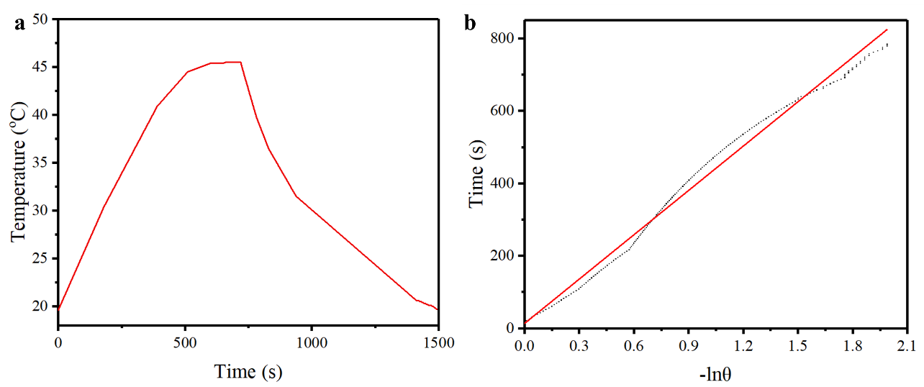
Fig S4. (a) Photothermal effect of water dispersion of SP94-Fe₃O₄@ICG&DOX nanoparticles (50 µg/mL) when illuminated with an 808 nm laser. The laser was turned off after irradiation for 12 min; (b) Plot of cooling time versus negative natural logarithm of the temperature driving force obtained from the cooling stage as shown in (a).
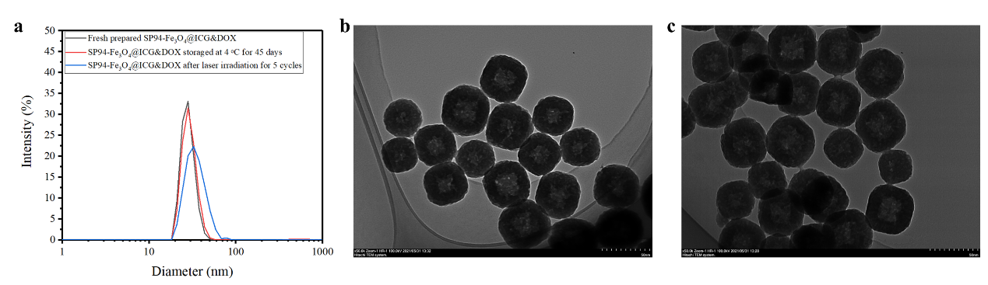
Fig S5. (a) The DLS size distribution of the SP94-Fe₃O₄@ICG&DOX nanoparticles after different treatments; (b-c) the TEM of the SP94-Fe₃O₄@ICG&DOX nanoparticles after storage at 4 ºC for 45 days (b) and laser irradiation for 5 cycles (c).

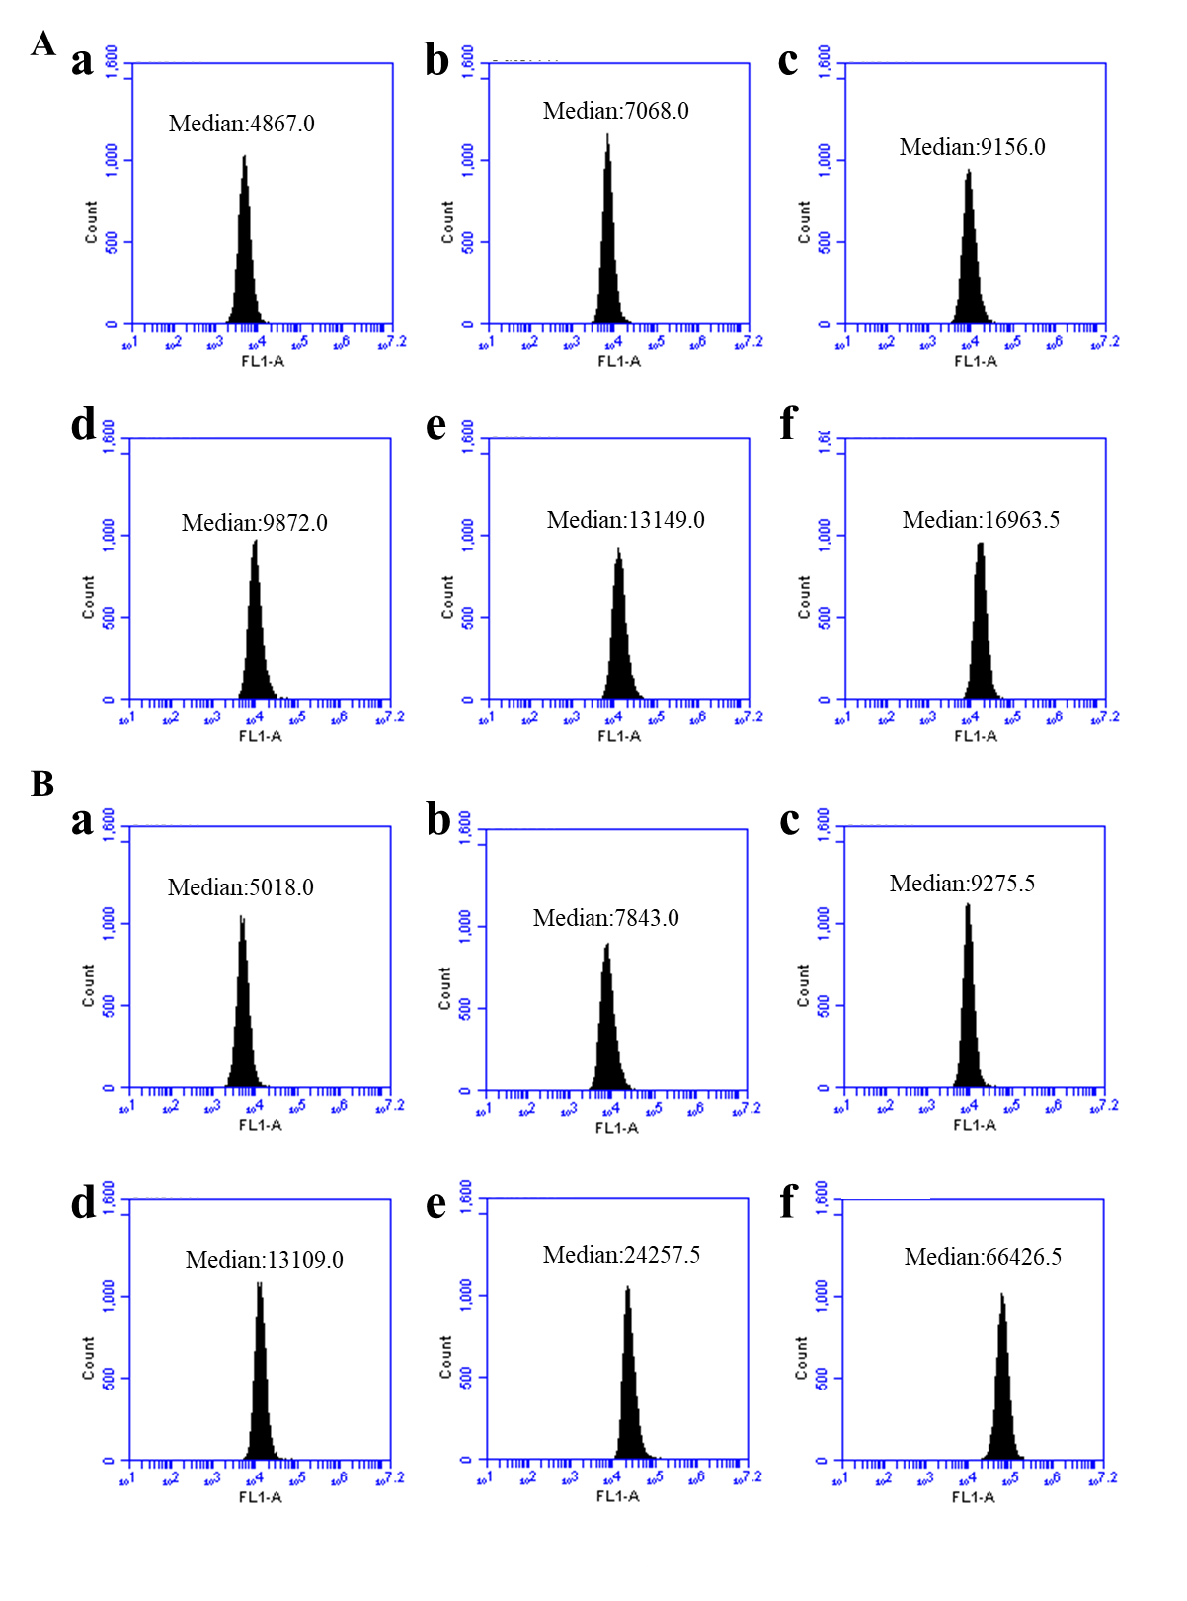
Fig S6. Flow cytometric analysis of mean FL intensity (n = 10 000 cells) in Hepa1-6 cells incubated with FITC labelled Fe₃O₄@ICG&DOX (A) and FITC labelled SP94-Fe₃O₄@ICG&DOX nanoparticles (B) for 4 h: a) 0 µg/mL, b) 5 µg/mL, c) 10 µg/mL, d) 20 µg/mL, e) 50 µg/mL and f) 100 µg/mL

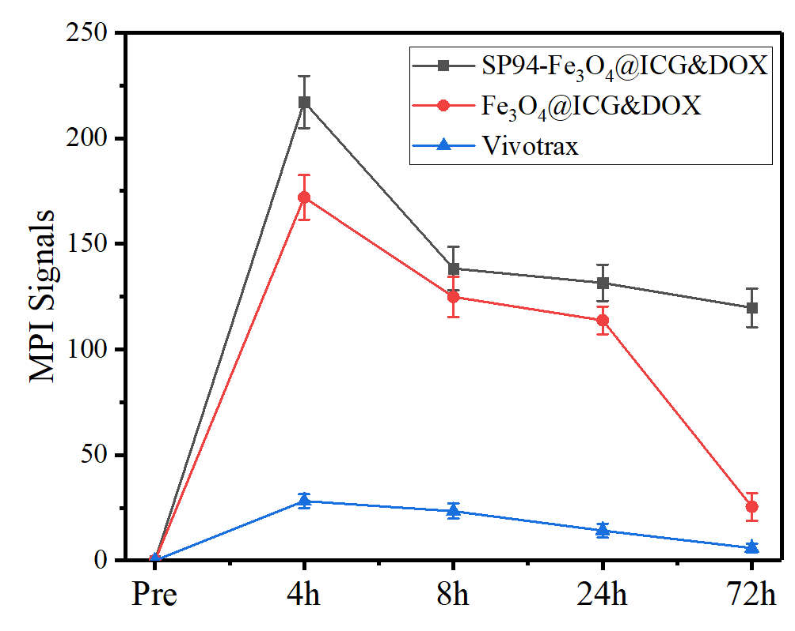
Fig S7. MPI signal calculation and comparison between groups
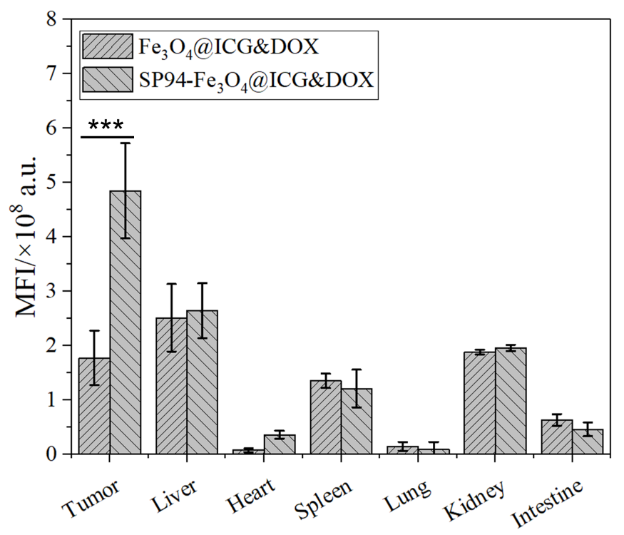
Fig S8. Mean fluorescence intensity of the main organ and tumor 72 h after injection of the Fe₃O₄@ICG&DOX and SP94-Fe₃O₄@ICG&DOX nanoparticles

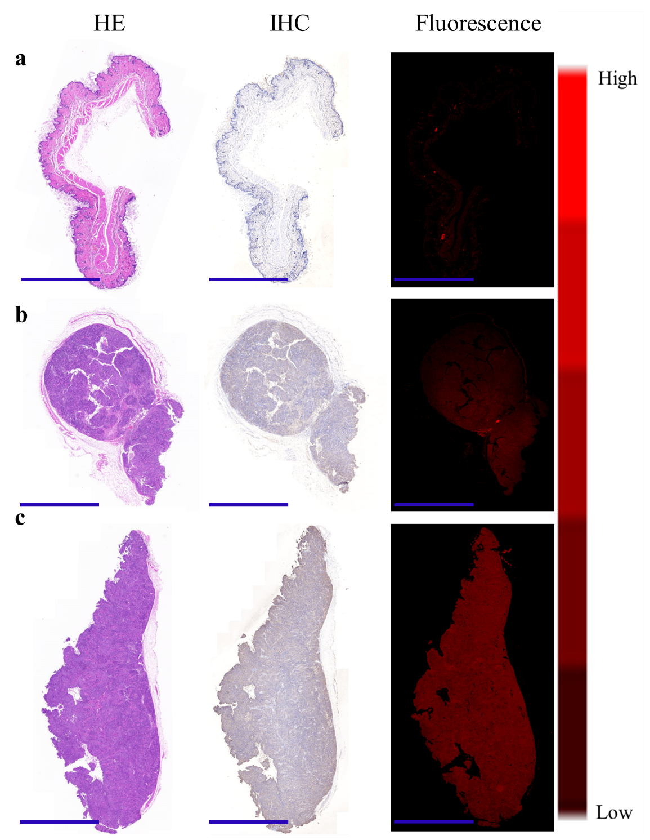
Fig S9. H&E, IHC and Fluorescence staining of skin, 4T1 tumor and Hepa1-6 tumor slices collected from mice 24 h after i.v. injection of SP94-Fe3O4@ICG&DOX nanoparticles; scale bar is 2000 μm.

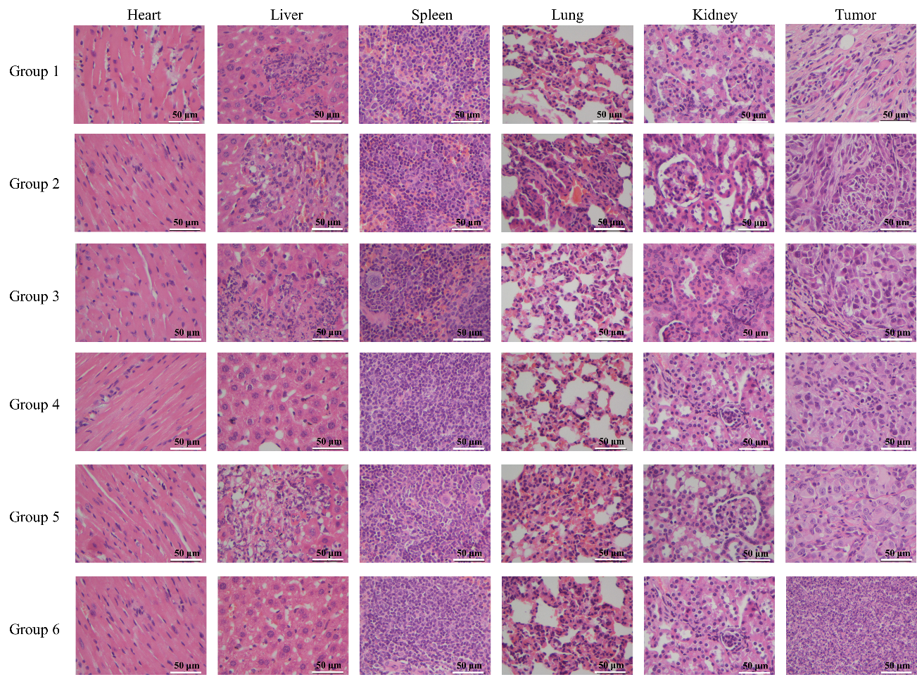
Fig S10. H&E staining of heart, liver, spleen, lung, kidney and tumor slices collected from mice after various treatments indicated in the manuscript; scale bar is 50 μm

Table S1 Blood routine analysis of the mice after treated with SP94-Fe₃O₄@ICG&DOX nanoparticles
 | Control | 1th Day | 12th Day | 25th Day
Red blood cells (10¹²/L) | 8.88±0.54 | 8.04±1.02 | 8.40±1.35 | 8.49±0.98
White blood cells (10⁹/L) | 5.1±0.3 | 6.6±0.5 | 6.7±0.8 | 6.5±0.4
Platelets (10⁹/L) | 1296±195 | 1095±210 | 1068±246 | 1087±187
Lymphocyte (10⁹/L) | 1.10±0.05 | 0.91±0.11 | 0.85±0.09 | 1.00±0.06
Haemoglobin (g/L) | 116±8 | 108±5 | 114±6 | 120±9
Mean corpuscaular haemoglobin concentration (g/L) | 314±9 | 320±12 | 323±11 | 320±15
Mean corpuscaular haemoglobin (pg/cell) | 13.0±0.9 | 13.4±0.6 | 13.5±1.2 | 14.1±1.9
Mean corpuscaular volume (fL) | 41.6±1.5 | 42.0±2.1 | 42.0±2.4 | 44.1±3.2
Alanine aminotransferase (U/L) | 42.5±2.3 | 41.2±1.3 | 42.7±3.4 | 40.2±2.5
Aspartate aminotransferase (U/L) | 111.0±12.4 | 123.2±10.3 | 115.6±6.4 | 104.9±12.8
Alkaline phosphatase (U/L) | 175.1±20.4 | 186.2±15.9 | 189.4±21.4 | 163.5±18.7
Blood urea nitrogen (mmol/L) | 7.2±1.2 | 7.5±1.5 | 8.1±1.4 | 7.3±0.8
The examined parameters included (a) alanine aminotransferase (ALT), aspartate aminotransferase (AST), and alkaline phosphatase (ALP); (b) blood urea nitrogen (BUN); (c) red blood cell (RBC) counts; (d) white blood cell (WBC) counts; (e) platelets (PLT); (f) hemoglobin (HGB); (g) mean corpuscular hemoglobin concentration (MCHC); (h) mean corpuscular hemoglobin (MCH); as well as (i) mean corpuscular volume (MCV).

