Supplementary information

S1. Relaxation time measurements and MRI
In vitro study, a T₁ spin echo (T₁-SE) sequence was utilized to perform MRI of nanoparticle solutions. The parameters are as follows: repetition time (TR) = 200 ms, echo time (TE) = 12 ms , flip angle (FA) = 90.0°, Square factor = 100, number of averages = 2, field of vision (FOV) = 60 × 60 mm, matrix size (M) = 192 × 192, slice thickness (THK) = 3.00 mm, GAP = 0.50 mm. Furthermore, we selected a T₂ turbo spin echo (T₂-TSE) sequence to obtain the T₂-weighted image. Parameters of the T₂-TSE: repetition time (TR) = 10000 ms, echo time (TE) = 668 ms, flip angle (FA) = 90.0°, Square factor = 100, number of averages = 2, field of vision (FOV) = 60 × 60 mm, matrix size (M) =192 × 160, slice thickness (THK) = 3.00 mm, GAP = 0.50 mm.
In vivo study, MRI of GONs uses a T₁ turbo spin echo sequence. The parameters are as follows: repetition time (TR) =1000 ms, echo time (TE) = 17 ms, flip angle (FA) = 90.0°, Square factor = 100, number of averages = 2, field of vision (FOV) = 80 × 80 mm, matrix size (M) =192 × 144, slice thickness (THK) = 1.50 mm, GAP = 0.30 mm.

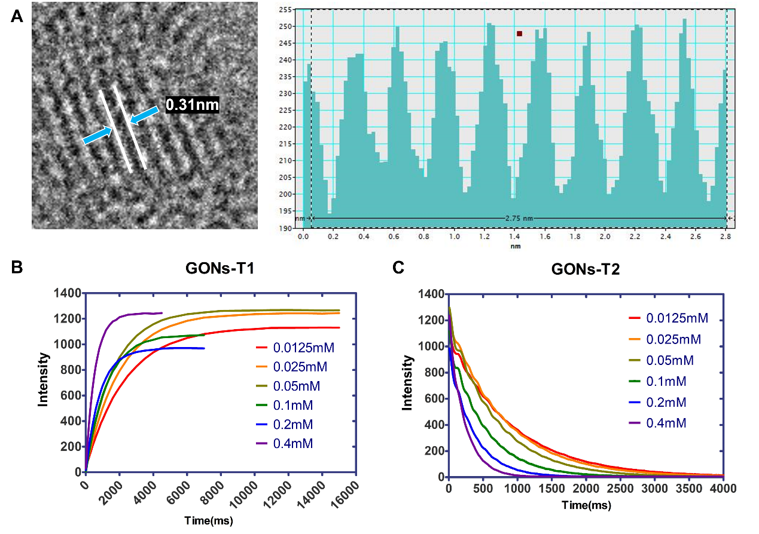
Figure S1 (A) GATAN Digital Macrograph (Version 3.40.2804.0) software was utilized to measure the lattice spacing of GONs. The blue arrow indicates a lattice spacing between two white lines. (B) and (C) Longitudinal (T₁) and transverse (T₂) relaxation time measurement fitting curves.

Figure S2 Blood routine analysis was performed on mice injected with GONs and PBS via tail vein to evaluate the safety of GONs. (A) WBC: white blood cell count; (B) RDW: red blood cell distribution width; (C) RBC: Red blood cell count; (D) PLT: platelet count; (E) PDW: platelet distribution width; (F) PCT: plateletocrit; (G) MPV: mean platelet volume; (H) Mon: monocyte count; (I) MCV: mean corpuscular volume; (J) MCHC: mean corpuscular hemoglobin concentration; (K) MCH: mean corpuscular hemoglobin; (L) Lymph: lymphocyte count; (M) HGB: hemoglobin; (N) HCT: packed cell volume; (O) Gran: granulocyte count. Data quantifications were analyzed using a student t-test and expressed as mean ± s.e.m, ns means not significant.
Figure S3: (A) HE staining showed that GONs had no toxic effect on heart, liver, spleen, lung and kidney of GONs or PBS injection group.All the scale bars in the figure are 100 μm; Weight of different organs 30 days after GONs or PBS injection: (B) Weight of heart; (C) Weight of liver; (D) Weight of Spleen; (E) Weight of lung; (F) Weight of kidney; (G) Body weight curves of mice injected with GONs or PBS. Data quantifications were analyzed using a student t-test and expressed as mean ± s.e.m, ns means not significant.

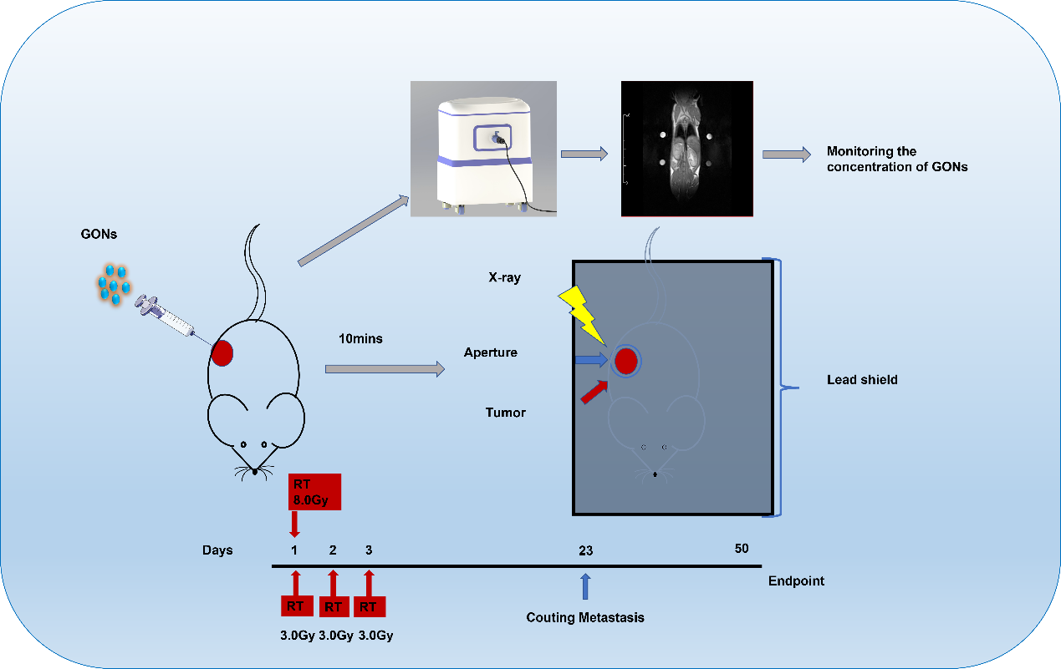
Figure S4 Flow chart of animal experiment.

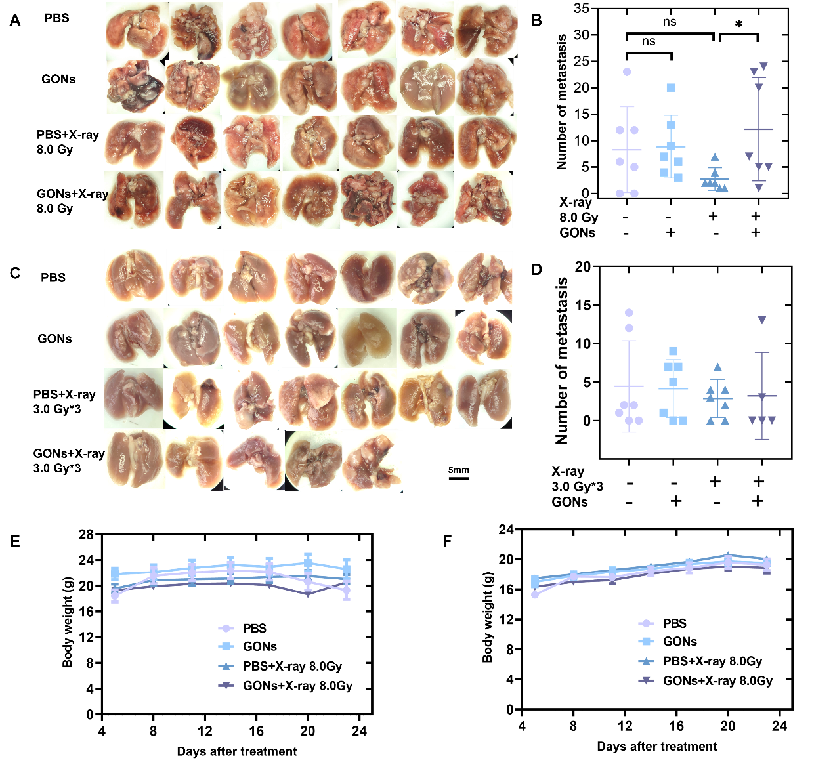
Figure S5 (A-B) The number of pulmonary metastatic nodules in different treatment groups after irradiation with 8.0 Gy×1Fr. Data quantifications were analyzed using a student t-test and expressed as mean ± s.e.m, *p < 0.05, ns means not significant. (C-D) The number of pulmonary metastatic nodules in different treatment groups after irradiation with 3.0 Gy×3Fr. (E-F) Body weight change curve of animals in different treatment groups.
Figure S6 (A-F) Tumor growth curves of individual immunodeficient mice in different treatment groups; (G) Tumor growth curve of immunodeficient mice in different treatment groups; (H) Tumor volume in different treatment groups on day 19 after treatment. Data quantifications were analyzed using a student t-test and expressed as mean ± s.e.m, *p < 0.05, **p < 0.01, ns means not significant.

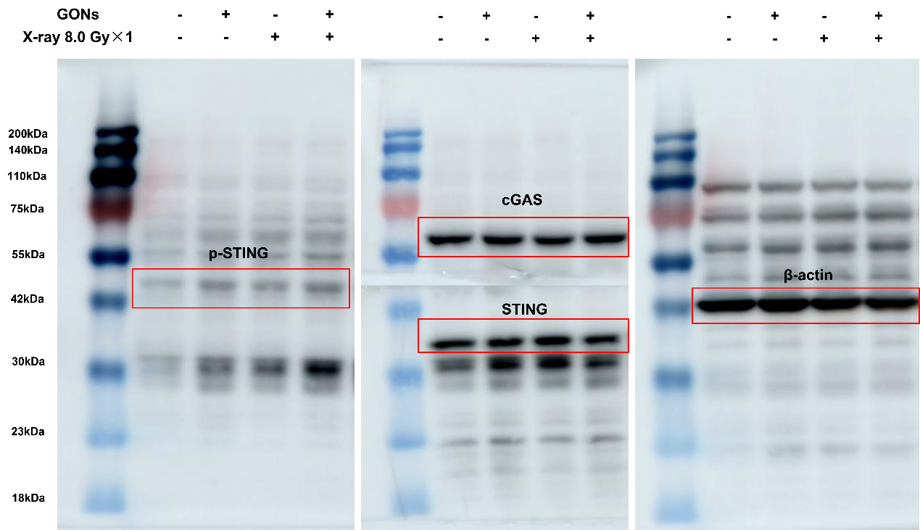
Figure S7 Full-length Western Blot bands of cGAS-STING pathway related protein expression in each treatment group under the condition of single X-ray 8.0Gy irradiation.

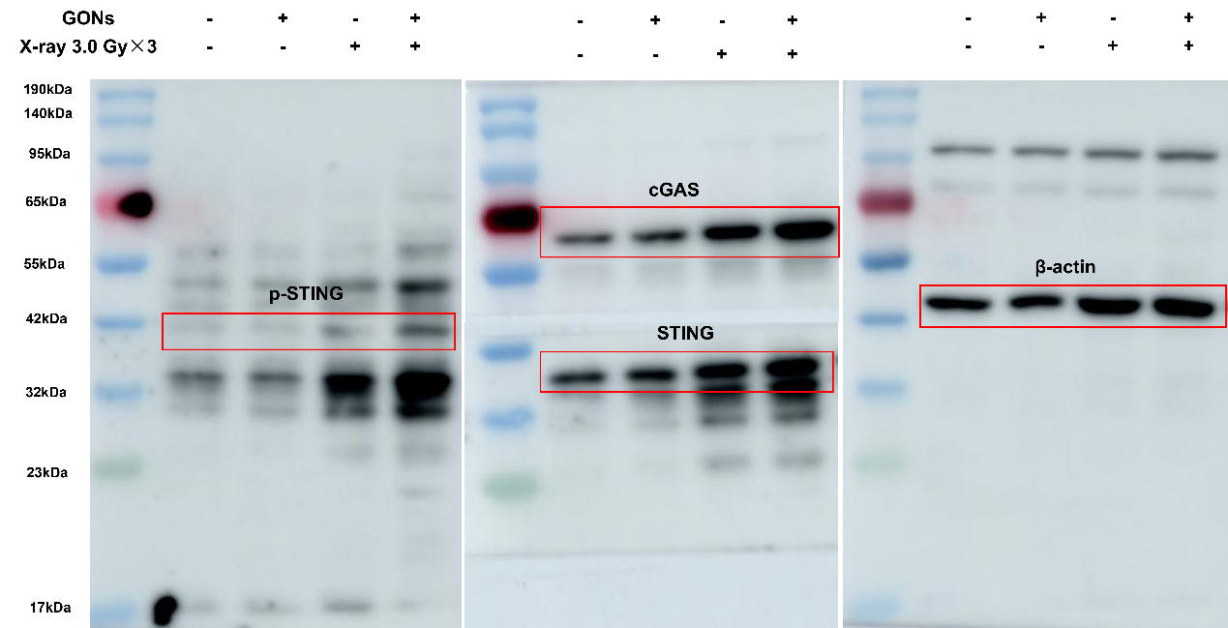
Figure S8 Full-length Western Blot bands of cGAS-STING pathway related protein expression in each treatment group under the condition of X-ray 3.0 Gyⅹ3Fr irradiation.

