Appendix 1: Representative chromatograms

Curcumin
- Blank

- CC-1

- ULOQ

- HQC

- MQC
- LQC

- Representative sample

Demethoxy Curcumin
- Blank

- CC-1

- ULOQ

- HQC

- MQC
- LQC

- Representative sample

Bis-demethoxy Curcumin
- Blank

- CC-1

- ULOQ

- HQC

- MQC
- LQC

- Representative sample

Appendix 2: Transwell Plate Map for Permeability assay
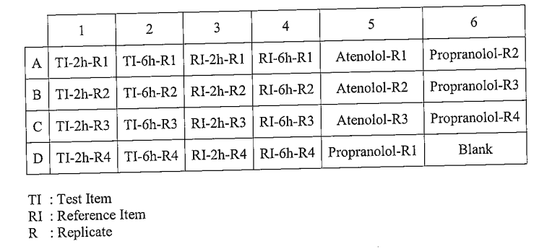

Supplementary Table 1: Chromatography parameters used for LC-MS/MS assay of the samples collected from the permeability assay/experiment at different time points
Parameter | Value
Polarity | Negative ion mode
Column oven temperature | 40°C
Peltier temperature | 10°C
Mobile phase | 0.2% formic acid in water:acetonitrile (30:70)
Detection ions
Curcumin | 367.500 amu (parent), 134.000 amu (product)
Curcumin-D6 | 373.300 amu (parent), 152.000 amu (product)
Demethoxycurcumin | 338.100 amu (parent), 119.100 amu (product)
Bisdemethoxycurcumin | 308.100 amu (parent), 119.100 amu (product)
Retention time
Curcumin | 1.84 ± 0.5 min
Curcumin-D6 | 1.82 ± 0.5 min
Demethoxycurcumin | 1.71 ± 0.5 min
Bisdemethoxycurcumin | 1.59 ± 0.5 min
Run time | 3 min

Supplementary Table 2: Spectrometric parameters used for LC-MS/MS assay of the samples collected from the permeability assay/experiment at different time points
Ion spray voltage | −4500 V
Curtain gas | Psis
CAD gas | Psis
Temperature | 550°C
Gas 1 | Psis
Gas 2 | Psis
Entrance potential | −10.00
Declustering potential
Curcumin | −50
Curcumin-D6 | −60
Demethoxycurcumin | −60
Bisdemethoxycurcumin | −60
Collision potential
Curcumin | −45
Curcumin-D6 | −26
Demethoxycurcumin | −41
Bisdemethoxycurcumin | −38
Collision cell exit potential
Curcumin | −24
Curcumin-D6 | −10
Demethoxycurcumin | −8
Bisdemethoxycurcumin | −9

