Sleep duration and kidney function – Does weekend sleep matter?

Chia-Chao Wu ^{1,2} , Pei-Lin Yang ³, Li-Ting Kao ^{4,5,6}, Yi-Chun Liu ^{7,8}, Cai-Mei Zheng ⁹, Pauling Chu ¹, Kuo‐Cheng Lu ¹⁰, Chi-Ming Chu^{, 7,11,12,13}, Yu-Tien Chang ^{7*}

Authors’ affiliations:  ¹ Division of Nephrology, Department of Internal Medicine, Tri-Service General Hospital, National Defense Medical Center, Taipei, Taiwan  ² Department and Graduate Institute of Microbiology and Immunology, National Defense Medical Center, Taipei, Taiwan  ³School of Nursing, National Defense Medical Center, Taipei City, Taiwan  ⁴School of Pharmacy, National Defense Medical Center, Taipei, Taiwan  ⁵Graduate Institute of Life Sciences, National Defense Medical Center, Taipei, Taiwan  ⁶ Department of Pharmacy Practice, Tri-Service General Hospital, Taipei, Taiwan  ⁷ School of Public Health, National Defense Medical Center, Taipei City, Taiwan  ⁸ Institute of Medical Sciences, National Defense Medical Center, Taipei City, Taiwan  ⁹Division of Nephrology, Department of Internal Medicine, Shuang Ho Hospital, Taipei Medical University, Taipei, Taiwan  ¹⁰Division of Nephrology, Fu-Jen Catholic Hospital, Fu-Jen Catholic University  ¹¹ Department of Surgery, Songshan Branch of Tri-Service General Hospital, National Defense Medical Center, Taipei City, Taiwan  ¹² Division of Biostatistics and Informatics, Department of Epidemiology, School of Public Health, National Defense Medical Center, Taipei, Taiwan  ¹³Department of Public Health, China Medical University, Taichung City, Taiwan | *Corresponding author:  Ph.D. Yu-Tien Chang  Tel.: +886-2-87923100#18454  Address:  School of Public Health, National Defense Medical Center  No.161, Sec. 6, Minquan E. Rd., Neihu Dist., Taipei City 11490, Taiwan (R.O.C.)  Email: greengarden720925@gmail.com

Institution where work was performed
National Defense Medical Center

A statement that all authors have seen and approved the manuscript
All authors made a significant contribution to the work reported, whether that is in the conception, study design, execution, acquisition of data, analysis and interpretation, or in all these areas; took part in drafting, revising or critically reviewing the article; gave final approval of the version to be published; have agreed on the journal to which the article has been submitted; and agree to be accountable for all aspects of the work.

Declarations for each author:
All the authors have no known conflict to disclosure. This study was funded by Ministry of Science and Technology in Taiwan (110M142-143). This is not a clinical trial study.

Number of tables: 2

Number of figures:5

Abstract word count:235

Manuscript word count: 2,457

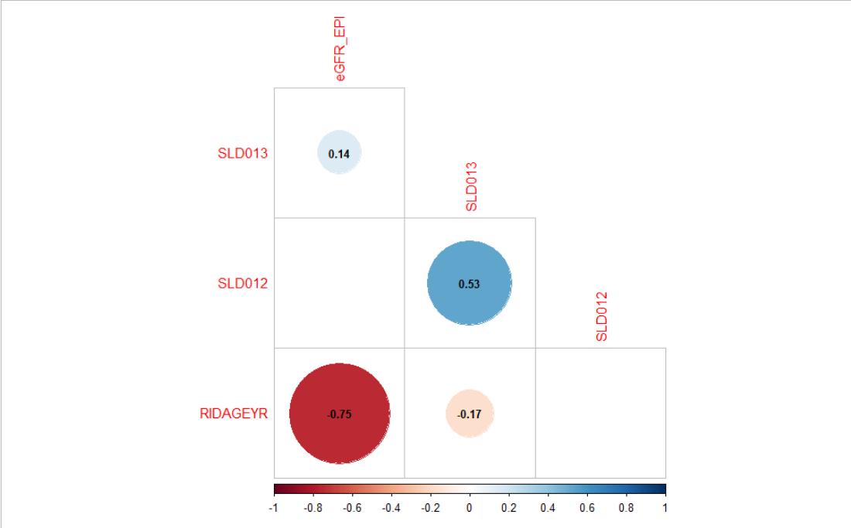

eGFR
Sleep duration on weekends
Sleep duration on weekends
Sleep duration on weekdays
Sleep duration on weekdays

Age

Pearson correlation r

Figure S1 Pearson correlation matrix of sleep duration on weekdays/weekends, age, and eGFR levels. Not significant coefficients (p ≧ 0.05) were left blank.

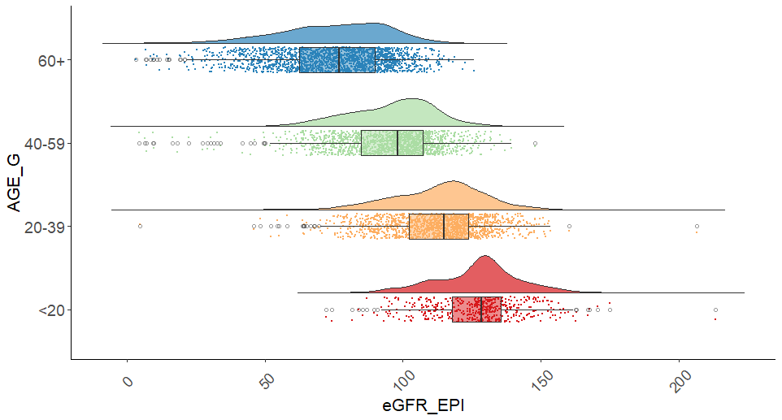
Age (year)
eGFR (ml/min/1.73 m²)
 | eGFR (ml/min/1.73 m²)
Age (year) | Mean | Standard deviation
60+ | 74.7 | 19.8
40-59 | 95.3 | 17.4
20-39 | 112.9 | 17.0
<20 | 136.2 | 18.9
The p value of ANOVA test of age groups on eGFR levels was less than 2e-16.

Figure S2 The raincloud plot of eGFR levels grouped by age.

