Table S1 Top 10 Journals ordered by H-index
Element | h_index | m_index | TC | NP | PY_start | IF
Brain Stimulation | 15 | 0,938 | 1076 | 27 | 2008 | 9.184
Journal of Pain | 14 | 0,875 | 1018 | 22 | 2008 | 5.383
Pain | 12 | 0,667 | 1055 | 15 | 2006 | 7.926
Clinical Journal of Pain | 10 | 0,625 | 452 | 13 | 2008 | 3.423
Clinical Neurophysiology | 10 | 0,625 | 1360 | 12 | 2008 | 4.861
Frontiers in Human Neuroscience | 9 | 0,818 | 447 | 15 | 2013 | 3.473
Pain Medicine | 9 |  | 196 | 17 |  | 3.637
European Journal of Pain | 8 | 0,667 | 243 | 10 | 2012 | 3.651
Neuroscience Letters | 8 | 0,667 | 265 | 14 | 2012 | 3.197
Plos One | 8 | 0,667 | 231 | 10 | 2012 | 3.752
Abbreviations:NP, number of publications; h-index, the largest number h such that at least h articles in that journal were cited at least h times each; m-index, h-index divided to the number of years since the first publication; TC, total citations; PY start, publication year of start; IF, impact factor, number of citations divided to number of published articles in a period of time.

Table S2. Most local cited authors

Author | Local Citations
FREGNI F | 1723
NITSCHE MA | 665
PASCUAL-LEONE A | 649
BOGGIO PS | 595
PAULUS W | 538
ANTAL A | 459
FREEDMAN SD | 435
BIKSON M | 434
LEFAUCHEUR JP | 383
FERREIRA MJL | 382

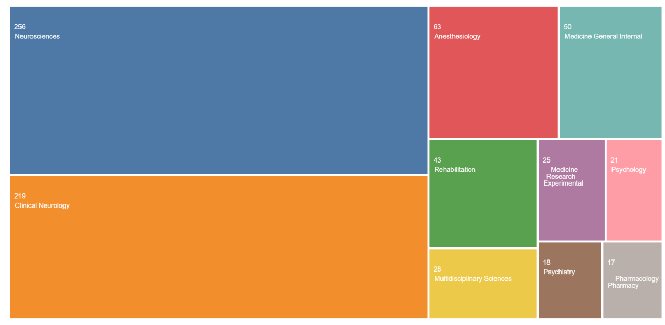
Figure S1. Top 10 categories in Web of Science Database.

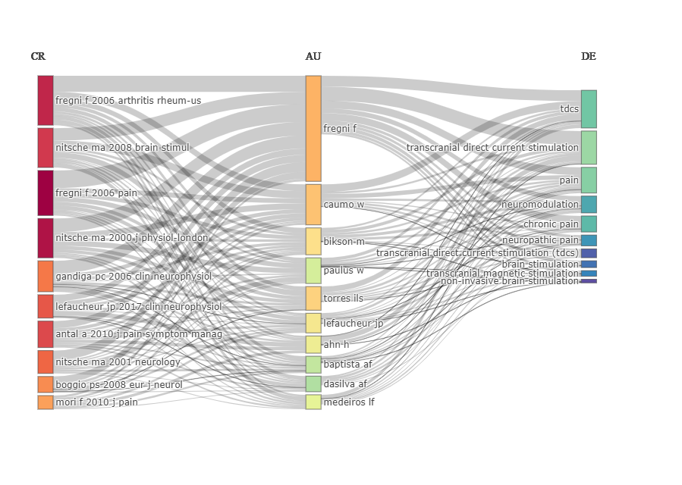Figure S2. Three field plot.
Abbreviations:AU- authors, DE- top keywords, CR- Citation references.

