Supplementary Material
Study results

This supplementary material has been provided by the authors to give readers additional information about the study results.

Supplement to: Trends in abdominal aortic aneurysm repair incidence, comorbidity, treatment, and mortality: a Danish nationwide cohort study, 1996-2018.

Table of content – Supplementary digital content
Table of content – Supplementary digital content 1
Supplemental eFigures 2
eFigure 1. Study flow chart 2
eFigure 2. Standardized incidence rate by indication and technique 3
eFigure 3a. Trend in age specific incidence rates of all AAA repairs 4
eFigure 3b. Trend in age specific incidence rates for intact and ruptured AAA 4
eFigure 4. Plot of 5-year mortality hazard ratio following AAA repair compared to Danish residents aged 41-99 5
eFigure 5. AAA Comorbidity-specific incidence, age- and sex standardized 6
Supplemental eTables 7
eTables 1: Annual incidence rate subgroup analyses, calendar year:covariate 7
eTable 1a. Total AAA repair, annual change in repair incidence by subgruop 7
eTable 1b. Ruptured AAA, annual change in repair incidence by subgruop 8
eTable 1c. Intact AAA, annual change in repair incidence by subgruop 9
eTable 2. Baseline characteristics by calendar period 10
eTable 2a. Ruptured AAA 10
eTable 2b. Intact AAA 11
eTable 3. Sensitivity analyses of the AAA repair survival rates. 12
eTable 4. Regression table of survival analyses 14
eTable 4a. Ruptured AAA 14
eTable 4b. Intact AAA. 14
Miscellaneous 15
CCI item coding used 15
ICD8-Criteria for excluding patients with AAA surgery prior to 1996: 15
Criteria for imputing the operation code from the Danish National Patient Registry based on substring match between the DNPR and DVR 16
Additional baseline characteristics coding 16
Age trend by indication 18
Age trend by indication and technique 19

Supplemental eFigures

eFigure 1. Study flow chart
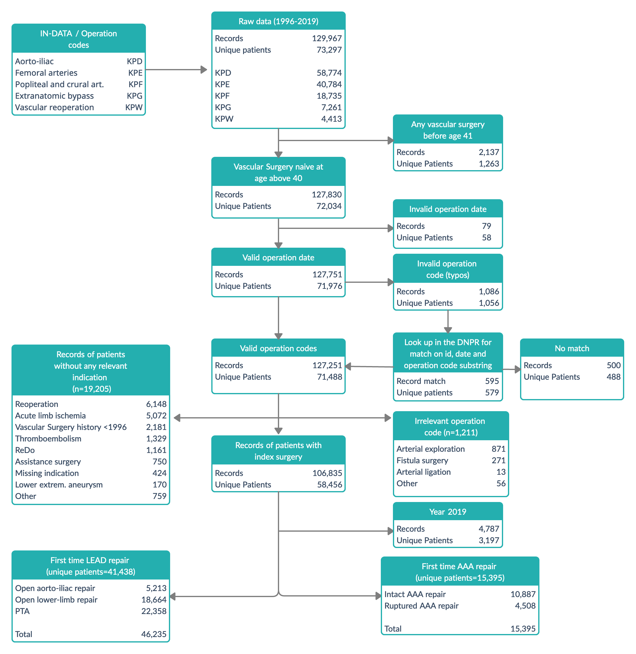

AAA, abdominal aortic aneurysm.
LEAD, lower extremity artery disease. The LEAD data set was prepared for another publication.

eFigure 2. Standardized incidence rate by indication and technique

eFigure 3a. Trend in age specific incidence rates of all AAA repairs

eFigure 3b. Trend in age specific incidence rates for intact and ruptured AAA
Note, extreme age groups, 41-50 years and 91-99 years, were not plotted for clarity.

eFigure 4. Plot of 5-year mortality hazard ratio following AAA repair compared to Danish residents aged 41-99

eFigure 5. AAA Comorbidity-specific incidence, age- and sex standardized
iAAA, elective and symptomatic AAA (intact AAA). rAAA, ruptured AAA.

Supplemental eTables

eTables 1: Annual incidence rate subgroup analyses, calendar year:covariate
LYear, Calendar year as linear predictor.
IRR, annual incidence rate ratio.
CCI, Charlson’s comorbidity index.

eTable 1a. Total AAA repair, annual change in repair incidence by subgruop

eTable 1b. Ruptured AAA, annual change in repair incidence by subgruop

eTable 1c. Intact AAA, annual change in repair incidence by subgruop

eTable 2. Baseline characteristics by calendar period

eTable 2a. Ruptured AAA
Ruptured AAA | Level | 1996 - 1999 (n=880) | 2000 - 2004 (n=1114) | 2005 - 2009 (n=1000) | 2010 - 2014 (n=907) | 2015 - 2018 (n=607)
Age | mean (sd) | 72 (7) | 73 (8) | 73 (8) | 73 (8) | 74 (8)
Male_sex | Yes | 777 (88) | 976 (88) | 868 (87) | 777 (86) | 525 (86)
CCI_group | Normal | 379 (43) | 437 (39) | 367 (37) | 315 (35) | 229 (38)
 | Moderate | 260 (30) | 317 (28) | 291 (29) | 253 (28) | 157 (26)
 | Severe | 134 (15) | 177 (16) | 159 (16) | 169 (19) | 107 (18)
 | Very Severe | 107 (12) | 183 (16) | 183 (18) | 170 (19) | 114 (19)
Dependency | Independent | 611 (69) | 821 (74) | 834 (83) | 774 (85) | 532 (88)
 | Home care | 65 (7) | 89 (8) | 82 (8) | 61 (7) | 20 (3)
 | Nursing home | 10 (1) | 12 (1) | 11 (1) | 19 (2) | 36 (6)
 | missing | 194 (22) | 192 (17) | 73 (7) | 53 (6) | 19 (3)
TOBACCO | None | 81 (9) | 102 (9) | 200 (20) | 206 (23) | 116 (19)
 | Previous | 80 (9) | 133 (12) | 218 (22) | 260 (29) | 216 (36)
 | Smoker | 274 (31) | 347 (31) | 383 (38) | 314 (35) | 196 (32)
 | missing | 445 (51) | 532 (48) | 199 (20) | 127 (14) | 79 (13)
alcohol_abuse | No | 468 (53) | 868 (78) | 905 (90) | 826 (91) | 561 (92)
 | > 5 units/day | 19 (2) | 19 (2) | 34 (3) | 39 (4) | 20 (3)
 | missing | 393 (45) | 227 (20) | 61 (6) | 42 (5) | 26 (4)
PRIORITY | Elective | 14 (2) | 10-15 (1) | 15 (2) | 9 (1) | 5 (1)
 | Subacute | 82 (9) | 123 (11) | 79 (8) | 42 (5) | 15 (2)
 | Acute | 604 (69) | 975 (88) | 906 (91) | 856 (94) | 587 (97)
 | missing | 180 (20) | <5 (0) | 0 (0) | 0 (0) | 0 (0)
Region | North | 110 (12) | 126 (11) | 130 (13) | 113 (12) | 80 (13)
 | Central | 172 (20) | 224 (20) | 178 (18) | 173 (19) | 110 (18)
 | South | 237 (27) | 293 (26) | 266 (27) | 321 (35) | 263 (43)
 | Capital | 298 (34) | 401 (36) | 415 (42) | 269 (30) | 144 (24)
 | Zealand | 63 (7) | 70 (6) | 11 (1) | 31 (3) | 10 (2)
Technique | Open | 875-885 (100) | 1,105-1,114 (100) | 990-999 (100) | 853 (94) | 560 (92)
 | Endovascular | <5 (0) | <5 (0) | <5 (0) | 54 (6) | 47 (8)

eTable 2b. Intact AAA
Intact AAA | Level | 1996 - 1999 (n=1529) | 2000 - 2004 (n=1824) | 2005 - 2009 (n=2499) | 2010 - 2014 (n=2792) | 2015 - 2018 (n=2243)
Age | mean (sd) | 70 (7) | 70 (8) | 71 (7) | 72 (7) | 73 (7)
Male_sex | Yes | 1,269 (83) | 1,522 (83) | 2,060 (82) | 2,326 (83) | 1,895 (84)
CCI_group | Normal | 139 (9) | 115 (6) | 147 (6) | 134 (5) | 54 (2)
 | Moderate | 637 (42) | 761 (42) | 883 (35) | 956 (34) | 735 (33)
 | Severe | 389 (25) | 456 (25) | 610 (24) | 676 (24) | 556 (25)
 | Very Severe | 364 (24) | 492 (27) | 859 (34) | 1026 (37) | 898 (40)
Dependency | Independent | 1,360 (89) | 1,646 (90) | 2,336 (93) | 2,675 (96) | 2,114 (94)
 | Home care | 121 (8) | 129 (7) | 129 (5) | 79 (3) | 89 (4)
 | Nursing home | <5 (0) | <5 (0) | 8 (0) | 7 (0) | 5 (0)
 | missing | 35-45 (3) | 35-45 (2) | 26 (1) | 31 (1) | 35 (2)
TOBACCO | None | 207 (14) | 270 (15) | 386 (15) | 506 (18) | 421 (19)
 | Previous | 337 (22) | 536 (29) | 985 (39) | 1261 (45) | 1106 (49)
 | Smoker | 884 (58) | 930 (51) | 1078 (43) | 971 (35) | 664 (30)
 | missing | 101 (7) | 88 (5) | 50 (2) | 54 (2) | 52 (2)
alcohol_abuse | No | 1,047 (68) | 1,742 (96) | 2,392 (96) | 2,694 (96) | 2,147 (96)
 | > 5 units/day | 20 (1) | 40 (2) | 70 (3) | 55 (2) | 31 (1)
 | missing | 462 (30) | 42 (2) | 37 (1) | 43 (2) | 65 (3)
PRIORITY | Elective | 898 (59) | 1,532 (84) | 2,151 (86) | 2,379 (85) | 1,983 (88)
 | Subacute | 154 (10) | 204 (11) | 249 (10) | 249 (9) | 140 (6)
 | Acute | 101 (7) | 88 (5) | 99 (4) | 164 (6) | 110-120 (5)
 | missing | 376 (25) | 0 (0) | 0 (0) | 0 (0) | <5 (0)
Region | North | 173 (11) | 179 (10) | 204 (8) | 260 (9) | 228 (10)
 | Central | 359 (23) | 398 (22) | 536 (21) | 707 (25) | 454 (20)
 | South | 354 (23) | 532 (29) | 671 (27) | 884 (32) | 856 (38)
 | Capital | 516 (34) | 560 (31) | 968 (39) | 749 (27) | 571 (25)
 | Zealand | 127 (8) | 155 (8) | 120 (5) | 192 (7) | 134 (6)
Technique | Open | 1,498 (98) | 1,713 (94) | 1,918 (77) | 1,797 (64) | 1,292 (58)
 | Endovascular | 31 (2) | 111 (6) | 581 (23) | 995 (36) | 951 (42)

eTable 3. Sensitivity analyses of the AAA repair survival rates.
Sensitivity analyses of five- and one-year mortality hazard ratios by repair type, plot (above) and table with estimates (below)
Follow time | Repair  type | Calendar  period | Model 1  Crude | Model 2  Primary analysis | Model 3  Second. analysis | Model 4  Complete cases
Five-year | iAAA | 1996 - 2000 | Reference | Reference | Reference | Reference
Five-year | iAAA | 2001 - 2005 | 0.87 (0.78-0.97) | 0.80 (0.71-0.89) | 0.81 (0.72-0.91) | 0.83 (0.73-0.94)
Five-year | iAAA | 2006 - 2010 | 0.77 (0.69-0.85) | 0.64 (0.57-0.71) | 0.68 (0.61-0.77) | 0.69 (0.61-0.78)
Five-year | iAAA | 2011 - 2015 | 0.64 (0.58-0.72) | 0.52 (0.46-0.58) | 0.56 (0.49-0.63) | 0.56 (0.49-0.64)
Five-year | iAAA | 2016 - 2018 | 0.63 (0.54-0.75) | 0.50 (0.43-0.60) | 0.54 (0.46-0.65) | 0.57 (0.47-0.68)
Five-year | rAAA | 1996 - 2000 | Reference | Reference | Reference | Reference
Five-year | rAAA | 2001 - 2005 | 1.00 (0.90-1.11) | 0.94 (0.84-1.04) | 0.96 (0.86-1.07) | 0.98 (0.83-1.15)
Five-year | rAAA | 2006 - 2010 | 0.76 (0.68-0.85) | 0.72 (0.64-0.80) | 0.78 (0.69-0.89) | 0.75 (0.63-0.88)
Five-year | rAAA | 2011 - 2015 | 0.69 (0.62-0.78) | 0.61 (0.54-0.69) | 0.66 (0.58-0.75) | 0.65 (0.55-0.78)
Five-year | rAAA | 2016 - 2018 | 0.50 (0.42-0.61) | 0.46 (0.38-0.56) | 0.51 (0.42-0.61) | 0.52 (0.42-0.66)
One-year | iAAA | 1996 - 2000 | Reference | Reference | Reference | Reference
One-year | iAAA | 2001 - 2005 | 0.74 (0.61-0.90) | 0.71 (0.58-0.86) | 0.73 (0.59-0.90) | 0.74 (0.60-0.93)
One-year | iAAA | 2006 - 2010 | 0.64 (0.53-0.77) | 0.60 (0.50-0.73) | 0.65 (0.53-0.80) | 0.66 (0.53-0.82)
One-year | iAAA | 2011 - 2015 | 0.51 (0.42-0.62) | 0.49 (0.40-0.60) | 0.51 (0.41-0.64) | 0.54 (0.43-0.67)
One-year | iAAA | 2016 - 2018 | 0.46 (0.36-0.58) | 0.43 (0.33-0.55) | 0.45 (0.35-0.59) | 0.50 (0.38-0.66)
One-year | rAAA | 1996 - 2000 | Reference | Reference | Reference | Reference
One-year | rAAA | 2001 - 2005 | 1.04 (0.92-1.17) | 0.97 (0.86-1.09) | 1.00 (0.88-1.13) | 0.97 (0.80-1.17)
One-year | rAAA | 2006 - 2010 | 0.80 (0.70-0.91) | 0.75 (0.66-0.86) | 0.85 (0.74-0.99) | 0.78 (0.64-0.94)
One-year | rAAA | 2011 - 2015 | 0.62 (0.54-0.72) | 0.56 (0.49-0.65) | 0.63 (0.54-0.74) | 0.59 (0.48-0.73)
One-year | rAAA | 2016 - 2018 | 0.51 (0.42-0.62) | 0.46 (0.38-0.57) | 0.53 (0.43-0.65) | 0.51 (0.39-0.65)
iAAA, intact AAA.
rAAA, ruptured AAA.

eTable 4. Regression table of survival analyses
Note, extreme age groups, 41-50 years and 91-99 years, were included as parameters in the Cox regression model, but were not included in the Forest plots below, for clarity.

eTable 4a. Ruptured AAA

eTable 4b. Intact AAA.

Miscellaneous

CCI item coding used

Disease categories and the International Classification of Diseases codes used to calculate Charlson’s Comorbidity Index.

Disease category | Danish coding system 1977-1995 | ICD-10  1996-2018 | Score
Myocardial infarction | 410 | I21, I23 | 1
Congestive heart failure | 427.09; 427.10; 427.11; 427.19; 428.99; 782.49 | I50; I11.0; I13.0; I13.2 | 1
Peripheral vascular disease | 440; 441; 442; 443; 444; 445 | I70- I74; I77 | 1
Cerebrovascular disease | 430-438 | I60-I69; G45; G46 | 1
Dementia | 290.09-290.19; 293.09 | F00-F03; F05.1; G30 | 1
Chronic pulmonary disease | 490-493; 515-518 | J40-J47; J60-J67; J68.4; J70.1; J70.3; J84.1; J92.0; J96.1; J98.2-J98.3 | 1
Connective tissue disease | 712; 716; 734; 446; 135.99 | M05; M06; M08; M09; M30-M36; D86 | 1
Ulcer disease | 530.91; 530.98; 531-534 | K22.1; K25-K28 | 1
Mild liver disease | 571; 573.01; 573.04 | B18; K70.0-K70.3; K70.9; K71; K73; K74; K76.0 | 1
Diabetes | 249.00; 249.06; 249.07; 249.09; 250.00; 250.06; 250.07; 250.09 | E10.0; E10.1; E10.9; E11.0; E11.1; E11.9 | 1
Hemiplegia | 344 | G81; G82 | 2
Moderate to severe renal disease | 403; 404; 580-584; 590.09; 593.19; 753.10-753.19; 792 | I12; I13; N00-N05; N07; N11; N14; N17-N19; Q61 | 2
Diabetes with end organ damage | 249.01-249.05; 249.08; 250.01-250.05; 250.08 | E10.2-E10.8;  E11.2-E11.8 | 2
Any tumor | 140-194 | C00-C75 | 2
Leukemia | 204-207 | C91-C95 | 2
Lymphoma | 200-203; 275.59 | C81-C85; C88; C90; C96 | 2
Moderate to severe liver disease | 070.00; 070.02; 070:04; 070.06; 070.08; 573.00; 456.00-456.09 | B15.0; B16.0; B16.2; B19.0; K70.4; K72; K76.6; I85 | 3
Metastatic solid tumor | 195-199 | C76-C80 | 6
AIDS | 079.83 | B21-B24 | 6

ICD8-Criteria for excluding patients with AAA surgery prior to 1996:
- Explicit operations codes for AAA surgery: ICD-8 codes 86550-5 and 86560
OR
- The combination of
  - ICD-8 codes for aorto-iliac bypass surgery:
86740, 86760, 87049-55, 87060, 87063, 87064, 87069
AND
  - A-diagnosis code consistent with AAA:
ICD8: 44120-1, 44129
ICD10: DI713, DI714

Criteria for imputing the operation code from the Danish National Patient Registry based on substring match between the DNPR and DVR
Due to type errors, some of the operation codes registered in the DVR did not match the Scandinavian coding system. In that case we looked-up and imputed the operations code from the Danish National Patient Registry if it matched on i) patient identifier, ii) date, and iii) a substring-match a described below

Imputation assumption /  character match | No. of imputed cases / operation codes
Character 1to5 | 25
Letters 1to4 | 56
Character 4to6 | 97
Character 12356 | 72
Character 5to6 | 56
Character char | 12
SUM | 318

Additional baseline characteristics coding
 | DIAGNOSES | DIAGNOSES | SURGERY | SURGERY | Sks_ube*
 | Danish coding system 1977-1995 | ICD10  1996-2018 | Danish coding system 1977-1995 | Scandinavian coding system  1996-2018
Angina history | 413; | I20
Stroke or  TIA | 430; 431; 433; 434;  435;  43601; 43690 | I60-I64; I69
PM/ICD/loop recorder | 99750 | T821;  T827I-P;  T828P;  Z450;  Z950 | 32122  32159  32199 | FPF-H | BFC
CABG/PCI |  |  | 300;301;  30200;  30240;  30350 | FN
Heart valve disease | 394-6;39700;  424 | I05-8;  I091, I091B  I098  I34-7  T820 | 303;  30600;  30620;  30640;  30729;  30780;  30799;  30800;  30810;  30920;  30925;  30939;  30959;  30990;  311;  31268-9;  Excl:30354,  30359 | FG; FJE;  FJF;  FJW;  FK;  FM
Cardiomyopathy | 42599 | I42-3
*Sks_ube is a Danish national patient registry database which contains records of examinations and procedures not considered surgical cases. I was used for additional baseline characterics in the period 1996-2018.

Age trend by indication

Age trend by indication and technique

