Supplementary Material
Study results

This supplementary material has been provided by the authors to give readers additional information about the study results.

Supplement to: Trends in lower extremity artery disease repair incidence, comorbidity, and mortality: a Danish nationwide cohort study, 1996-2018.

Table of contents
Table of contents 2
Supplemental eFigures 4
eFigure 1. Study flow chart 4
eFigure 2. Sankey plot with number of patients revascularized, censored, and dead following primary repair 5
eFigure 3. Alternative presentation of the Sankey plot 6
eFigure 4. Trend in age specific incidence rates for LEAD repair 7
eFigure 5. Heatmap of sex-standardized age specific incidence rate of LEAD repair 8
eFigure 6. Heatmap of age specific incidence rate of LEAD repair by sex 9
eFigure 7. Comorbidity-specific incidence of lower extremity artery disease repair, age- and sex standardized 10
eFigure 8. Indication-specific incidence rate for lower extremity artery disease repair (primary revascularization), age- and sex standardized 11
eFigure 9. Mean age by procedure and calendar year 11
eFigure 10. Trend in Charlson’s comorbidity index score relative to the sex-and age distribution of the Danish population in calendar year 2000 12
eFigure 11. Plot of 5-year mortality rate ratios 13
Supplemental eTables 14
eTables 1a-d: Subgroup analyses of annual percent change in incidence rate 14
eTable 1a. Primary revascularization, annual percent change in incidence rate by subgroup 14
eTable 1b. Open aorto-iliac surgery, annual percent change in incidence rate by subgroup 15
eTable 1c. Open peripheral surgery, annual percent change in incidence rate by subgroup 16
eTable 1d. Percutaneous transluminal angioplasty (PTA), , annual percent change in incidence rate by subgroup 17
Result summary of eTable 1a-d 17
By age 17
By sex 18
eTable 2a-d. Baseline characteristics disaggregated by calendar period 19
eTable 2a. Primary revascularization: baseline characteristics by calendar period 19
eTable 2b. Open aorto-iliac surgery, baseline characteristics by calendar period 20
eTable 2c. Open peripheral surgery, baseline characteristics by calendar period 21
eTable 2d. Percutaneous transluminal angioplasty (PTA): baseline characteristics by calendar period 22
eTable 3. 5-yr survival sensitivity analyses with plot 23
eTable 4. Regression tables of survival analyses 25
eTable 4a1. Open Aorto-iliac LEAD repair, primary analysis (“apriori” model) 25
eTable 4a2. Open Aorto-iliac LEAD repair, secondary analysis 26
eTable 4b1. Open Peripheral LEAD repair, primary analysis (“apriori” model) 27
eTable 4b2. Open Peripheral LEAD repair, secondary analysis 28
eTable 4c1. Percutaneous transluminal angioplasty (PTA), primary analysis (“apriori” model) 29
eTable 4c2. Percutaneous transluminal angioplasty (PTA), secondary analysis 30
Miscellaneous 31
Charlson’s Comorbidity Index item coding used 31
Operation codes used 31
Criteria for imputing the operation code from the Danish National Patient Registry based on substring match between the DNPR and DVR 32
Additional baseline characteristics coding 32
Primary diagnosis ICD-codes used when the indication for LEAD repair was missing or unclear 33
Repair hierarchy 34

Supplemental eFigures

eFigure 1. Study flow chart
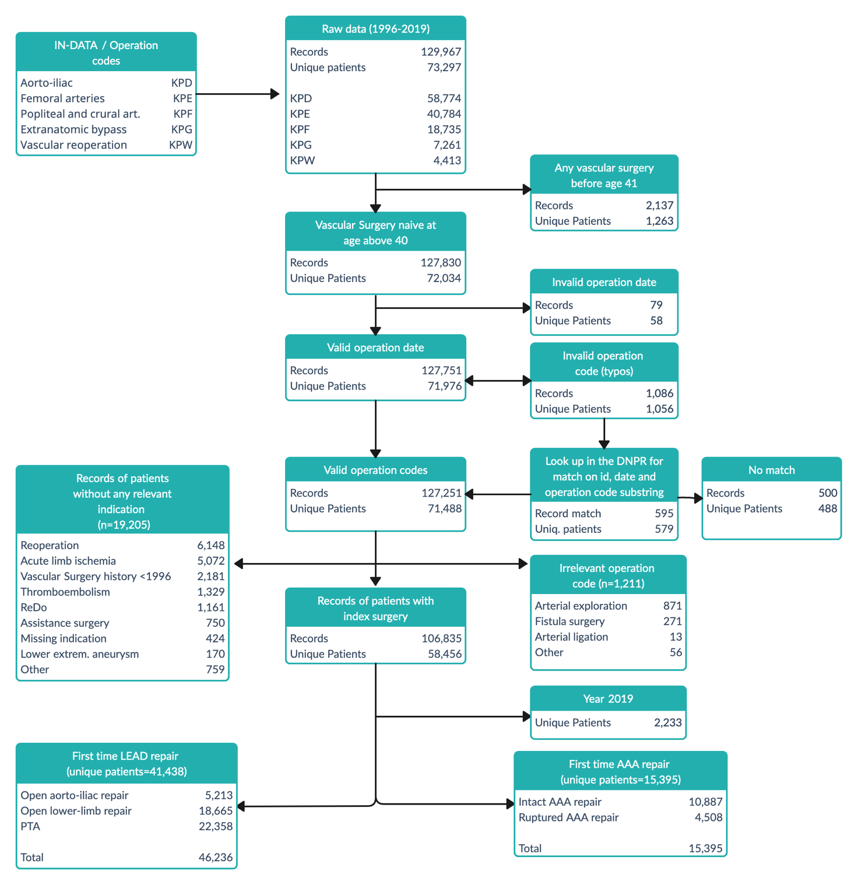

AAA, abdominal aortic aneurysm.
LEAD, lower extremity artery disease.
PTA, percutaneous transluminal angioplasty.
The AAA data set was prepared for another publication.
Note, 610 unique patients were included in both the LEAD and the AAA cohort.

eFigure 2. Sankey plot with number of patients revascularized, censored, and dead following primary repair
Primary revascularization |  |  |  |  | Second revascularisation |  |  |  |  | Third revascularization
source | target | Count |  | source |  | target | Count |  |  | source | target | Count
Peripheral#1 | Aorto-iliac#2 | 124 |  | Peripheral#2 |  | Aorto-iliac#3 | 20-25 |  |  | Peripheral#3 | Death<5yr | 13
Peripheral#1 | PTA#2 | 914 |  | Peripheral#2 |  | PTA#3 | <5 |  |  | Peripheral#3 | Censoring<5yr | 11
Peripheral#1 | Censoring<5yr | 8,603 |  | Peripheral#2 |  | Censoring<5yr | 1,105 |  |  | PTA#3 | Death<5yr | <5
Peripheral#1 | Death<5yr | 6,311 |  | Peripheral#2 |  | Death<5yr | 697 |  |  | PTA#3 | Censoring<5yr | <5
PTA#1 | Aorto-iliac#2 | 204 |  | PTA#2 |  | Aorto-iliac#3 | <5 |  |  | Aorto-iliac#3 | Death<5yr | 13
PTA#1 | Peripheral#2 | 1,597 |  | PTA#2 |  | Peripheral#3 | 5-10 |  |  | Aorto-iliac#3 | Censoring<5yr | 12
PTA#1 | Censoring<5yr | 13,052 |  | PTA#2 |  | Censoring<5yr | 584
PTA#1 | Death<5yr | 5947 |  | PTA#2 |  | Death<5yr | 421
Aorto-iliac#1 | Peripheral#2 | 230 |  | Aorto-iliac#2 |  | Peripheral#3 | 10-15
Aorto-iliac#1 | PTA#2 | 105 |  | Aorto-iliac#2 |  | PTA#3 | <5
Aorto-iliac#1 | Censoring<5yr | 3,228 |  | Aorto-iliac#2 |  | Censoring<5yr | 229
Aorto-iliac#1 | Death<5yr | 1,123 |  | Aorto-iliac#2 |  | Death<5yr | 84

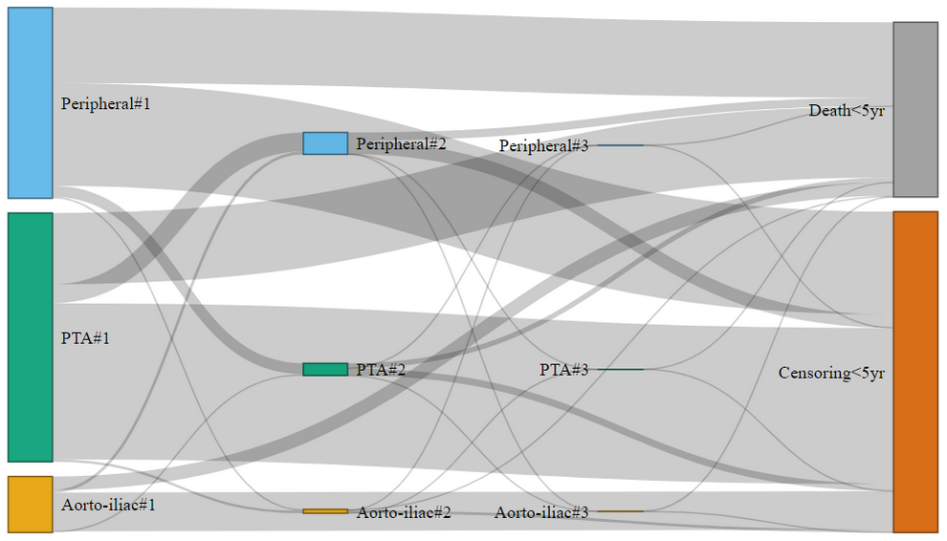

eFigure 3. Alternative presentation of the Sankey plot

Primary revascularization or “Any first-time repair”
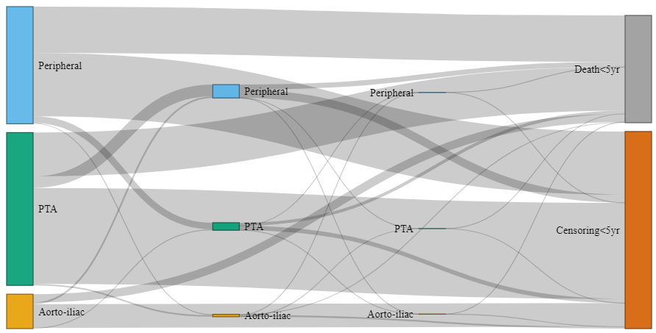

Peripheral

PTA

Aorto-
Iliac

Patients that have undergone
all three types of surgery < 5 yrs
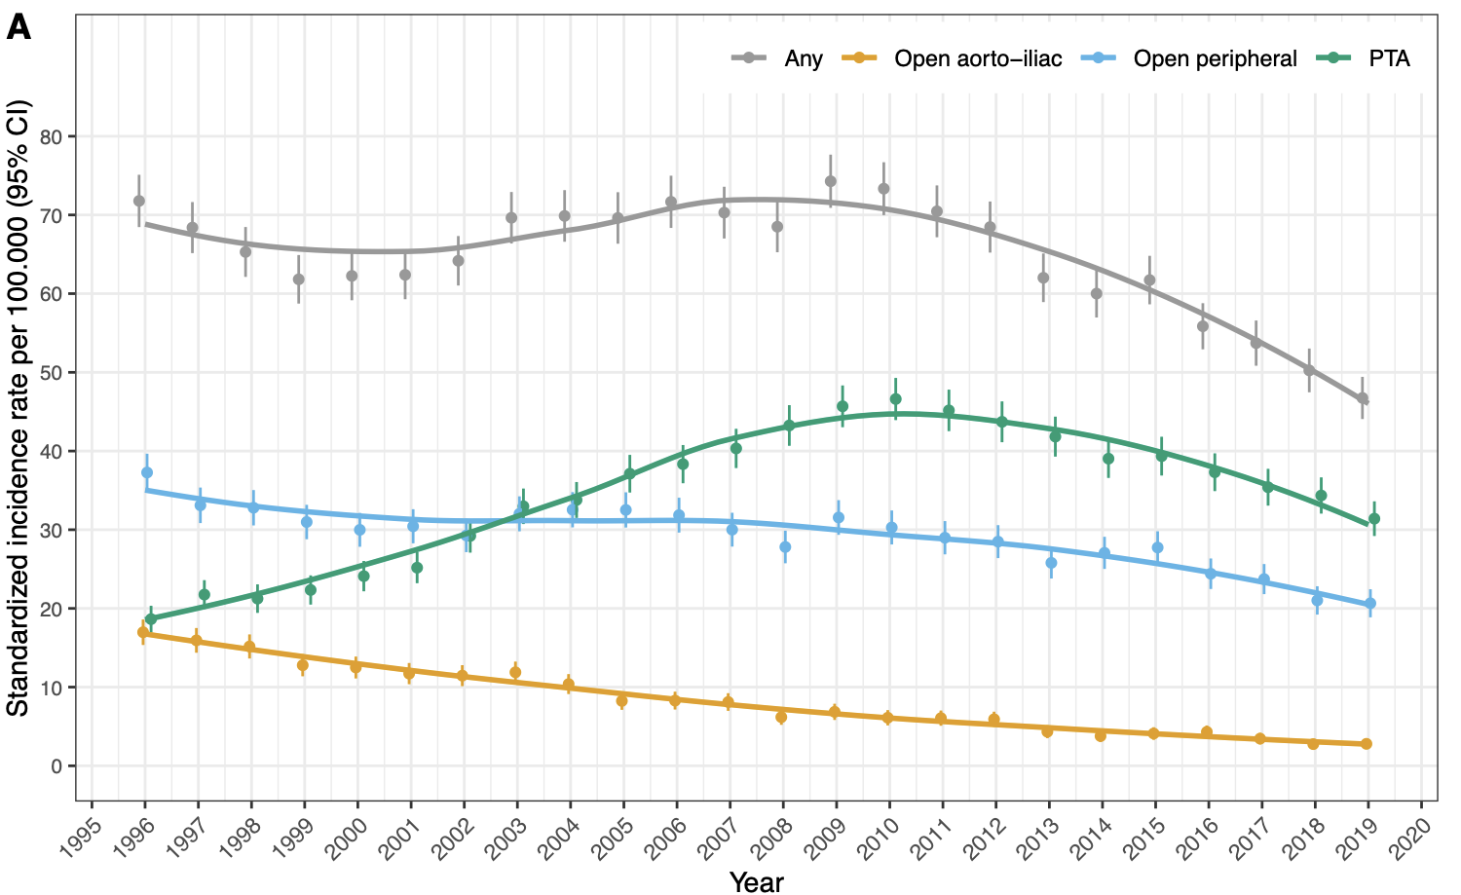

eFigure 4. Trend in age specific incidence rates for LEAD repair

PTA, percutaneous transluminal angioplasty.
Note, to secure pseudonymization of the data, the following have been removed from the open aorto-iliac surgery plot: age groups 41-50 and 91-99 years and annual incidence rate estimates for age group 81-90. Likewise, for open peripheral surgery annual incidence rate estimates for age group 41-50 have been removed.

eFigure 5. Heatmap of sex-standardized age specific incidence rate of LEAD repair

eFigure 6. Heatmap of age specific incidence rate of LEAD repair by sex

eFigure 7. Comorbidity-specific incidence of lower extremity artery disease repair, age- and sex standardized

eFigure 8. Indication-specific incidence rate for lower extremity artery disease repair (primary revascularization), age- and sex standardized

eFigure 9. Mean age by procedure and calendar year

eFigure 10. Trend in Charlson’s comorbidity index score relative to the sex-and age distribution of the Danish population in calendar year 2000

eFigure 11. Plot of 5-year mortality rate ratios

5-year mortality rate ratio following LEAD repair vs. the Danish population aged 41-99, with calendar year 1996-2000 as reference

PTA, percutaneous transluminal angioplasty.

Supplemental eTables

eTables 1a-d: Subgroup analyses of annual percent change in incidence rate
LYear, Calendar year as linear predictor.
IRR, annual incidence rate ratio.
CCI, Charlson’s comorbidity index.
Change (%) is the annual percent change in incidence rate and is calculated by (IRR-1) x 100 %.

eTable 1a. Primary revascularization, annual percent change in incidence rate by subgroup

“LEAD_1st” is an abbreviation for primary revascularization.

eTable 1b. Open aorto-iliac surgery, annual percent change in incidence rate by subgroup
Central LEAD = Open aorto-iliac surgery for lower extremity artery disease

eTable 1c. Open peripheral surgery, annual percent change in incidence rate by subgroup
Peripheral LEAD = Open peripheral surgery for lower extremity artery disease

eTable 1d. Percutaneous transluminal angioplasty (PTA), , annual percent change in incidence rate by subgroup
PTA, percutaneous transluminal angioplasty for lower extremity artery disease.

Result summary of eTable 1a-d

By age
For aorto-iliac surgery, the annual percent change (APC) in incidence rate (IR) was by around -7% across age groups 41-80 years and was by -4% (95% CI, 0.94-0.99) in persons aged 81-90 (p interaction= 0.007; eTable 1b). The APC of peripheral surgery was by -3.3% (95% CI, 0.95-0.98) in persons aged 41-50 and attenuated gradually with increasing age to an APC of -0.51% (95% CI, 0.99 to 1.00) in persons aged 81-90 years (p interaction < 0.001; eTable 1c). The APC of PTA decrease decreased by -1% (95% CI, 0.98 to 1.00) in persons aged 41-50, but increased in all other age group, with an increasing magnitude with age; the APC of PTA was by +6.7% (95% CI, 1.06 to 1.07) in persons aged 81-90 years (eTable 1d, p interaction<0.001).

By sex
Between 1996 and 2018, the age-standardized IR of aorto-iliac surgery decreased from 16.6 to 3.2 per 100.000 person-years in males and from 17.3 to 2.4 per 100.000 person-years in females, which corresponded to a small, but statistically significant sex heterogeneity (APC_{male} -6.6% vs. APC_{female} -7.8%, p interaction=0.003). See also figure 2 in the main manuscript.
Correspondingly, for open peripheral repair, the age-standardized IR decreased from 44.7 to 25.7 per 100.000 person-years in males and from 30.5 to 16.8 per 100.000 person-years in females (APC_{male} -1.4% vs. APC_{female} -1.8%, p interaction=0.08); and for PTA, the age-standardized IR increased from 21.2 to 36.8 per 100.000 person-years in males and from 16.3 to 32.1 per 100.000 person-years in females (APC_{male} +2.7% vs. APC_{female} +2.7%, p interaction=0.85 ).

eTable 2a-d. Baseline characteristics disaggregated by calendar period

eTable 2a. Primary revascularization: baseline characteristics by calendar period
Any first-time LEAD repair | Level | 1996 - 1999 (n=6517) | 2000 - 2004 (n=8369) | 2005 - 2009 (n=9621) | 2010 - 2014 (n=9823) | 2015 - 2018 (n=7109)
Age | mean (sd) | 68 (11) | 68 (10) | 69 (11) | 70 (10) | 71 (10)
Male_sex | Yes | 3473 (53) | 4523 (54) | 5262 (55) | 5440 (55) | 4104 (58)
 | No | 3044 (47) | 3846 (46) | 4359 (45) | 4383 (45) | 3005 (42)
CCI_group | Normal | 258 (4) | 359 (4) | 629 (7) | 691 (7) | 527 (7)
 | Moderate | 2900 (44) | 3219 (38) | 3318 (34) | 2996 (30) | 1912 (27)
 | Severe | 1322 (20) | 1694 (20) | 2060 (21) | 1971 (20) | 1403 (20)
 | Very Severe | 2037 (31) | 3097 (37) | 3614 (38) | 4165 (42) | 3267 (46)
Dependency | Independent | 4973 (76) | 6522 (78) | 7674 (80) | 8229 (84) | 5999 (84)
 | Home care | 1275 (20) | 1411 (17) | 1450 (15) | 1255 (13) | 799 (11)
 | Nursing home | 102 (2) | 159 (2) | 235 (2) | 228 (2) | 138 (2)
 | missing | 167 (3) | 277 (3) | 262 (3) | 111 (1) | 173 (2)
TOBACCO | None | 881 (14) | 1083 (13) | 1483 (15) | 1323 (13) | 1085 (15)
 | Previous | 1443 (22) | 2375 (28) | 3351 (35) | 3955 (40) | 2938 (41)
 | Smoker | 3889 (60) | 4491 (54) | 4466 (46) | 4331 (44) | 2825 (40)
 | missing | 304 (5) | 420 (5) | 321 (3) | 214 (2) | 261 (4)
alcohol_abuse | No | 4541 (70) | 7890 (94) | 9079 (94) | 9374 (95) | 6603 (93)
 | > 5 units/day | 106 (2) | 192 (2) | 272 (3) | 302 (3) | 204 (3)
 | missing | 1870 (29) | 287 (3) | 270 (3) | 147 (1) | 302 (4)
PRIORITY | Elective | 4483 (69) | 7774 (93) | 8650 (90) | 8571 (87) | 5962 (84)
 | Subacute | 314 (5) | 487 (6) | 910 (9) | 1099 (11) | 947 (13)
 | Acute | 100 (2) | 100-110 (1) | 61 (1) | 145-155 (2) | 185-195 (3)
 | missing | 1620 (25) | <5 (0) | 0 (0) | <5 (0) | 5-15 (0)
Region | North | 642 (10) | 798 (10) | 994 (10) | 1074 (11) | 917 (13)
 | Central | 1343 (21) | 1749 (21) | 1983 (21) | 2023 (21) | 1456 (20)
 | South | 1741 (27) | 2408 (29) | 3005 (31) | 3086 (31) | 2179 (31)
 | Capital | 2208 (34) | 2518 (30) | 2549 (26) | 2293 (23) | 1602 (23)
 | Zealand | 583 (9) | 896 (11) | 1090 (11) | 1347 (14) | 955 (13)
Technique | Open | 4417 (68) | 4776 (57) | 4299 (45) | 3687 (38) | 2455 (35)
 | Endovascular | 1984 (30) | 3473 (41) | 5196 (54) | 5881 (60) | 4267 (60)
 | Hybrid | 116 (2) | 120 (1) | 126 (1) | 255 (3) | 387 (5)

eTable 2b. Open aorto-iliac surgery, baseline characteristics by calendar period
Aorto-iliac surgery | Level | 1996 - 1999 (n=1,473) | 2000 - 2004 (n=1,480) | 2005 - 2009 (n=1,026) | 2010 - 2014 (n= 772) | 2015 - 2019 (n= 462)
Age | mean (sd) | 64 (9) | 64 (9) | 65 (10) | 64 (9) | 65 (9)
Male_sex | Yes | 728 (49) | 725 (49) | 528 (51) | 412 (53) | 276 (60)
CCI_group | Normal | 62 (4) | 20 (1) | 26 (3) | 26 (3) | 13 (3)
 | Moderate | 784 (53) | 762 (51) | 473 (46) | 363 (47) | 218 (47)
 | Severe | 312 (21) | 317 (21) | 241 (23) | 184 (24) | 101 (22)
 | Very Severe | 315 (21) | 381 (26) | 286 (28) | 199 (26) | 130 (28)
Dependency | Independent | 1,266 (86) | 1,298 (88) | 916 (89) | 719 (93) | 433 (94)
 | Home care | 176 (12) | 148 (10) | 98 (10) | 43 (6) | 22 (5)
 | Nursing home | 9 (1) | 12 (1) | 5-10 (1) | 5 (1) | <5 (1)
 | missing | 22 (1) | 22 (1) | <5 (0) | 5 (1) | <5 (1)
TOBACCO | None | 59 (4) | 75 (5) | 55-60 (6) | 42 (5) | 36 (8)
 | Previous | 323 (22) | 455 (31) | 357 (35) | 298 (39) | 168 (36)
 | Smoker | 1,062 (72) | 917 (62) | 606 (59) | 423 (55) | 251 (54)
 | missing | 29 (2) | 33 (2) | <5 (0) | 9 (1) | 5-10 (2)
alcohol_abuse | No | 995 (68) | 1,405 (95) | 963 (94) | 723 (94) | 432 (94)
 | > 5 units/day | 30 (2) | 49 (3) | 49 (5) | 37 (5) | 17 (4)
 | missing | 448 (30) | 26 (2) | 14 (1) | 12 (2) | 13 (3)
PRIORITY | Elective | 1,016 (69) | 1,417 (96) | 969 (94) | 709 (92) | 404 (87)
 | Subacute | 47 (3) | 41 (3) | 49 (5) | 57 (7) | 41 (9)
 | Acute | 18 (1) | 22 (1) | 8 (1) | 6 (1) | 17 (4)
 | missing | 392 (27) | 0 (0) | 0 (0) | 0 (0) | 0 (0)
Region | North | 249 (17) | 209 (14) | 141 (14) | 149 (19) | 105 (23)
 | Central | 366 (25) | 383 (26) | 193 (19) | 142 (18) | 57 (12)
 | South | 344 (23) | 468 (32) | 397 (39) | 320 (41) | 178 (39)
 | Capital | 360 (24) | 286 (19) | 194 (19) | 88 (11) | 85 (18)
 | Zealand | 154 (10) | 134 (9) | 101 (10) | 73 (9) | 37 (8)
Technique | Open | 1,473 (100) | 1,480 (100) | 1,026 (100) | 772 (100) | 462 (100)
 | Endovascular | 0 (0) | 0 (0) | 0 (0) | 0 (0) | 0 (0)
 | Hybrid | 0 (0) | 0 (0) | 0 (0) | 0 (0) | 0 (0)

eTable 2c. Open peripheral surgery, baseline characteristics by calendar period
Peripheral Surgery | Level | 1996 - 1999 (n=3,286) | 2000 - 2004 (n=3,925) | 2005 - 2009 (n=4,155) | 2010 - 2014 (n=4,148) | 2015 - 2019 (n=3,151)
Age | mean (sd) | 71 (10) | 71 (10) | 71 (10) | 72 (10) | 72 (9)
Male_sex | Yes | 1,848 (56) | 2,295 (58) | 2,412 (58) | 2,510 (61) | 1,955 (62)
CCI_group | Normal | 99 (3) | 96 (2) | 107 (3) | 103 (2) | 49 (2)
 | Moderate | 1,252 (38) | 1,301 (33) | 1,305 (31) | 1,181 (28) | 815 (26)
 | Severe | 648 (20) | 789 (20) | 896 (22) | 834 (20) | 665 (21)
 | Very Severe | 1,287 (39) | 1,739 (44) | 1,847 (44) | 2,030 (49) | 1,622 (51)
Dependency | Independent | 2,286 (70) | 2,815 (72) | 3,155 (76) | 3,425 (83) | 2,710 (86)
 | Home care | 843 (26) | 900 (23) | 846 (20) | 618 (15) | 352 (11)
 | Nursing home | 73 (2) | 110 (3) | 111 (3) | 74 (2) | 34 (1)
 | missing | 84 (3) | 100 (3) | 43 (1) | 31 (1) | 55 (2)
TOBACCO | None | 612 (19) | 644 (16) | 713 (17) | 580 (14) | 444 (14)
 | Previous | 727 (22) | 1,147 (29) | 1,515 (36) | 1,794 (43) | 1,393 (44)
 | Smoker | 1,788 (54) | 1,981 (50) | 1,858 (45) | 1,723 (42) | 1,227 (39)
 | missing | 159 (5) | 153 (4) | 69 (2) | 51 (1) | 87 (3)
alcohol_abuse | No | 2,264 (69) | 3,739 (95) | 3,952 (95) | 3,927 (95) | 2,888 (92)
 | > 5 units/day | 63 (2) | 91 (2) | 145 (3) | 161 (4) | 113 (4)
 | missing | 959 (29) | 95 (2) | 58 (1) | 60 (1) | 150 (5)
PRIORITY | Elective | 2,168 (66) | 3,530 (90) | 3,527 (85) | 3,430 (83) | 2,500 (79)
 | Subacute | 224 (7) | 345-355 (9) | 595 (14) | 645-655 (16) | 516 (16)
 | Acute | 54 (2) | 40-50 (1) | 33 (1) | 60-70 (2) | 125-135 (4)
 | missing | 840 (26) | <5 (0) | 0 (0) | <5 (0) | 0-10 (0)
Region | North | 313 (10) | 452 (12) | 462 (11) | 422 (10) | 336 (11)
 | Central | 609 (19) | 823 (21) | 945 (23) | 927 (22) | 689 (22)
 | South | 885 (27) | 1,177 (30) | 1,236 (30) | 1,302 (31) | 1,010 (32)
 | Capital | 1,137 (35) | 1,062 (27) | 1,032 (25) | 987 (24) | 697 (22)
 | Zealand | 342 (10) | 411 (10) | 480 (12) | 510 (12) | 419 (13)
Technique | Open | 3,165 (96) | 3,792 (97) | 4,013 (97) | 3,845 (93) | 2,680 (85)
 | Endovascular | 0 (0) | 0 (0) | 0 (0) | 0 (0) | 0 (0)
 | Hybrid | 121 (4) | 133 (3) | 142 (3) | 303 (7) | 471 (15)

eTable 2d. Percutaneous transluminal angioplasty (PTA): baseline characteristics by calendar period
PTA | Level | 1996 - 1999 (n=2,045) | 2000 - 2004 (n=3,709) | 2005 - 2009 (n=5,570) | 2010 - 2014 (n=6,355) | 2015 - 2019 (n=4,679)
Age | mean (sd) | 66 (11) | 67 (10) | 69 (11) | 70 (10) | 71 (10)
Male_sex | Yes | 1,060 (52) | 1,910 (51) | 2,949 (53) | 3,351 (53) | 2,589 (55)
CCI_group | Normal | 97 (5) | 243 (7) | 496 (9) | 563 (9) | 465 (10)
 | Moderate | 968 (47) | 1,414 (38) | 1,871 (34) | 1,825 (29) | 1,144 (24)
 | Severe | 426 (21) | 734 (20) | 1,158 (21) | 1,240 (20) | 856 (18)
 | Very Severe | 554 (27) | 1,318 (36) | 2,045 (37) | 2,727 (43) | 2,214 (47)
Dependency | Independent | 1,634 (80) | 2,979 (80) | 4,503 (81) | 5,267 (83) | 3,860 (82)
 | Home care | 318 (16) | 503 (14) | 696 (12) | 823 (13) | 569 (12)
 | Nursing home | 26 (1) | 54 (1) | 131 (2) | 177 (3) | 113 (2)
 | missing | 67 (3) | 173 (5) | 240 (4) | 88 (1) | 137 (3)
TOBACCO | None | 243 (12) | 466 (13) | 858 (15) | 882 (14) | 776 (17)
 | Previous | 470 (23) | 990 (27) | 1,927 (35) | 2,558 (40) | 1,955 (42)
 | Smoker | 1,209 (59) | 1,994 (54) | 2,503 (45) | 2,740 (43) | 1,747 (37)
 | missing | 123 (6) | 259 (7) | 282 (5) | 175 (3) | 201 (4)
alcohol_abuse | No | 1,528 (75) | 3,450 (93) | 5,223 (94) | 6,119 (96) | 4,347 (93)
 | > 5 units/day | 19 (1) | 74 (2) | 118 (2) | 139 (2) | 105 (2)
 | missing | 498 (24) | 185 (5) | 229 (4) | 97 (2) | 227 (5)
PRIORITY | Elective | 1,548 (76) | 3,526 (95) | 5,172 (93) | 5,704 (90) | 4,039 (86)
 | Subacute | 55 (3) | 136 (4) | 366 (7) | 558 (9) | 555 (12)
 | Acute | 32 (2) | 47 (1) | 32 (1) | 90-95 (1) | 70-80 (2)
 | missing | 410 (20) | 0 (0) | 0 (0) | <5 (0) | 5-15 (0)
Region | North | 114 (6) | 198 (5) | 489 (9) | 694 (11) | 623 (13)
 | Central | 421 (21) | 689 (19) | 1,084 (19) | 1,216 (19) | 911 (19)
 | South | 594 (29) | 979 (26) | 1,726 (31) | 1,957 (31) | 1,444 (31)
 | Capital | 816 (40) | 1,425 (38) | 1,653 (30) | 1,534 (24) | 1,045 (22)
 | Zealand | 100 (5) | 418 (11) | 618 (11) | 954 (15) | 656 (14)
Technique | Open | 0 (0) | 0 (0) | 0 (0) | 0 (0) | 0 (0)
 | Endovascular | 2,045 (100) | 3,709 (100) | 5,570 (100) | 6,355 (100) | 4,679 (100)
 | Hybrid | 0 (0) | 0 (0) | 0 (0) | 0 (0) | 0 (0)

eTable 3. 5-yr survival sensitivity analyses with plot
follow_up | Surgery | Units | Model 1 | Model 2 | Model 3 | Model 4
Five-year | PTA | 1996 - 2000 | Reference | Reference | Reference | Reference
Five-year | PTA | 2001 - 2005 | 1.07 (0.98-1.16) | 0.95 (0.87-1.03) | 0.97 (0.88-1.06) | 0.99 (0.90-1.09)
Five-year | PTA | 2006 - 2010 | 1.08 (0.99-1.17) | 0.86 (0.79-0.93) | 0.91 (0.84-1.00) | 0.93 (0.85-1.02)
Five-year | PTA | 2011 - 2015 | 1.22 (1.13-1.32) | 0.88 (0.81-0.96) | 0.94 (0.87-1.03) | 0.96 (0.87-1.05)
Five-year | PTA | 2016 - 2018 | 1.35 (1.22-1.49) | 0.89 (0.80-0.98) | 0.95 (0.86-1.06) | 0.97 (0.86-1.09)
Five-year | Aorto-iliac | 1996 - 2000 | Reference | Reference | Reference | Reference
Five-year | Aorto-iliac | 2001 - 2005 | 0.93 (0.81-1.06) | 0.88 (0.77-1.00) | 0.93 (0.80-1.07) | 0.98 (0.84-1.13)
Five-year | Aorto-iliac | 2006 - 2010 | 0.91 (0.79-1.06) | 0.81 (0.69-0.94) | 0.88 (0.75-1.03) | 0.93 (0.79-1.10)
Five-year | Aorto-iliac | 2011 - 2015 | 0.67 (0.56-0.81) | 0.60 (0.50-0.72) | 0.67 (0.55-0.82) | 0.71 (0.58-0.87)
Five-year | Aorto-iliac | 2016 - 2018 | 0.86 (0.63-1.17) | 0.72 (0.53-0.99) | 0.81 (0.59-1.11) | 0.86 (0.63-1.19)
Five-year | Peripheral | 1996 - 2000 | Reference | Reference | Reference | Reference
Five-year | Peripheral | 2001 - 2005 | 0.94 (0.88-1.00) | 0.88 (0.83-0.94) | 0.93 (0.87-1.00) | 0.93 (0.86-1.00)
Five-year | Peripheral | 2006 - 2010 | 0.85 (0.80-0.91) | 0.77 (0.72-0.82) | 0.84 (0.78-0.90) | 0.85 (0.79-0.92)
Five-year | Peripheral | 2011 - 2015 | 0.82 (0.77-0.87) | 0.70 (0.66-0.75) | 0.80 (0.74-0.86) | 0.81 (0.75-0.87)
Five-year | Peripheral | 2016 - 2018 | 0.79 (0.71-0.87) | 0.66 (0.60-0.74) | 0.79 (0.71-0.87) | 0.81 (0.73-0.91)
One-year | PTA | 1996 - 2000 | Reference | Reference | Reference | Reference
One-year | PTA | 2001 - 2005 | 1.03 (0.87-1.22) | 0.89 (0.75-1.05) | 0.92 (0.77-1.10) | 0.91 (0.75-1.10)
One-year | PTA | 2006 - 2010 | 1.15 (0.99-1.34) | 0.87 (0.74-1.02) | 0.92 (0.78-1.08) | 0.93 (0.78-1.10)
One-year | PTA | 2011 - 2015 | 1.40 (1.20-1.62) | 0.93 (0.80-1.09) | 0.98 (0.83-1.15) | 0.99 (0.83-1.18)
One-year | PTA | 2016 - 2018 | 1.42 (1.21-1.67) | 0.86 (0.73-1.01) | 0.92 (0.77-1.10) | 0.93 (0.77-1.13)
One-year | Aorto-iliac | 1996 - 2000 | Reference | Reference | Reference | Reference
One-year | Aorto-iliac | 2001 - 2005 | 0.89 (0.70-1.13) | 0.84 (0.66-1.07) | 0.90 (0.69-1.17) | 0.93 (0.71-1.22)
One-year | Aorto-iliac | 2006 - 2010 | 0.78 (0.58-1.03) | 0.68 (0.51-0.90) | 0.76 (0.56-1.03) | 0.80 (0.59-1.09)
One-year | Aorto-iliac | 2011 - 2015 | 0.62 (0.44-0.87) | 0.56 (0.40-0.79) | 0.63 (0.44-0.91) | 0.66 (0.45-0.97)
One-year | Aorto-iliac | 2016 - 2018 | 0.71 (0.45-1.12) | 0.61 (0.38-0.96) | 0.67 (0.42-1.08) | 0.70 (0.43-1.14)
One-year | Peripheral | 1996 - 2000 | Reference | Reference | Reference | Reference
One-year | Peripheral | 2001 - 2005 | 0.94 (0.84-1.06) | 0.88 (0.79-0.99) | 0.95 (0.84-1.07) | 0.93 (0.82-1.06)
One-year | Peripheral | 2006 - 2010 | 0.85 (0.75-0.95) | 0.77 (0.69-0.87) | 0.86 (0.76-0.97) | 0.86 (0.75-0.98)
One-year | Peripheral | 2011 - 2015 | 0.73 (0.65-0.82) | 0.64 (0.57-0.72) | 0.75 (0.65-0.85) | 0.75 (0.65-0.86)
One-year | Peripheral | 2016 - 2018 | 0.71 (0.61-0.83) | 0.61 (0.52-0.71) | 0.75 (0.64-0.88) | 0.76 (0.64-0.90)

PTA, percutaneous transluminal angioplasty

eTable 4. Regression tables of survival analyses
Note, age groups 41-50 and 91-99 year are also included as parameters in the multivariable Cox regression analyses, but the corresponding estimates are not displayed in the plots below to secure pseudonymization of the data.

eTable 4a1. Open Aorto-iliac LEAD repair, primary analysis (“apriori” model)

eTable 4a2. Open Aorto-iliac LEAD repair, secondary analysis

eTable 4b1. Open Peripheral LEAD repair, primary analysis (“apriori” model)

eTable 4b2. Open Peripheral LEAD repair, secondary analysis

eTable 4c1. Percutaneous transluminal angioplasty (PTA), primary analysis (“apriori” model)

eTable 4c2. Percutaneous transluminal angioplasty (PTA), secondary analysis

PTA, percutaneous transluminal angioplasty

Miscellaneous

Charlson’s Comorbidity Index item coding used

Disease categories and the International Classification of Diseases codes used to calculate Charlson’s Comorbidity Index.

Disease category | Danish coding system 1977-1995 | ICD-10  1996-2018 | Score
Myocardial infarction | 410 | I21, I23 | 1
Congestive heart failure | 427.09; 427.10; 427.11; 427.19; 428.99; 782.49 | I50; I11.0; I13.0; I13.2 | 1
Peripheral vascular disease | 440; 441; 442; 443; 444; 445 | I70- I74; I77 | 1
Cerebrovascular disease | 430-438 | I60-I69; G45; G46 | 1
Dementia | 290.09-290.19; 293.09 | F00-F03; F05.1; G30 | 1
Chronic pulmonary disease | 490-493; 515-518 | J40-J47; J60-J67; J68.4; J70.1; J70.3; J84.1; J92.0; J96.1; J98.2-J98.3 | 1
Connective tissue disease | 712; 716; 734; 446; 135.99 | M05; M06; M08; M09; M30-M36; D86 | 1
Ulcer disease | 530.91; 530.98; 531-534 | K22.1; K25-K28 | 1
Mild liver disease | 571; 573.01; 573.04 | B18; K70.0-K70.3; K70.9; K71; K73; K74; K76.0 | 1
Diabetes | 249.00; 249.06; 249.07; 249.09; 250.00; 250.06; 250.07; 250.09 | E10.0; E10.1; E10.9; E11.0; E11.1; E11.9 | 1
Hemiplegia | 344 | G81; G82 | 2
Moderate to severe renal disease | 403; 404; 580-584; 590.09; 593.19; 753.10-753.19; 792 | I12; I13; N00-N05; N07; N11; N14; N17-N19; Q61 | 2
Diabetes with end organ damage | 249.01-249.05; 249.08; 250.01-250.05; 250.08 | E10.2-E10.8;  E11.2-E11.8 | 2
Any tumor | 140-194 | C00-C75 | 2
Leukemia | 204-207 | C91-C95 | 2
Lymphoma | 200-203; 275.59 | C81-C85; C88; C90; C96 | 2
Moderate to severe liver disease | 070.00; 070.02; 070:04; 070.06; 070.08; 573.00; 456.00-456.09 | B15.0; B16.0; B16.2; B19.0; K70.4; K72; K76.6; I85 | 3
Metastatic solid tumor | 195-199 | C76-C80 | 6
AIDS | 079.83 | B21-B24 | 6

Operation codes used
Inclusion was based on the DVR and the criteria were i) operation code as per the Scandinavian classifications of surgical and other procedures (NOMESCO) relevant to aortoiliac or lower extremity reconstruction: PDH (aortoiliac bypass), PDF (aortoiliac endarterectomy), PGH (axillobifem. bypass), PDP (aortoiliac PTA). Lower extremity repair: PGH40 (femorofemoral cross-over), PEH and PFH (lower extremity/peripheral bypass), PEN and PEF (lower extremity/peripheral endarterectomy), PEP and PFP (lower extremity PTA)); an exhaustive list is available at the end of this document. ii) indication being either claudication, rest pain, wound/gangrene defined by the DVR-variable “GC_PI_INDIK1” takes on the value 16-19. iii) age above 40 and below 100 years.

Criteria for imputing the operation code from the Danish National Patient Registry based on substring match between the DNPR and DVR
Due to type errors, some of the operation codes registered in the DVR did not match the Scandinavian coding system. In that case we looked-up and imputed the operations code from the Danish National Patient Registry if it matched on i) patient identifier, ii) date, and iii) a substring-match a described below

Imputation assumption /  character match | No. of imputed cases / operation codes
Character 1to5 | 25
Letters 1to4 | 56
Character 4to6 | 97
Character 12356 | 72
Character 5to6 | 56
Character char | 12
SUM | 318

Additional baseline characteristics coding
 | DIAGNOSES | DIAGNOSES | SURGERY | SURGERY | Sks_ube*
 | Danish coding system 1977-1995 | ICD10  1996-2018 | Danish coding system 1977-1995 | Scandinavian coding system  1996-2018
Angina history | 413; | I20
Stroke or  TIA | 430; 431; 433; 434;  435;  43601; 43690 | I60-I64; I69
PM/ICD/loop recorder | 99750 | T821;  T827I-P;  T828P;  Z450;  Z950 | 32122  32159  32199 | FPF-H | BFC
CABG/PCI |  |  | 300;301;  30200;  30240;  30350 | FN
Heart valve disease | 394-6;39700;  424 | I05-8;  I091, I091B  I098  I34-7  T820 | 303;  30600;  30620;  30640;  30729;  30780;  30799;  30800;  30810;  30920;  30925;  30939;  30959;  30990;  311;  31268-9;  Excl:30354,  30359 | FG; FJE;  FJF;  FJW;  FK;  FM
Cardiomyopathy | 42599 | I42-3
*Sks_ube is a Danish national patient registry database which contains records of examinations and procedures not considered surgical cases. I was used for additional baseline characterics in the period 1996-2018.

Primary diagnosis ICD-codes used when the indication for LEAD repair was missing or unclear
ICD-code and # Explanatory text in Danish
'DI700' #Aterosklerose i aorta
,'DI702' #Aterosklerose i arterie i underekstremitet
,'DI702A'#Aterosklerotisk gangræn
,'DI739' #"Sygdom i perifere kar UNS"
,'DI739A'#"Claudicatio intermittens"
,'DI739C'#"Iskæmiske hvilesmerter i underekstremitet"
,'DL97' #Sår på ben IKA
,'DL979' #Ulcus på ben IKA
,'DL979B'#Ulcus cruris arterioscleroticum
,'DL979C'#Ulcus perforans pedis
,'DL979E'#Ulcus pedis arterioscleroticum
,'DL984' #Kronisk ulcus i huden IKA
ICD-Codes pertaining to LEAD secondary to diabetes
'DE105','DE105A','DE105B','DE105C','DE115','DE115B', 'DE115C','DE135B','DE145','DE145B','DE145C'

Repair hierarchy
A two level hierarchy was used for choosing the most comprehensive procedure in case of multiple records on the same day.
OPKODE_PRIM | Group | Tekst | HIERARCHY_1 | HIERARCHY_2
KPDQ10 | Infraren. aorta, iliac aa. and distally | Indsaettelse af endoprotese i infrarenale aorta | 1 | 1
KPDQ20 | Infraren. aorta, iliac aa. and distally | Indsaettelse af endoprotese aorto-iliakalt | 1 | 1
KPDQ21 | Infraren. aorta, iliac aa. and distally | Indsaettelse af endoprotese aorto-bi-iliakalt | 1 | 1
KPDG10 | Infraren. aorta, iliac aa. and distally | Aneurismeoperation paa infrarenale aorta | 1 | 1
KPDG20 | Infraren. aorta, iliac aa. and distally | Aneurismeoperation med aortoiliakal bypass | 1 | 1
KPDG21 | Infraren. aorta, iliac aa. and distally | Aneurismeoperation med aortobi-iliakal bypass | 1 | 1
KPDG22 | Infraren. aorta, iliac aa. and distally | Aneurismeoperation med aortoiliakal og kontralateral iliakofemoral bypass | 1 | 1
KPDG23 | Infraren. aorta, iliac aa. and distally | Aneurismeoperation med aortofemoral bypass | 1 | 1
KPDG24 | Infraren. aorta, iliac aa. and distally | Aneurismeoperation med aortobifemoral bypass | 1 | 1
KPDH10 | Infraren. aorta, iliac aa. and distally | Bypass-operation af segment af infrarenale aorta | 1 | 1
KPDH20 | Infraren. aorta, iliac aa. and distally | Aortoiliakal bypass-operation | 1 | 1
KPDH21 | Infraren. aorta, iliac aa. and distally | Aortobiiliakal bypass-operation | 1 | 1
KPDH22 | Infraren. aorta, iliac aa. and distally | Aortoiliakal og kontralateral femoral bypass-operation | 1 | 1
KPDH23 | Infraren. aorta, iliac aa. and distally | Aortofemoral bypass-operation | 1 | 1
KPDH24 | Infraren. aorta, iliac aa. and distally | Aortobifemoral bypass-operation | 1 | 1
KPDQ30 | Infraren. aorta, iliac aa. and distally | Indsaettelse af endoprotese i iliaka-arterie | 1 | 2
KPDG30 | Infraren. aorta, iliac aa. and distally | Aneurismeoperation paa iliaka-arterie | 1 | 2
KPDG35 | Infraren. aorta, iliac aa. and distally | Aneurismeoperation med iliakofemoral bypass | 1 | 2
KPDG99 | Infraren. aorta, iliac aa. and distally | Anden aneurismeoperation paa infrarenale aorta eller iliaka-arterie | 1 | 2
KPDH30 | Infraren. aorta, iliac aa. and distally | Bypass-operation af segment af iliaka-arterie | 1 | 2
KPDH35 | Infraren. aorta, iliac aa. and distally | Iliakofemoral bypass-operation | 1 | 2
KPDH99 | Infraren. aorta, iliac aa. and distally | Anden bypass-operation fra infrarenale aorta eller iliaka-arterie | 1 | 2
KPDF10 | Infraren. aorta, iliac aa. and distally | Trombendarterektomi i infrarenale aorta | 1 | 3
KPDF15 | Infraren. aorta, iliac aa. and distally | Trombendarterektomi i aortoiliakalt segment | 1 | 3
KPDF30 | Infraren. aorta, iliac aa. and distally | Trombendarterektomi i iliaka-arterie | 1 | 3
KPDF35 | Infraren. aorta, iliac aa. and distally | Trombendarterektomi i iliakofemoralt segment | 1 | 3
KPDN10 | Infraren. aorta, iliac aa. and distally | Plastik paa infrarenale aorta | 1 | 3
KPDN30 | Infraren. aorta, iliac aa. and distally | Plastik paa iliaka-arterie | 1 | 3
KPGH22 | Extra-anatomic bypass | Aksillofemoral bypass-operation | 2 | NA
KPGH23 | Extra-anatomic bypass | Aksillobifemoral bypass-operation | 2 | NA
KPFH10 | popliteal aa. and distally | Bypass-operation fra arteria poplitea | 3 | 1
KPFH20 | popliteal aa. and distally | Bypass-operation fra arteria femoralis eller arteria poplitea til arterie i underben | 3 | 1
KPFH21 | popliteal aa. and distally | Bypass-operation fra arteria femoralis eller arteria poplitea til proksimal del af arteria tibialis anterior | 3 | 1
KPFH22 | popliteal aa. and distally | Bypass-operation fra arteria femoralis eller arteria poplitea til distal del af arteria tibialis anterior | 3 | 1
KPFH23 | popliteal aa. and distally | Bypass-operation fra arteria femoralis eller arteria poplitea til truncus tibioperonealis | 3 | 1
KPFH24 | popliteal aa. and distally | Bypass-operation fra arteria femoralis eller arteria poplitea til proksimal del af arteria tibialis posterior | 3 | 1
KPFH25 | popliteal aa. and distally | Bypass-operation fra arteria femoralis eller arteria poplitea til distal del af arteria tibialis posterior | 3 | 1
KPFH26 | popliteal aa. and distally | Bypass-operation fra arteria femoralis eller arteria poplitea til proksimal del af arteria peronealis | 3 | 1
KPFH27 | popliteal aa. and distally | Bypass-operation fra arteria femoralis eller arteria poplitea til distal del af arteria peronealis | 3 | 1
KPFH28 | popliteal aa. and distally | Bypass-operation fra arteria femoralis eller arteria poplitea til arteria dorsalis pedis | 3 | 1
KPFH29 | popliteal aa. and distally | Bypass-operation fra arteria femoralis eller arteria poplitea til arteria tibialis posterior i foden | 3 | 1
KPFH99 | popliteal aa. and distally | Anden bypass-operation fra arteria femoralis eller arteria poplitea til arterie i underben eller fod | 3 | 1
KPEH | a.femoralis and branches | Bypass-operation fra arteria femoralis og dens grene | 3 | 2
KPEH10 | a.femoralis and branches | Bypass-operation fra arteria femoralis communis | 3 | 2
KPEH11 | a.femoralis and branches | Bypass-operation fra arteria profunda femoris | 3 | 2
KPEH12 | a.femoralis and branches | Bypass-operation fra arteria femoralis superficialis | 3 | 2
KPEH20 | a.femoralis and branches | Bypass-operation fra arteria femoralis til arteria poplitea oven for knaeet | 3 | 2
KPEH30 | a.femoralis and branches | Bypass-operation fra arteria femoralis til arteria poplitea neden for knaeet | 3 | 2
KPEN10 | a.femoralis and branches | Plastik paa arteria femoralis communis | 3 | 3
KPEN11 | a.femoralis and branches | Plastik paa arteria profunda femoris | 3 | 3
KPEN12 | a.femoralis and branches | Plastik paa arteria femoralis superficialis | 3 | 3
KPFN10 | popliteal aa. and distally | Plastik paa arteria poplitea | 3 | 3
KPFN30 | popliteal aa. and distally | Plastik paa arterie i underben eller fod | 3 | 3
KPGH40 | Extra-anatomic bypass | Femorofemoral kontralateral bypass-operation | 3 | 3
KPEF | a.femoralis and branches | Trombendarterektomier i arteria femoralis og dens grene | 3 | 4
KPEF10 | a.femoralis and branches | Trombendarterektomi i arteria femoralis communis | 3 | 4
KPEF11 | a.femoralis and branches | Trombendarterektomi i arteria profunda femoris | 3 | 4
KPEF12 | a.femoralis and branches | Trombendarterektomi i arteria femoralis superficialis | 3 | 4
KPDP | Infraren. aorta, iliac aa. and distally | Perkutane plastikker paa infrarenale aorta og iliaka-arterier | 4 | 1
KPDP10 | Infraren. aorta, iliac aa. and distally | Perkutan plastik paa infrarenale aorta | 4 | 1
KPDP30 | Infraren. aorta, iliac aa. and distally | Perkutan plastik paa iliaka-arterie | 4 | 1
KPDP50 | Infraren. aorta, iliac aa. and distally | Perkutan indlÃ¦ggelse af stent i infrarenale aorta/a.iliaca | 4 | 1
KPEP10 | a.femoralis and branches | Perkutan plastik paa arteria femoralis communis | 4 | 2
KPEP11 | a.femoralis and branches | Perkutan plastik paa arteria profunda femoris | 4 | 2
KPEP12 | a.femoralis and branches | Perkutan plastik paa arteria femoralis superficialis | 4 | 2
KPEP50 | a.femoralis and branches | Perkutan indlÃ¦ggelse af stent i a. femoralis/femoralis gren | 4 | 2
KPFP10 | popliteal aa. and distally | Perkutan plastik paa arteria poplitea | 4 | 2
KPFP30 | popliteal aa. and distally | Perkutan plastik paa arterie i underben eller fod | 4 | 2
KPFP50 | popliteal aa. and distally | Perkutan indlÃ¦ggelse af stent i a. poplitea/crus/fodarterie | 4 | 2

