Supplementary information
A
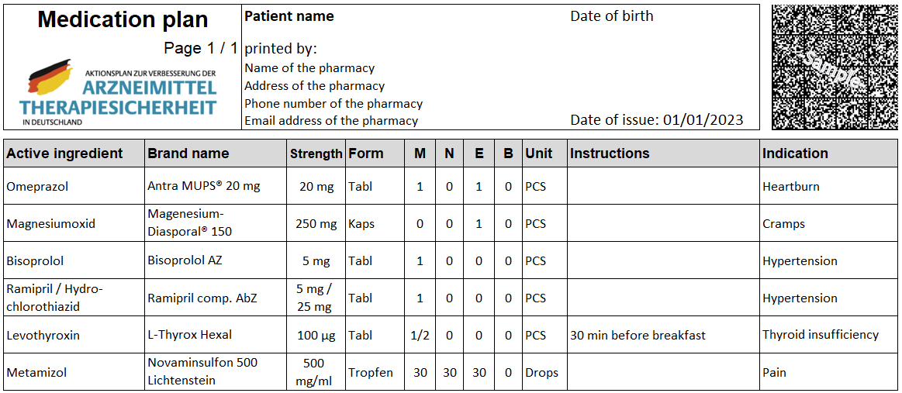

B
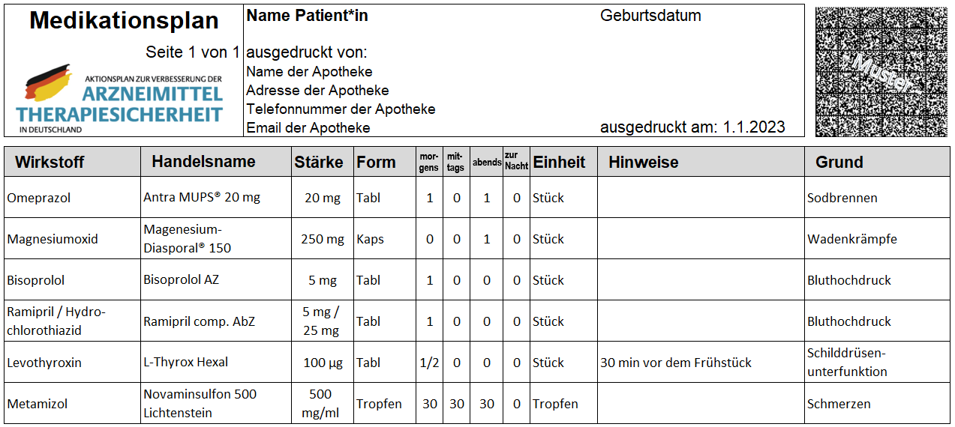
Figure S1 Fictive standardized medication list (ML; in German “Medikationsplan”) listing several drugs. (A) English translation; (B) German original version.
Notes:
Logo top left: Drug Therapy Safety Action Plan logo standardized for all official medication lists. Top right image: 2D barcode according to Drug Therapy Safety Action Plan requirements.
Reprinted from Botermann L, Krueger K, Eickhoff C, Kloft C, Schulz M. Patients’ handling of a standardized medication plan: a pilot study and method development. Patient Prefer Adherence. 2016;22(10):621–630.⁵
Abbreviations:
A (Englisch): M, Morning; N, Noon; E, Evening; B, Bedtime; PCS, Pieces. B (German): Tabl, Tablette; min, Minute.

