Supplementary material
Supplementary Figure 1: Burgel clustering criteria
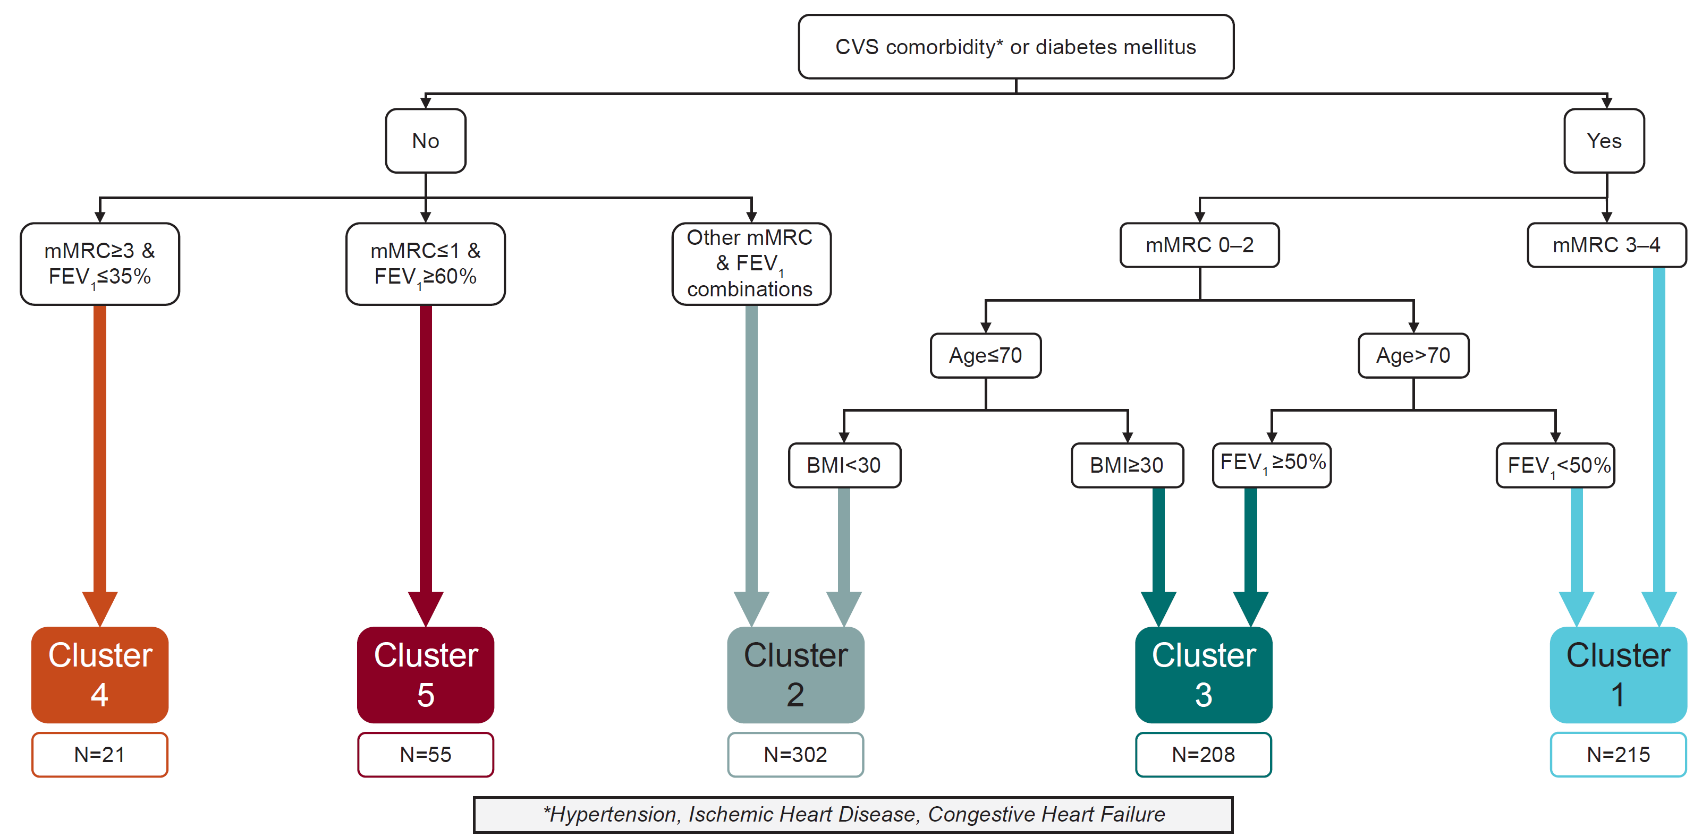
BMI, body mass index; CVS, cardiovascular; FEV₁, forced expiratory volume in 1 second; mMRC, modified Medical Research Council.
Each cluster refers to a specific patient phenotype: Cluster 1, very severe comorbid; Cluster 2, moderate-to-severe respiratory; Cluster 3, moderate-to-severe comorbid/obese; Cluster 4, very severe respiratory; Cluster 5, mild respiratory.

Supplementary Figure 2: Study sites and patient numbers from the Czech Republic and Serbia

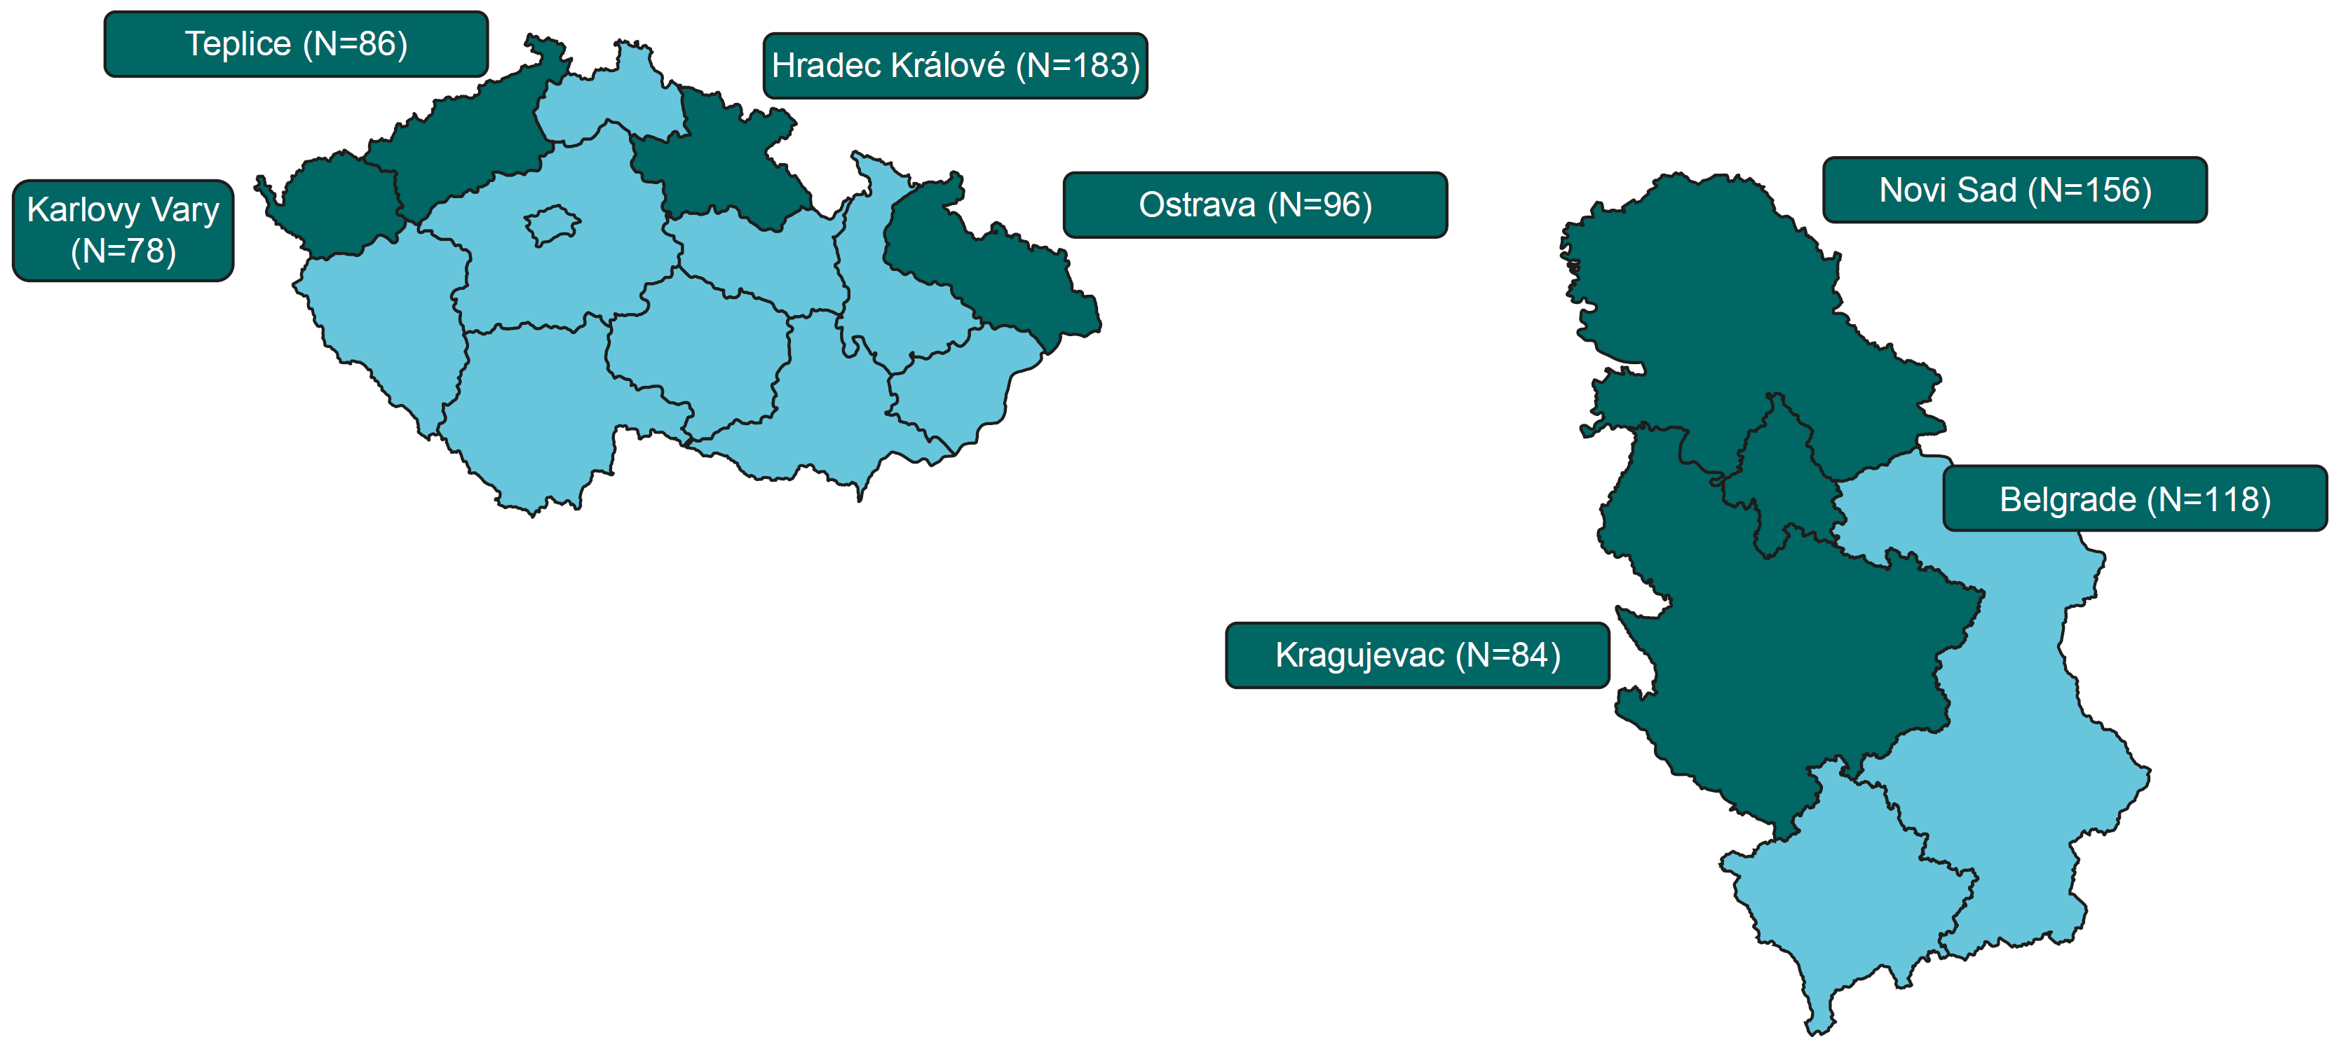
Supplementary Figure 3: Patient disposition
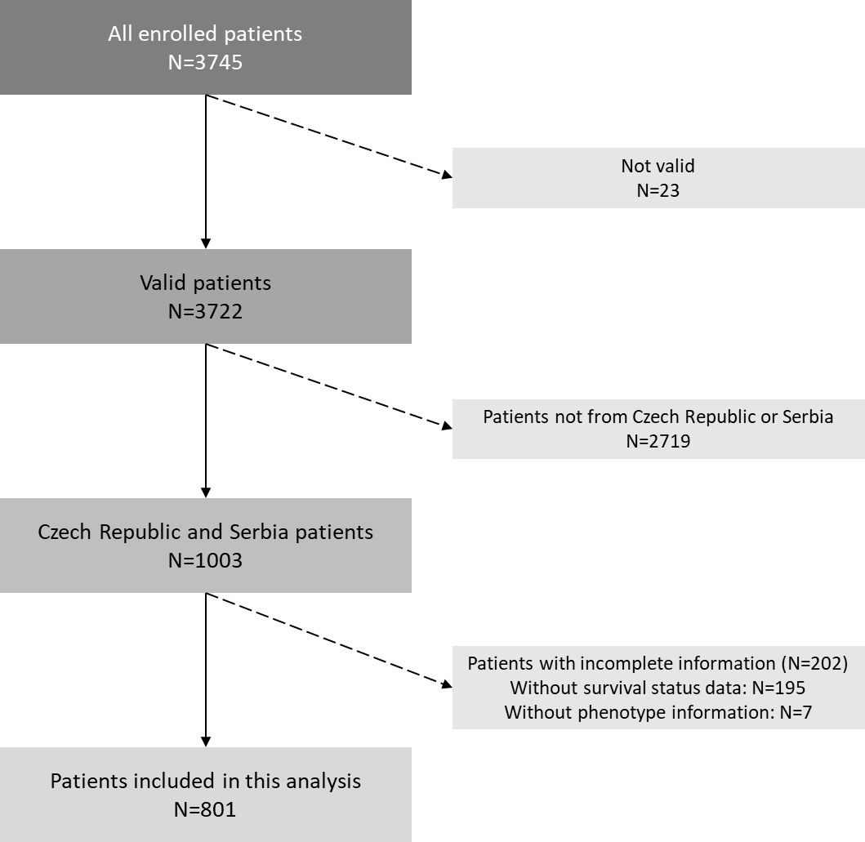
Supplementary Figure 4: Survival by (a) clinical phenotype and by (b) Burgel clustering
a)
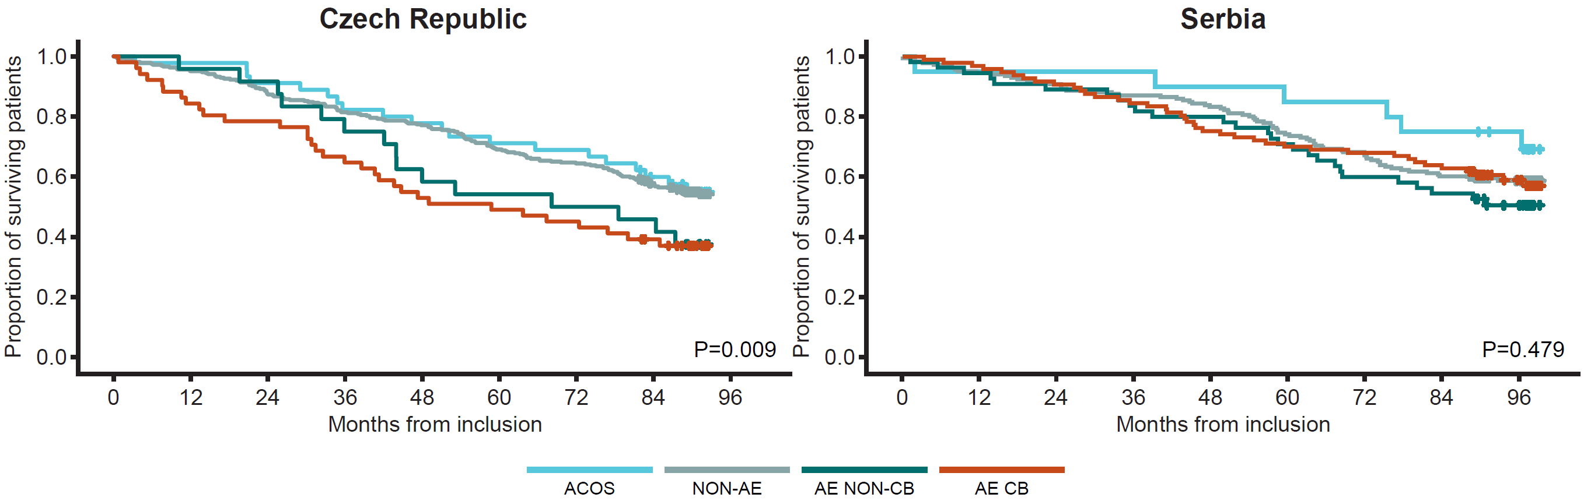
b)
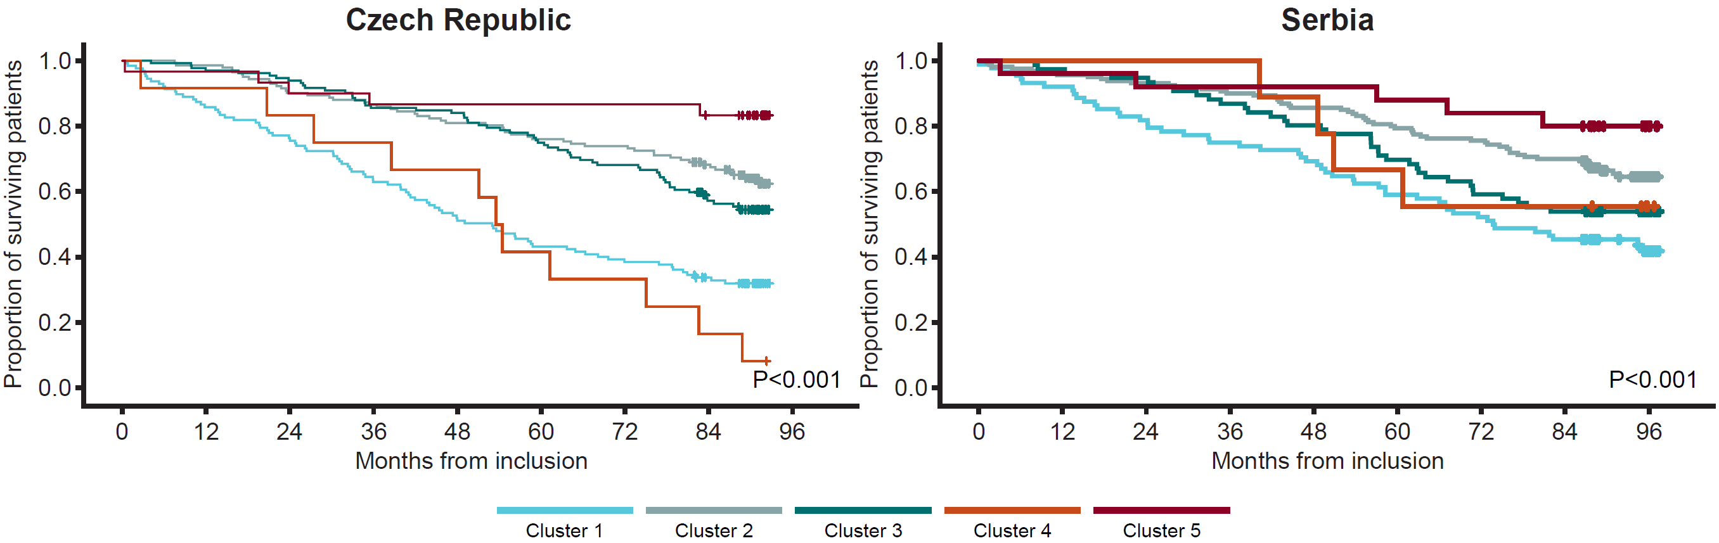
ACOS, asthma–COPD overlap syndrome; AE CB, frequent exacerbators with chronic bronchitis; AE NON-CB, frequent exacerbators without chronic bronchitis; NON-AE, non-exacerbators.
Each cluster refers to a specific patient phenotype: Cluster 1, very severe comorbid; Cluster 2, moderate-to-severe respiratory; Cluster 3, moderate-to-severe comorbid/obese; Cluster 4, very severe respiratory; Cluster 5, mild respiratory.

Supplementary Figure 5: Patient mortality (a) by clinical phenotype and (b) by Burgel cluster
a)
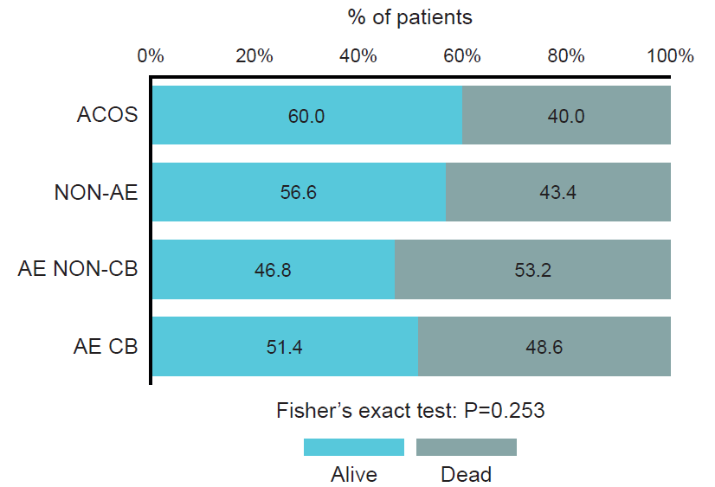
b)
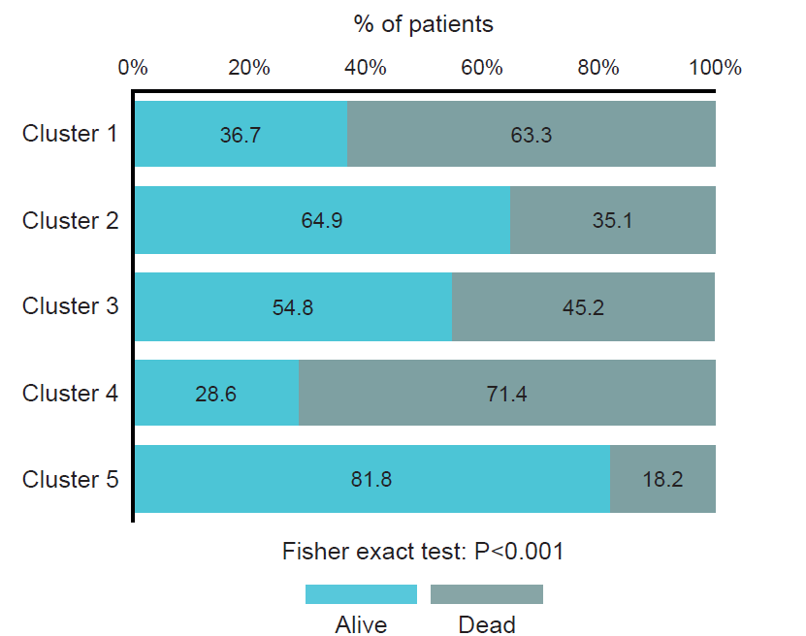
ACOS, asthma–COPD overlap syndrome; AE CB, frequent exacerbators with chronic bronchitis; AE NON-CB, frequent exacerbators without chronic bronchitis; NON-AE, non-exacerbators.
Cluster 1, very severe comorbid; Cluster 2, moderate-to-severe respiratory; Cluster 3, moderate-to-severe comorbid/obese; Cluster 4, very severe respiratory; Cluster 5, mild respiratory.

Supplementary Figure 6: Overall causes of death
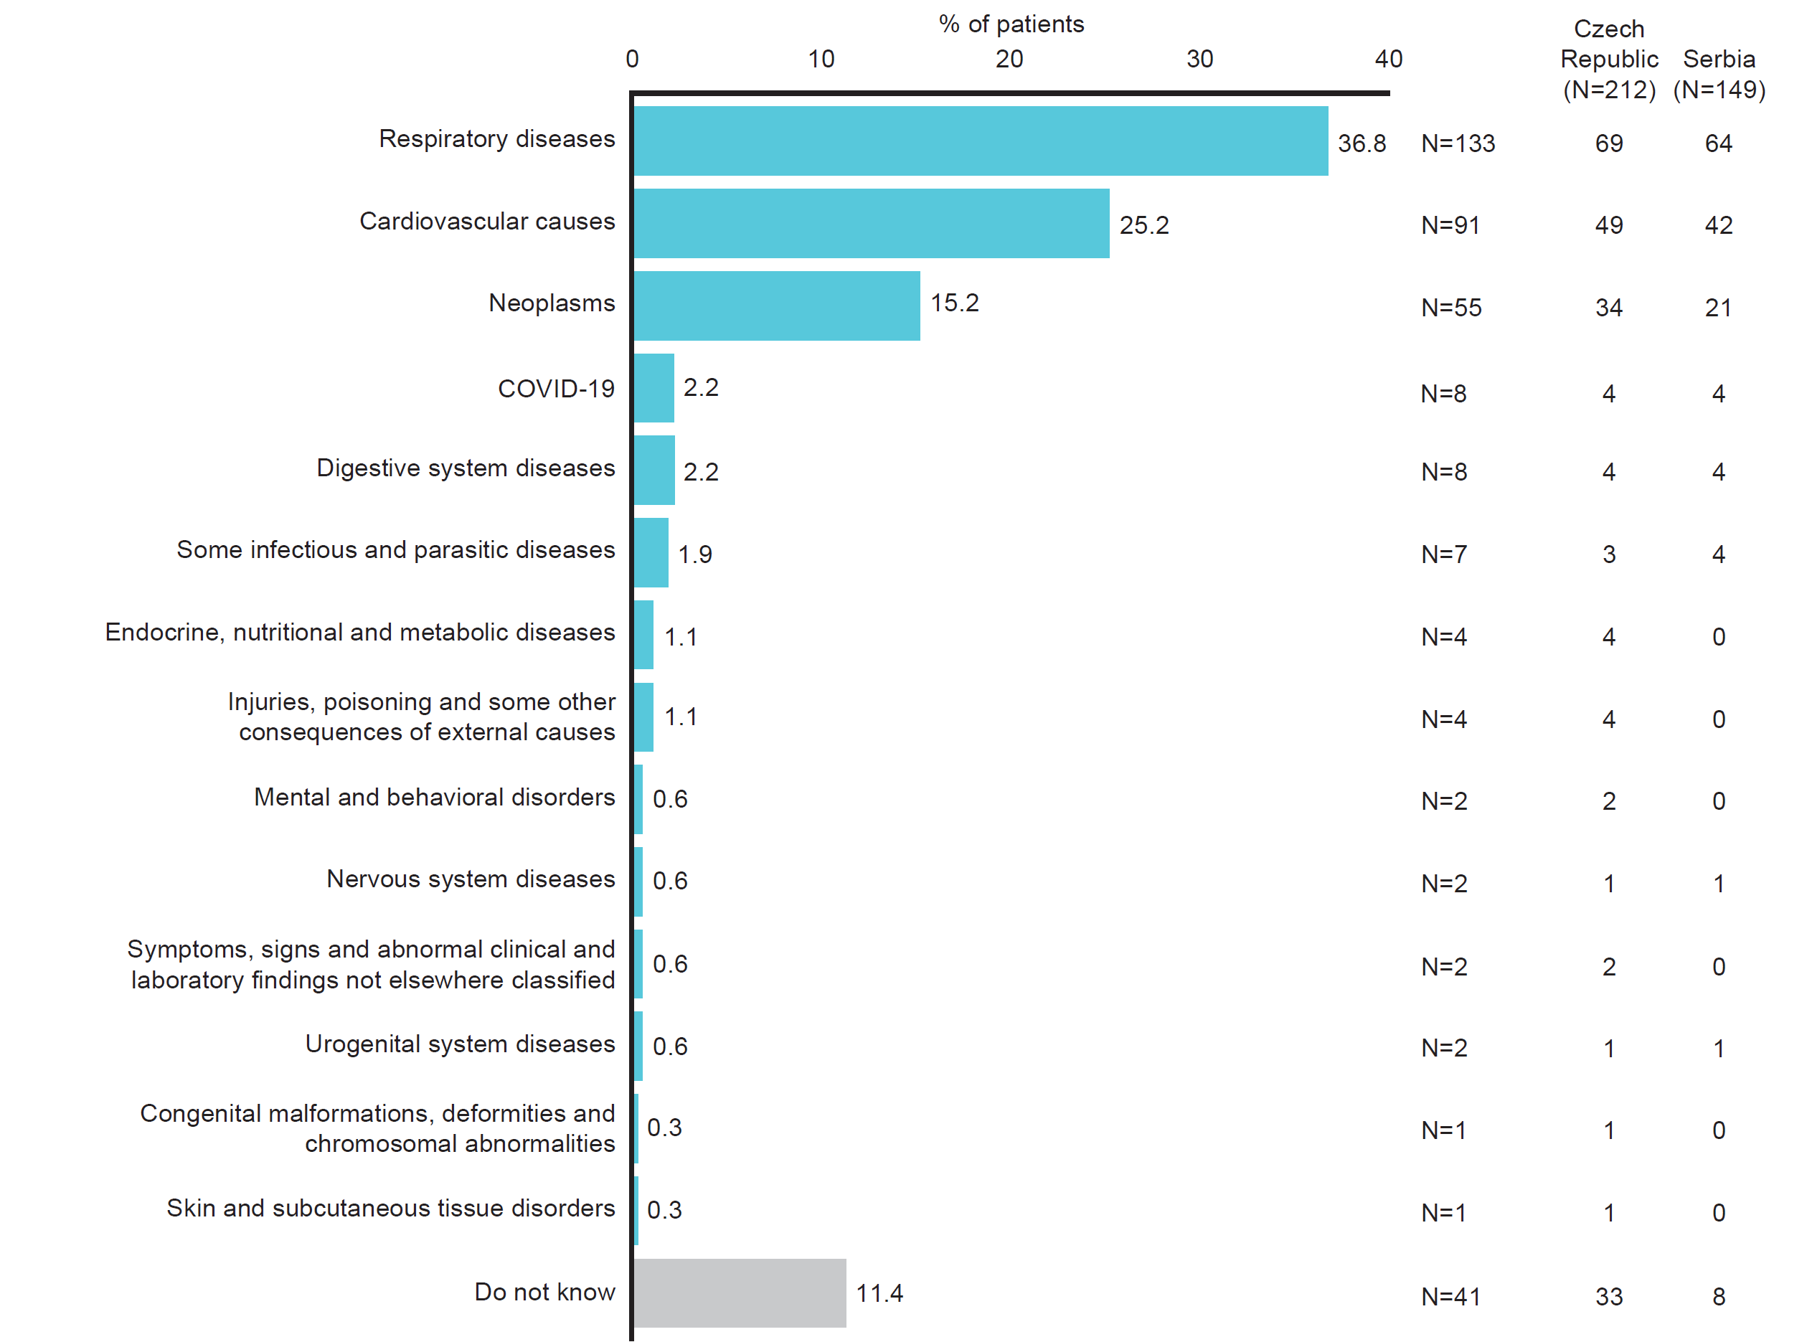
COVID-19, coronavirus disease 2019.

Supplementary Table 1: Overlap at baseline – percentages indicate proportion of population in a specific category
 |  | Clinical phenotypes |  |  |  | P-value  (Fisher’s exact test)
 |  | ACOS | NON-AE | AE NON-CB | AE CB | P-value  (Fisher’s exact test)
All (n=801) |  |  |  |  |  | P<0.001
Burgel cluster | 1 | 15 (23.1%) | 108 (21.2%) | 26 (32.9%) | 66 (44.6%)
Burgel cluster | 2 | 27 (41.5%) | 186 (36.5%) | 32 (40.5%) | 57 (38.5%)
Burgel cluster | 3 | 13 (20.0%) | 164 (32.2%) | 15 (19.0%) | 16 (10.8%)
Burgel cluster | 4 | 3 (4.6%) | 11 (2.2%) | 1 (1.3%) | 6 (4.1%)
Burgel cluster | 5 | 7 (10.8%) | 40 (7.9%) | 5 (6.3%) | 3 (2.0%)
Czech Republic |  |  |  |  |  | P<0.001
Burgel cluster | 1 | 11 (24.4%) | 77 (23.8%) | 11 (45.8%) | 28 (54.9%)
Burgel cluster | 2 | 16 (35.6%) | 103 (31.9%) | 7 (29.2%) | 16 (31.4%)
Burgel cluster | 3 | 11 (24.4%) | 110 (34.1%) | 6 (25.0%) | 5 (9.8%)
Burgel cluster | 4 | 2 (4.4%) | 8 (2.5%) | 0 (0.0%) | 2 (3.9%)
Burgel cluster | 5 | 5 (11.1%) | 25 (7.7%) | 0 (0.0%) | 0 (0.0%)
Serbia |  |  |  |  |  | P=0.002
Burgel cluster | 1 | 4 (20.0%) | 31 (16.7%) | 15 (27.3%) | 38 (39.2%)
Burgel cluster | 2 | 11 (55.0%) | 83 (44.6%) | 25 (45.5%) | 41 (42.3%)
Burgel cluster | 3 | 2 (10.0%) | 54 (29.0%) | 9 (16.4%) | 11 (11.3%)
Burgel cluster | 4 | 1 (5.0%) | 3 (1.6%) | 1 (1.8%) | 4 (4.1%)
Burgel cluster | 5 | 2 (10.0%) | 15 (8.1%) | 5 (9.1%) | 3 (3.1%)
ACOS, asthma–COPD overlap syndrome; AE CB, frequent exacerbators with chronic bronchitis; AE NON-CB, frequent exacerbators without chronic bronchitis; NON-AE, non-exacerbators.
Cluster 1, very severe comorbid; Cluster 2, moderate-to-severe respiratory; Cluster 3, moderate-to-severe comorbid/obese; Cluster 4, very severe respiratory; Cluster 5, mild respiratory.
Supplementary Table 2: Overlap by mortality – percentages indicate proportion of the category dead at follow-up
 |  | Clinical phenotypes
 |  | ACOS | NON-AE | AE NON-CB | AE CB
All (n=361)
Burgel cluster | 1 | 8 (53.3%) | 66 (61.1%) | 19 (73.1%) | 43 (65.2%)
Burgel cluster | 2 | 7 (25.9%) | 64 (34.4%) | 13 (40.6%) | 22 (38.6%)
Burgel cluster | 3 | 8 (61.5%) | 73 (44.5%) | 8 (53.3%) | 5 (31.3%)
Burgel cluster | 4 | 2 (66.7%) | 10 (90.9%) | 1 (100.0%) | 2 (33.3%)
Burgel cluster | 5 | 1 (14.3%) | 8 (20.0%) | 1 (20.0%) | 0 (0.0%)
Czech Republic
Burgel cluster | 1 | 5 (45.5%) | 48 (62.3%) | 10 (90.9%) | 23 (82.1%)
Burgel cluster | 2 | 5 (31.3%) | 37 (35.9%) | 3 (42.9%) | 6 (37.5%)
Burgel cluster | 3 | 7 (63.6%) | 48 (43.6%) | 2 (33.3%) | 2 (40.0%)
Burgel cluster | 4 | 2 (100.0%) | 8 (100.0%) | - | 1 (50.0%)
Burgel cluster | 5 | 1 (20.0%) | 4 (16.0%) | - | -
Serbia
Burgel cluster | 1 | 3 (75.0%) | 18 (58.1%) | 9 (60.0%) | 20 (52.6%)
Burgel cluster | 2 | 2 (18.2%) | 27 (32.5%) | 10 (40.0%) | 16 (39.0%)
Burgel cluster | 3 | 1 (50.0%) | 25 (46.3%) | 6 (66.7%) | 3 (27.3%)
Burgel cluster | 4 | 0 (0.0%) | 2 (66.7%) | 1 (100.0%) | 1 (25.0%)
Burgel cluster | 5 | 0 (0.0%) | 4 (26.7%) | 1 (20.0%) | 0 (0.0%)
Groups with a low proportion of deaths (<35%) are colored in green. Groups with a moderate proportion of deaths (≥35% to <80%) are colored in yellow to orange. Groups with a high proportion of deaths (≥80%) are colored in red.
ACOS, asthma–COPD overlap syndrome; AE CB, frequent exacerbators with chronic bronchitis; AE NON-CB, frequent exacerbators without chronic bronchitis; NON-AE, non-exacerbators.
Cluster 1, very severe comorbid; Cluster 2, moderate-to-severe respiratory; Cluster 3, moderate-to-severe comorbid/obese; Cluster 4, very severe respiratory; Cluster 5, mild respiratory.

Supplementary Table 3: Baseline demographics by country
 | Czech Republic (N=443) | Serbia  (N=358) | P-value
Age, mean (SD)* | 68.8 (8.4) | 65.6 (8.6) | P<0.001
Gender, %†  Male  Female | 66.1  33.9 | 65.6  34.4 | P=0.881
Mean FEV₁, % (SD)* | 59.1 (18.4) | 53.4 (18.4) | P<0.001
Mean BMI, kg/m² (SD)* | 28.5 (6.2) | 26.3 (4.7) | P<0.001
Smoking status, n (%)†  Never  Passive  Ex-smoker  Current smoker | 45 (10.2)  2 (0.5)  291 (65.7)  105 (23.7) | 19 (5.3)  5 (1.4)  222 (62.0)  112 (31.3) | P=0.005
Smoking pack-years mean (SD)* | 33.2 (20.8) | 45.0 (26.5) | P<0.001
Charlson Comorbidity Index, %†  1  2  3  4  ≥5 | 40.6  26.6  17.4  8.1  7.2 | 69.8  19.6  7.0  2.8  0.8 | P<0.001
Comorbidities, n (%)†  Coronary artery disease  Hypertension  Atrial fibrillation  Hyperlipidemia  Osteoporosis  Pulmonary embolism  Depression  Anxiety  Insomnia  Gastroesophageal reflux disease  Anemia | 89 (20.1)  288 (65.0)  55 (12.4)  170 (38.4)  51 (11.5)  13 (2.9)  53 (12.0)  46 (10.4)  86 (19.4)  95 (21.4)  16 (3.6) | 51 (14.2)  247 (69.0)  29 (8.1)  40 (11.2)  14 (3.9)  4 (1.1)  17 (4.7)  14 (3.9)  18 (5.0)  11 (3.1)  4 (1.1) | 0.032  0.258  0.049  <0.001  <0.001  0.088  <0.001  0.001  <0.001  <0.001  0.038
Treatment, n (%)†  LAMA  LABA  ICS  LAMA + LABA  LAMA + ICS  LABA + ICS  LAMA + LABA + ICS  LTOT‡  None of them | 42 (9.5)  89 (20.1)  3 (0.7)  71 (16.0)  3 (0.7)  68 (15.3)  134 (30.2)  30 (6.9)  33 (7.4) | 69 (19.3)  9 (2.5)  5 (1.4)  11 (3.1)  0 (0.0)  74 (20.7)  171 (47.8)  15 (4.2)  19 (5.3) | P<0.001
*Mann–Whitney test.
†Fisher’s exact test.
‡No information about LTOT in 12 patients (7 Czech and 5 Serbian).
BMI, body mass index; FEV₁, forced expiratory volume in 1 second; ICS, inhaled corticosteroid; LABA, long-acting β₂-agonist; LAMA, long-acting muscarinic antagonist; LTOT, long-term oxygen therapy; SD, standard deviation.

Supplementary Table 4: Survival by country
 | 1-year |  | 2-year |  | 3-year |  | 4-year |  | 5-year
 | N at risk | OS (95% CI) | N at risk | OS (95% CI) | N at risk | OS (95% CI) | N at risk | OS (95% CI) | N at risk | OS (95% CI) | Median of survival  (95% CI) [months] | HR (95% CI)
Czech Republic | N=417 | 0.941  (0.919–0.963) | N=385 | 0.869  (0.838–0.900) | N=351 | 0.792  (0.755–0.830) | N=325 | 0.734  (0.692–0.775) | N=293 | 0.661  (0.617–0.705) | - | Reference category
Serbia | N=341 | 0.953  (0.930–0.975) | N=325 | 0.908  (0.878–0.938) | N=308 | 0.860  (0.824–0.896) | N=290 | 0.810  (0.769–0.851) | N=260 | 0.726  (0.680–0.772) | - | 0.8 (0.6–1.0); P=0.036
CI, confidence interval; HR, hazard ratio; OS, overall survival.
Patients from the Czech Republic were used as the comparator for the Serbian data. Neither the Czech Republic or Serbian data met the requirements to calculate median of survival.

Supplementary Table 5: Difference in survival multivariate model
 | HR | 95% CI | P-value
Univariate model
Czech Republic (ref. cat.)
Serbia | 0.80 | 0.65–0.99 | 0.036
Multivariate model
Czech Republic (ref. cat.)
Serbia | 0.88 | 0.70–1.10 | 0.257
Age (inclusion) | 1.07 | 1.06–1.09 | <0.001
BMI | 0.98 | 0.96–1.00 | 0.033
CCI | 1.13 | 1.06–1.21 | <0.001
FEV₁ (%) | 0.97 | 0.97–0.98 | <0.001
BMI, body mass index; CCI, Charlson Comorbidity index; CI, confidence interval; FEV₁, forced expiratory volume in 1 second; HR, hazard ratio.
The Czech Republic data were used as the reference category in both the univariate and multivariate models.

Supplementary Table 6: Survival in the Czech Republic by clinical phenotype
 | 1-year |  | 2-year |  | 3-year |  | 4-year |  | 5-year
 | N at risk | OS (95% CI) | N at risk | OS (95% CI) | N at risk | OS (95% CI) | N at risk | OS (95% CI) | N at risk | OS (95% CI) | Median of survival  (95% CI) [months] | HR (95% CI)
ACOS | N=44 | 0.978  (0.935–1.000) | N=41 | 0.911  (0.828–0.994) | N=37 | 0.822  (0.711–0.934) | N=35 | 0.778  (0.656–0.899) | N=32 | 0.711  (0.579–0.844) | - | Reference category
NON-AE | N=307 | 0.950  (0.927–0.974) | N=282 | 0.873  (0.837–0.909) | N=263 | 0.814  (0.772–0.857) | N=249 | 0.771  (0.725–0.817) | N=223 | 0.690  (0.640–0.741) | - | 1.050  (0.658–1.675)
AE-NON-CB | N=23 | 0.958  (0.878–1.000) | N=22 | 0.917  (0.806–1.000) | N=18 | 0.750  (0.577–0.923) | N=14 | 0.583  (0.386–0.781) | N=13 | 0.542  (0.342–0.741) | 68.1  (24.4–111.8) | 1.638  (0.838–3.199)
AE-CB | N=43 | 0.843  (0.743–0.943) | N=40 | 0.784  (0.671–0.897) | N=33 | 0.647  (0.516–0.778) | N=27 | 0.529  (0.392–0.666) | N=25 | 0.490  (0.353–0.627) | 58.8  (30.0–87.5) | 1.889  (1.080–3.304)
ACOS, asthma–COPD overlap syndrome; AE CB, frequent exacerbators with chronic bronchitis; AE NON-CB, frequent exacerbators without chronic bronchitis; CI, confidence interval; HR, hazard ratio; OS, overall survival; NON-AE, non-exacerbators.
ACOS patients were used as the comparator for the other three clinical phenotypes. Neither the ACOS or NON-AE clinical phenotypes met the requirements to calculate median of survival.
Supplementary Table 7: Survival in Serbia by clinical phenotype
 | 1-year |  | 2-year |  | 3-year |  | 4-year |  | 5-year
 | N at risk | OS (95% CI) | N at risk | OS (95% CI) | N at risk | OS (95% CI) | N at risk | OS (95% CI) | N at risk | OS (95% CI) | Median of survival  (95% CI) [months] | HR (95% CI)
ACOS | N=19 | 0.950  (0.854–1.000) | N=19 | 0.950  (0.854–1.000) | N=19 | 0.950  (0.854–1.000) | N=18 | 0.900  (0.769–1.000) | N=17 | 0.850  (0.694–1.000) | - | Reference category
NON-AE | N=176 | 0.946  (0.914–0.979) | N=169 | 0.909  (0.867–0.950) | N=162 | 0.871  (0.823–0.919) | N=155 | 0.833  (0.780–0.887) | N=137 | 0.737  (0.673–0.800) | - | 1.561  (0.680–3.584)
AE-NON-CB | N=52 | 0.945  (0.885–1.000) | N=49 | 0.891  (0.809–0.973) | N=45 | 0.818  (0.716–0.920) | N=44 | 0.800  (0.694–0.906) | N=38 | 0.691  (0.569–0.813) | - | 1.952  (0.806–4.730)
AE-CB | N=94 | 0.969  (0.935–1.000) | N=88 | 0.907  (0.849–0.965) | N=82 | 0.845  (0.773–0.917) | N=73 | 0.753  (0.667–0.838) | N=68 | 0.701  (0.610–0.792) | - | 1.600  (0.678–3.776)
ACOS, asthma–COPD overlap syndrome; AE CB, frequent exacerbators with chronic bronchitis; AE NON-CB, frequent exacerbators without chronic bronchitis; CI, confidence interval; HR, hazard ratio; OS, overall survival; NON-AE, non-exacerbators.
ACOS patients were used as the comparator for the other three clinical phenotypes. In Serbia, none of the clinical phenotypes met the requirements to calculate median of survival.

Supplementary Table 8: Survival in the Czech Republic by Burgel clustering
 | 1-year |  | 2-year |  | 3-year |  | 4-year |  | 5-year
 | N at risk | OS (95% CI) | N at risk | OS (95% CI) | N at risk | OS (95% CI) | N at risk | OS (95% CI) | N at risk | OS (95% CI) | Median of survival  (95% CI) [months] | HR (95% CI)
Cluster 1 | N=109 | 0.858  (0.798–0.919) | N=96 | 0.756  (0.681–0.831) | N=80 | 0.630  (0.546–0.714) | N=65 | 0.512  (0.425–0.599) | N=55 | 0.433  (0.347–0.519) | 53.0  (41.6–64.3) | 6.6 (2.7–16.2); P<0.001
Cluster 2 | N=140 | 0.986  (0.967–1.000) | N=128 | 0.901  (0.852–0.950) | N=123 | 0.866  (0.810–0.922) | N=115 | 0.810  (0.745–0.874) | N=108 | 0.761  (0.690–0.831) | - | 2.4 (0.9–5.9); P=0.066
Cluster 3 | N=128 | 0.970  (0.940–0.999) | N=124 | 0.939  (0.899–0.980) | N=113 | 0.856  (0.796–0.916) | N=111 | 0.841  (0.779–0.903) | N=99 | 0.750  (0.676–0.824) | - | 3.0 (1.2–7.6); P=0.017
Cluster 4 | N=11 | 0.917  (0.760–1.000) | N=10 | 0.833  (0.622–1.000) | N=9 | 0.750  (0.505–0.995) | N=8 | 0.667  (0.400–0.933) | N=5 | 0.417  (0.138–0.696) | 53.5  (47.8–59.2) | 9.0 (3.1–25.9); P<0.001
Cluster 5 | N=29 | 0.967  (0.902–1.000) | N=27 | 0.900  (0.793–1.000) | N=26 | 0.867  (0.745–0.988) | N=26 | 0.867  (0.745–0.988) | N=26 | 0.867  (0.745–0.988) | - | Reference category
CI, confidence interval; HR, hazard ratio; OS, overall survival.
Burgel cluster 5 patients were used as the comparator for the other four Burgel clusters in this analysis. During the follow-up period, Burgel clusters 2, 3 and 5 did not meet the requirements to calculate median of survival.

Supplementary Table 9: Survival in Serbia by Burgel clustering
 | 1-year |  | 2-year |  | 3-year |  | 4-year |  | 5-year
 | N at risk | OS (95% CI) | N at risk | OS (95% CI) | N at risk | OS (95% CI) | N at risk | OS (95% CI) | N at risk | OS (95% CI) | Median of survival  (95% CI) [months] | HR (95% CI)
Cluster 1 | N=81 | 0.920  (0.864–0.977) | N=72 | 0.818  (0.738–0.899) | N=66 | 0.750  (0.660–0.840) | N=61 | 0.693  (0.597–0.790) | N=52 | 0.591  (0.488–0.694) | 73.7  (49.6–97.8) | 3.8 (1.5–9.6); P=0.004
Cluster 2 | N=153 | 0.956  (0.925–0.988) | N=149 | 0.931  (0.892–0.970) | N=144 | 0.900  (0.854–0.946) | N=137 | 0.856  (0.802–0.911) | N=127 | 0.794  (0.731–0.856) | - | 1.9 (0.7–4.6); P=0.187
Cluster 3 | N=74 | 0.974  (0.938–1.000) | N=72 | 0.947  (0.897–0.998) | N=66 | 0.868  (0.792–0.944) | N=61 | 0.803  (0.713–0.892) | N=53 | 0.697  (0.594–0.801) | - | 2.7 (1.1–7.0); P=0.035
Cluster 4 | N=9 | 1.000 | N=9 | 1.000 | N=9 | 1.000 | N=8 | 0.889  (0.684–1.000) | N=6 | 0.667  (0.359–0.975) | - | 2.6 (0.7–9.8); p=0.150
Cluster 5 | N=24 | 0.960  (0.883–1.000) | N=23 | 0.920  (0.814–1.000) | N=23 | 0.920  (0.814–1.000) | N=23 | 0.920  (0.814–1.000) | N=22 | 0.880  (0.753–1.000) | - | Reference category
CI, confidence interval; HR, hazard ratio; OS, overall survival.
Burgel cluster 5 patients were used as the comparator for the other four Burgel clusters in this analysis. During the follow-up period, Burgel clusters 2-5 did not meet the requirements to calculate median of survival.

Supplementary Table 10: Survival by clinical phenotype
 | 1-year |  | 2-year |  | 3-year |  | 4-year |  | 5-year
 | N at risk | OS (95% CI) | N at risk | OS (95% CI) | N at risk | OS (95% CI) | N at risk | OS (95% CI) | N at risk | OS (95% CI) | Median of survival  (95% CI) [months] | HR (95% CI)
ACOS | N=63 | 0.969  (0.927–1.000) | N=60 | 0.923  (0.858–0.988) | N=56 | 0.862  (0.778–0.946) | N=53 | 0.815  (0.721–0.910) | N=49 | 0.754  (0.649–0.859) | - | Reference category
NON-AE | N=483 | 0.951  (0.932–0.970) | N=451 | 0.888  (0.860–0.915) | N=425 | 0.837  (0.804–0.869) | N=404 | 0.795  (0.760–0.830) | N=360 | 0.709  (0.669–0.748) | - | 1.2 (0.8–1.7); P=0.479
AE NON-CB | N=75 | 0.949  (0.901–0.998) | N=71 | 0.899  (0.832–0.965) | N=63 | 0.797  (0.709–0.886) | N=58 | 0.734  (0.637–0.832) | N=51 | 0.646  (0.540–0.751) | 87.0 (NA) | 1.5 (0.9–2.4); P=0.115
AE CB | N=137 | 0.926  (0.883–0.968) | N=128 | 0.865  (0.810–0.920) | N=115 | 0.777  (0.710–0.844) | N=100 | 0.676  (0.600–0.751) | N=93 | 0.628  (0.551–0.706) | 95.1 (NA) | 1.4 (0.9–2.2); P=0.147
ACOS, asthma–COPD overlap syndrome; AE CB, frequent exacerbators with chronic bronchitis; AE NON-CB, frequent exacerbators without chronic bronchitis; CI, confidence interval; HR, hazard ratio; OS, overall survival; NA, not applicable; NON-AE, non-exacerbators.
ACOS patients were used as the comparator for the other three clinical phenotypes. Neither the ACOS or NON-AE clinical phenotypes met the requirements to calculate median of survival.
Supplementary Table 11: Survival by Burgel cluster
 | 1-year |  | 2-year |  | 3-year |  | 4-year |  | 5-year
 | N at risk | OS (95% CI) | N at risk | OS (95% CI) | N at risk | OS (95% CI) | N at risk | OS (95% CI) | N at risk | OS (95% CI) | Median of survival  (95% CI) [months] | HR (95% CI)
Cluster 1 | N=190 | 0.884  (0.841–0.927) | N=168 | 0.781  (0.726–0.837) | N=146 | 0.679  (0.617–0.741) | N=126 | 0.586  (0.520–0.652) | N=107 | 0.498  (0.431–0.565) | 58.8  (47.3–70.2) | 5.2 (2.7–9.9); P<0.001
Cluster 2 | N=293 | 0.970  (0.951–0.989) | N=277 | 0.917  (0.886–0.948) | N=267 | 0.884  (0.848–0.920) | N=252 | 0.834  (0.793–0.876) | N=235 | 0.778  (0.731–0.825) | - | 2.1 (1.1–4.0); P=0.026
Cluster 3 | N=202 | 0.971  (0.948–0.994) | N=196 | 0.942  (0.911–0.974) | N=179 | 0.861  (0.814–0.908) | N=172 | 0.827  (0.776–0.878) | N=152 | 0.731  (0.670–0.791) | - | 2.9 (1.5–5.5); P=0.002
Cluster 4 | N=20 | 0.952  (0.861–1.000) | N=19 | 0.905  (0.779–1.000) | N=18 | 0.857  (0.707–1.000) | N=16 | 0.762  (0.580–0.944) | N=11 | 0.524  (0.310–0.737) | 60.7  (49.2–72.3) | 5.5 (2.5–12.2); P<0.001
Cluster 5 | N=53 | 0.964  (0.914–1.000) | N=50 | 0.909  (0.833–0.985) | N=49 | 0.891  (0.809–0.973) | N=49 | 0.891  (0.809–0.973) | N=48 | 0.873  (0.785–0.961) | - | Reference category
CI, confidence interval; HR, hazard ratio; OS, overall survival.
Cluster 1, very severe comorbid; Cluster 2, moderate-to-severe respiratory; Cluster 3, moderate-to-severe comorbid/obese; Cluster 4, very severe respiratory; Cluster 5, mild respiratory.
Burgel cluster 5 patients were used as the comparator for the other four Burgel clusters in this analysis. During the follow-up period, Burgel clusters 2, 3 and 5 did not meet the requirements to calculate median of survival.

Supplementary Table 12: Long-term overall survival univariate models
 | HR (95% CI) | P-value
FEV₁ (%) | 0.978 (0.972–0.984) | <0.001
CAT | 1.033 (1.021–1.046) | <0.001
Smoking status  Never smoker  Passive  Ex-  Current | Reference category  1.177 (0.355–3.897)  1.250 (0.828–1.888)  1.229 (0.791–1.909) | -  0.790  0.288  0.358
CAT, COPD Assessment Test; CI, confidence interval; FEV₁, forced expiratory volume in 1 second; HR, hazard ratio.
Never smokers were used as the reference category which the other three smoking status groups were compared against.

