Table S1 Primers used to amplify of capsular serotyping, resistance and virulence-associated genes in this study
Gene | Primer name | Primer sequence (5’–3’) | Product size (bp)
bla_{TEM} | TEM-F | ATAAAATTCTTGAAGACGAAA | 1080
bla_{TEM} | TEM-R | GACAGTTACCAATGCTTAATCA | 1080
bla_{SHV} | SHV-F | CGCCGGGTTATTCTTATTTGTCGC | 1017
bla_{SHV} | SHV-R | TCT TTCCGATGCCGCCGCCAGTCA | 1017
bla_{CTX-M-1} group | CTX-M-1-F | CAGCGCTTTTGCCGTCTAAGC | 945
bla_{CTX-M-1} group | CTX-M-1-R | GGCCCATGGTTAAAAAATCACTGC | 945
bla_{CTX-M-2} group | CTX-M-2-F | CTC AGA GCA TTC GCC GCT CA | 848
bla_{CTX-M-2} group | CTX-M-2-R | CCG CCG CAG CCA GAA TAT CC | 848
bla_{CTX-M-8} group | CTX-M-8-F | ACTTCAGCCACACGGATTCA | 1024
bla_{CTX-M-8} group | CTX-M-8-R | CGA GTA CGT CAC GAC GAC TT | 1024
bla_{CTX-M-9} group | CTX-M-9-F | GTT ACA GCC CTT CGG CGA TGA TTC | 881
bla_{CTX-M-9} group | CTX-M-9-R | GCG CAT GGT GAC AAA GAG AGTGCAA | 881
bla_{KPC} | KPC-F | ATG TCA CTG TAT CGC CGT C | 882
bla_{KPC} | KPC-R | TTA CTG CCC GTT GAC GCC | 882
bla_{NDM} | NDM-F | GAAGCTGAGCACCGCATTAG | 982
bla_{NDM} | NDM-R | GGGCCGTATGAGTGATTGC | 982
bla_{VIM} | VIM-F | GCMCTTCTCGCGGAGATTGA | 257
bla_{VIM} | VIM-R | TGCGCAGCACCRGGATAGA | 257
bla_{IMP} | IMP-F | CTACCGCAGCAGAGTCTTTG | 587
bla_{IMP} | IMP-R | AACCAGTTTTGCCTTACCAT | 587
bla_{OXA-48} | OXA48-F | TTGGTGGCATCGATTATCGG | 743
bla_{OXA-48} | OXA48-R | GAGCACTTCTTTTGTGATGGC | 743
bla_{CMY} | CMY-F | TGGCCAGAACTGACAGGCAAA | 462
bla_{CMY} | CMY-R | TTTCTCCTGAACGTGGCTGGC | 462
bla_{DHA} | DHA-F | AACTTTCACAGGTGTGCTGGGT | 405
bla_{DHA} | DHA-R | CCGTACGCATACTGGCTTTGC | 405
wzi | wzi-F | GTGCCGCGAGCGCTTTCTATCTTGGTATTCC | 447
wzi | wzi-R | GAGAGCCACTGGTTCCAG AATTACCGC | 447
aerobactin | aerobactin-F | GCATAGGCGGATACGAACAT | 556
aerobactin | aerobactin-R | CACAGGGCAATTGCTTACCT | 556
rmpA | rmpA-F | CATAAGAGTATTGGTTGACAG | 429
rmpA | rmpA-R | CTTGCATGAGCCATCTTTCA | 429
rmpA2 | rmpA2-F | TGTGCAATAAGGATGTTACATTAGT | 609
rmpA2 | rmpA2-R | TTTGATGTGCACCATTTTTCA | 609
magA | magA-F | GGTGCTCTTTACATCATTGC | 1283
magA | magA-R | GCAATGGCCATTTGCGTTAG | 1283
kfu | kfu-F | ATAGTAGGCGAGCACCGAGA | 530
kfu | kfu-R | AGAACCTTCCTCGCTGAACA | 530
allS | allS-F | CCGAAACATTACGCACCTTT | 508
allS | allS-R | ATCACGAAGAGCCAGGTCAC | 508
ybtS | ybt-F | GACGGAAACAGCACGGTAAA | 782
ybtS | ybt-R | GAGCATAATAAGGCGAAAGA | 782
entB | entB-F | GTCAACTGGGCCTTTGAGCCGTC | 400
entB | entB-R | TATGGGCGTAAACGCCGGTGAT | 400
fimH | fimH-F | TGCTGCTGGGCTGGTCGATG | 609
fimH | fimH-R | GGGAGGGTGACGGTGACATC | 609
mrkD | mrkD-F | AAGCTATCGCTGTACTTCCGGCA | 340
mrkD | mrkD-R | GGCGTTGGCGCTCAGATAGG | 340
iroN | iroN-F | GTCCGGCGGTAACTTCAGCC | 829
iroN | iroN-R | TCAGAATGAAACTACCGCCC | 829
iucA | iucA-F | AATCAATGGCTATTCCCGCTG | 239
iucA | iucA-R | CGCTTCACTTCTTTCACTGACAGG | 239

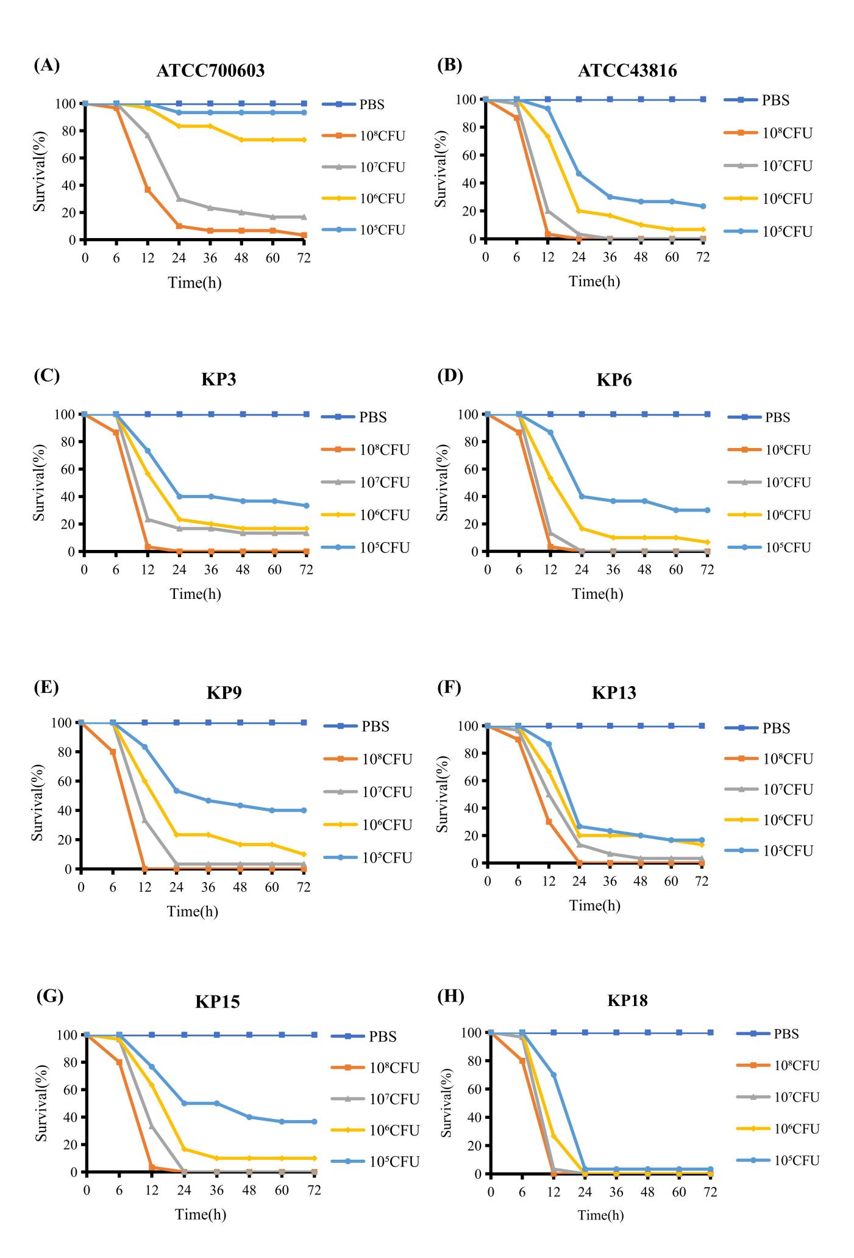
Fig S1 Larvae were injected with PBS or with 10⁵, 10⁶, 10⁷ or 10⁸ CFU/mL of KP3, KP6, KP9, KP13, KP15, KP18, ATCC700603 or ATCC43816. The survival rate of G. mellonella larvae was calculated after 72 hours of infection. (A)virulence assay of low virulence standard strain ATCC700603, (B)virulence assay of high virulence standard strain ATCC43816, (C)virulence assay of clinical strain KP3, (D)virulence assay of clinical strain KP6, (E)virulence assay of clinical strain KP9, (F)virulence assay of clinical strain KP13, (G)virulence assay of clinical strain KP15, (H)virulence assay of clinical strain KP18.

