Suplementary Data

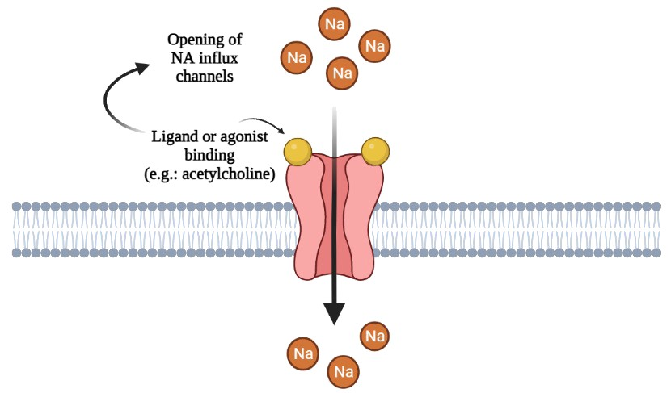
Figure S1: Ionotropic receptors. These are transmembrane ion channels, which are characterized as large protein complexes. The binding of their respective ligands, which are mainly neurotransmitters, such as acetylcholine, or their agonists, leads to a conformational change in these receptors, causing these channels opening. This then allows ions passage through them, which can lead to an excitatory or inhibitory effect, thus producing very fast physiological responses.
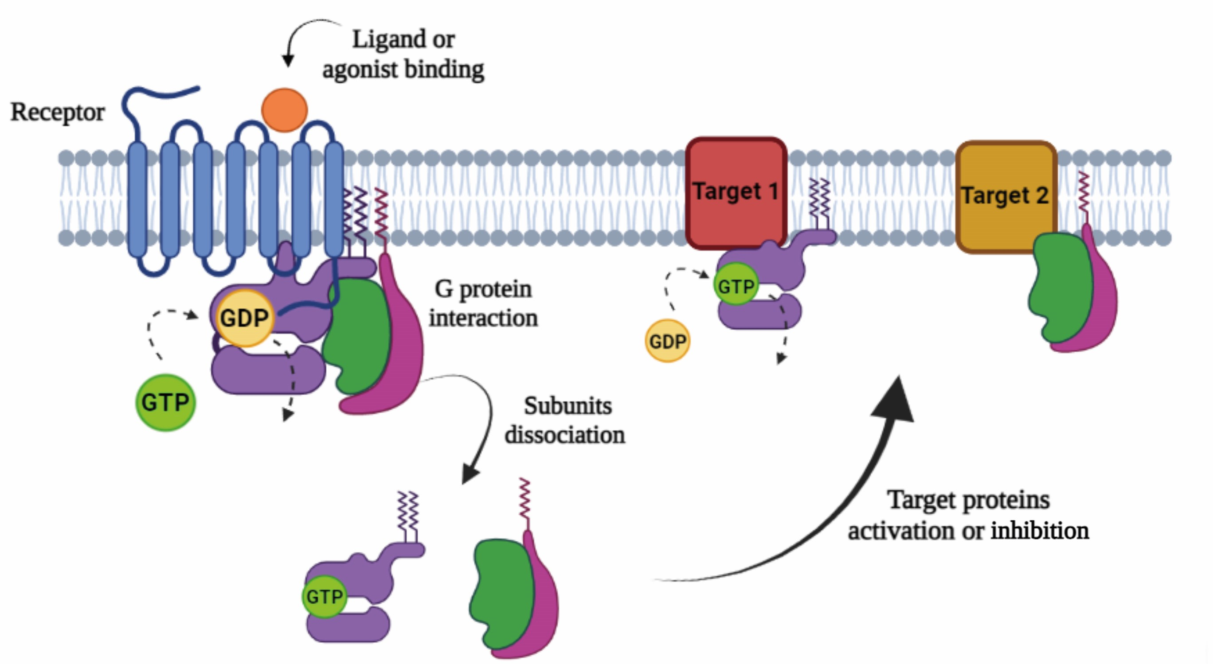
Figure S2: Metabotropic receptors. Signaling from these often involves a second messenger pathway and, as such, their responses tend to be slower. These are transmembrane receptors where the binding of their respective ligands or agonists leads to a conformational change that favors their interaction with a G protein. This allows the binding of a GTP molecule with this protein, instead of GDP, which leads to activation of the same and the dissociation of its subunits into α and βγ, which bind to different target proteins (which may be enzymes or ion channels), leading to their activation or inhibition. The adrenergic receptors fall into this category, being the target of different lipolytic actives, such as caffeine and yohimbine, resulting in an increase in cAMP levels.

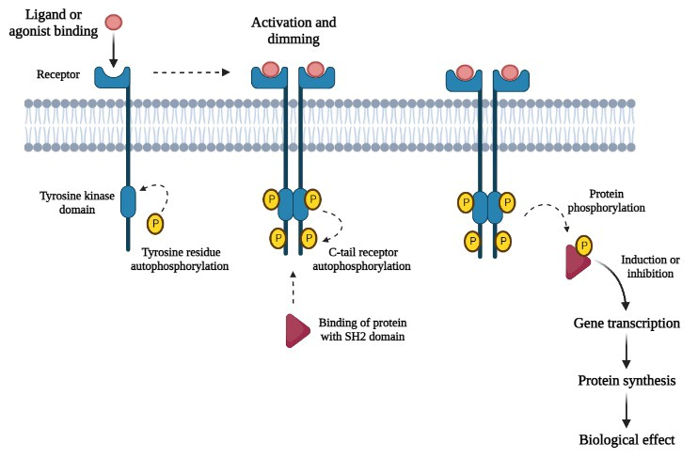
Figure S3: Receptors tyrosine kinases (RTKs). This class of membrane receptors is characterized by having an extracellular portion and an intracellular portion, which has a tyrosine kinase domain. When these receptors are activated by their respective ligands or agonists, autophosphorylation occurs on a tyrosine residue in the tyrosine kinase domain. With this, the RTKs are activated and form dimers, leading to a new autophosphorylation in its C-tail, which enables the phosphorylation of a protein with an SH2 domain. There are different proteins of this type that, when phosphorylated, are activated and act by inducing or inhibiting the transcription of genes involved in different biological pathways.
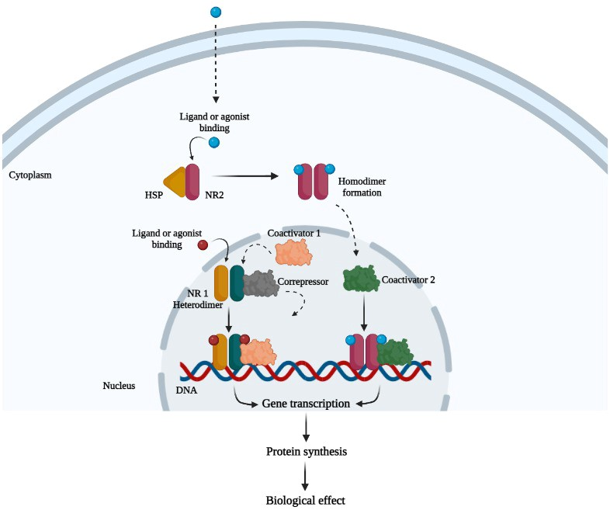
Figure S4: Nuclear receptors. There are different types of these receptors. One of these (NR1) is located in the nucleus forming a heterodimer and linked to a correpressor. When this is activated by its ligand or agonist binding, NR1 begins to interact with a coactivator, which enables interaction with DNA, promoting the transcription of specific genes. Another type (NR2) occurs in the cytoplasm bound to a heat shock protein (HSP). When this is activated by its ligand or agonist binding, NR2 stops interacting with HSP and forms a homodimer, which migrates to the nucleus and begins to interact with a coactivator. This makes possible the interaction with the DNA and the subsequent transcription of specific genes.

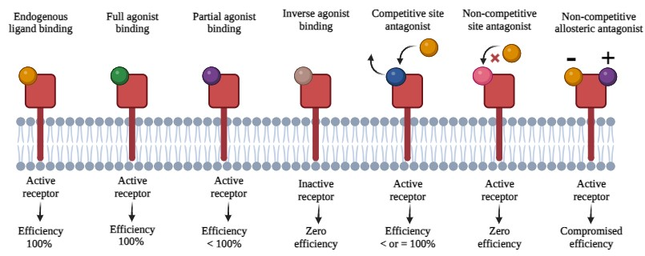
Figure S5: Types of interaction between drug and receptor. When its endogenous ligand binds to the receptor, like its full antagonist, it is activated with 100% efficiency. However, when a partial antagonist is bound, the receptor is activated, but with less than 100% efficiency. The inverse agonist, on the other hand, has a greater affinity with the inactive form of the receptor, which remains in this state after its binding. In the case of a competitive site antagonist, it competes with the endogenous ligand to bind to the receptor, which can lead to receptor activation with an efficiency less than or equal to 100%. When a non-competitive antagonist site binds to the receptor, endogenous ligand binding is blocked, resulting in zero efficiency. Finally, a non-competitive allosteric antagonist binds to the receptor at the same time as its endogenous ligand, but has a predominant interaction, leading to compromised receptor efficiency.

Table S1: Injectable Pharmacological Actives of Body Harmonization and High Performance

DRUG | GROUP | CHEMICAL COMPOST | MECHANISM OF ACTION | APPLICATION TECHNIQUES
Hyaluronic acid | Eutrophic | Glycosaminoglycans | Water retention and non-occlusive biofilm | ID/SC
ADN (Hyaluronic acid + Condroitin) | Eutrophic | Glycosaminoglycans | Moisturizing | ID
Collagen | Eutrophic | Polypeptide | It is synthesized by fibroblasts and secreted into the intercellular space in the form of soluble collagen. Collagen is a primary protein of connective tissue. Considered a key protein of the body, which ensures the cohesion, elasticity and regeneration of the skin | ID/SC
GAGs | Eutrophic | Glycosaminoglycans | Moisturizing | ID
Hyaluronidase | Eutrophic | Enzyme | It acts by reversibly depolymerizing the existing hyaluronic acid around the cells of the connective tissue, thus temporarily reducing the viscosity of this tissue and making it more permeable to the diffusion of liquids. | ID
Glycolic acid | Eutrophic | Alpha hydroxy acid | Keratolytic, moisturizing and cell turnover stimulator | ID
Alpha lipoic acid | Eutrophic | Organosulfur | Anti-inflammatory,Antioxidant, hepatoprotective and hypoglycemic | IV/ D-IM /ID
Elemental Copper | Eutrophic | Metals | It acts in several enzymatic reactions, produces energy, has anti-free radical action, promotes the integrity of collagen and the formation of melanin and elastin. Participates in iron metabolism and hemoglobin synthesis | IV/D-IM
Organic silicon | Eutrophic | Semimetals (mineral) | Production of collagen, elastin and fibroblast in the skin, promoting elasticity and firmness, being also an antioxidant, preventing aging | IM/ID
Copper sulfate | Eutrophic | Metals (mineral) | It is an essential element in the incorporation of Iron in erythrocytes, it helps in the use of Vitamin C, in addition to stimulating immunity. Acts as a hair and skin pigmentation factor | ID/SC
Chondroitin sulfate | Eutrophic | Glycosaminoglycans | Provides resistance to cartilage, with a vital role in the production of proteins and lipids | ID/SC
Zinc sulfate | Eutrophic | Metals (mineral) | It has a role in the immune system, healing, protein synthesis, growth and development. It is essential for skin health, as well as improving physical performance and muscle recovery | IV/D-IM/ID
Selenium Sulfide | Eutrophic | Chalcogen | Due to the cytostatic effect of selenium on the cells of the dermis and follicular epithelium, it is easier to remove fungi from the stratum corneum, reducing the adhesion of corneocytes, reducing seborrhea | IV/D-IM
Dimethylaminoethanol (DMAE) | Eutrophic | Alkanolamine | Stimulates Acetylcholine synthesis and increases tensioning anisotropic force | D-IM/SC/ID
Raffermine | Eutrophic | Glycoproteins and polysaccharides | Direct and indirect stimulation of fibroblast contraction and anti-elastase action
Tensine | Eutrophic | Protein | It acts on the small bumps on the skin, leaving its surface more uniform, bringing more shine and a satiny appearance
Matrixyl | Eutrophic | Lipopeptide | Stimulates fibroblasts and collagen synthesis in addition to repairing skin injuries, aiding rejuvenation
Mesoglycan | Eutrophic | Heparinoids | It has the function of breaking the fibrinogen beams and subsequent reorganization of these fibers, restoring a selective endothelial barrier that interacts with type I collagen. It has anti-edema activity
D-Panthenol | Eutrophic | Alcohol | Promotes skin hydration in addition to delaying the early signs of aging, in addition to having anti-inflammatory characteristics. Helps cell renewal and also helps with the healing process in cases of acne marks and peeling processes | D-IM/SC/ID
D-Ribose | Eutrophic | Carbohydrate | It has a potential role in increasing energy components and in promoting an improvement in performance during exercise, helping in the rapid synthesis of ATP by muscle cells | IV/D-IM/SC/ID
Sodium Pyruvate | Eutrophic | Alpha-keto acid | Muscle contraction, stimulation of glucose consumption and transport, in addition to collagen synthesis | SC/ID
Pycnogenol | Eutrophic | Procyanidins, phenolic glycosides and esters of organic acids | Contributes to skin uniformity, cell renewal and collagen and elastin production, bringing firmness and reducing physical aging damage | IV
Polypodium Leucotomos | Eutrophic | Phytosterols, Saponins and Polyphenols | Oral photoprotector, anti-aging effect, elastin and collagen production regulator
Glutathione | Eutrophic | Amino acid | Antioxidant, detoxification of the organism and strengthening of the immune system | IV/D-IM/SC/ID
Resveratrol | Eutrophic | Polyphenol | Antioxidant, fights uneven skin pigmentation by the Sun, reducing hyperpigmentation | D-IM/SC
Melatonin | Eutrophic | Hormone | Biological rhythm regulator, immunomodulator and anti-inflammatory | IV/D-IM/SC/ID
Luteolin | Eutrophic | Flavonoid | Antioxidant, anti-inflammatory and with anti-tumor properties
Pool of Growth Factors | Eutrophic | Protein | Increase collagen and elastin production and reduce red spots. Facial and body fat reducer, stimulates hair follicles to produce denser and stronger hair | ID/SC
Growth Factors of Anti-aging | Eutrophic | Protein | Stimulation of skin regeneration, improvement of acne lesions, keloid prevention and indicated for use after laser treatment, peeling and microneedling | ID/IA
Asiaticoside | Eutrophic/ Lipolytic | Triterpenes, Asiatic and Madecassic acids | Indicated for the treatment of cellulite, telangiectasias, capillary fragility, varicose veins, cryptitis, thrombosis, fissures and fistulas, treatment of keloids and hypertrophic scars in the active stage, burns and dermatological lesions that are difficult to heal | D-IM/SC/ID
Baicalin | Eutrophic | Polyphenol | Anti-inflammatory and potent antioxidant action | IV/D-IM/SC/ID
Arginine ID | Lipolytic | Amino acid | Lipolytic action, draining, reduces flaccidity and has vasodilator action | SC
Tripeptide 41 Plus | Lipolytic | Peptide | Indicated for the treatment of localized fat and cellulite | SC/ID
Caffeine | Lipolytic/  Metabolic Accelerator | Xanthines | It has lipolytic activity in fat cells and has a proliferative action | IV/D-IM/SC/ID
Cafeisilane C | Lipolytic | Biotechnology association | Inhibits phosphodiesterase and stimulates cAMP for triglyceride breakdown and inhibition of triglyceride synthesis and storage by inhibiting lipoprotein lipase | IV/D-IM/SC/ID
Yohimbine | Lipolytic/  Metabolic Accelerator | Alpha-adrenergic blockers | Selective antagonist of alpha-2 adrenergic receptors | SC
Inositol | Lipolytic/  Metabolic Accelerator | Vitamins | Increases fat-breaking metabolism, reducing its accumulation in the body | IV/D-IM/SC/ID
Choline | Lipolytic/  Metabolic Accelerator | Precursor of phospholipids | Choline is a precursor in the biosynthesis of phosphatidylcholine, an important phospholipid in the intestinal absorption of lipids, as well as lysophosphatidylcholine and sphingomyelin, essential constituents of the cell membrane | D-IM/SC
L-Carnitine | Lipolytic/  Metabolic Accelerator | Amine | Transports fatty acids across cell membranes to the mitochondria, where beta-oxidation takes place | IV/D-IM/SC
Mitochondrial Vitamin Cofactors (vitamins B1, B2, B3, B6, B9 and B12.) | Lipolytic/  Metabolic Accelerator | Vitamins | Cofactors for enzymatic activity and production of neurotransmitters, mitochondrial cofactors and formation of serotonin, GABA, NADH and the conversion of choline to Acetylcholine | IV/D-IM/SC/ID
Citrus Sinensis | Lipolytic | Polyphenolic antioxidant | Lipolytic, anti-inflammatory and antioxidant action | IV/D-IM/SC
Sinetrol | Lipolytic | Phenolic compound | Fat burning and increased physical performance | SC
Chromium Picolinate | Weight manager | Mineral | Assists in weight loss and increase in lean mass, acts on insulin resistance | D-IM/SC/ID
Silicon | Lipolytic | Antioxidant | It works as a cross-linking agent, providing strength and resilience to collagen and elastin in tissues. It is antioxidant, lipolytic, draining and anti-inflammatory, in addition to increasing elasticity and tone | IV/D-IM/SC/ID
Vanadium | Lipolytic |  | Partially inhibits the MAO enzyme, leading to an accumulation of serotonin in the CNS and hypoglycemic | IV/D-IM
Human Chorionic Gonadotropin  (HCG) | Lipolytic | Hormone | Helps burn calories and reduce hunger | SC
Sodium Deoxycholate | Lipolytic | Saponifiers/ necrotizing | Reduction of subcutaneous fat | SC
Deoxy - sil | Lipolytic | Saponifiers/ necrotizing | It enhances the lipolytic action, emulsifies fats, drains and restructures flaccidity | SC
Sodium Deoxycholate Liposome | Lipolytic | Saponifiers/ necrotizing | More effective and prolonged lipolytic action directly at its site of action | SC
Sunflower Liposome | Lipolytic | Saponifiers/ necrotizing | Breakdown and mobilization of fat molecules | SC
L-Phenylalanine | Satiate/  Weight manager | Amino acid | Precursor of Tyrosine and also of catecholamines (tyramine, dopamine, epinephrine and norepinephrine) | IV/D-IM/SC
5-Hydroxytryptophan (5-HTP) | Satiate/  Weight manager | Amino acid | Precursor in the biosynthesis of the neurotransmitter 5-hydroxytryptamine | IV/D-IM/SC
Phenylethylamine | Satiate/  Weight manager | Alkaloid | Precursor metabolite for the formation of Dopamine
OH-Tryptophan | Satiate/  Weight manager | Amino acid | Stimulation of weight loss by increasing the production of serotonin | IV/D-IM/SC
Gamamino Butyric Acid (GABA) | Satiate/  Weight manager | Amino acid | Modulator of neuronal excitability by acting as the main inhibitory neurotransmitter in the Central Nervous System (CNS)
Coenzyme Q-10 (Ubiquinol) | Mitochondrial fatigue | Antioxidant | Antioxidant, mitochondrial activator, cardiovascular, muscular and neuronal protector | D-IM
Pyrroliquinoquinone (PQQ) | Mitochondrial fatigue | Vitamin | It has an antioxidant property 100 times greater than that of vitamin C to inhibit free radicals and protect the body against oxidative stress | IV/D-IM/SC
Glutathione | Mitochondrial fatigue | Antioxidant | Powerful antioxidant action against free radicals | IV/D-IM/ID/SC
Beta Hydroxybutyrate (BHB) | Satiate/  Weight manager | Ketone body | Sacytogen and efficiency in ATP formation in mitochondria | IV/D-IM/ID
Disodium EDTA |  |  | Heavy metal detoxification. Chelant for aluminum, lead, cadmium, iron, mercury, cobalt, lithium
N-Acetyl Cysteine |  |  | Improves antioxidant levels and decreases inflammation leading to better performance in physical training
BCAA (L-Leucine + L-Isoleucine + L-Valine) | Ergogenic / Hypertrophic | Essential amino acids | It acts in the production of energy, assists in the regulation of serum sugar levels, in addition to gaining muscle mass | IV/D-IM
Zinc | Ergogenic/  Hormonal Modulation |  | Aid in bone strengthening, improving the immune system and nervous system
Magnesium | Ergogenic/  Hormonal Modulation
Vitamin B6 | Ergogenic/  Hormonal Modulation
Beta Alanine | Ergogenic / Hypertrophic |  | Rate-limiting precursor of muscle carnosine resulting in buffering effect | IV/D-IM
Blend of Amino Acids | Ergogenic/  Hormonal Modulation | Essential amino acids | Stimulates muscle protein synthesis, increases lean mass and accelerates muscle recovery with decreased muscle breakdown | IV/D-IM/ID
Ornitina de alfa-cetoglutarato (OKG) | Ergogenic/  Hormonal Modulation |  | Stimulates increased protein synthesis, growth hormones and IGF-1 and decreased muscle catabolism
Citrulline Malate | Ergogenic/  Hormonal Modulation | Non-essential amino acid | Increases cellular ATP and endogenous nitric oxide production
Chrysin | Ergogenic/  Hormonal Modulation | Flavonoid | Aromatase inhibitor | D-IM/SC/ID
Alpha-glycerylphosphorylcholine (Alpha-GPC) |  |  | Acetylcholine precursor that stimulates GH
Palmitoyl Tripeptide-1 |  | Oligopeptide | Messenger peptide involved in skin repair and neosynthesis of proteins and glycans
Palmitoyl Tripeptide-7 |  | Oligopeptide | Messenger peptide components of the extracellular matrix (collagen 1, fibronectin and hyaluronic acid) and inhibits inflammation-activated matrix degradation
Threonine |  | Amino acid | It is important for muscle growth, synthesis of digestive enzymes and immune system proteins
Methionine | Ergogenic/Physical performance | Amino acid | Supports natural detoxification processes | IV/D-IM/SC
L-Carnosine | Ergogenic/Physical performance | Dipeptide | Scavenger of reactive oxygen species such as alpha-beta unsaturated aldehydes, formed by fatty acid peroxidation of cell membranes during oxidative stress | IV/D-IM/SC/ID
Glutamic Acid | Sacietógeno/  Desempenho Físico | Amino acid | Acts on brain metabolism by modulating glutamate, proline, gamma-aminobutyric acid  (GABA), ornithine and glutamine. And it stimulates the process of muscle formation
Aspartic acid | Ergogenic/  Hormonal Modulation | Non-essential amino acid | Increases physical performance by improving the availability of muscle glycogen, LH and testosterone
L-Histidine | Ergogenic/  Hormonal Modulation | Essential amino acids | Cardiovascular vasodilator and hypotensive action
L-Cystine | Ergogenic/  Hormonal Modulation | Non-essential amino acid | Detoxifying action, antioxidant and collagen synthesis
Tyrosine | Ergogenic/  Hormonal Modulation | Non-essential amino acid | It acts in the synthesis of neurotransmitters such as dopamine, noradrenaline and epinephrine and hormones such as melanin. It is a constituent of most proteins, helping to build muscle fibers and the structure of various organs
Glycine | Ergogenic/  Hormonal Modulation | Amino acid
L-Serine | Ergogenic/  Hormonal Modulation | Amino acid | Stimulates protein biosynthesis and modulates the central nervous system and immune system
L-Arginine | Ergogenic/Physical performance | Non-essential amino acid | Precursor of nitric oxide, it stimulates the secretion of GH and the conversion of ammonia into urea, reducing muscle fatigue
L-Alanine | Ergogenic/Physical performance | Non-essential amino acid | It stimulates protein synthesis and muscle glycogen and is involved in the metabolism of tryptophan and the vitamin pyridoxine
L-Lysine | Ergogenic/Physical performance | Essential amino acid | Assists in energy production and muscle development | IV/D-IM
L-Proline | Ergogenic/Physical performance | Non-essential amino acid | Involved in carbohydrate and protein metabolism | IV/D-IM/SC/ID
L-Ornithine | Ergogenic/Physical performance | Non-essential amino acid | Stimulates GH and increases muscle mass | IV/D-IM/SC
L-Theanine | Ergogenic/Physical performance | Non-essential amino acid | The antioxidant activity of L-theanine has been studied with respect to its effect on LDL cholesterol oxidation. Protects cells through antioxidant activity, especially by maintaining cellular levels of GSH | IV/D-IM/SC
L-Tryptofan | Satiate |  |  | IV/D-IM/SC
Theacrine | Ergogenic/Physical performance |  |  | D-IM/SC
Taurine | Ergogenic/Physical performance |  |  | IV/D-IM/SC/ID
Furosemide | Diurétic |  | Na+-K+-2Cl- symporter inhibitor (loop diuretics) | IV/D-IM
Benzopyrone | Vasodilatador | Venolymphokinetic | It increases the activity of macrophages which, once activated, has proteolytic activity, removing proteins from the interstitium and decreasing the osmotic pressure of the interstitium in relation to the capillaries, thus promoting the passage of water to the capillaries and reducing edema and local inflammation | IV/SC/ID
Rutin+Benzopyrone | Vasodilatador | Venolymphokinetic | Benzopyrone (Cumarin) and rutin (glucoside from the bioflavonoid group) act in synergism and improve peripheral circulation | IV/SC/ID
Buflomedil | Vasodilatador | Venolymphokinetic | Non-specific inhibitor of α-adrenoceptors in vascular smooth muscle, platelet aggregation inhibitor, improvement of erythrocyte deformability, non-specific calcium antagonist and oxygen-sparing activity. Vasodilator and peripheral circulation stimulant. Improves nutritional blood flow in ischemic tissues without producing systemic effects, inhibition of platelet aggregation | IV/SC/ID
Pentoxifylline | Vasodilatador | Dimethylxanthine derivative | Provides a reduction in blood viscosity, decreasing the plasma concentration of fibrinogen and inhibiting erythrocyte and platelet aggregation | IV/SC/ID
DMSO | Vasodilatador |  |  | IV
Lidocaine | Anesthetic |  | Lidocaine stabilizes the neuronal membrane by inhibiting the ionic fluxes necessary for the initiation and conduction of impulses, thereby effecting the action of the local anesthetic | IV/D-IM/SC/ID
Procaine | Anesthetic |  | It prevents nerve impulse generation and conduction through its direct interaction with voltage-gated sodium channels, thereby blocking the flow of sodium into the cell and preventing the action potential | IV/D-IM/SC/ID

Abbreviations: D-IM, deep intramuscular; ID, intradermal; IV, intravenous; SC, subcutaneous; S-IM, short intramuscular.

