Supplement Figure captions:
Supplement Figure 1. Tg of NOB/SD in different formulations.

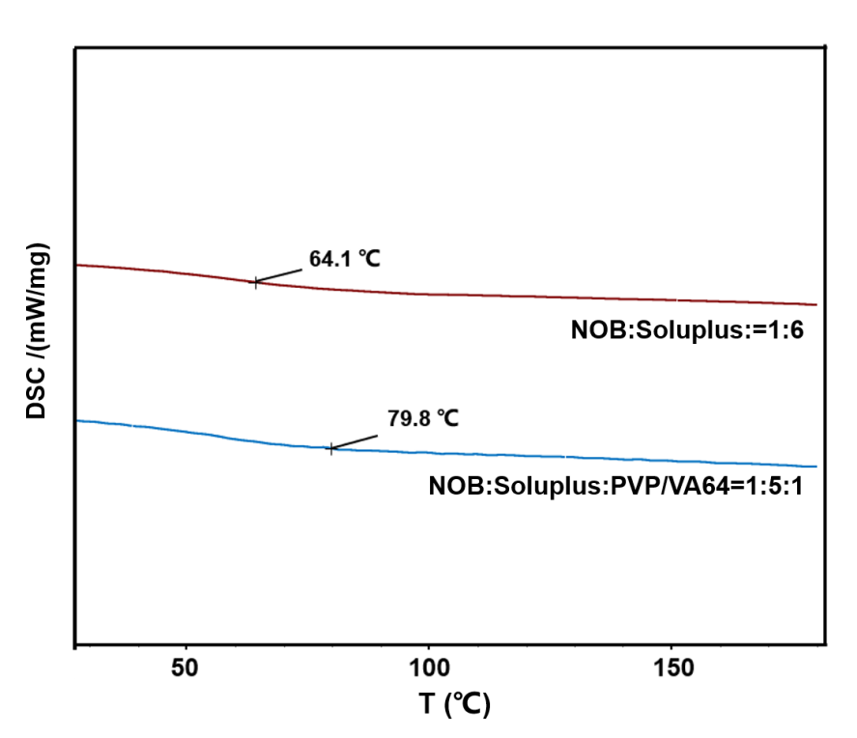
Supplement Figure 1. Tg of NOB/SD in different formulations.

