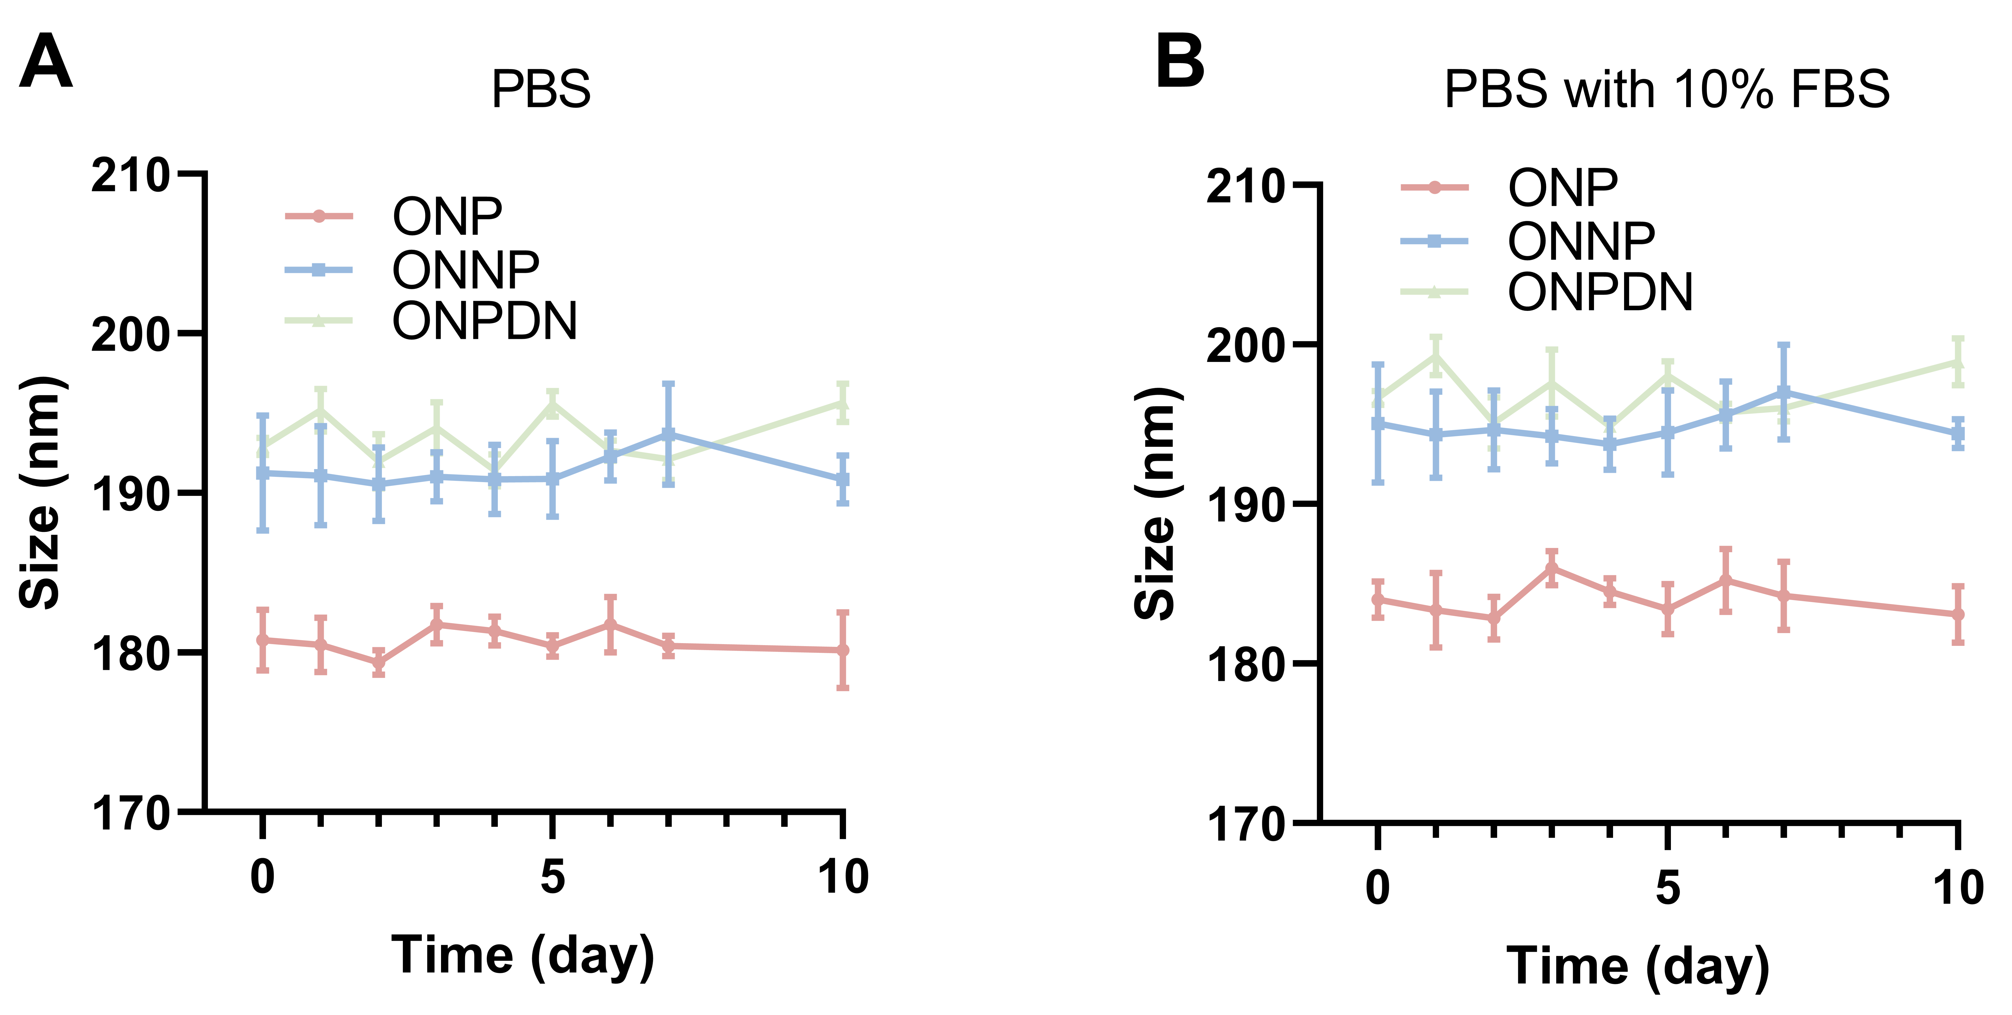
Figure S1 Size changes of ONP, ONNP, and ONPDN in the (A) PBS and (B) PBS supplemented with 10% FBS.

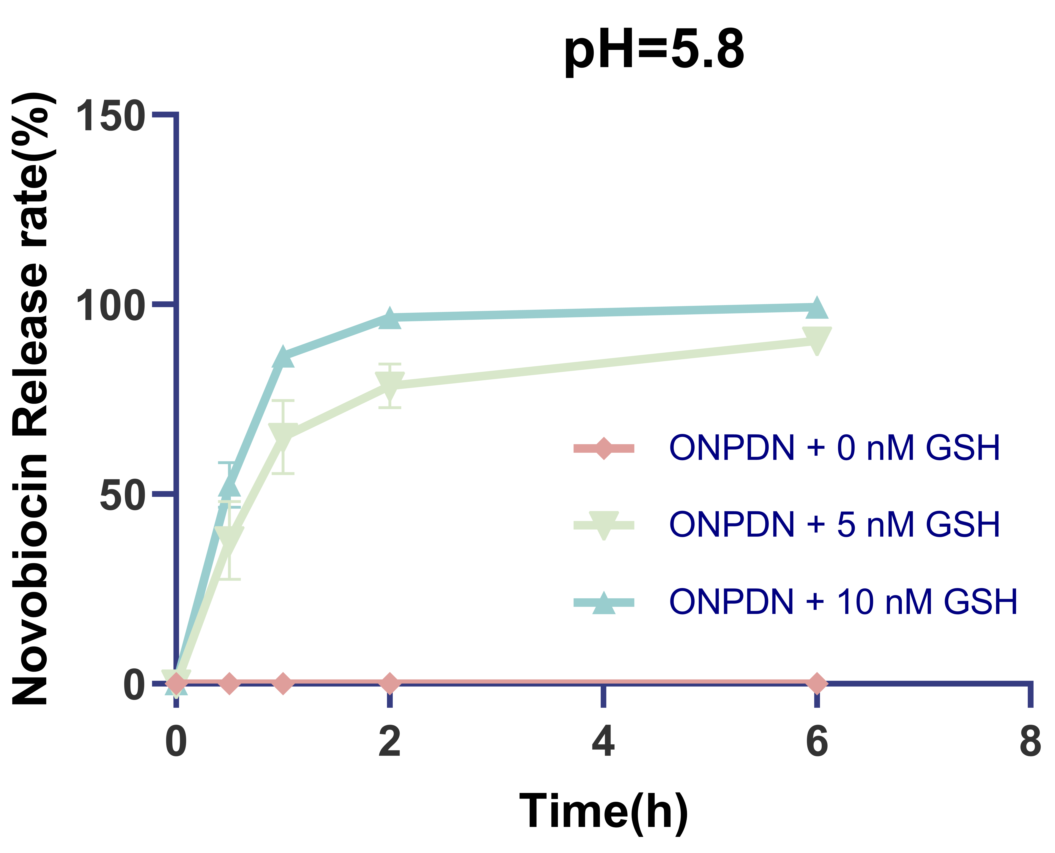
Figure S2 Novobiocin release rate of ONPDN at pH=5.8 with different concentrations of GSH.

Figure S3 Drug release of ONPDN. (A) Schematic illustration of the nanosystem's structural collapse and drug release triggered by an acidic glutathione environment. (B) TEM images of ONPDN at pH=5.8 and 10 mM of glutathione for 10, 30 and 60 minutes. Scale bar = 100 nm.

Figure S4 Cytotoxicity of ONPDN. (A) IC₅₀ values of MDA-MB-436, HCC1937, SKOV3 and MDA-MB-231 cells treated with free olaparib, olaparib and novobiocin (ON), OPDN and ONPDN. (B) Investigation of the growth inhibition effect on MDA-MB-231 cells treated with different concentrations of olaparib and novobiocin (ON), OPDN or ONPDN using a 48-hour MTT assay. (C) Evaluation of the growth inhibition effect on MDA-MB-231 cells treated with different concentrations of olaparib and novobiocin (ON), NPDN or ONPDN using a 48-hour MTT assay. **P < 0.01; ***P < 0.001.

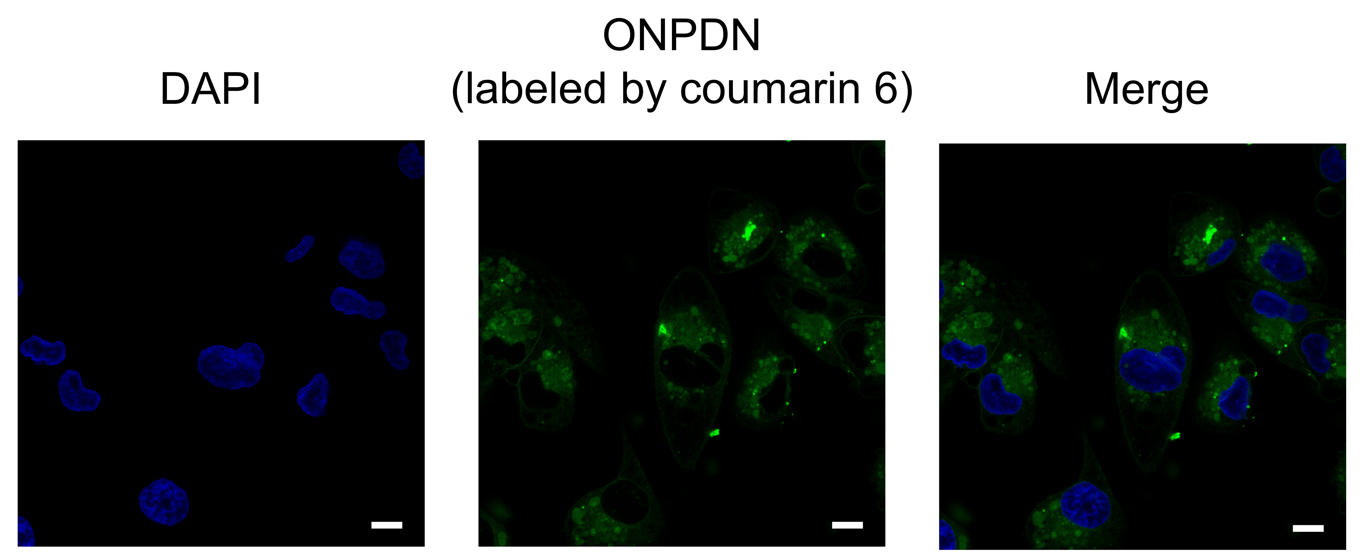
Figure S5 In vitro uptake of ONPDN (labeled by coumarin 6) by MDA-MB-231 cells. Scale bar = 20 μm.

Figure S6 ROS evaluation of ONPDN. (A) Normalized intracellular ROS intensities in MDA-MB-231 cells from Figure 3A. (B) ROS levels in MDA-MB-231 cells after treatment with PBS (G1), PDN (G2), olaparib and novobiocin (G3), NPDN (G4), OPDN (G5) or ONPDN (G6). All data are shown as mean ± SD (n = 3). ***P < 0.001.

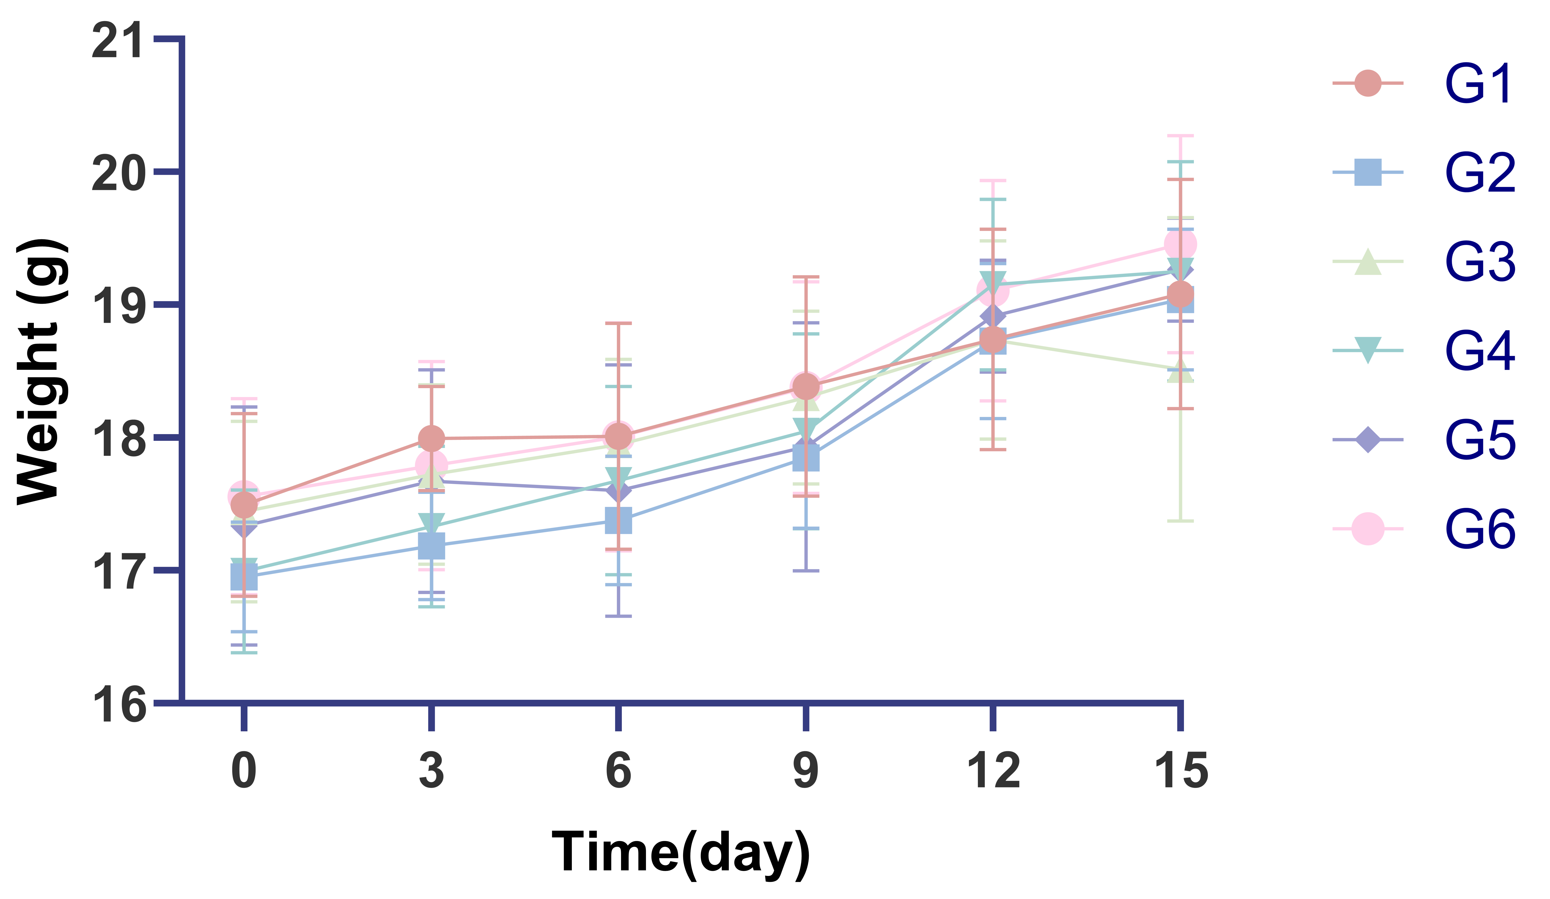
Figure S7 Body weight of nude mice treated with PBS (G1), PDN (G2), olaparib and novobiocin (G3), NPDN (G4), OPDN (G5) or ONPDN (G6). All data are shown as mean ± SD (n = 4).

