SI-1: Samples of Prepared medical sheets

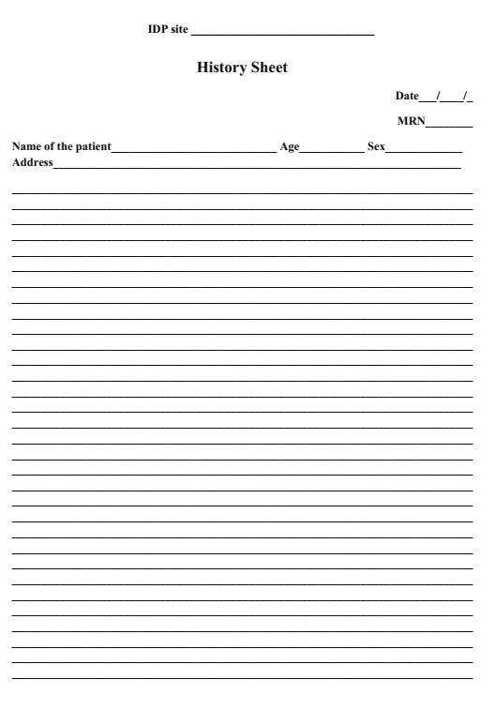

SI-1. Cont.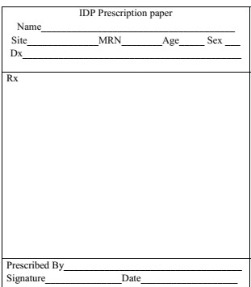

SI-1. Cont.
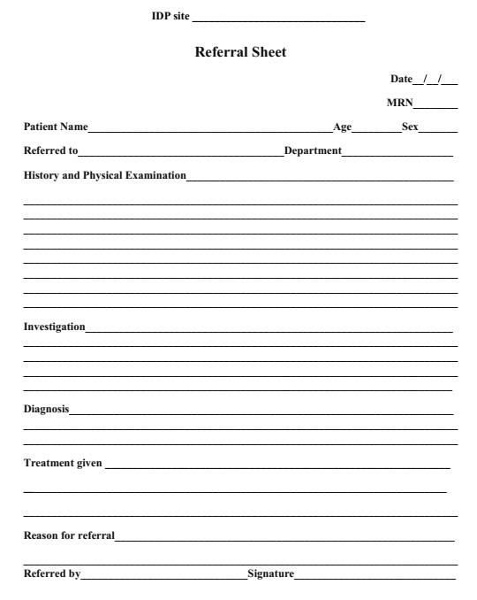

SI-2. Case definition of disease outbreak

Standard case definition of immediately and weekly reportable diseases I. Immediately reportable
- Acute flaccid paralysis: Any child under 15 years of age with acute flaccid paralysis (AFP) or any person with paralytic illness at any age in whom the clinician suspects poliomyelitis.
- Anthrax: Any person with acute onset illness characterized by several clinical forms Cutaneous/Gastro-intestinal/Pulmonary (inhalational) anthrax suspected by clinician with an appropriate epidemiological link to confirmed or suspected animal cases or contact to contaminated animal products.
    - Cutaneous: Skin lesion evolving over 1 to 6 days from a papular through a vesicular stage to a depressed black eschar invariably accompanied by edema that may be accompanied by mild to severe systemic forms.
    - Gastro-intestinal: abdominal symptoms characterized by nausea, vomiting, anorexia followed by fever
    - Pulmonary (inhalational): brief prodorm resembling acute viral respiratory illness, followed by rapid onset of hypoxia, dyspnea and high temperature, with X-ray evidence of mediastinal widening.
    - Meningeal: Acute onset of high fever possibly with convulsions, loss of consciousness, meningeal signs and symptoms commonly noted in all systemic infections.
- Cholera: Any person of age 5 years or more, with severe dehydration or death from acute watery diarrhea. If there is a cholera epidemic, a suspected case in any person with acute watery diarrhea, with or without vomiting.
- Measles: Any person with fever, and macula-papular (non-vesicular) generalized skin rash and cough, coryza, or conjunctivitis (red eyes) Or any person in whom a clinician suspects measles.
- Neonatal tetanus: any newborn with a normal ability to suck and cry during the first two days of life, and who, between the 3rd and 28th day of age, cannot suck normally, and becomes stiff or has convulsions or both.
- Rabies: A person bitten by suspected rabid dog and presented with fever, nausea, vomiting , agitation, pharyngeal spasms ( hydrophobia/aerophobia).
- COVID-19: Any person with history of fever , or documented fever > 38 oc and one or more symptoms of lower respiratory tract illness ( cough , difficulty of breathing , shortness of breath , and radiographic evidence of lung infiltrates consistent with pneumonia or ARDS without an identifiable cause and no alternative diagnosis can fully explain the illness).
- Viral hemorrhagic fever (VHF): Illness with onset of fever and not showing improvement to treatments of usual causes of fever in the area, and at least one of the following signs: bloody diarrhea, bleeding from gums, bleeding in to skin (purpura) bleeding in to eyes and urine.
- Pertussis (whooping cough): Cough lasting more than 2 weeks and at least one of the following symptoms
  - Paroxysmal cough
  - Inspiratory whoop
  - Post cough vomiting
  - Apnea with or without cyanosis (red face)

II. Weekly reportable
- Dysentery: a person with diarrhea with visible blood in stool
- Malaria: any person with fever or fever with headache, rigor, back pain, chills, sweats, myalgia, nausea, and vomiting diagnosed clinically as malaria.
- Meningitis: Any person with sudden onset fever (38 oc) and one of the following signs: neck stiffness, altered consciousness or meningeal signs.
- Relapsing fever: Any person presented with an abrupt onset of rigors with fever, usually remittent, headache, arthralgia, and myalgia, dry cough, epistaxis not explained by other causes.
- Typhoid fever: Any person with gradual onset of remittent fever (rising in step ladder fashion) in the 1st week, headache, arthralgia, anorexia, constipation, and abdominal pain.
- Typhus: Any person with an abrupt onset of headache, chills, and rapidly mounting fever, malaise , prostration ,not explained by other causes.
- Malnutrition:
  - Children age from 6 months to 5 years:
  - MUAC less than 11.5 cm, weight for length/height less than -3SD, and /or children with bilateral pitting edema.
  - Infants less than 6 month of age
  - Diagnosed by clinician with evidences of visible wasting, and/or weight for length less than -3SD, and /or bilateral pitting edema.
- Scabies: Any person with pururitic skin lesions affecting hands/inter-digital spaces/other body parts and/or close contact with affected person and/or clinician suspected scabies. Note: Any unusual occurrences, outbreaks, clusters of illness that may indicate public health hazards should also be reported immediately.

List of Medications and others supplies distributed to the Mekelle IDP Clinics based on the time frame

Table S1. 1st round- Medications and others distributed to Mekelle IDP Clinics on11/8/2013 E.C
S.N O | Item Name | Unit | Total Supplied
1 | Albendazole - 400mg - Tablet | 2*50 | 6
2 | Amoxicillin - 500mg - Capsule | 50X10 | 10
3 | Perimetrin 0.5% cream | 100gm | 40
4 | Ciprofloxacin - 250mg - Tablet | 10x10 | 12
5 | Cloxacillin Sodium - 500 mg - Capsule | 50X10 | 6
6 | Cotrimoxazole 240mg/5ml- Mixture | 100 ml | 96
7 | DNS 1000ml | 1000 ml | 36
8 | Diclofenac Sodium - 25mg/ml in 3ml ampoule | Amp | 100
9 | Diclofenac Sodium - 50mg - Tablet | 10*10 | 15
10 | Digoxin - 0.25mg - Tablet | 10*10 | 6
11 | Glibenclamide - 5mg - Tablet | 10x10 | 20
12 | Hyoscine Butylbromide, 10mg Tablet | 1000 | 2
13 | Metformin - 500mg - Tablet | 10x10 | 15
14 | Metronidazole - 250mg - Capsule | 100x10 | 12
15 | Nifedipine - 20mg - Tablet | 10X10 | 10
16 | Oral contraceptive pills | Cycle | 54
17 | Emergency contraceptive pills of 2 tab | 2 | 120
18 | Oral Rehydration Salt - 21.8gm - Powder | Sachet | 200
19 | Phenytoin - 50mg - Tablet | 200 | 7
20 | Prednisolone - 5mg - Tablet | 1000 | 6
21 | Propranolol - 40mg - Tablet | 10x10 | 8
22 | Salbutamol (Albuterol) - 200mcg - puff | 200mcg | 30
23 | Sodium valproate, 200 mg Tablet | 10*10 | 6
24 | TTC 1% eye ointment | 15gm | 100
25 | Warfarin 5mg tablet | 10x10 | 6
26 | Adhesive Plaster Zinc Oxide - Size 7.5cm | Roll | 36
27 | Disposable Insulin Syringe- 1ml,30G | pcs | 100
28 | Disposable Syringe - 5ml with 21G needle | 100 | 15
29 | IV Cannula - 18G | 100 | 6
30 | IV Cannula- 24G | 100 | 6
31 | Medical mask of 50 pcs | Box | 10
32 | Nasal prong adult | Each | 12
33 | Nasal prong pediatric | Each | 10
34 | Surgical Glove - No. 7.5 | 50 pairs | 24
35 | Tongue Depressor - wooden | 50 pairs | 6
36 | Glucometer strip of 50 | Pk | 6
37 | HBsAg kit of 100 | pack | 6
38 | Urine HCG strip | Box | 6
39 | BP cuff (adult) | each | 6
40 | BP cuff (pedi) | each | 3
41 | Glucometer | each | 1

Table S2. 2nd round- Medications and others supplies distributed to Mekelle IDP Clinics
Date on 13/9/2013 E.C

S.N | Name of items | Unit | Quantity Distributed
1 | Amoxicillin - 250 mg/5 ml - Suspension | 100 ml | 100
2 | Azithromycin 200 mg/5ml syrup | 15ml | 50
3 | Azithromycin 500 mg | 10x3 | 30
4 | Cephalexine - 125mg/5ml - Suspension | 100 ml | 20
5 | Ciprofloxacin - 500mg - Tablet | 10x10 | 20
6 | Clotrimazole - 1% - Cream | 20 gm | 20
7 | Cloxacillin Sodium - 500 mg - Capsule | 50X10 | 15
8 | Cotrimoxazole 240mg/5ml- Mixture | 100 ml | 60
9 | Dextrose - 40% in 20ml - IV Infusion | 20ml | 100
10 | Diphenhydramine Hydrochloride - 12.5mg/5ml - | 100 ml | 90
11 | Enalapril 5 mg tablet | 10X10 | 20
12 | Examination Glove - Medium size | 10*10 | 24
13 | Guaifenesin - 100mg/5ml - Syrup | 100 ml | 50
14 | Hydrochlorothiazide 25mg tablet | 10x10 | 90
15 | Ibuprofen - 100 mg/5 ml - Syrup | 100 ml | 90
16 | Ibuprofen - 400mg - Tablet | 10x10 | 60
17 | Ketoconazole - 2% - Cream | 20 gm | 30
18 | Ketoconazole 200 tablet | 10x10 | 15
19 | Metformin - 1gm - Tablet | 10*10 | 6
20 | Metronidazole - 125mg/5ml - Oral Suspension | 100 ml | 100
21 | Nifedipine - 20mg - Tablet | 10X10 | 90
22 | Omeprazole - 20 mg - Capsule | 10x10 | 100
23 | Paracetamol - 120mg/5ml - Syrup | 60 ml | 100
24 | Paracetamol - 500mg - Tablet | 100x10 | 2
25 | Tinidazole - 500 mg - Tablet | 60x4 | 10
26 | Tramadol Hydrochloride - 50mg - Capsule | 10x10 | 60
27 | TTC 3% skin ointment | 30gm | 50
28 | Stethoscope | each | 6
29 | Thermometer-digital | pack | 6
30 | IV stand | each | 6
31 | Cetirizine - 10mg - Tablet | 10x10 | 50
33 | Hydrochlorothiazide - 25mg – Tablet | 10x10 | 30
34 | Ibuprofen - 400mg – Tablet | 10x10 | 50
35 | Omeprazole - 20 mg - Capsule | 10x10 | 50
36 | Amitriptyline - 25mg - Tablet | 10x10 | 36
37 | Amoxicillin + Clavulanic Acid156.5mg/5ml | 100 ml | 180
38 | Ciprofloxacin - 3% eye/ear | tube | 90
39 | Clarithromycin - 500mg - Tablet | 10x10 | 36
40 | Diclofenac Sodium - 50mg - Tablet | 10x10 | 90
41 | Digoxin - 0.25mg - Tablet | 10x10 | 36
42 | Hyoscine Butylbromide 10 mg tablet | 10x10 | 10
43 | Insulin suspension - 100 Units/ml - Injection | 10 ml | 40
44 | Lidoccaine + adrenaline | 25 | 2
45 | MultiVitamin - - Syrup | 100 ml | 90
46 | Paracetamol - 120mg - Suppository | 20x5 | 36
47 | Prednisolone - 5mg - Tablet | 100x10 | 18
48 | Propronalol 40 mg tablet | 10x10 | 18
49 | Spironolactone - 25mg - Tablet | 10x10 | 36
50 | TTC 1% eye ontiment | 4gm | 300
51 | Chlorampheramine mg tablet | 10x10 | 36
52 | Frusemide - 10mg/ml in 2ml ampoule | 10 | 30
53 | Salbutamol (Albuterol) - 2mg/5ml - Syrup | 100 ml | 90
54 | Surgical Glove - No. 7.5 | 50 | 208
55 | Naso Gastric Tube - CH 14 | Each | 54
56 | Naso Gastric Tube - CH 8 | Each | 54
57 | Plaster Of Paris (POP) - 15cm x 3m | Dozen | 12
58 | Insulin Syringe- with needle 1ml | 100 | 18
59 | Tongue Depressor - wooden | 100 pc | 36
60 | Urine Bag -2000ml | Each | 90
61 | Glucometer strip | 50 | 54
62 | Glucometer | Set | 19
63 | Adhesive Plaster Zinc Oxide - Size 7.5cm X 10m | Each | 108
64 | IV Cannula- 24G | 100 | 18
65 | IV Cannula - 22G | 100 | 3
66 | IV Cannula - 18G | 100 | 18
68 | Syringe - 10ml with needle 21G | 100 | 60
69 | Syringe - 5ml with 21G needle | 100 | 100
71 | Normal saline 0.9% solution | 1000ml | 144
72 | Ceftriaxone 1 gm injection | vial | 180

Table S3. 3rd round- Medications and others supplies distributed to Mekelle IDP Clinics
S.N | Name of items | Unit | Quantity Distributed
1 | Azithromycin 200mg/5ml | Bottle | 88
2 | BBL 25% lotions | Bottle | 86
3 | Pregnancy test of 50 | Pk | 5
4 | HBSag test of 100 | Box | 11
5 | HIV rapid test kit of 20 | Box | 36

Table S4. 4th round- Medications and others supplies distributed to Mekelle IDP Clinics

S.N | Name of items | Unit | Quantity Distributed
1 | Acyclovir 200mg tablet | 10*10 | 20
2 | Amoxicillin - 500mg - Capsule | 50X10 | 25
3 | Amoxicillin + Clavulanic Acid 312.5mg/5ml suspension | 100 ml | 100
4 | Azithromycin 200 mg/5ml syrup | 15ml | 50
5 | Azithromycin 250 mg | 10x3 | 47
6 | Cephalexine - 125mg/5ml - Powder for Suspension | 100 ml | 50
7 | Ciprofloxacin - 500mg - Tablet | 5x10 | 40
8 | Cloxacillin Sodium - 500 mg - Capsule | 50X10 | 15
9 | Dexametasone eye drop | Tube | 50
10 | Dextromethorphan syrup- 10mg/5ml - Elixir | 100 ml | 100
12 | Doxycycline - 100mg - Capsule | 20x10 | 25
13 | Enalapril 5 mg tablet | 10X10 | 20
16 | Gentamycin eye drop | Tube | 50
18 | Loratidine 10 mg tablet | 10x10 | 50
20 | Metoclopramide - 5mg/5ml - Syrup | 60 ml | 50
23 | Metronidazole - 125mg/5ml - Oral Suspension | 100 ml | 100
24 | Metformin 500mg | 10x10 | 25
26 | Paracetamol - 120mg/5ml - Syrup | 60 ml | 200
27 | Paracetamol - 250mg - Suppository | 20x5 | 15
28 | Salbutamol puff | Pk | 20
29 | Spironolactone - 25mg - Tablet | Pk | 10
30 | TTC 1% eye ointment | Tube | 200
31 | Xylometazole 0.05% nasal drop | Tube | 40
32 | Xylometazole 0.1% nasal drop | Tube | 40
33 | Whitfield's field Ointment | 20 gm | 100

Table S5. Distributed medical equipment’s, Furniture’s, stationary, and sanitation materials

S.N | Item | Unit | Quantity
1 | Classer (patient card) | Pack | 12
2 | Rubber sheet 1 meter | each | 24
3 | Registration Book | each | 11
4 | Stapler | each | 11
5 | Staples | pack | 17
6 | Paper clipper | pack | 12
7 | Meseben ( large ) | each | 6
8 | Meseben (medium) | each | 11
9 | Meseben (small) | each | 6
10 | Monquet | each | 6
11 | Mokoster | each | 6
12 | Mewelweli | each | 12
13 | Cleaning Towel | each | 28
14 | Rubber glove | each | 12
15 | Berekina | each | 11
16 | Soap | each | 6
17 | Tapmeter | each | 6
18 | Ehu | each | 6
19 | Mobile card | each | 80
20 | Copy ink | each | 2
21 | Layers for Shelf | each | 14
22 | Shelf | each | 4
23 | Classer | Pack | 4
24 | Table(large) | each | 1
25 | Table (small) | each | 1
26 | Shelf | each | 4
27 | Copy paper (sheet) | each | 10
28 | Bed | each | 12
29 | Chupud | each | 12
30 | Foam | each | 12
31 | Chair | each | 7
32 | Common contagious illness | each | 30
33 | Guideline for STI | each | 33
34 | Patients card large | Pcs | 6000
35 | Patients card small | Pcs | 9000
36 | History sheet | Pcs | 2400
37 | Referral sheet | Pcs | 2250
38 | Investigation sheet | Pcs | 1500
39 | Prescription sheet | Pcs | 2,100
40 | Consultation form, F/up sheet | Pcs | 450

