Supplementary Information
Supplementary Table1 Details of searches in each database
Database | Search strategy | Records
PubMed | ("schizophrenia"[MeSH Terms] OR "schizophrenia"[All Fields] OR "schizophrenias"[All Fields] OR "schizophrenia s"[All Fields] OR "schizophrenic Disorders"[All Fields OR "schizophrenic"[All Fields) AND ("3 carboxamido 4 hydroxynaltrexone"[Supplementary Concept] OR "3 carboxamido 4 hydroxynaltrexone"[All Fields] OR "samidorphan"[All Fields]) | 42
Web of Science | samidorphan (Topic) and schizophrenia* (Topic) and Preprint Citation Index (Exclude – Database) | 66
Cochrane Library | samidorphan in Title Abstract Keyword AND schizophrenia in Title Abstract Keyword | 52
Embase | ('samidorphan'/exp OR samidorphan) AND olanzapine AND schizophrenia | 70
CNKI | (''Lybalvi'' OR "Samidorphan") AND ''schizophrenia'')) | 1
Wanfang | (''Lybalvi'' OR "Samidorphan") AND ''schizophrenia'')) | 2
VIP | (''Lybalvi'' OR "Samidorphan") AND ''schizophrenia'')) | 2
CBM | (''Lybalvi'' OR "Samidorphan") AND ''schizophrenia'')) | 2
Note: Literature search was conducted on 31 May, 2023. CBM, Chinese Biology Medicine; CNKI, China National Knowledge Infrastructure.

Supplementary Figures 1-14: Estimating Reporting Bias with Funnel Plots
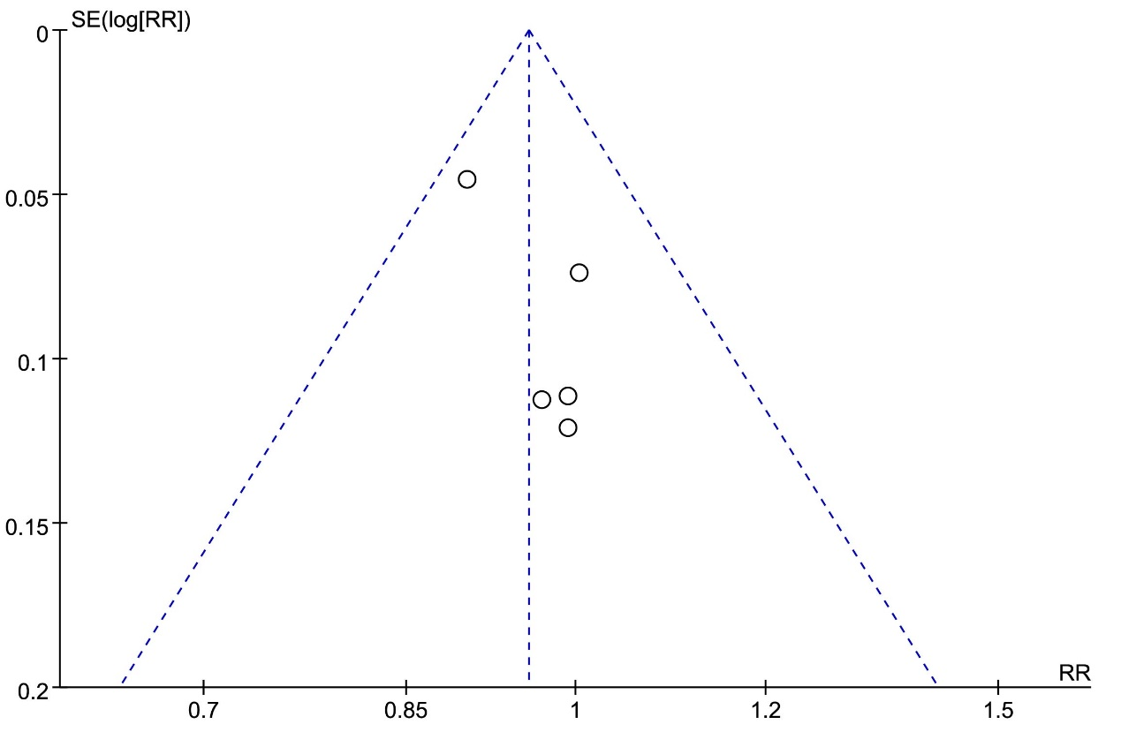 Supplementary Figure1 Funnel plot: assessing the publication bias of the incidence of any adverse events
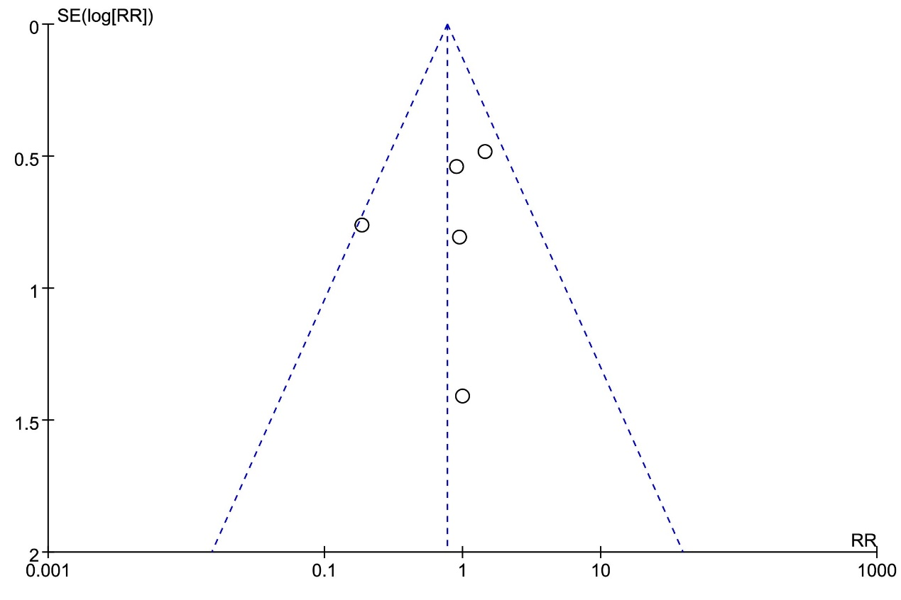 Supplementary Figure2 Funnel plot: assessing the publication bias of the incidence of serious adverse events
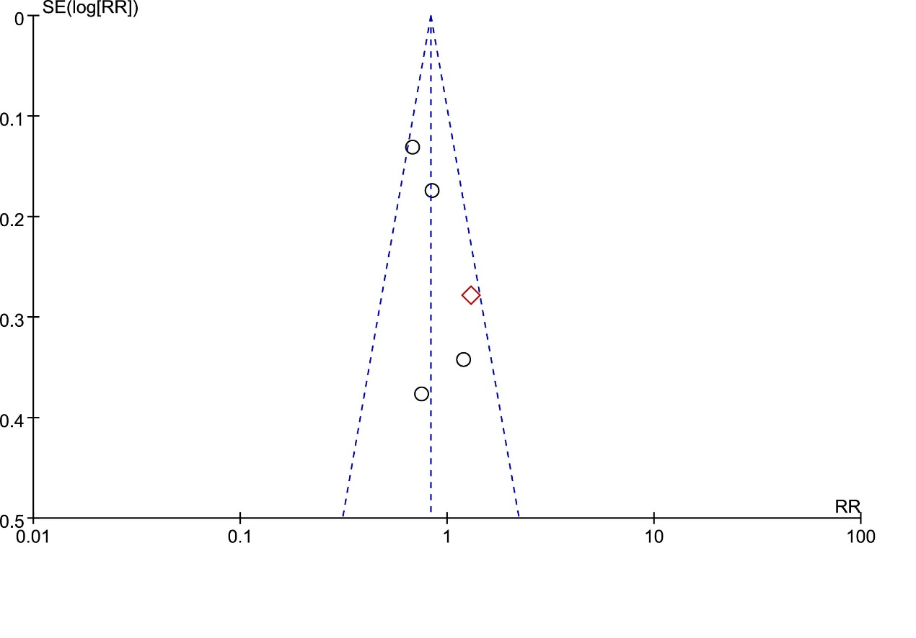 Supplementary Figure3 Funnel plot: assessing the publication bias of the incidence of weight gain
In terms of adverse events related to weight gain, subgroup analysis was conducted. The ◇ symbol represents the short follow-up time group, while the ○ symbol represents the long follow-up time group.
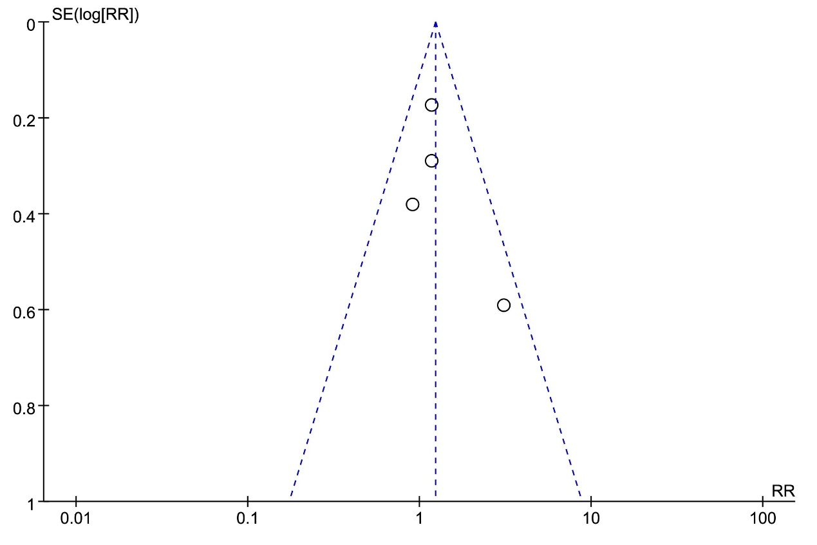 Supplementary Figure4 Funnel plot: assessing the publication bias of the incidence of somnolence
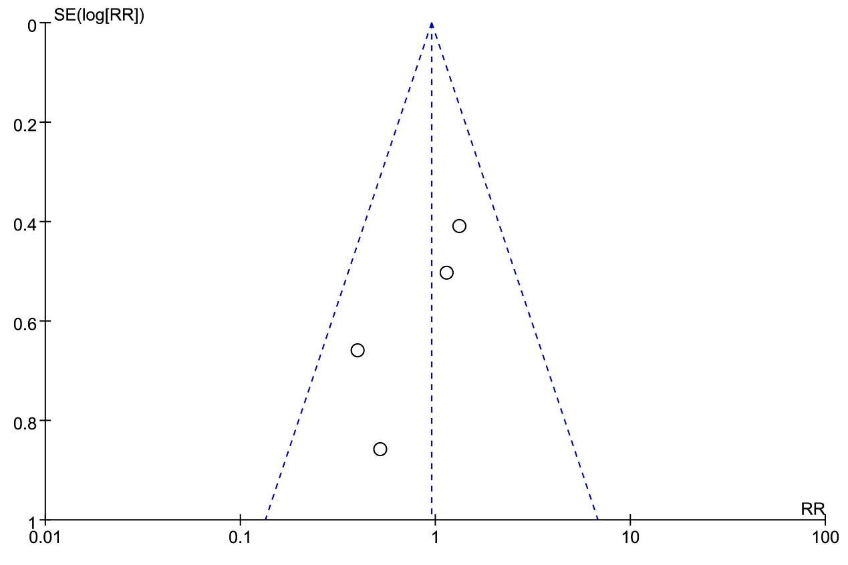 Supplementary Figure5 Funnel plot: assessing the publication bias of the incidence of headache
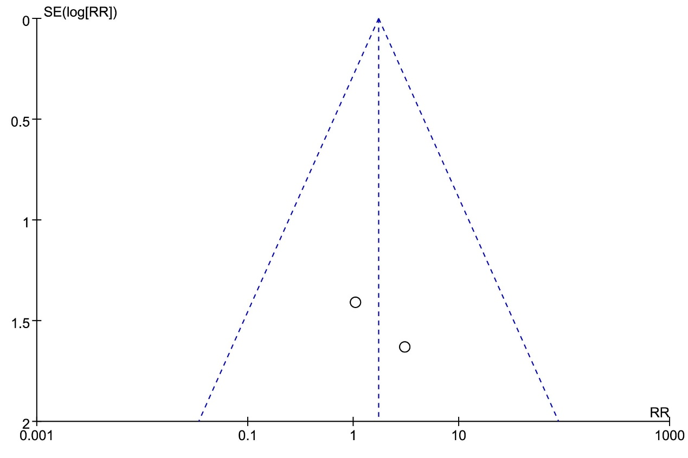 Supplementary Figure6 Funnel plot: assessing the publication bias of the incidence of death
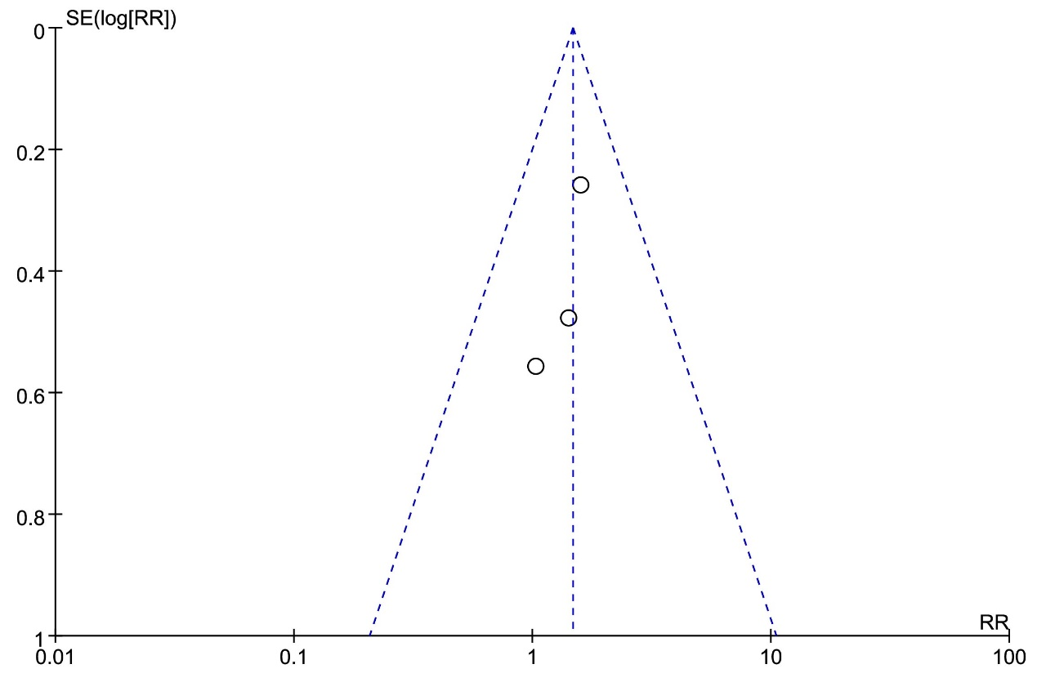 Supplementary Figure7 Funnel plot: assessing the publication bias of the incidence of dry mouth
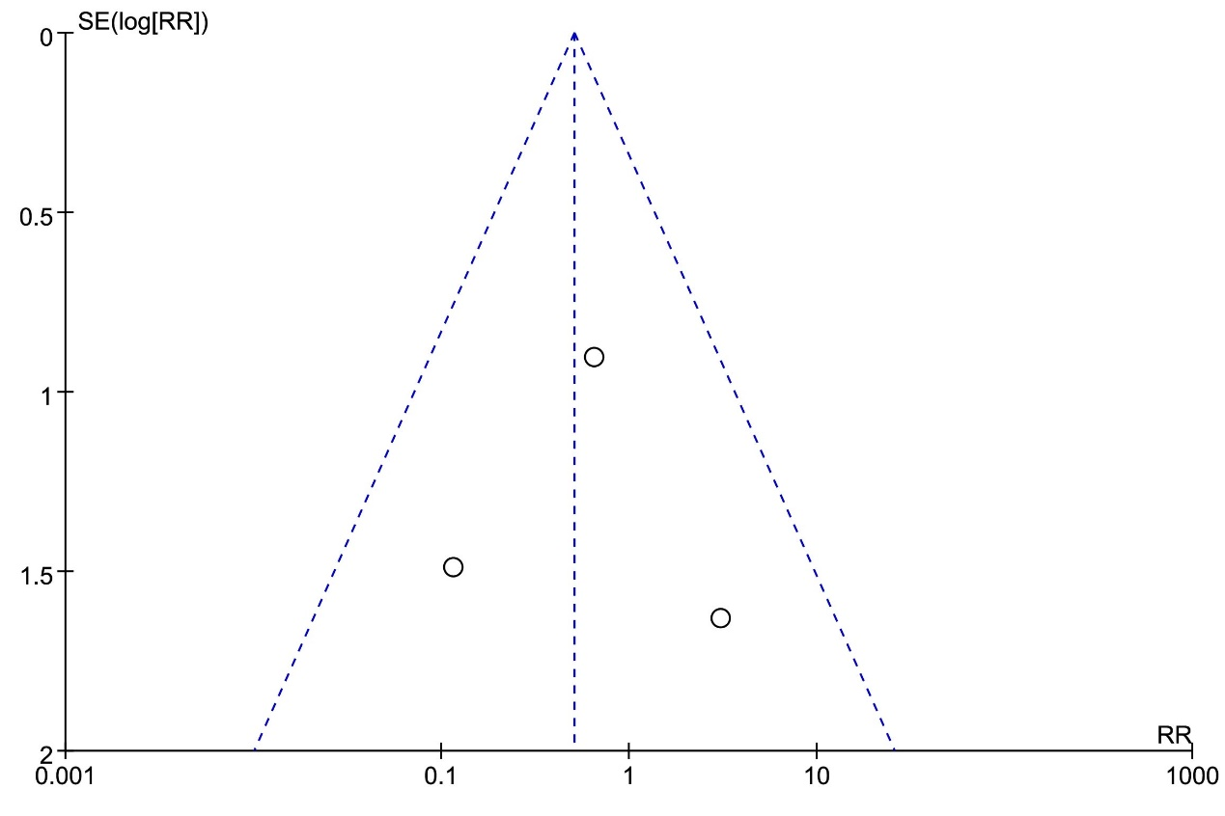 Supplementary Figure8 Funnel plot: assessing the publication bias of the incidence of suicide perception
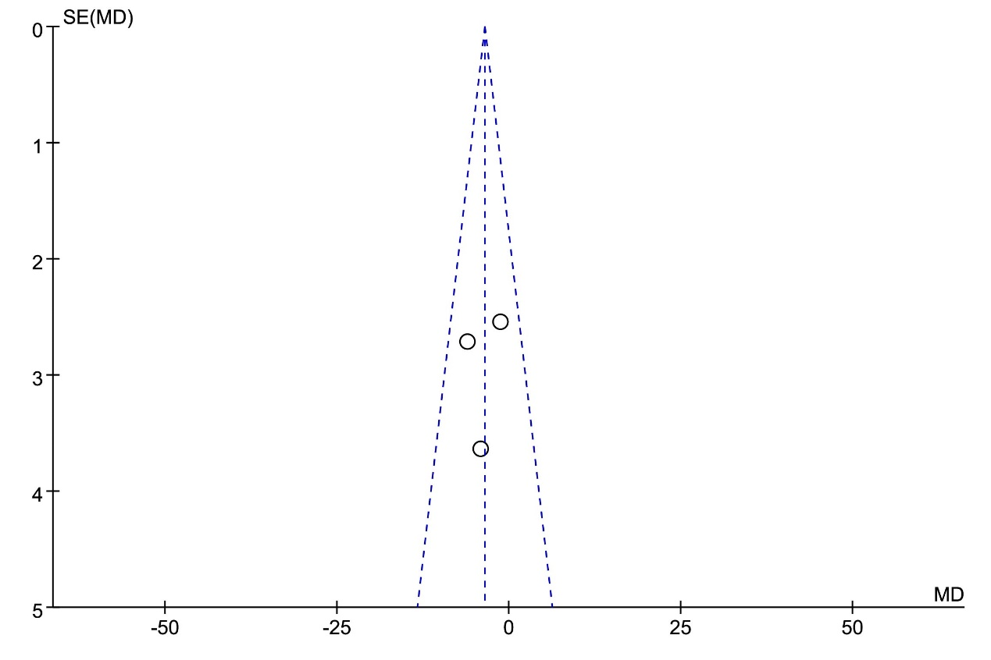 Supplementary Figure9 Funnel plot: assessing the publication bias of total cholesterol (mg/dL)
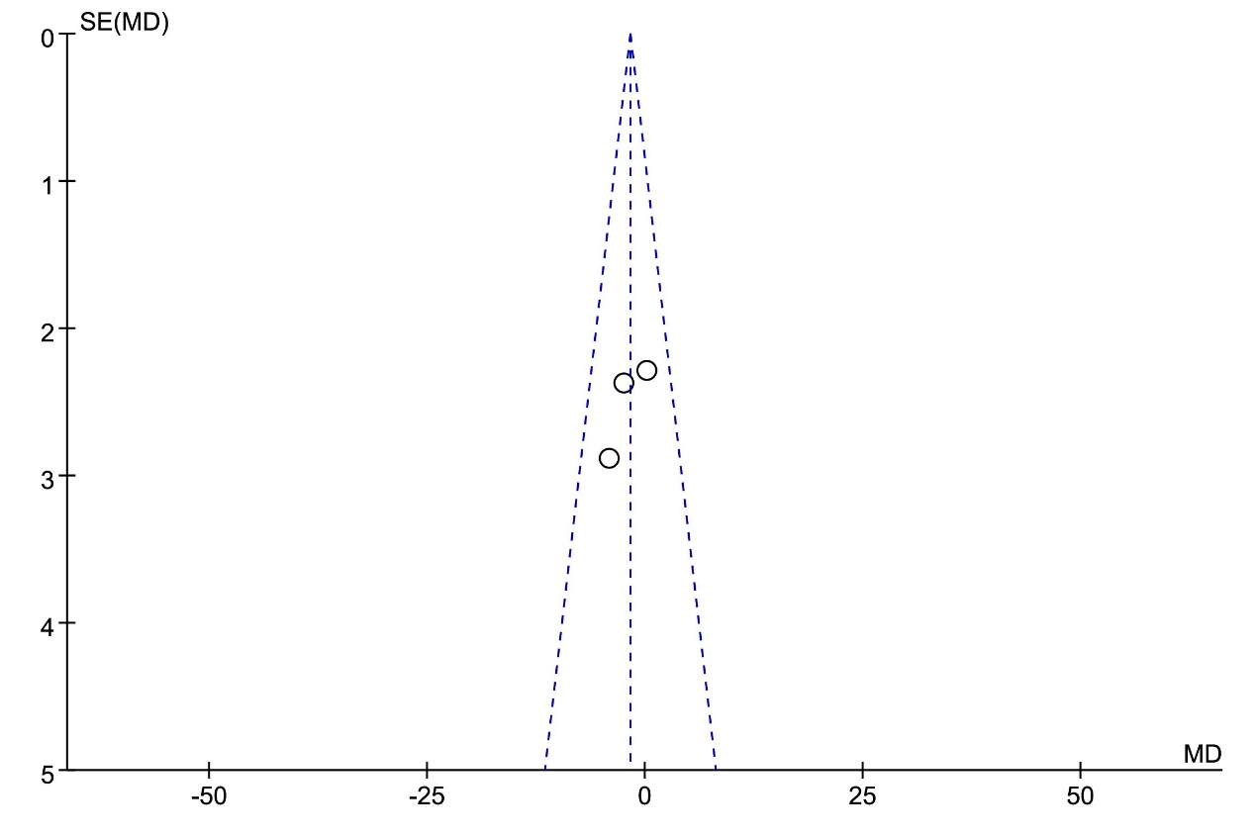 Supplementary Figure10 Funnel plot: assessing the publication bias of low density lipoprotein (mg/dL)
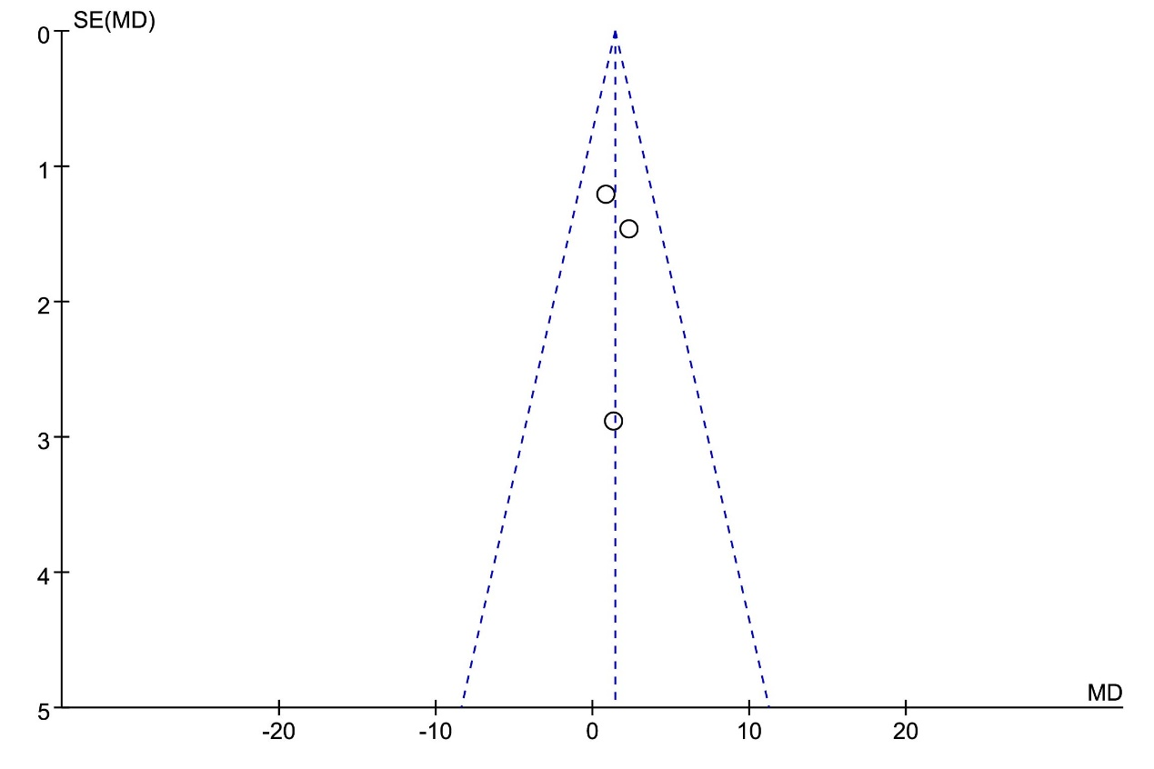
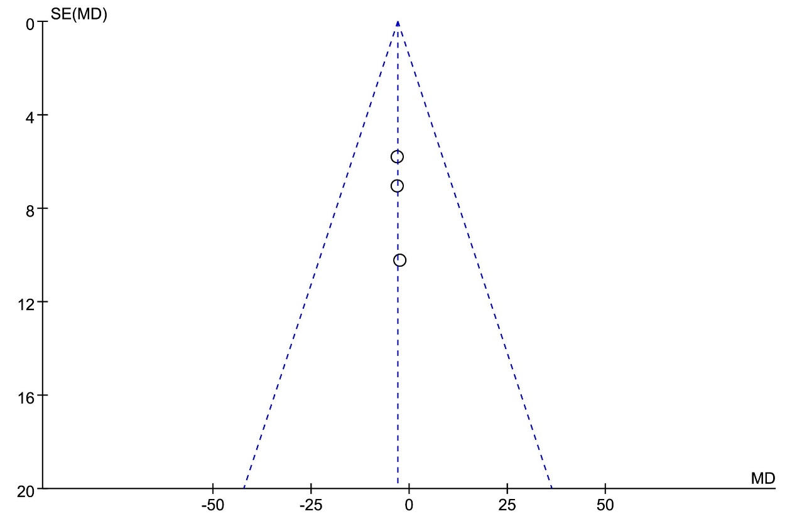 Supplementary Figure11 Funnel plot: assessing the publication bias of Triglycerides (mg/dL)

Supplementary Figure12 Funnel plot: assessing the publication bias of Glucose (mg/dL)
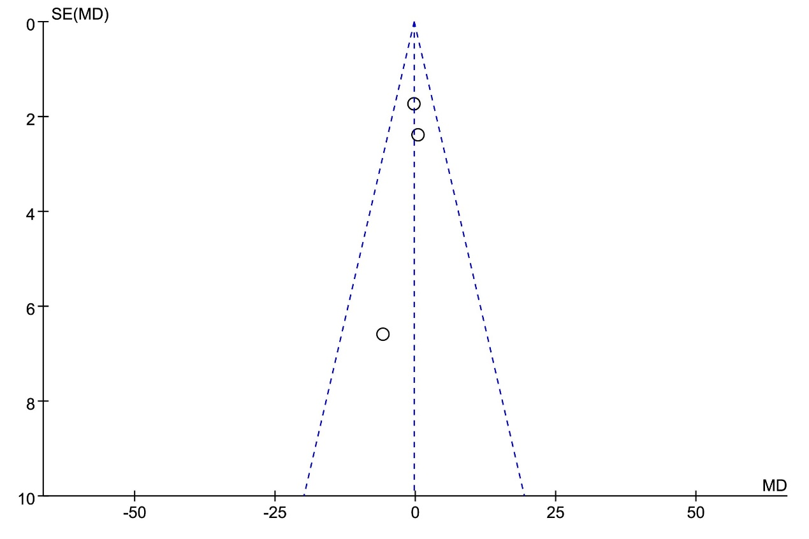 Supplementary Figure13 Funnel plot: assessing the publication bias of Insulin (mIU/dL)
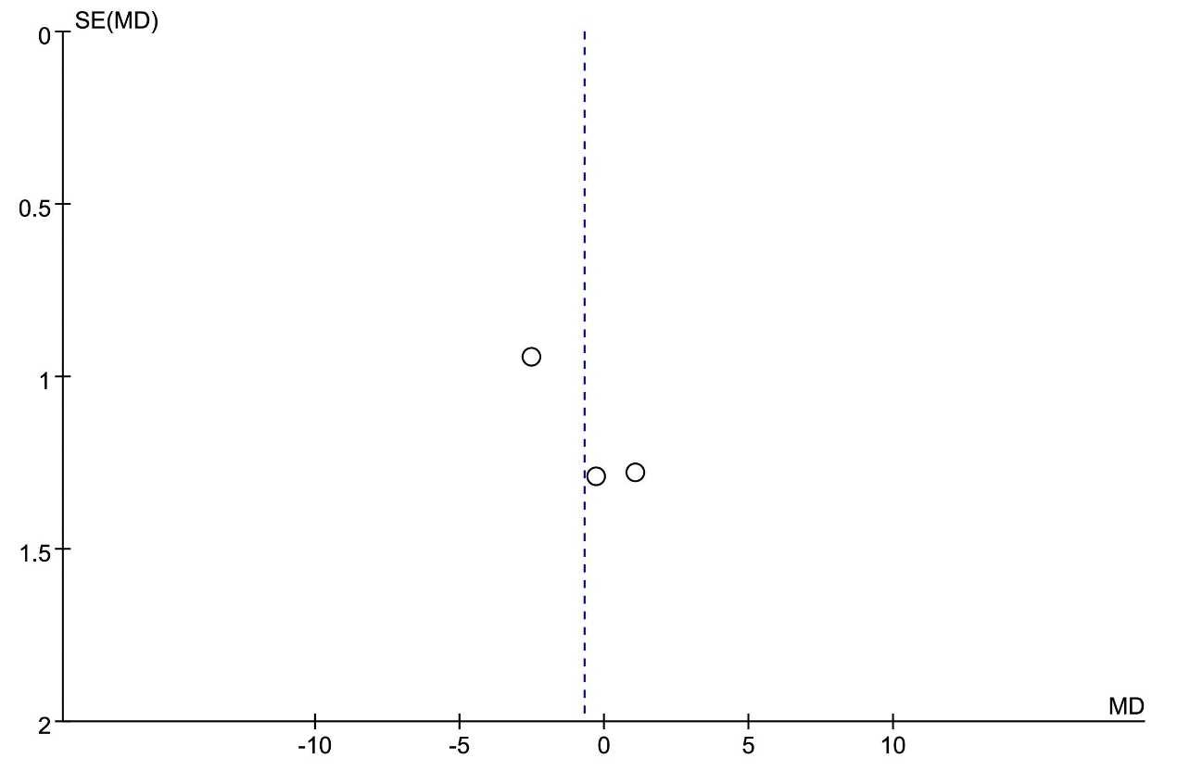 Supplementary Figure14 Funnel plot: assessing the publication bias of high density lipoprotein (mg/dL)

