Supplementary Information for
Sono-Immunotherapy Mediated Controllable Composite Nano Fluorescent Probes Reprogram the Immune Microenvironment of Hepatocellular Carcinoma
Yichi Chen ^{1, 2, 3}, Bolin Wu ^{1, 2, 3}, Haitao Shang ^{1, 2, 3}, Yucao Sun ^{1, 2, 3}, Huimin Tian ^{1, 2, 3}, Huajing Yang ^{1, 2, 3}, Chunyue Wang ^{1, 2, 3}, Xiaodong Wang ^{1, 2, 3}, Wen Cheng ^{1, 2, 3, *}
1 Department of Ultrasound, Harbin Medical University Cancer Hospital, Harbin, 150081, China.
2 Department of Interventional Ultrasound, Harbin Medical University Cancer Hospital, Harbin, 150081, China.
3 Institute of Cancer Prevention and Treatment, Heilongjiang Academy of Medical Science, Harbin, 150081, China.

Corresponding Author:
Full name: Wen Cheng
Department: Department of Ultrasound, Department of Interventional Ultrasound,
University/Hospital: Harbin Medical University Cancer Hospital
Street Name & Number: No.150, Haping Road, Nangang District
City, State, Postal code, Country: Harbin, Heilongjiang Province, China, 150081.
Tel: +86 13313677182
Fax: +86 451 85718392
E-mail: chengwen@hrbmu.edu.cn

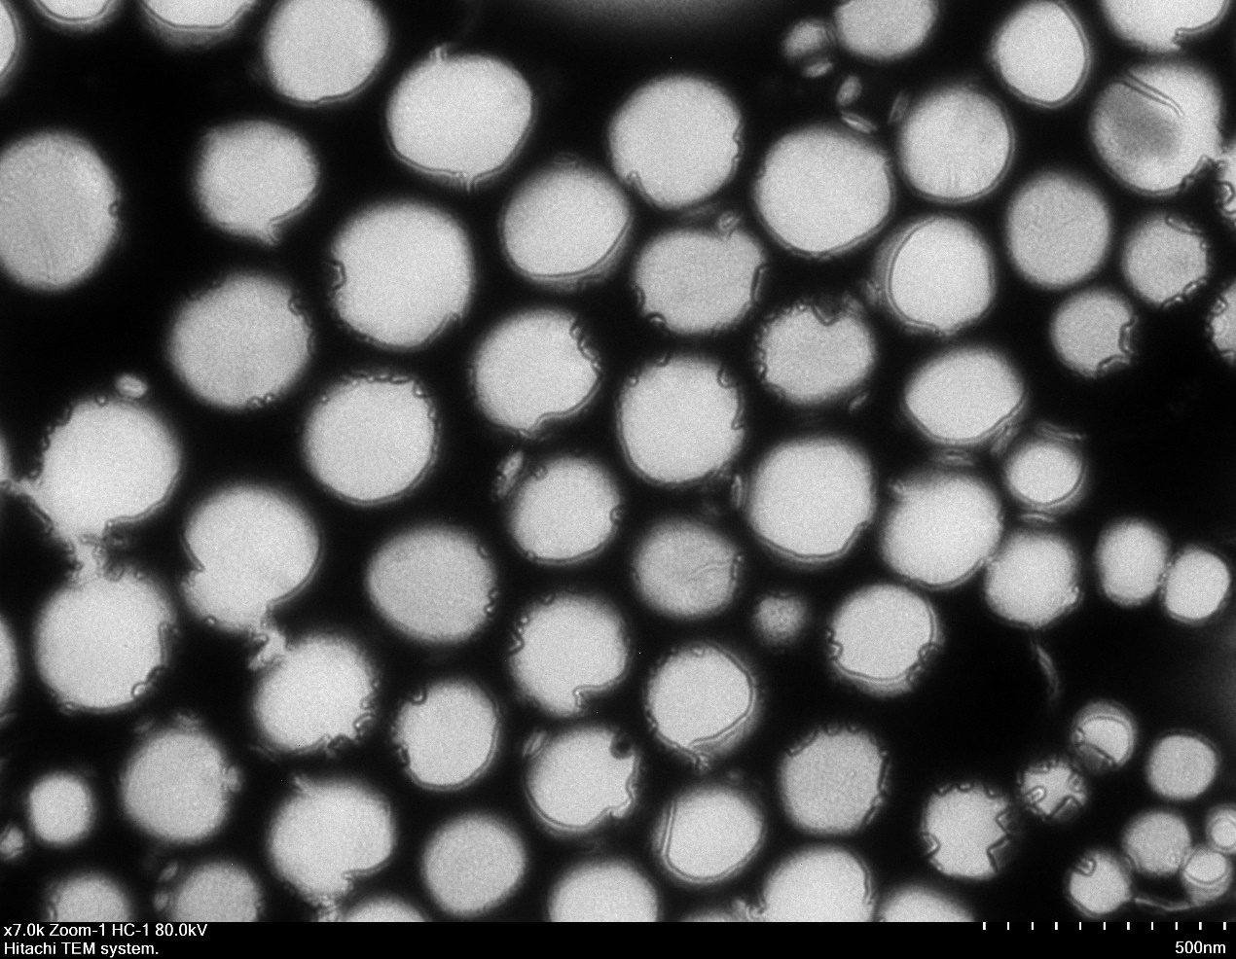
Figure S1. The TEM image of NBs. Scale bar=500 nm.

Figure S2. ROS generation of various formulations under SDT using DPBF as the probe.

Figure S3. The expression of CRT in Hepa 1-6 cells.

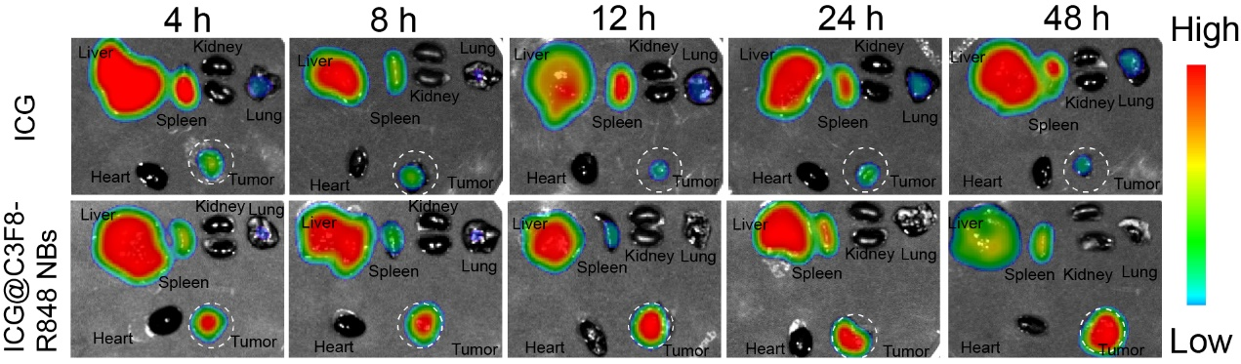
Figure S4. Representative NIR fluorescence images of ex vivo organs at different time points after intravenous injection of ICG@C3F8-R848 NBs and ICG.

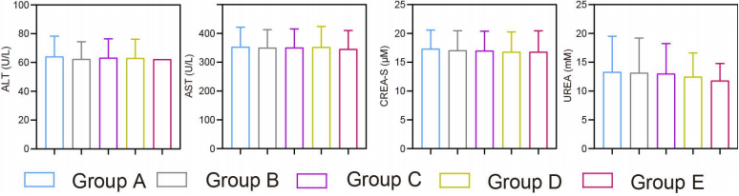
Figure S5. Blood cells and biochemical index tests. Biochemical index including alanine aminotransferase (ALT), blood urea nitrogen (UREA), total bilirubin (TBIL), total bilirubin (TBIL), Direct bilirubin (DBIL), creatinine (CRE), aspartate aminotransferase (AST) of tumor-bearing mice after treating for 16 days. (n=3).
Figure S6. ELISA detects expression changes of TNF-α (A), IL-2 (B) and IFN-γ (C) in tumor tissues.
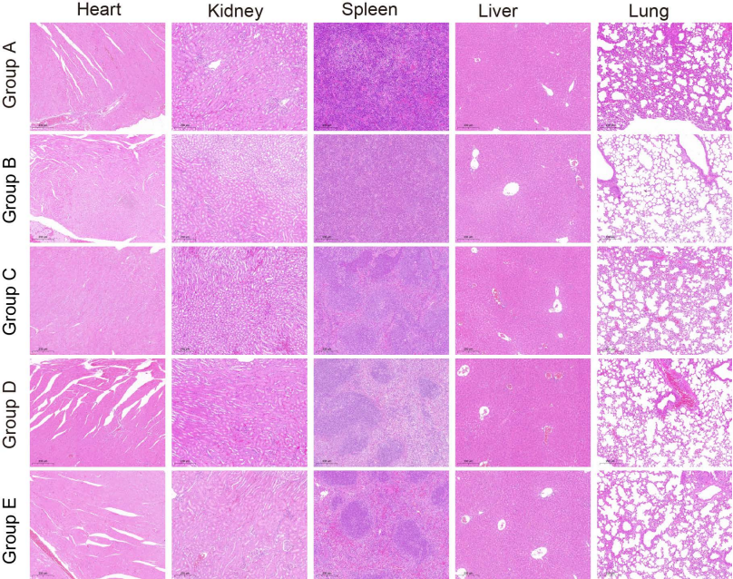
Figure S7. H&E staining of Brain, heart, liver, spleen, lung and kidney tissue slices from tumor-bearing mice after treatment for 16 days. Scale bar for organs is 200nm.

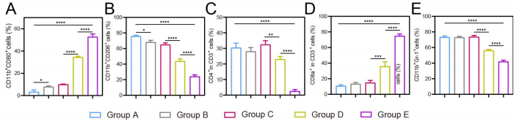
Fig.S8. Quantitative analysis of immune cells in experimental animals after synergistic Sono-immunotherapy. (A) Quantitative analysis of CD4+ T cells and CD8+ T cells. (B) Quantitative analysis of MDSCs by Gr-1 marker. (C, D) Quantitative analysis of M1 macrophages and M2 macrophages by CD86 marker and CD206 marker. The data represent mean ± SD, Student t-test, *P < 0.05, **P <0.01, ***P < 0.001, **** P < 0.0001.

Table S1. Routine Blood Analysis
Group | WBC (10⁹/L) | RBC (10¹²/L) | PLT (10⁹/L) | HGB(g/L) | RDW (%)
PBS | 5.20 ± 1.05 | 6.59±0.35 | 768.67 ± 139.00 | 113.00 ±21.38 | 12.73 ± 2.48
ICG@C3F8-R848 NBs | 5.70 ± 0.72 | 7.84±1.09 | 966.00 ± 76.39 | 108.00 ± 1.73 | 11.93 ± 0.15
ICG@C3F8 NBs+SDT | 4.40 ± 0.87 | 8.09±1.32 | 791.00 ± 111.85 | 118.00± 20.78 | 11.60 ± 0.20
R848 | 4.90 ± 0.53 | 7.75±0.56 | 646.33 ± 72.34 | 102.67 ± 36.95 | 10.90 ± 0.40
ICG@C3F8-R848 NBs+SDT | 4.83 ± 0.12 | 5.83±0.70 | 623.00 ± 139.31 | 86.33 ± 4.62 | 12.30 ± 1.04

