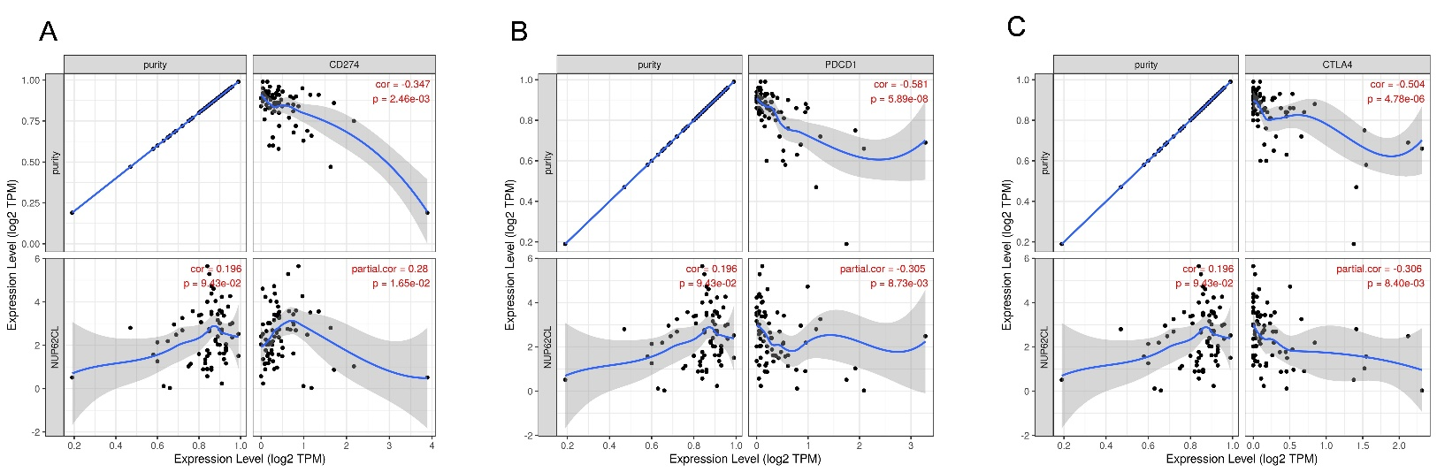
Figure S1. The correlation of NUP62CL mRNA expression with PD-L1 (CD274) (A), PD-1, (PDCD1) (B) and CTLA-4 (CTLA4) (C) mRNA expression after adjusting by tumor purity in TIMER 2.0 database.

