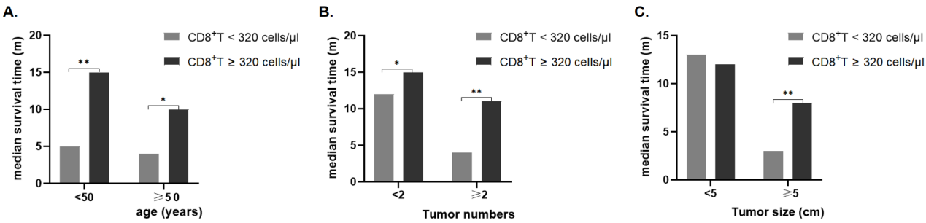
Figure S1. Interaction between CD8⁺T cell counts and (A) age (years), (B) tumor numbers, and (C) tumor size (cm) regarding the median survival time (month) for advanced HCC. *P < 0.05, **P < 0.01.
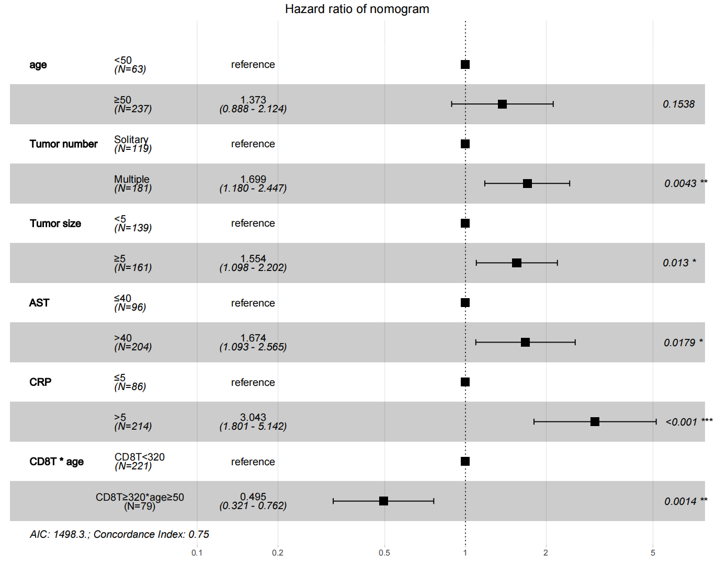
Figure S2. HRs of nomogram model variables for advanced HCC. Forest plot showing the HRs and 95% CIs for advanced HCC. HRs, hazard ratios; CIs, confidence intervals. *P < 0.05, **P < 0.01, ***P < 0.001.

