Supplementary file 1
The business intelligence tool utilized in this context is the system provided by the Data Health for Analysis section within the Faculty of Medicine at Ramathibodi Hospital. This section's services provide data warehouse services through Microsoft Power Business Intelligence (BI). The authors provided the International Classification of Disease (ICD)-9 and ICD-10 codes, along with keywords such as "cardiopulmonary resuscitation," "mortality," and "ICU transfer rate." Subsequently, this section's staff collected the data using Microsoft Power BI and sent it to the investigators. Microsoft Power BI, a component of the Microsoft Power Platform, is a data visualization platform primarily employed for business intelligence purposes.

Supplementary file 2

Ramathibodi rapid response system committee
- Yuda Sutherasan, MD, Division of Pulmonary and Pulmonary Critical Care, Department of Medicine, Faculty of Medicine Ramathibodi Hospital, Mahidol University.
- Detajin Junhasavasdikul, MD, Division of Pulmonary and Pulmonary Critical Care, Department of Medicine, Faculty of Medicine Ramathibodi Hospital, Mahidol University.
- Pongsasit Singhatas, MD, Division of Trauma Surgery and Surgical Critical Care, Department of Surgery, Faculty of Medicine Ramathibodi Hospital, Mahidol University.
- Nattachai Anantaait, MD, Division of Pediatric Critical Care Medicine, Department of Pediatrics, Faculty of Medicine Ramathibodi Hospital, Mahidol University.
- Pharuhad Pongmee, MD, Division of Neonatology, Department of Pediatrics, Faculty of Medicine Ramathibodi Hospital, Mahidol University.
- Wirada Hansahiranwadee, MD, Division of Maternal Fetal Medicine, Department of Obstetrics & Gynaecology, Faculty of Medicine Ramathibodi Hospital, Mahidol University.
- Norachart Sirisreetreerux, MD, Division of Orthopaedic Trauma, Department of Orthopaedics, Faculty of Medicine Ramathibodi Hospital, Mahidol University.
- Kasamon Aramvanitch, MD, Department of Emergency Medicine, Faculty of Medicine Ramathibodi Hospital, Mahidol University.
- Bunyada Putthirangsiwong, MD, Division of Ophthalmic Plastic and Reconstructive Surgery, Department of Ophthalmology, Faculty of Medicine Ramathibodi Hospital, Mahidol University.
- Natdanai Mankasetkit, MD, Ramathibodi Medical School, Faculty of Medicine Ramathibodi Hospital, Mahidol University.
- Vatinee Kutchamach, RN, Department of Nursing Service, Somdech Phra Debaratana Medical Center, Faculty of Medicine Ramathibodi Hospital, Mahidol University.
- Wanna Kongvivegkachornkij, RN, Department of Nursing Service, Faculty of Medicine Ramathibodi Hospital, Mahidol University.
- Supanee Wilainumchokechai, RN, Department of Nursing Service, Queen Sirikit Medical Center, Faculty of Medicine Ramathibodi Hospital, Mahidol University.
- Sompit Pongvirat, RN, Division of Medicine Nursing, Faculty of Medicine Ramathibodi Hospital, Mahidol University.
- Achara Jongjareonkumchok, RN, Division of Surgical Nursing, Faculty of Medicine Ramathibodi Hospital, Mahidol University.
- Montira​ Nuangkanya​, RN, Division of Surgical Nursing​, Faculty of Medicine Ramathibodi Hospital, Mahidol University.
- Somying Goonthon, RN, Division of Pediatric Nursing, Faculty of Medicine Ramathibodi Hospital, Mahidol University.
- Somporn Poolpanitoopatum, RN, Division of Pediatric Nursing, Faculty of Medicine Ramathibodi Hospital, Mahidol University.
- Chayada Piyakhachornrot, RN, Division of​ Orthopedics Nursing, Faculty of Medicine Ramathibodi Hospital, Mahidol University.
- Jomsri​ Potisan, RN, Division of​ Orthopedics Nursing, Faculty of Medicine Ramathibodi Hospital, Mahidol University.
- Aree​ Saebae, RN, Division of​ Specific Service Nursing, Faculty of Medicine Ramathibodi Hospital, Mahidol University.
- Worrawan Chanyagorn, RN, Division of Eye Ear Nose and Throat Nursing, Faculty of Medicine Ramathibodi Hospital, Mahidol University.
- Suleeporn Pittayanon, RN, Division of Emergency Nursing, Faculty of Medicine Ramathibodi Hospital, Mahidol University.
- Saowalak Sukawattana, RN, Department of Nursing Service, Queen Sirikit Medical Center, Faculty of Medicine Ramathibodi Hospital, Mahidol University.
- Kanya junjai, RN, Department of Nursing Service, Queen Sirikit Medical Center, Faculty of Medicine Ramathibodi Hospital, Mahidol University.
- Wachiraporn Phuengsripheng, RN, Department of Nursing Service, Queen Sirikit Medical Center, Faculty of Medicine Ramathibodi Hospital, Mahidol University.
- Noppakan Wannakansophon, RN, Department of Nursing Service, Somdech Phra Debaratana Medical Center, Faculty of Medicine Ramathibodi Hospital, Mahidol University.
- Sommanee Krungthongchan, RN, Department of Nursing Service, Somdech Phra Debaratana Medical Center, Faculty of Medicine Ramathibodi Hospital, Mahidol University.
- Taweerat Chawiwan, RN, Department of Nursing Service, Somdech Phra Debaratana Medical Center, Faculty of Medicine Ramathibodi Hospital, Mahidol University.
- Boontawee Soontornlimsiri, RN, Department of Nursing Service, Somdech Phra Debaratana Medical Center, Faculty of Medicine Ramathibodi Hospital, Mahidol University.
- Teepatad Chintapanyakun, RN, Ph.D., Senior Nurse Professional Level, Intensive Care Unit, Department of Nursing Service, Somdech Phra Debaratana Medical Center, Faculty of Medicine Ramathibodi Hospital, Mahidol University.
- Suchada Pangam, RN, Division of Pediatric Nursing, Faculty of Medicine Ramathibodi Hospital, Mahidol University.
- Orathai Khunpituk, RN, Division of Pediatric Nursing, Faculty of Medicine Ramathibodi Hospital, Mahidol University.

Supplementary Figure 1. The likelihood of transferring to the intensive care unit (ICU) rose as the total Ramathibodi early warning score (REWS) at admission increased (from logistic regression equation).

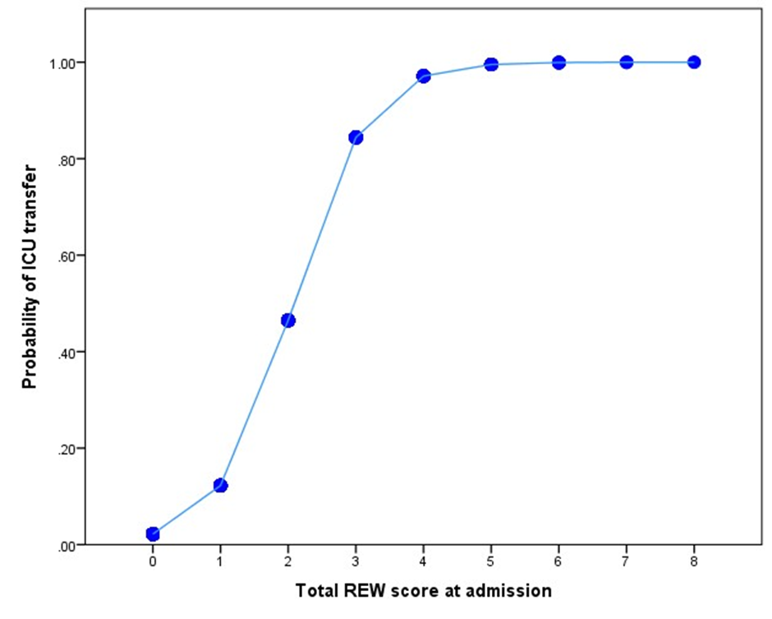

Supplementary Figure 2. The likelihood of in-hospital death increased with a rise in the total Ramathibodi early warning score (REWS) at admission (from logistic regression equation).

