Appendix A- 2022 Post-Clerkship Survey

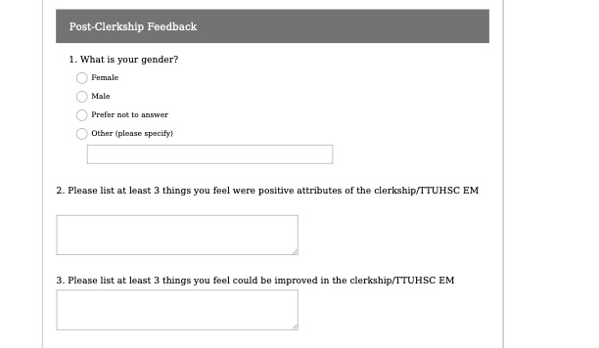
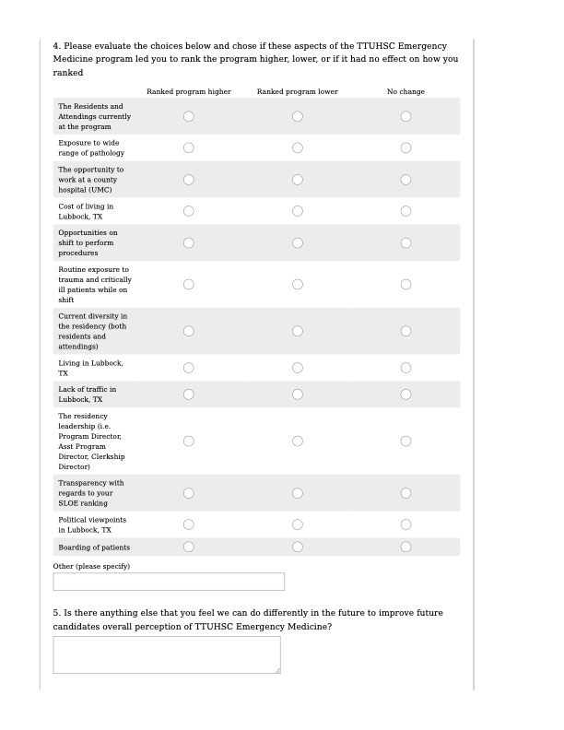

Appendix B-2023 Post-Clerkship Survey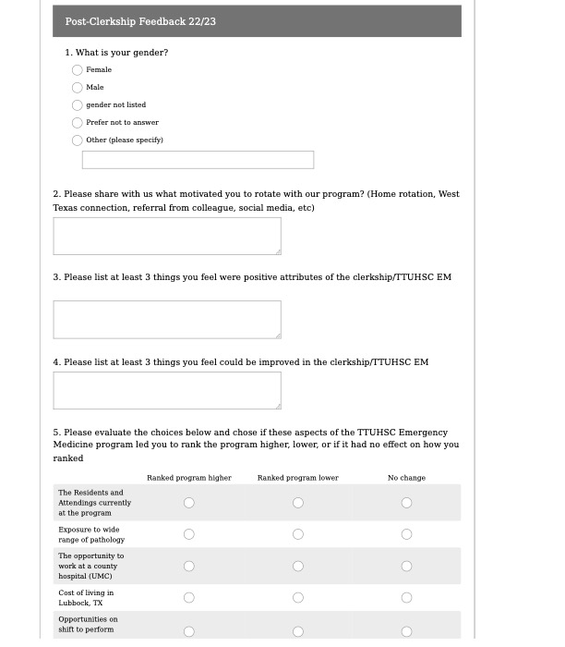
Appendix B continued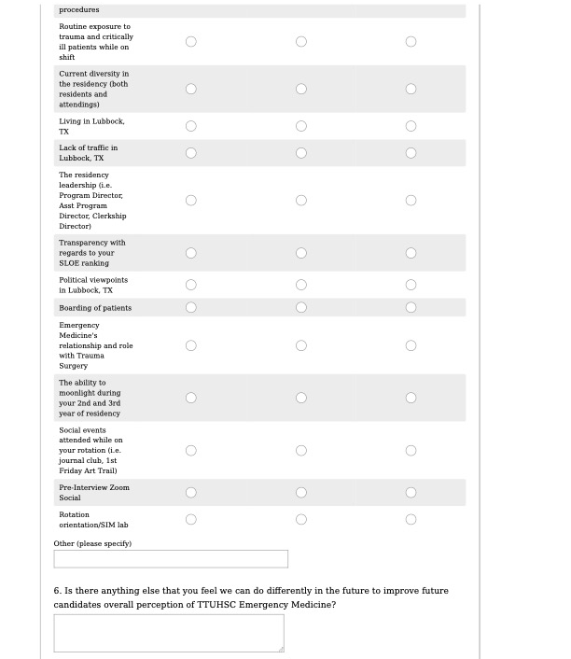

Appendix C- 2022 Post-Clerkship Survey Results
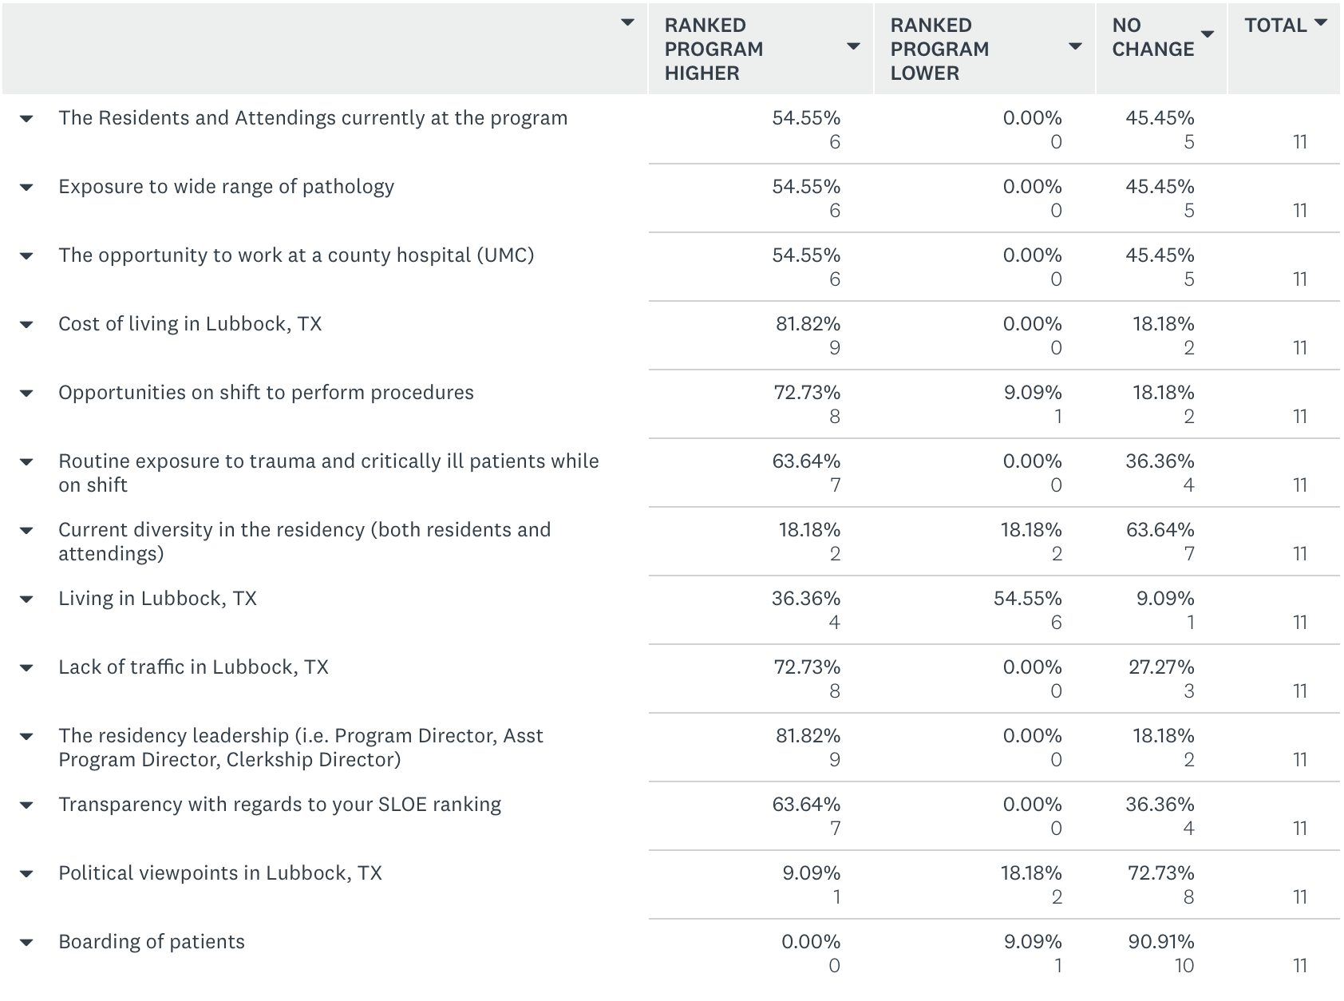

Appendix D- 2023 Post-Clerkship Survey Results
