Supplementary Material

The proallergenic activity of phytopathogenic Erysiphe palczewskii and Erysiphe convolvuli in in vitro studies
Monika Sztandera-Tymoczek¹, Sylwia Wdowiak-Wróbel², Urszula Świderska³, Marta Palusińska-Szysz², and Agnieszka Szuster-Ciesielska^{1*}
*Corresponding author: Agnieszka Szuster-Ciesielska, agnieszka.szuster-ciesielska@mail.umcs.pl

Supplementary Figures

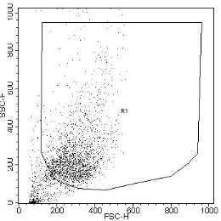 | 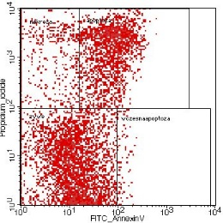 | 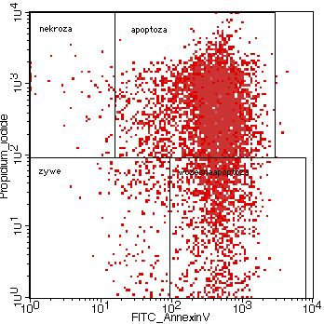
R1 gate | C(-) | C(+)
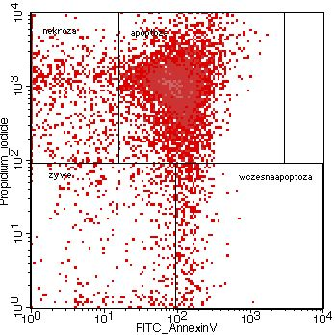 | 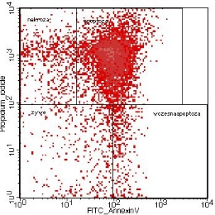 | 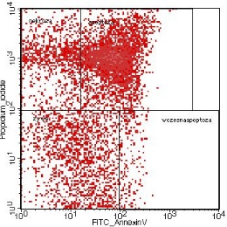
400 µg protein/ml | 200 µg protein/ml | 100 µg protein/ml
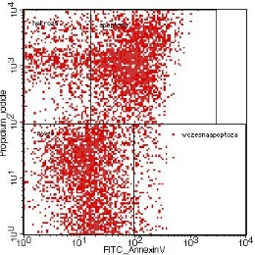 | 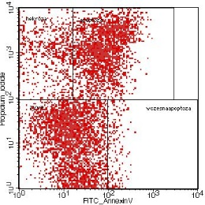 | 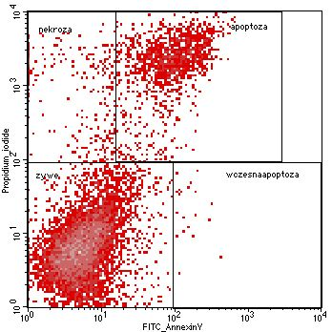
50 µg protein/ml | 25 µg protein/ml | 12.5 µg protein/ml

Supplementary Figure 1. Evaluation of cell viability in the A549 line after 24-hour incubation with the E. palczewskii fungal extract (representative cytometric dot blots). C(-) - negative control (without the addition of the fungal extract), C(+) - positive control (DMSO [5%]).

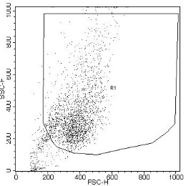 |  | 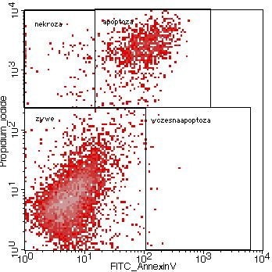 |  | 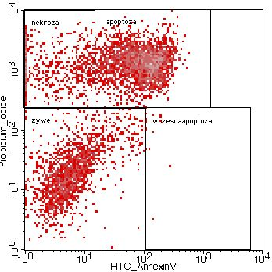
R1 gate |  | C(-) |  | C(+)
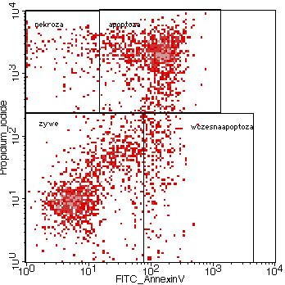 |  | 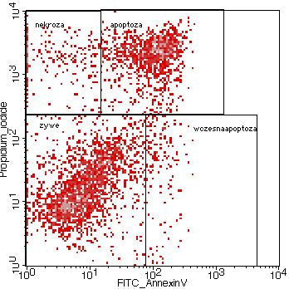 |  | 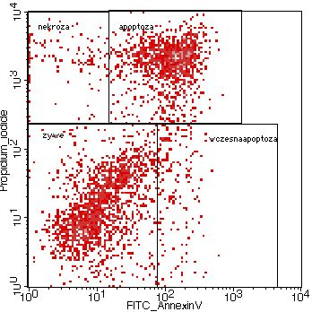
400 µg protein/ml |  | 200 µg protein/ml |  | 100 µg protein/ml
 | 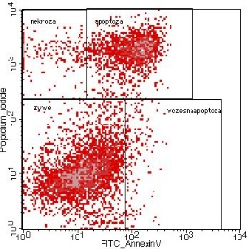 |  | 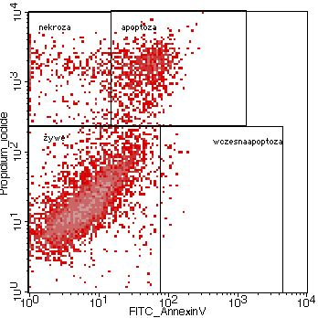
 | 50 µg protein/ml |  | 25 µg protein/ml
Supplementary Figure 2. Evaluation of cell viability in the BEAS-2B line after 24-hour incubation with the E. palczewskii fungal extract (representative cytometric dot blots). C(-) - negative control (without the addition of the fungal extract), C(+) - positive control (DMSO [5%]).

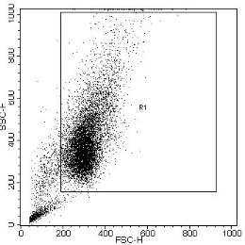 | 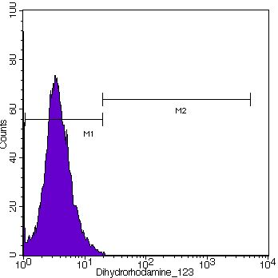 | 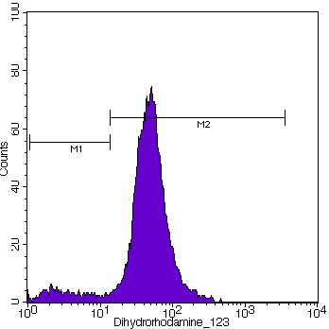
R1 gate | C(-) | C(+)
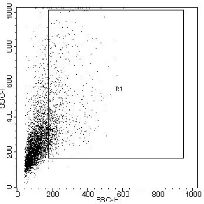 | 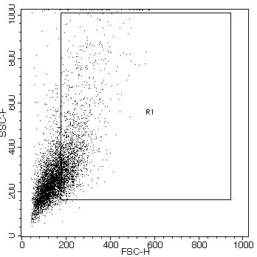 | 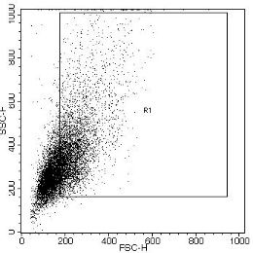
400 µg protein/ml | 200 µg protein/ml | 100 µg protein/ml
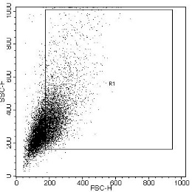 | 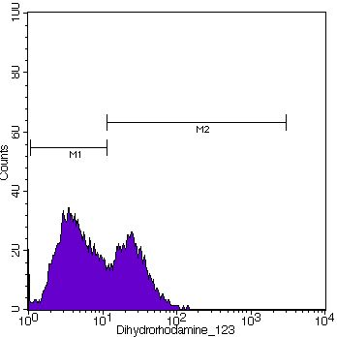 | 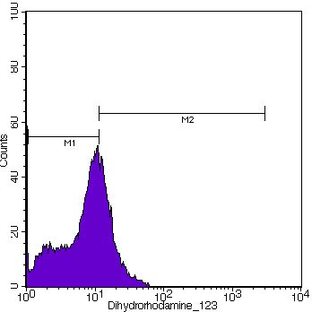
50 µg protein/ml | 25 µg protein/ml | 12.5 µg protein/ml
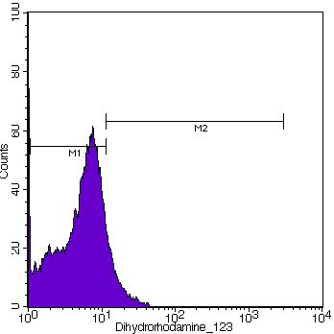 | 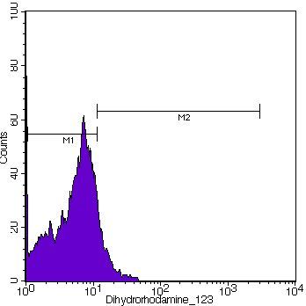 | 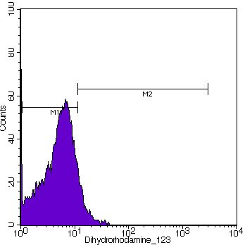
6.25 µg protein/ml | 3.125 µg protein/ml | 1.56 µg protein/ml

Supplementary Figure 3. Effect of the E. palczewskii extract on the production of reactive oxygen species (ROS) in the A549 cells after 24-hour incubation (representative cytometric histograms). C(-) - negative control (without the addition of the fungal extract), C(+) - positive control (tBHP [50µM]).

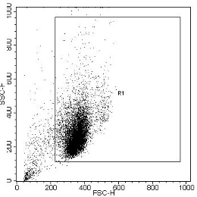 |  | 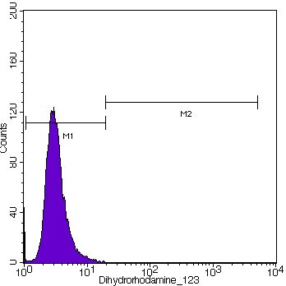 |  | 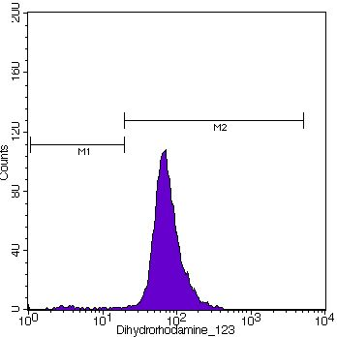
R1 gate |  | C(-) |  | C(+)
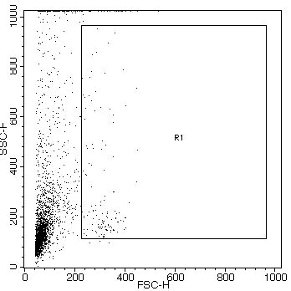 |  | 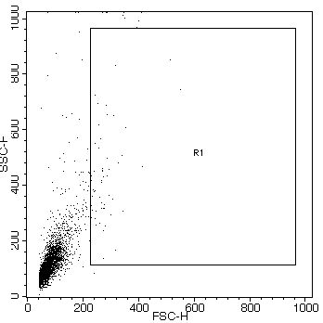 |  | 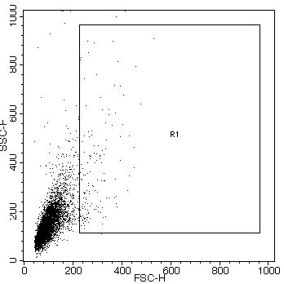
400 µg protein/ml |  | 200 µg protein/ml |  | 100 µg protein/ml
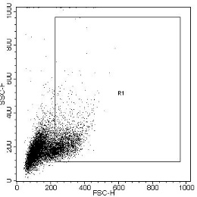 |  | 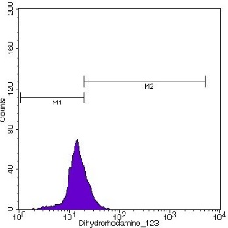 |  | 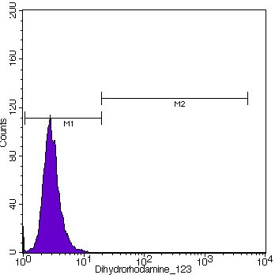
50 µg protein/ml |  | 25 µg protein/ml |  | 12.5 µg protein/ml
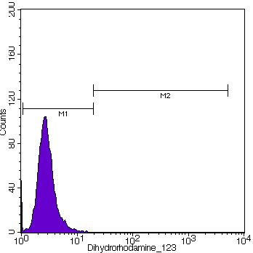 |  | 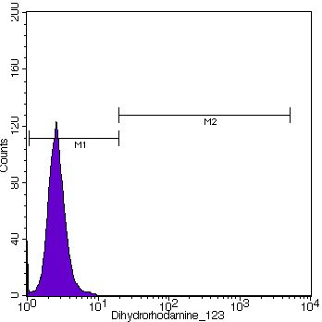
6.25 µg protein/ml |  | 3.125 µg protein/ml |  | 1.56 µg protein/ml
Supplementary Figure 4. Effect of E. the palczewskii extract on the production of reactive oxygen species (ROS) in the BEAS-2B cells after 24-hour incubation (representative cytometric histograms). C(-) - negative control (without the addition of the fungal extract), C(+) - positive control (tBHP [50µM]).

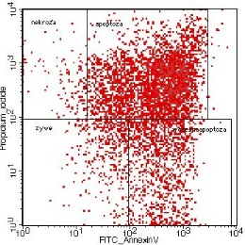
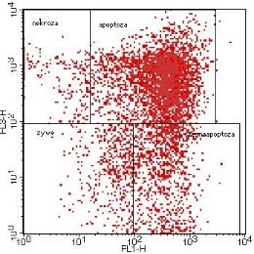
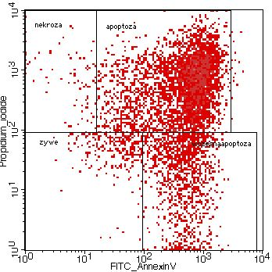
R1gate C(-) C(+)

400 µg protein/ml | 200 µg protein/ml | 100 µg protein/ml
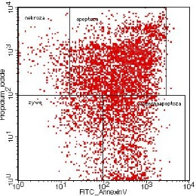
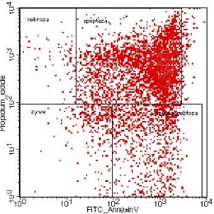

50 µg protein/ml | 25 µg protein/ml | 12.5 µg protein/ml
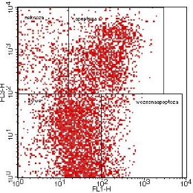
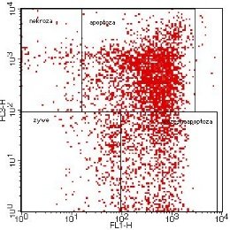
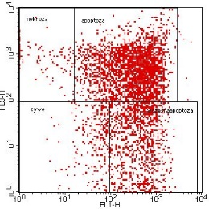

6.25 µg protein/ml | 3.125 µg protein/ml | 1.56 µg protein/ml

Supplementary Figure 5. Evaluation of cell viability in the A549 line after 24-hour incubation with the E. convolvuli fungal extract (representative cytometric dot blots). C(-) - negative control (without the addition of the fungal extract), C(+) - positive control (DMSO [5%]).

R1 gate C(-) C(+)
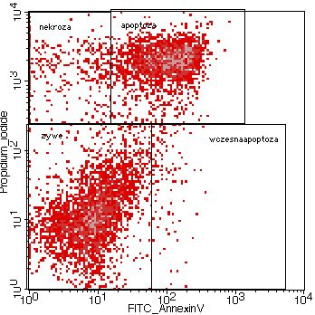
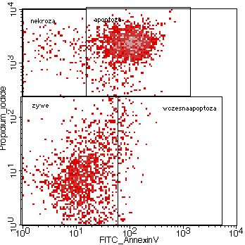
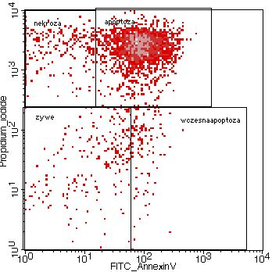

400 µg protein/ml | 200 µg protein/ml | 100 µg protein/ml
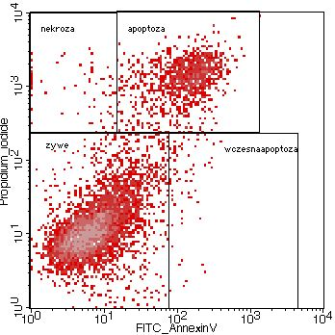
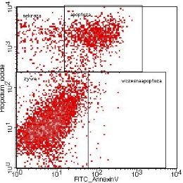
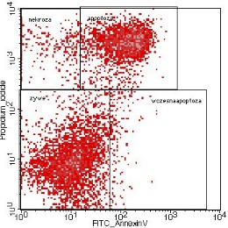

50 µg protein/ml | 25 µg protein/ml | 12.5 µg protein/ml

Supplementary Figure 6. Evaluation of cell viability in the BEAS-2B line after 24-hour incubation with the E. convolvuli fungal extract (representative cytometric dot blots). C(-) - negative control (without the addition of the fungal extract), C(+) - positive control (DMSO [5%]).

R1 gate | C(-) | C(+)
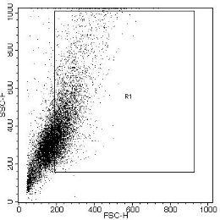
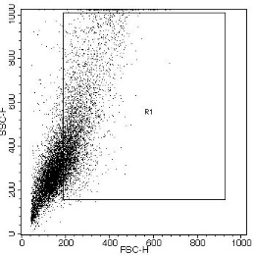
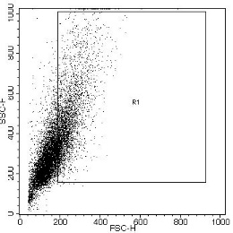

400 µg protein/ml | 200 µg protein/ml | 100 µg protein/ml
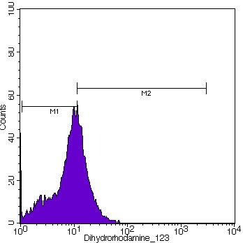
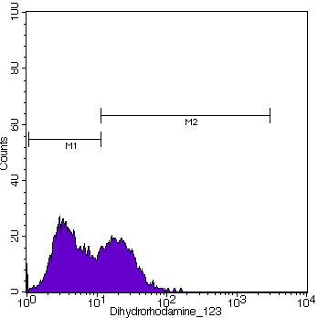
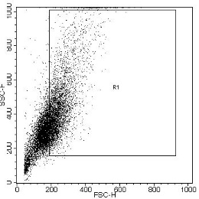

50 µg protein/ml | 25 µg protein/ml | 12.5 µg protein/ml

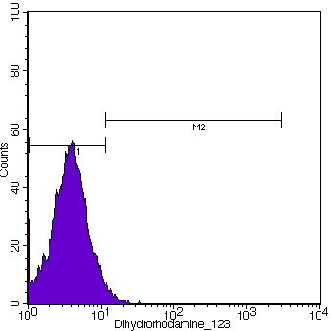
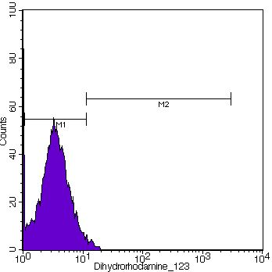
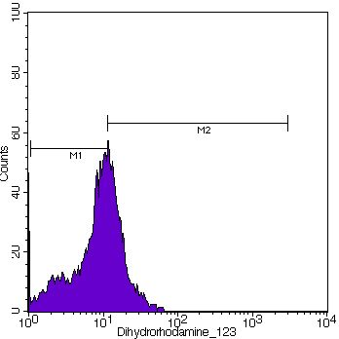

6.25 µg protein/ml | 3.125 µg protein/ml | 1.56 µg protein/ml

Supplementary Figure 7. Effect of the E. convolvuli extracts on the production of reactive oxygen species (ROS) in the A549 cells after 24-hour incubation (representative cytometric histograms). C(-) - negative control (without the addition of the fungal extract), C(+) - positive control (tBHP [50µM]).

R1 gate | C(-) | C(+)
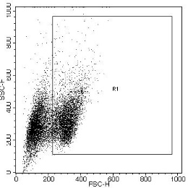
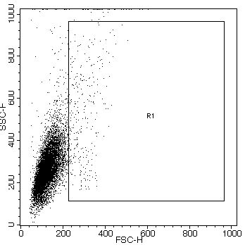
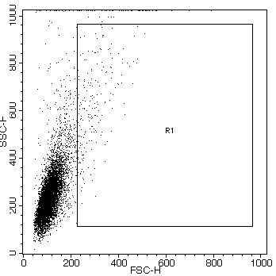

400 µg protein/ml | 200 µg protein/ml | 100 µg protein/ml
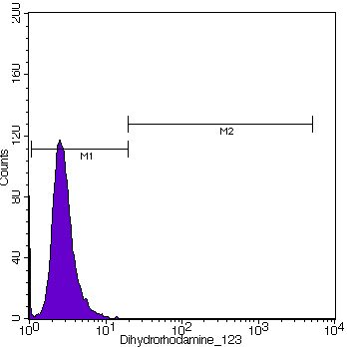
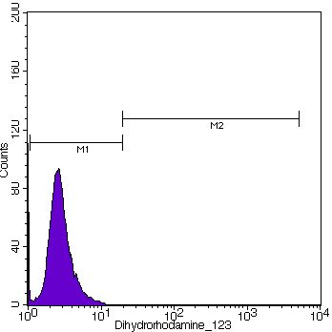
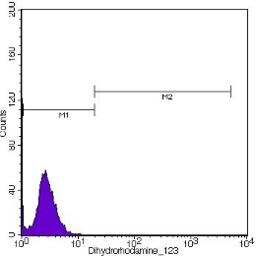

50 µg protein/ml | 25 µg protein/ml | 12.5 µg protein/ml

Supplementary Figure 8. Effect of the E. convolvuli extracts on the production of reactive oxygen species (ROS) in the BEAS-2B cells after 24-hour incubation (representative cytometric histograms). C(-) - negative control (without the addition of the fungal extract), C(+) - positive control (tBHP [50µM]).

