Supplementary information
Supplementary information S1: Description of variables based on questions from BOLD core questionnaire.
Smoking Status:
Have you ever smoked cigarettes?
How old were you when you first started regular cigarette smoking?
If you have stopped smoking, how old were you when you last stopped?
On average over the entire time that you smoke(d), about how many cigarettes per day do (did) you smoke?
Symptoms: based on presence or absence of symptom(s)
Cough
Do you usually cough when you don't have a cold?
Do you cough on most days for as much as three months each year?
Phlegm
Do you usually bring up phlegm from your chest, or do you usually have phlegm in your chest that is difficult to bring up when you don't have a cold?
Do you bring up phlegm on most days for as much as three months each year?
Wheezing/whistling
Have you had wheezing or whistling in your chest at any time in the last 12
months?
In the last 12 months, have you ever had an attack of wheezing or whistling that has made you feel short of breath?
Breathlessness
Are you troubled by shortness of breath when hurrying on the level or walking up a slight hill?
Do you have to walk slower than people of your age on level ground because of shortness of breath?
Do you ever have to stop for breath when walking at your own pace on level ground?
Do you ever have to stop for breath after walking about 100 yards (or after a few minutes) on level ground?
Are you too short of breath to leave the house or short of breath on dressing or undressing?
Exacerbation risk:
Have you ever had a period when you had breathing problems that got so bad that they interfered with your usual daily activities?
For how many of these episodes did you need to see a doctor in the past 12
months?
For how many of these episodes did you get hospitalized in the past 12 months?
Self-reported clinical diagnosis of current Asthma:
Has a doctor or other health care provider ever told you that you have asthma, asthmatic bronchitis or allergic bronchitis?
Do you still have asthma, asthmatic bronchitis or allergic bronchitis?

Figures S1
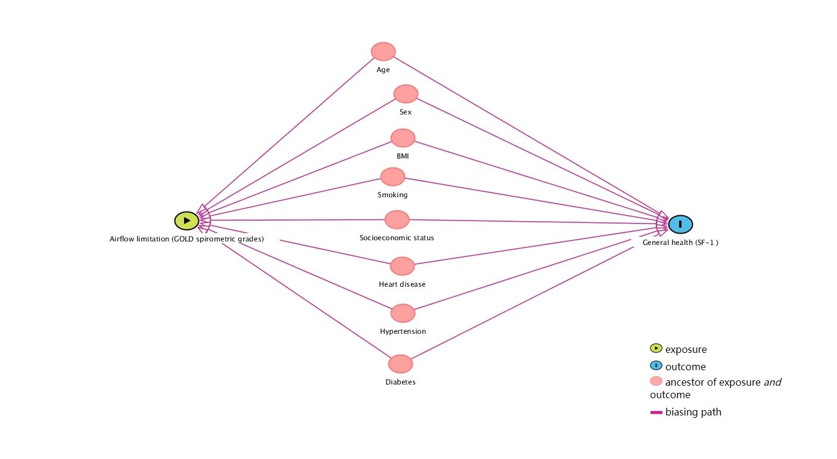
Directed Acyclic Graph (DAG) showing association between airflow limitation and general health (defined by SF-1)
Figures S2
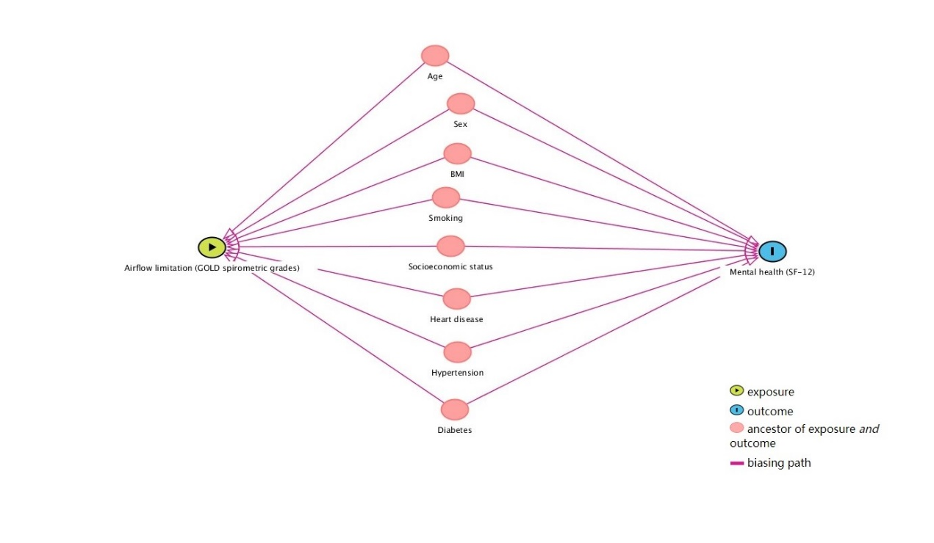
Directed Acyclic Graph (DAG) showing association between airflow limitation and mental health (defined by SF-12)
Figures S3
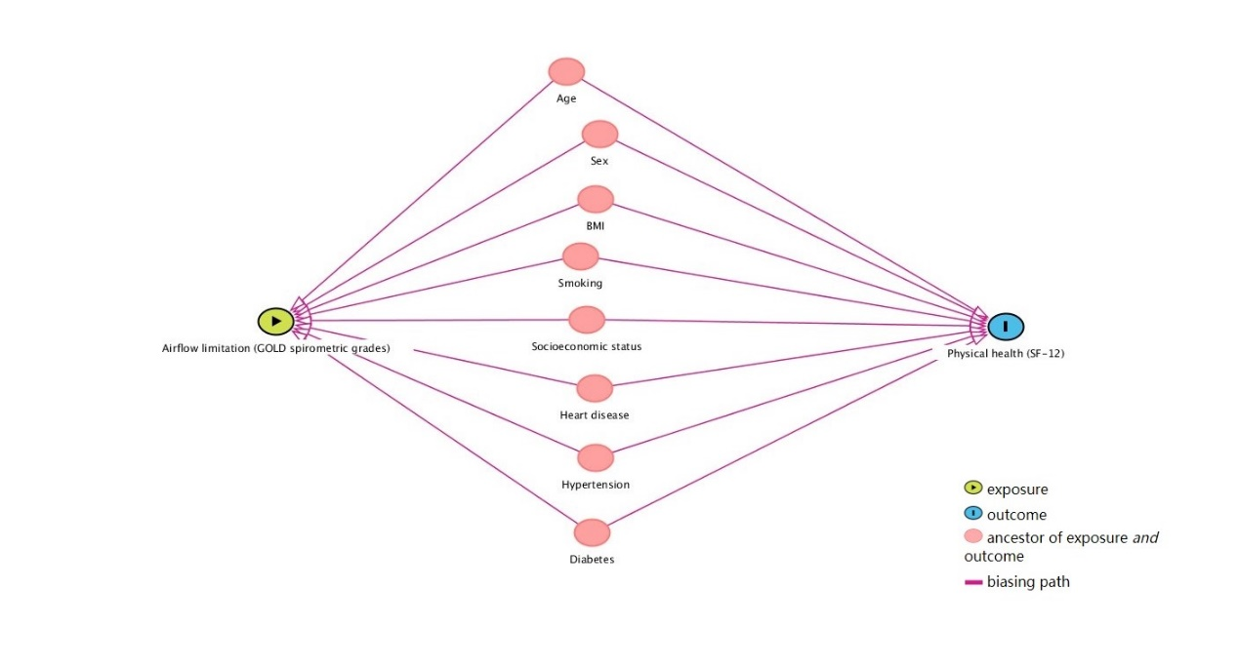
Directed Acyclic Graph (DAG) showing association between airflow limitation and physical health (defined by SF-12)

