Supplement
Plethysmography Procedure: Subjects began with a series of normal breaths in the plethysmograph until the end of each tidal exhalation was stable (on the y-axis of the spirogram). The average of the last three breaths was used to signify functional residual capacity (FRC). Subjects then followed a breathing rate as defined by protocol being performed (i.e. tidal breathing or panting, see manuscript). SR_{aw} was quantified over last 5 breaths during this period. The subject’s breaths were then occluded by an automated shutter system, to quantify volume of thoracic gas (VTG). VTG represents the gas in the thorax during occlusion and allows the preceding FRC to be plotted correctly on the y-axis of the spirogram. The subject was then allowed to return to normal breathing (i.e. return to FRC level), at which point the subject exhaled fully to residual volume (RV) and inhaled fully to total lung capacity (TLC) (see figure S1.) This procedure was repeated in order to obtain three measurements of FRC, expiratory reserve volume (ERV) and vital capacity (VC). RV was calculated as the average FRC minus the average ERV. TLC was calculated by adding the calculated RV to the highest VC.
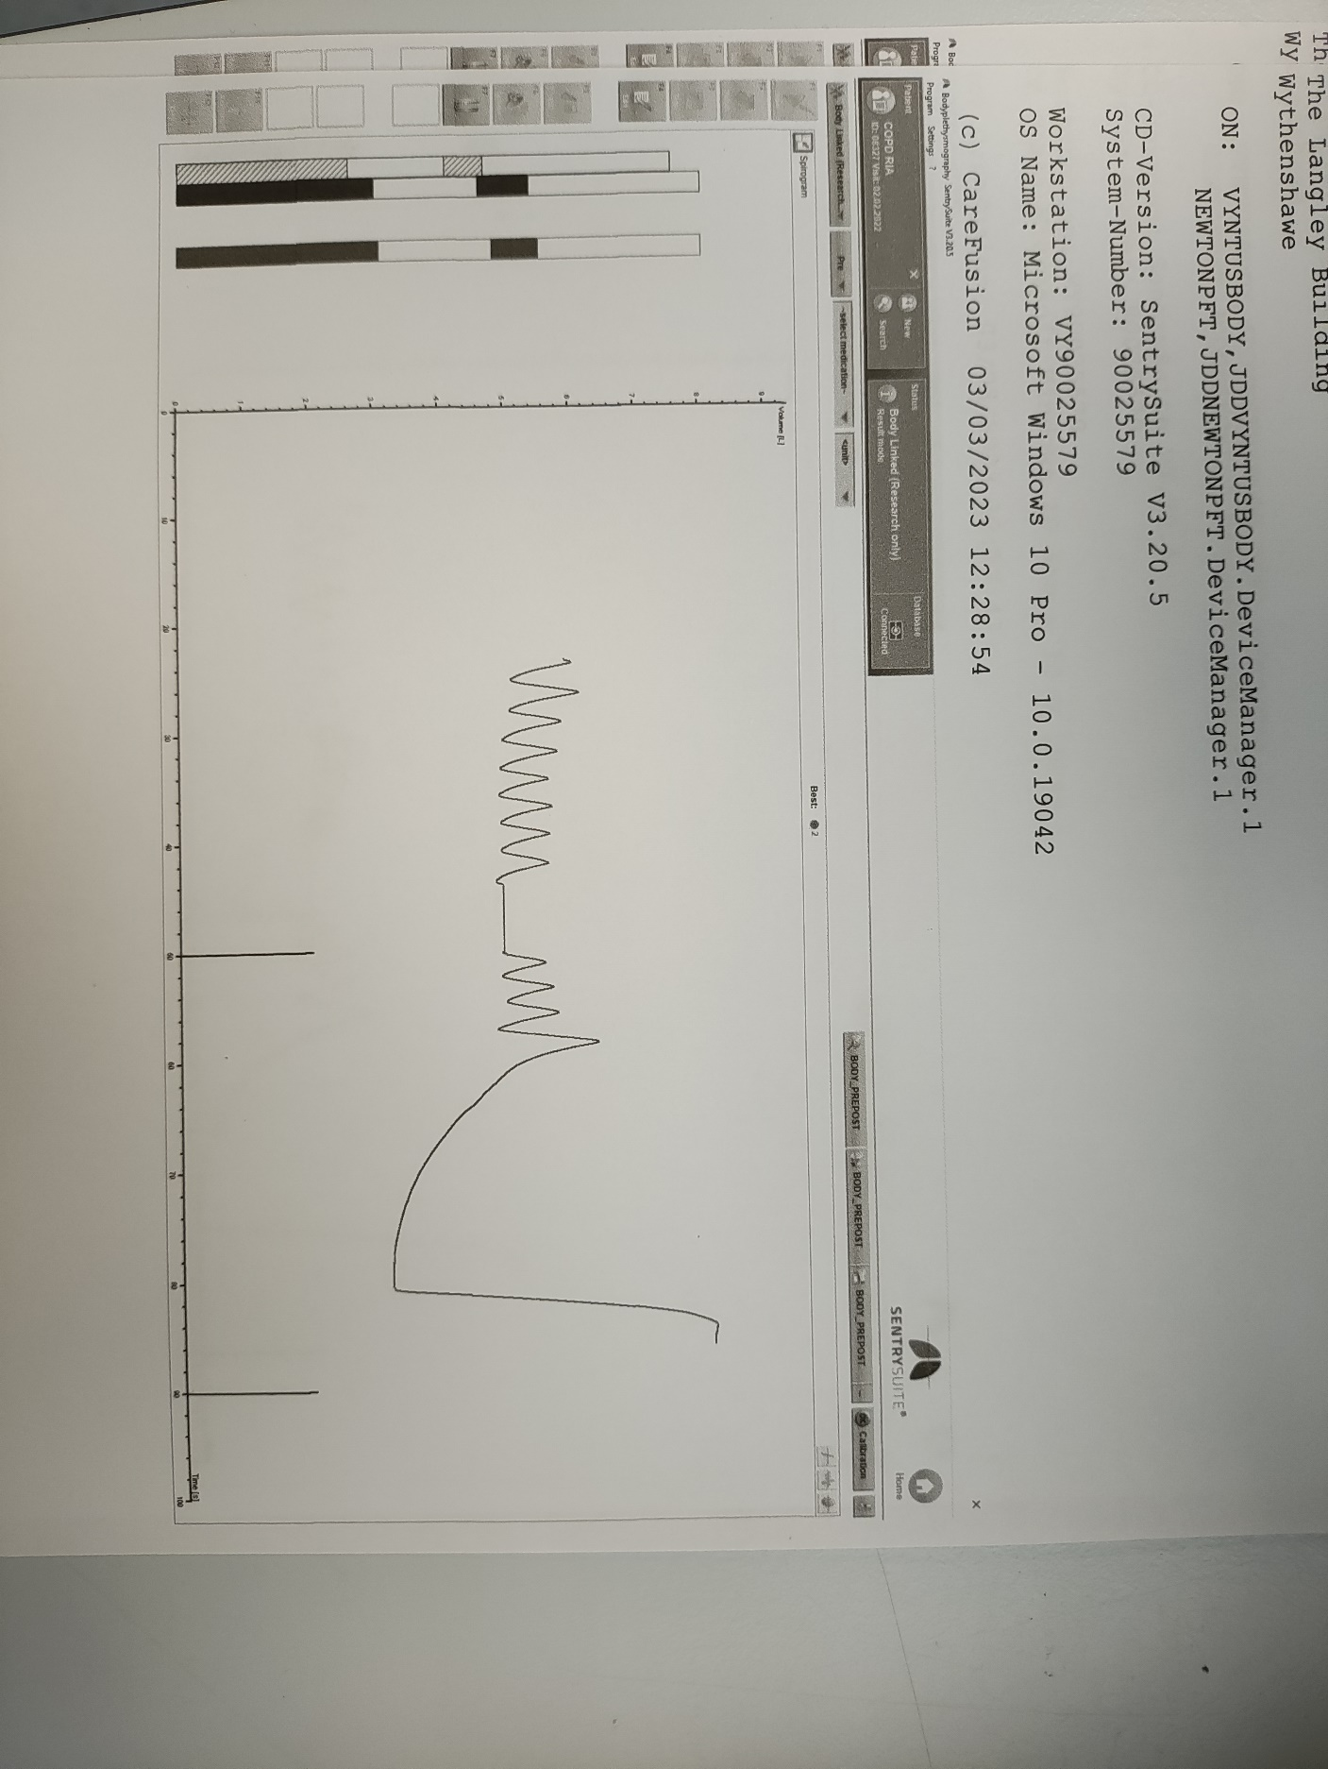
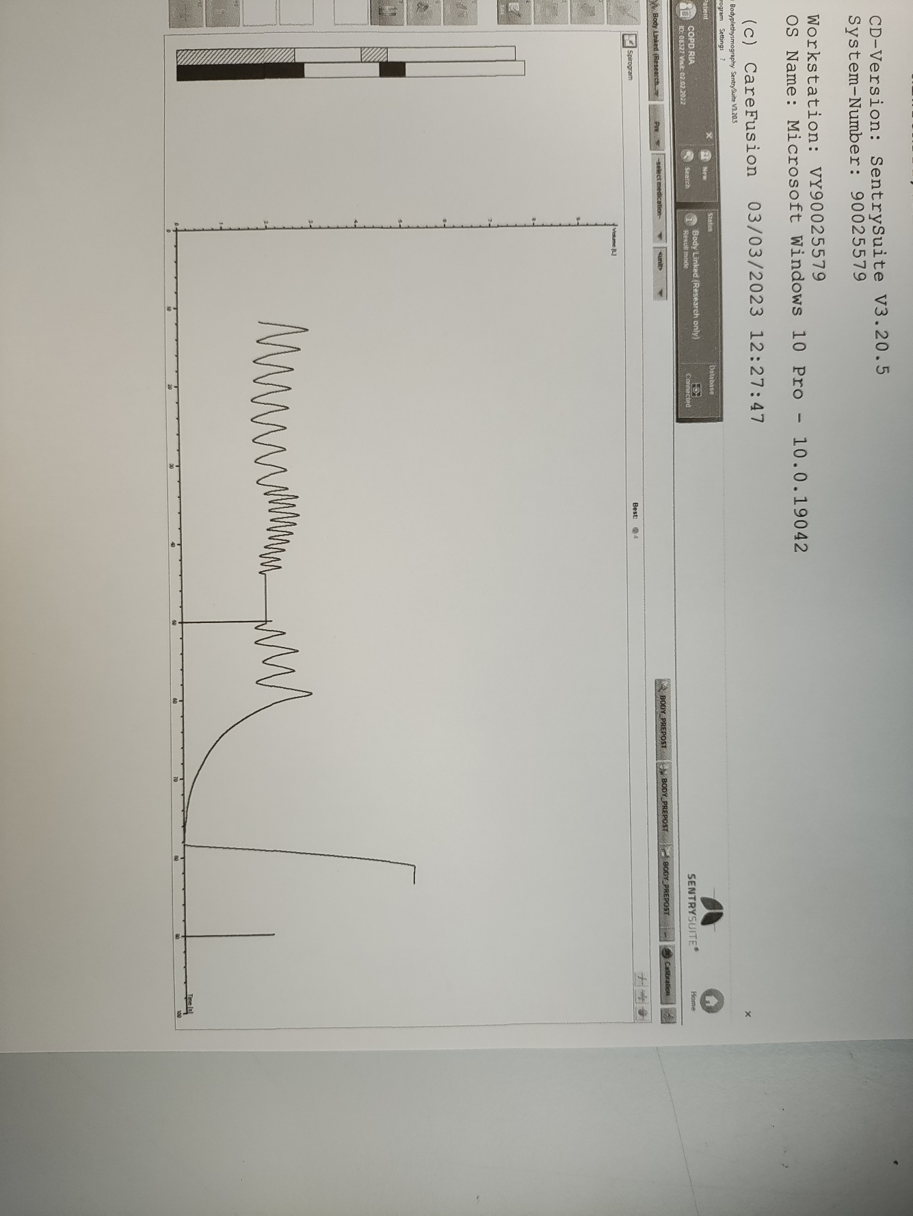
A)
B)
Figure S1. Example of the plethysmography trace using tidal breathing SR_{aw} (A) and panting SR_{aw} (B). Box key: Shaded area – tidal breathing (FRC & tidal SR_{aw} determination); White area – panting (panting SR_{aw} determination); Black area – occlusion (VTG determination); Chequered area – ERV+VC manoeuvre.
Table S1. Breathing frequency and lung volumes measured by tidal protocol 1 and panting protocol.
Parameter | Tidal Protocol 1 | Panting Protocol | p value
Breathing frequency (bpm) | 15.4 (12.7-20.0) | 57.6 (51.6-63.2) | <0.0001
TLC %predicted | 105.3 (±13.1) | 104.0 (±12.6) | 0.06
VC %predicted | 101.2 (±13.8) | 101.0 (±12.5) | 0.74
IC %predicted | 94.4 (88.2-114.0) | 92.0 (82.6-108.9) | 0.06
FRC %predicted | 113.1 (±28.2) | 113.4 (±27.2) | 0.87
RV %predicted | 117.7 (±39.8) | 114.7 (±40.0) | 0.06
RV/TLC %predicted | 108.6 (±25.3) | 107.0 (±25.5) | 0.11
Values are reported as mean (±SD) or median (IQR). P values calculated using Wilcoxon matched-pairs signed rank test or paired t-test, as appropriate. BPM – breaths per minute; TLC – total lung capacity; VC – vital capacity; IC – inspiratory capacity; FRC – functional residual capacity; RV – residual volume.

Table S2. SR_{aw} values measured by tidal protocol 1 and tidal protocol 2.
Parameter | Tidal Protocol 1 | Tidal Protocol 2 | p value
SR_{eff} (kPa∙s) | 1.45 (0.99-1.57) | 1.61 (0.97-2.15) | 0.31
SR_{tot} (kPa∙s) | 1.62 (1.15-1.75) | 1.78 (1.10-2.55) | 0.38
SR_{0.5} (kPa∙s) | 0.95 (0.72-1.47) | 1.12 (0.74-1.60) | 0.09
SR_{mid} (kPa∙s) | 1.23 (0.80-1.54) | 1.37 (0.94-1.92) | 0.23
Values are reported as median (IQR). P values calculated using Wilcoxon matched-pairs signed rank test. SR_{eff} – effective specific resistance; SR_{tot} – total specific resistance; SR_{0.5} – specific resistance at 0.5 L/sec; SR_{mid} – specific resistance through the centre of the loop at 0.5 L/sec.

