Supplemental Table 1 Baseline characteristics before and after IPTW
Characteristics | Before IPTW |  |  |  | After IPTW
Characteristics | NCRT(n=200) | NICT(n=81) | P value | SMD | NCRT(n=262) | NICT(n=275) | P value | SMD
Sex
Male | 176 (88.0%) | 70 (86.4%) | 0.870 | 0.047 | 231 (88.2%) | 242 (88.0%) | 0.969 | 0.005
Female | 24 (12.0%) | 11 (13.6%) |  |  | 31 (11.8%) | 33 (12.0%)
Age
<60 | 83 (41.5%) | 27 (33.3%) | 0.256 | 0.169 | 100 (38.2%) | 117 (42.5%) | 0.718 | 0.089
≥60 | 117 (58.5%) | 54 (66.7%) |  |  | 162 (61.8%) | 158 (57.5%)
Smoking
No | 80 (40.0%) | 35 (43.2%) | 0.718 | 0.065 | 110 (42.0%) | 110 (40.0%) | 0.786 | 0.040
Yes | 120 (60.0%) | 46 (56.8%) |  |  | 152 (58.0%) | 165 (60.0%)
Drinking
No | 90 (45.0%) | 42 (51.9%) | 0.363 | 0.137 | 125 (47.7%) | 142 (51.6%) | 0.609 | 0.079
Yes | 110 (55.0%) | 39 (48.1%) |  |  | 137 (52.3%) | 133 (48.4%)
Comorbidity
No | 128 (64.0%) | 57 (70.4%) | 0.378 | 0.136 | 178 (67.9%) | 186 (67.6%) | 0.965 | 0.006
Yes | 72 (36.0%) | 24 (29.6%) |  |  | 84 (32.1%) | 89 (32.4%)
Family history
No | 192 (96.0%) | 74 (91.4%) | 0.202 | 0.192 | 249 (95.0%) | 261 (94.9%) | 0.962 | 0.006
Yes | 8 (4.0%) | 7 (8.6%) |  |  | 13 ( 5.0%) | 14 ( 5.1%)
KPS
≤80 | 150 (75.0%) | 60 (74.1%) | 0.992 | 0.021 | 193 (73.7%) | 210 (76.4%) | 0.662 | 0.062
>80 | 50 (25.0%) | 21 (25.9%) |  |  | 69 (26.3%) | 65 (23.6%)
Tumor location
Lower-thoracic | 107 (53.5%) | 36 (44.4%) | 0.166 | 0.252 | 129 (49.2%) | 130 (47.3%) | 0.471 | 0.211
Middle-thoracic | 80 (40.0%) | 42 (51.95) |  |  | 120 (45.8%) | 116 (42.2%)
Upper-thoracic | 13 (6.5%) | 3 (3.7%) |  |  | 13 ( 5.0%) | 29 (10.5%)
Clinical stage T
T2 | 9 (4.5%) | 5 (6.2%) | 0.602 | 0.127 | 16 ( 6.1%) | 13 ( 4.7%) | 0.542 | 0.198
T3 | 185 (92.5%) | 72 (88.9%) |  |  | 234 (89.3%) | 236 (85.8%)
T4 | 6 (3.0%) | 4 (4.9%) |  |  | 12 ( 4.6%) | 26 ( 9.5%)
Clinical stage N
N0 | 62 (31.0%) | 21 (25.9%) | 0.484 | 0.113 | 78 (29.8%) | 75 (27.3%) | 0.706 | 0.055
N+ | 138 (69.0%) | 60 (74.1%) |  |  | 184 (70.2%) | 200 (72.7%)
Clinical stage TNM
II | 60 (30.0%) | 21 (25.9%) | 0.433 | 0.159 | 76 (29.0%) | 75 (27.3%) | 0.962 | 0.041
III | 137 (68.5%) | 57 (70.4%) |  |  | 178 (67.9%) | 192 (69.8%)
IV | 3 (1.5%) | 3 (3.7%) |  |  | 8 ( 3.1%) | 8 ( 2.9%)
Neoadjuvant cycle
<2 | 27 (13.5%) | 1 (1.2%) | 0.004 | 0.483 | 27 (10.3%) | 21 ( 7.6%) | 0.750 | 0.094
≥2 | 173 (86.5%) | 80 (98.85) |  |  | 235 (89.7%) | 254 (92.4%)
PET-CT
No | 148 (74.0%) | 62 (76.5%) | 0.770 | 0.059 | 197 (75.2%) | 189 (68.7%) | 0.402 | 0.144
Yes | 52 (26.0%) | 19 (23.5%) |  |  | 65 (24.8%) | 86 (31.3%)
EUS
No | 88 (44.0%) | 29 (35.8%) | 0.259 | 0.168 | 99 (37.8%) | 101 (36.7%) | 0.883 | 0.022
Yes | 112 (56.0%) | 52 (64.2%) |  |  | 163 (62.2%) | 174 (63.3%)
Chemotherapy
TP | 179 (89.5%) | 75 (92.6%) | 0.566 | 0.108 | 181 (69.1%) | 221 (80.4%) | 0.065 | 0.262
FP | 21 (10.5%) | 6 (7.4%) |  |  | 81 (30.9%) | 54 (19.6%)
Surgical approach
Thoracotomy | 63 (31.5%) | 19 (23.5%) | 0.231 | 0.181 | 29 (11.1%) | 18 ( 6.5%) | 0.257 | 0.160
MIE | 137 (68.5%) | 62 (76.5%) |  |  | 233 (88.9%) | 257 (93.5%)
Surgical interval(week)ª | 5.78±1.34 | 5.67±1.46 | 0.548 | 0.078 | 5.81±1.34 | 5.71±1.41 | 0.644 | 0.070

Abbreviations: IPTW, inverse probability of treatment weighting; NCRT, neoadjuvant chemoradiotherapy; NICT, neoadjuvant immunotherapy combined with chemotherapy; SMD, standardized mean difference; Comorbidity: including hypertension, diabetes mellitus, chronic obstructive pulmonary disease, coronary atherosclerotic heart disease; KPS, Karnofsky Performance Status; EUS, endoscopic ultrasound; TP, platinum-based drugs and paclitaxel/albumin paclitaxel; PF, platinum-based drugs and fluorouracil; MIE, minimally invasive esophagectomy; ª, Data presented as mean ± standard deviation.
Supplemental Table 2 Comparative analysis of pathological outcomes between NCRT and NICT before and after IPTW.
Clinicopathologic  characteristics | Before IPTW After IPTW
Clinicopathologic  characteristics | NCRT(n=200) | NICT(n=81) | P value | NCRT(n=262) | NICT(n=275) | P value
TRG
0 | 113 (56.5%) | 30 (37.0%) | 0.012 | 151 (57.6%) | 93 (33.8%) | 0.012
1 | 28 (14.0%) | 22 (27.2%) |  | 34 (13.0%) | 63 (22.9%)
2 | 42 (21.0%) | 22 (27.2%) |  | 58 (22.1%) | 94 (34.2%)
3 | 17 (8.5%) | 7 (8.6%) |  | 19 ( 7.3%) | 25 ( 9.1%)
R0 resection
Yes | 196 (98.0%) | 79 (97.5%) | 1.000 | 257 (98.1%) | 268 (97.5%) | 0.745
No | 4 (2.0%) | 2 (2.5%) |  | 5 ( 1.9%) | 7 ( 2.5%)
pCR
pCR | 94 (47.0%) | 24 (29.6%) | 0.011 | 125 (47.7%) | 76 (27.6%) | 0.005
Non-pCR | 106 (53.0%) | 57 (70.4%) |  | 137 (52.3%) | 199 (72.4%)
Primary lesion
complete pathological remission | 107 (53.5%) | 29 (35.8%) | 0.011 | 144 (55.0%) | 90 (32.7%) | 0.003
No | 93 (46.5%) | 52 (64.2%) |  | 118 (45.0%) | 185 (67.3%)
Lymph nodes
complete pathological remission | 159 (79.5%) | 55 (67.9%) | 0.056 | 209 (79.8%) | 169 (61.5%) | 0.010
No | 41 (20.5%) | 26 (32.1%) |  | 53 (20.2%) | 106 (38.5%)
Neural invasion
Yes | 17 (8.5%) | 4 (4.9%) | 0.437 | 18 ( 6.9%) | 15 ( 5.5%) | 0.679
No | 183 (91.5%) | 77 (95.1%) |  | 244 (93.1%) | 260 (94.5%)
LVSI
Yes | 3 (1.5%) | 7 (8.6%) | 0.010 | 3 ( 1.1%) | 22 ( 8.0%) | 0.002
No | 197 (98.5%) | 74 (91.4%) |  | 259 (98.9%) | 253 (92.0%)
Abbreviations: IPTW, inverse probability of treatment weighting; NCRT, neoadjuvant chemoradiotherapy; NICT, neoadjuvant immunotherapy combined with chemotherapy; TRG, tumor regression grade; pCR, pathological complete remission; LVSI, lymphovascular invasion.

Supplemental Table 3 Postoperative information.
Postoperative information | Before IPTW After IPTW
Postoperative information | NCRT(n=200) |  | NICT(n=81) |  | P value | NCRT(n=262) |  | NICT(n=275) |  | P value
Postoperative complications | 54(27.0%) | 17(21.0%) |  | 0.295 |  | 74 (28.2%) | 72 ( 26.2%) |  | 0.802
Anastomotic leakage | 30 (15.0%) | 7 (8.6%) |  | 0.154 |  | 41.0 (15.6%) | 23 ( 8.4%) |  | 0.154
Pulmonary complications | 14 (7.0%) | 9 (11.1%) |  | 0.256 |  | 17.0 ( 6.5%) | 44 ( 16.0%) |  | 0.090
Anastomotic Stenosis | 3 (1.5%) | 0 (0.0%) |  | 0.269 |  | 5 ( 1.9%) | 0 ( 0.0%) |  | 0.085
Wound infection/ Others | 7 (3.5%) | 1 (1.2%) |  | 0.303 |  | 11 ( 4.2%) | 5 ( 1.8%) |  | 0.421
POLS(day)a | 17.5±8.9 | 14.7±8.3 |  | 0.014 |  | 17.2±8.7 | 14.9±8.8 |  | 0.069
Abbreviations: IPTW, inverse probability of treatment weighting; NCRT, neoadjuvant chemoradiotherapy; NICT, neoadjuvant immunotherapy combined with chemotherapy; TRG, tumor regression grade; pCR, pathological complete remission; LVSI, lymphovascular invasion.
Supplemental Table 4 Failure modes after radical esophagectomy.
Failure mode | Before IPTW |  |  | After IPTW
Failure mode | NCRT(n=200) | NICT(n=81) | P value | NCRT(n=262) | NICT(n=275) | P value
LRR | 8 (4.0%) | 10 (12.3%) | 0.010 | 9 ( 3.4%) | 34 ( 12.4%) | 0.006
Metastasis | 13 (6.5%) | 1 (1.2%) | 0.067 | 17 ( 6.5%) | 4 ( 1.5%) | 0.112

Abbreviations: IPTW, inverse probability of treatment weighting; NCRT, neoadjuvant chemoradiotherapy; NICT, neoadjuvant immunotherapy combined with chemotherapy; LRR, locoregional recurrences.

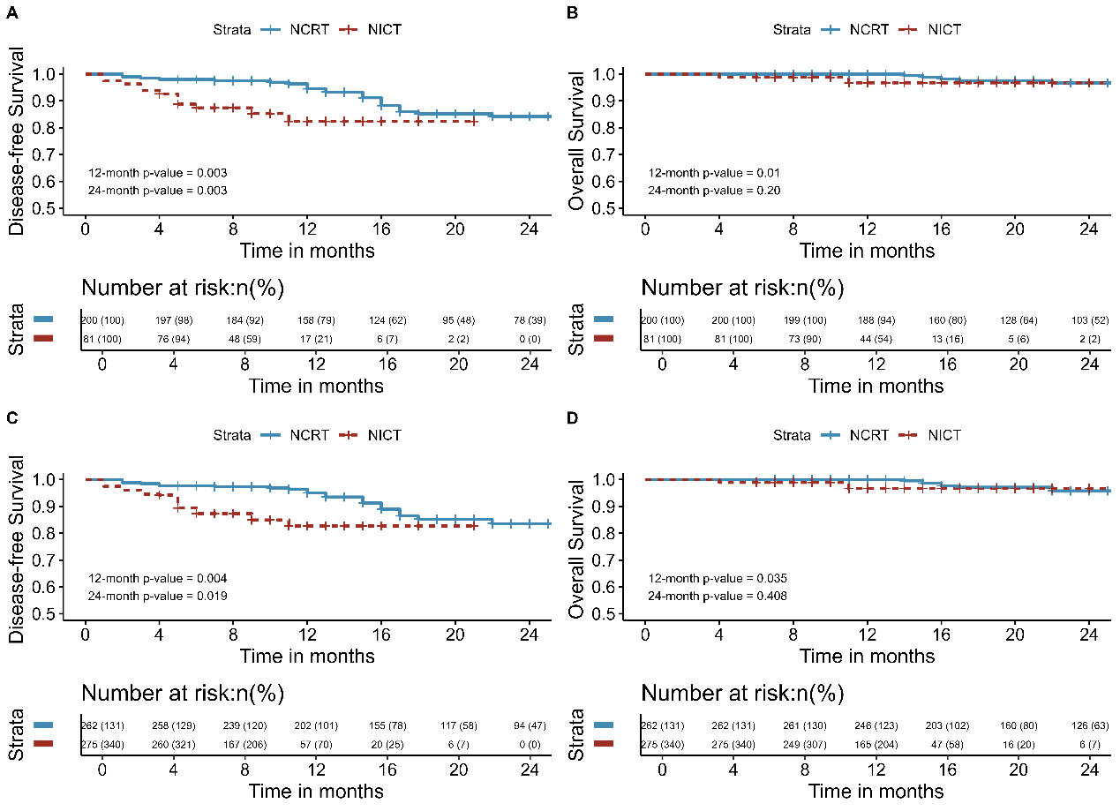
Supplemental Figure 1 Kaplan-Meier survival analysis of DFS (A) and OS (B) between NCRT and NICT before inverse probability of treatment weighting; Kaplan-Meier survival analysis of DFS (C) and OS (D) between NCRT and NICT after inverse probability of treatment weighting
Abbreviations: DFS, disease-free survival; OS, overall survival; NCRT, neoadjuvant chemoradiotherapy; NICT, neoadjuvant immunotherapy combined with chemotherapy.
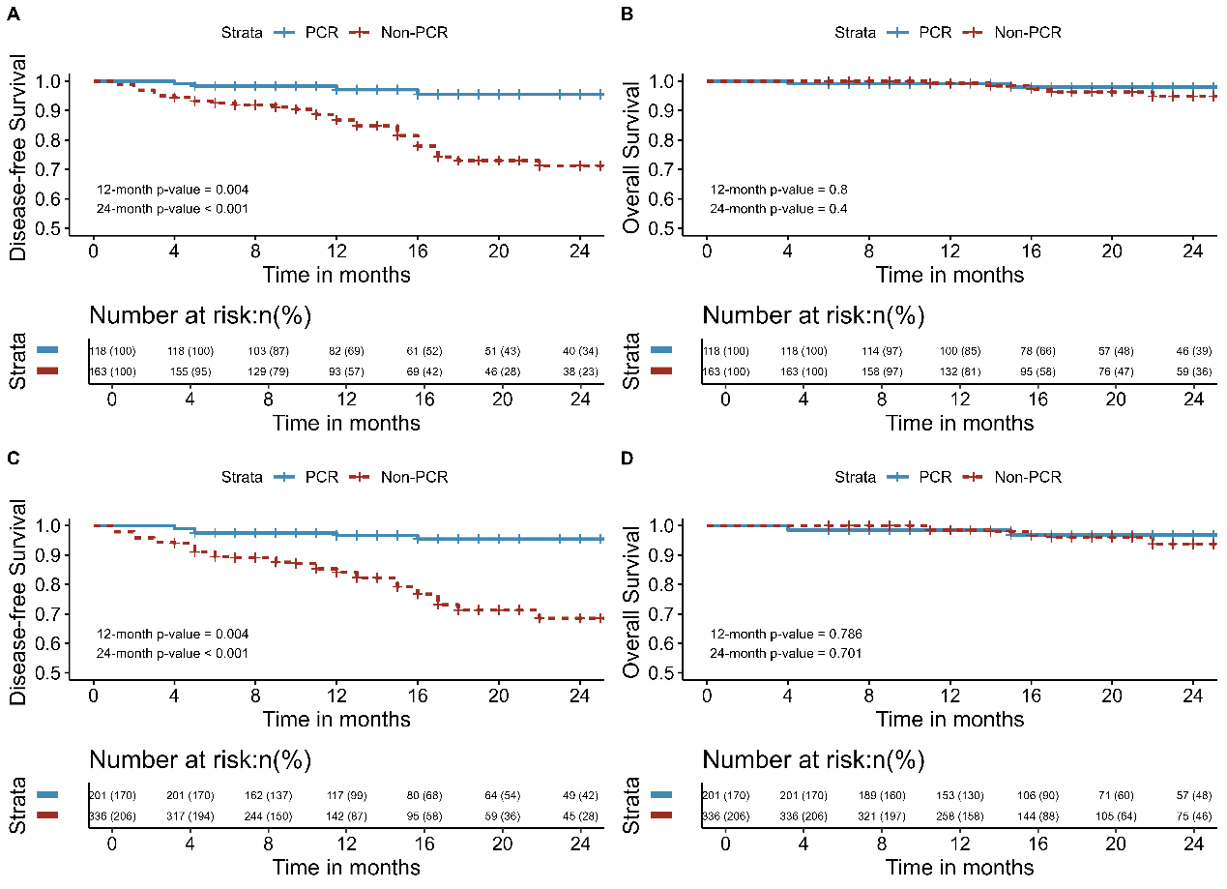
Supplemental Figure 2 Kaplan-Meier survival analysis of DFS (A) and OS (B) between pCR and Non-pCR before inverse probability of treatment weighting; Kaplan-Meier survival analysis of DFS (C) and OS (D) between pCR and Non-pCR after inverse probability of treatment weighting.
Abbreviations: DFS, disease-free survival; OS, overall survival; pCR, pathological complete remission

