Supplementary Table 1. Protein Sites with Over 1.5-fold Change in Crontonylation Levels Following Hypoxic Treatment
Gene name | Position | Regulated Type | Ratio |  | Gene name | Position | Regulated Type | Ratio
ABCB9 | 355 | Down | 0.558 |  | AARS | 19 | Up | 1.907
ALCAM | 152 | Down | 0.658 |  | AHNAK | 5103 | Up | 1.516
ATP1A1 | 36 | Down | 0.586 |  | ALDOA | 330 | Up | 1.768
ATP1A1 | 773 | Down | 0.457 |  | ANXA1 | 161 | Up | 1.512
ATP1B1 | 13 | Down | 0.551 |  | ANXA1 | 245 | Up | 1.598
ATP1B1 | 113 | Down | 0.464 |  | ANXA5 | 309 | Up | 2.069
ATP1B3 | 259 | Down | 0.621 |  | CBR1 | 180 | Up | 1.507
DDX21 | 131 | Down | 0.509 |  | CFL1 | 121 | Up | 1.504
DDX21 | 137 | Down | 0.562 |  | EEF1A1P5 | 386 | Up | 1.626
DDX21 | 285 | Down | 0.504 |  | EEF1A1P5 | 450 | Up | 1.501
DDX21 | 595 | Down | 0.514 |  | EIF4A1 | 174 | Up | 1.508
DDX5 | 33 | Down | 0.663 |  | EIF4H | 76 | Up | 1.799
EPCAM | 229 | Down | 0.663 |  | ENO1 | 228 | Up | 1.85
ERP29 | 237 | Down | 0.62 |  | FSCN1 | 41 | Up | 1.544
FTSJ3 | 214 | Down | 0.61 |  | GART | 404 | Up | 1.692
HIST1H1A | 66 | Down | 0.456 |  | HMGB1 | 43 | Up | 1.533
HIST1H1A | 93 | Down | 0.583 |  | HMGB1 | 59 | Up | 1.616
HIST1H1B | 55 | Down | 0.483 |  | HMGB1 | 88 | Up | 1.598
HIST1H1B | 66 | Down | 0.429 |  | HMGB1 | 172 | Up | 1.758
HIST1H1C | 46 | Down | 0.365 |  | HSP90AB1 | 265 | Up | 9.012
HIST1H1C | 52 | Down | 0.483 |  | IFIT1 | 392 | Up | 1.509
HIST1H1C | 63 | Down | 0.559 |  | MBIP | 139 | Up | 1.511
HIST1H1C | 85 | Down | 0.632 |  | MTHFD1 | 739 | Up | 1.832
HIST1H1C | 90 | Down | 0.583 |  | MYH9 | 403 | Up | 1.661
HIST1H1C | 106 | Down | 0.515 |  | MYH9 | 966 | Up | 1.593
HIST1H2AC | 96 | Down | 0.622 |  | MYH9 | 972 | Up | 1.559
HIST1H2AD | 37 | Down | 0.614 |  | MYH9 | 1330 | Up | 1.581
HIST1H2AH | 37 | Down | 0.587 |  | MYH9 | 1338 | Up | 1.58
HIST1H2AH | 96 | Down | 0.62 |  | MYH9 | 1445 | Up | 1.584
HIST1H4A | 78 | Down | 0.511 |  | MYH9 | 1518 | Up | 1.632
ITGA3 | 1031 | Down | 0.623 |  | MYH9 | 1806 | Up | 1.559
KTN1 | 872 | Down | 0.656 |  | MYH9 | 1862 | Up | 1.653
LRPAP1 | 180 | Down | 0.649 |  | MYL6 | 81 | Up | 1.565
LRPPRC | 1350 | Down | 0.65 |  | NAMPT | 330 | Up | 2.098
NDUFA4 | 10 | Down | 0.623 |  | P4HA1 | 229 | Up | 1.771
NOLC1 | 571 | Down | 0.635 |  | PFKL | 726 | Up | 1.59
NOLC1 | 601 | Down | 0.639 |  | PFKP | 736 | Up | 1.553
PRKCSH | 180 | Down | 0.657 |  | PGK1 | 11 | Up | 1.801
RPL17 | 27 | Down | 0.508 |  | PGK1 | 139 | Up | 1.7
RPL19 | 195 | Down | 0.641 |  | PGK1 | 146 | Up | 1.617
RPL4 | 368 | Down | 0.495 |  | PGK1 | 191 | Up | 1.726
RPL6 | 260 | Down | 0.626 |  | PGK1 | 192 | Up | 2.036
RPL7A | 107 | Down | 0.579 |  | PLOD2 | 335 | Up | 2.313
RPS9 | 22 | Down | 0.612 |  | PPIA | 131 | Up | 1.517
RRBP1 | 270 | Down | 0.642 |  | PRDX6 | 141 | Up | 1.536
RRS1 | 265 | Down | 0.598 |  | PSAT1 | 116 | Up | 1.744
RSL1D1 | 140 | Down | 0.599 |  | RANBP1 | 68 | Up | 1.581
RSL1D1 | 145 | Down | 0.579 |  | RPL5 | 255 | Up | 1.519
RSL1D1 | 254 | Down | 0.628 |  | S100A2 | 27 | Up | 1.686
 |  |  |  |  | S100A2 | 29 | Up | 1.987
 |  |  |  |  | S100A2 | 36 | Up | 1.694
 |  |  |  |  | S100A2 | 41 | Up | 1.698
 |  |  |  |  | S100A2 | 57 | Up | 1.896
 |  |  |  |  | S100A6 | 31 | Up | 1.514
 |  |  |  |  | SET | 177 | Up | 1.598
 |  |  |  |  | SSB | 191 | Up | 1.545
 |  |  |  |  | STAT1 | 379 | Up | 1.567
 |  |  |  |  | TKT | 538 | Up | 1.55
 |  |  |  |  | TPI1 | 43 | Up | 1.732
 |  |  |  |  | TUBA1C | 163 | Up | 1.543
 |  |  |  |  | UPP1 | 184 | Up | 2.053
 |  |  |  |  | YWHAG | 77 | Up | 1.62

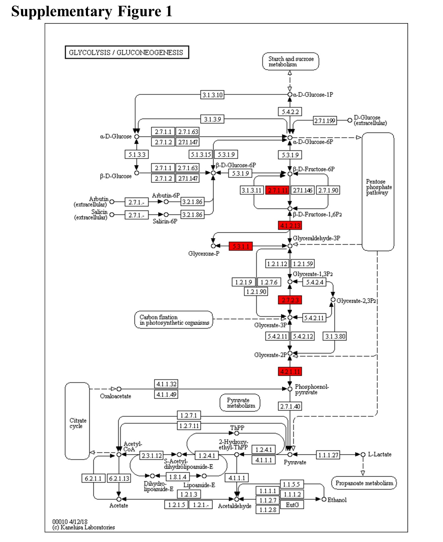
Supplementary Figure 1 The differential crotonylated proteins in glycolysis signaling pathway in OSCC cells after 24 hours of normoxia or hypoxia culture. Notes: 2.7.1.11, PFK, phosphofructokinase; 4.1.2.13, ALDOA, Fructose-bisphosphate aldolase A; 5.3.1.1, TPI1, Triosephosphate isomerase; 2.7.2.3, PGK, Phosphoglycerate kinase; 4.2.1.11, ENO1, Alpha-enolase.

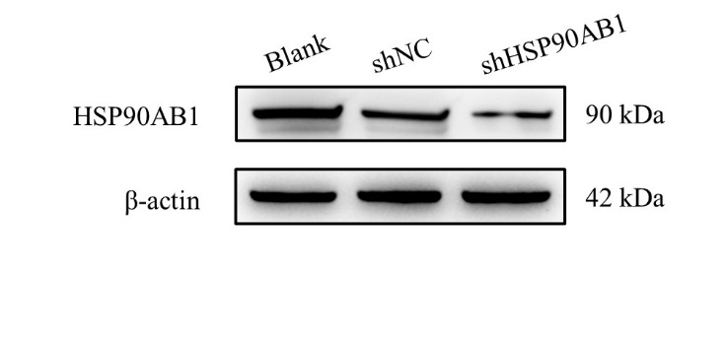
Supplementary Figure 2 Verification of HSP90AB1 knockdown efficiency in CAL27 cells through Western blot assay.

Supplementary File 1. Short Tandem Repeat(STR) analysis of OSCC cell line CAL27.
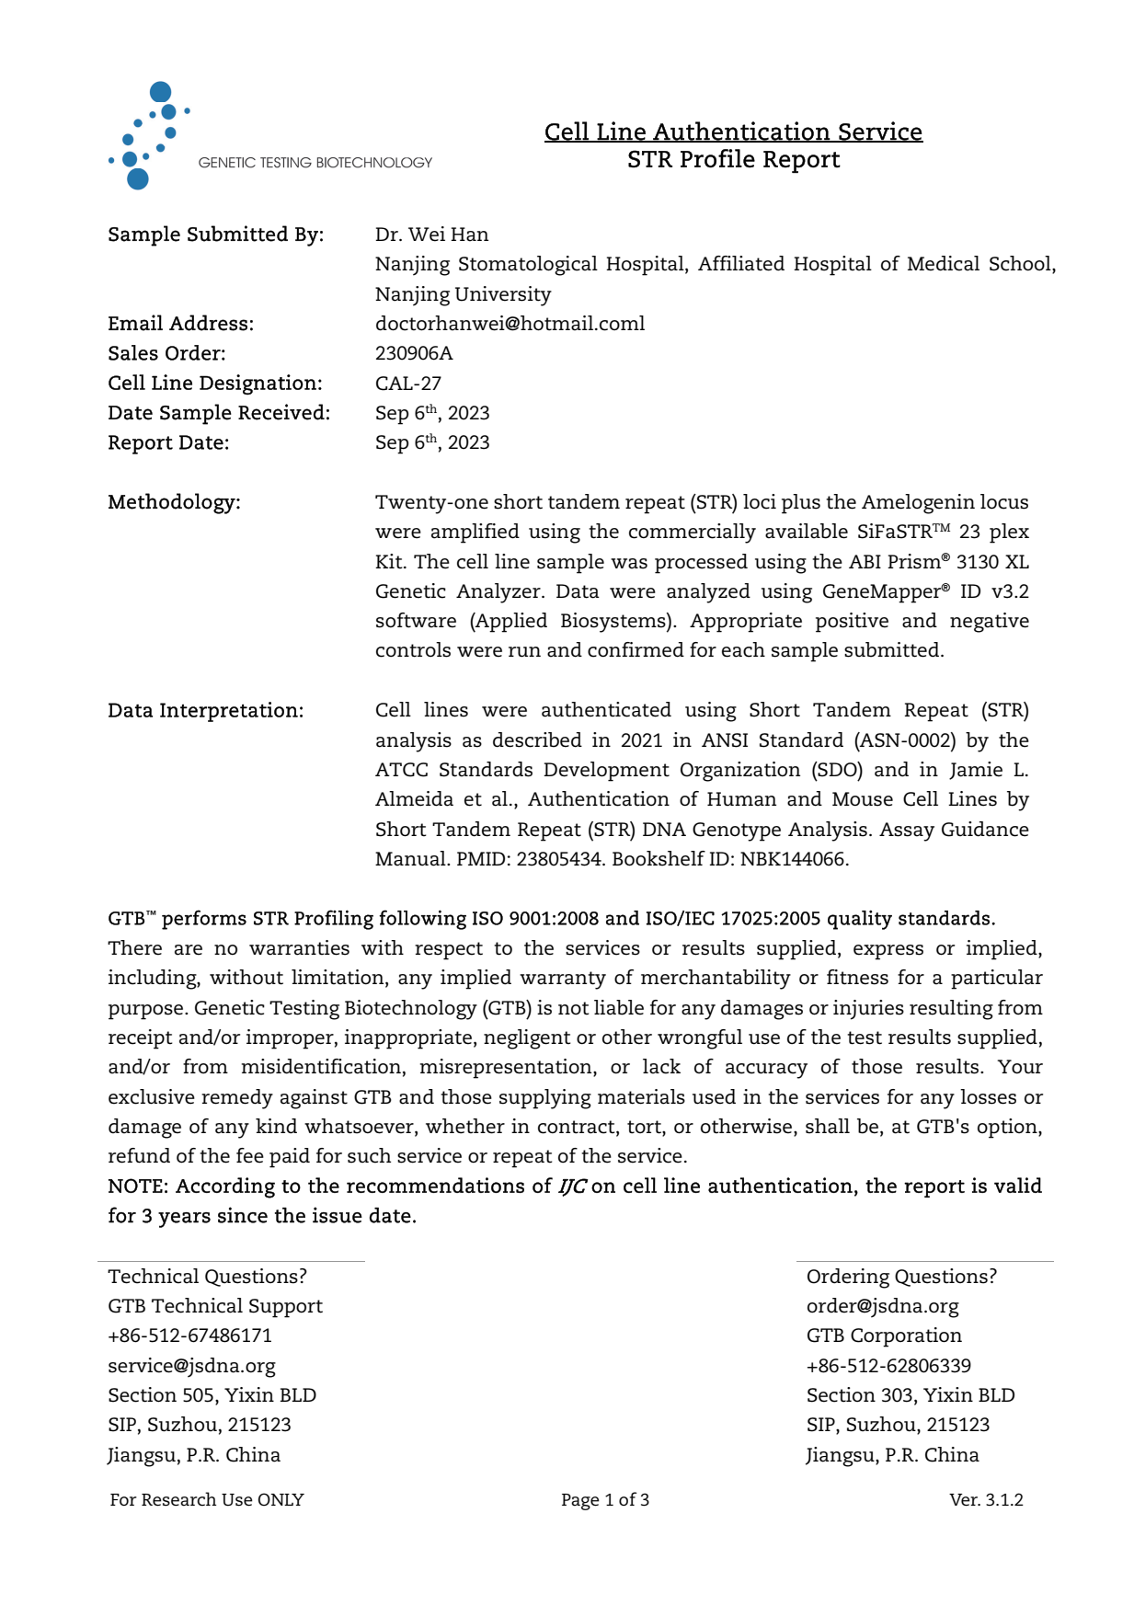
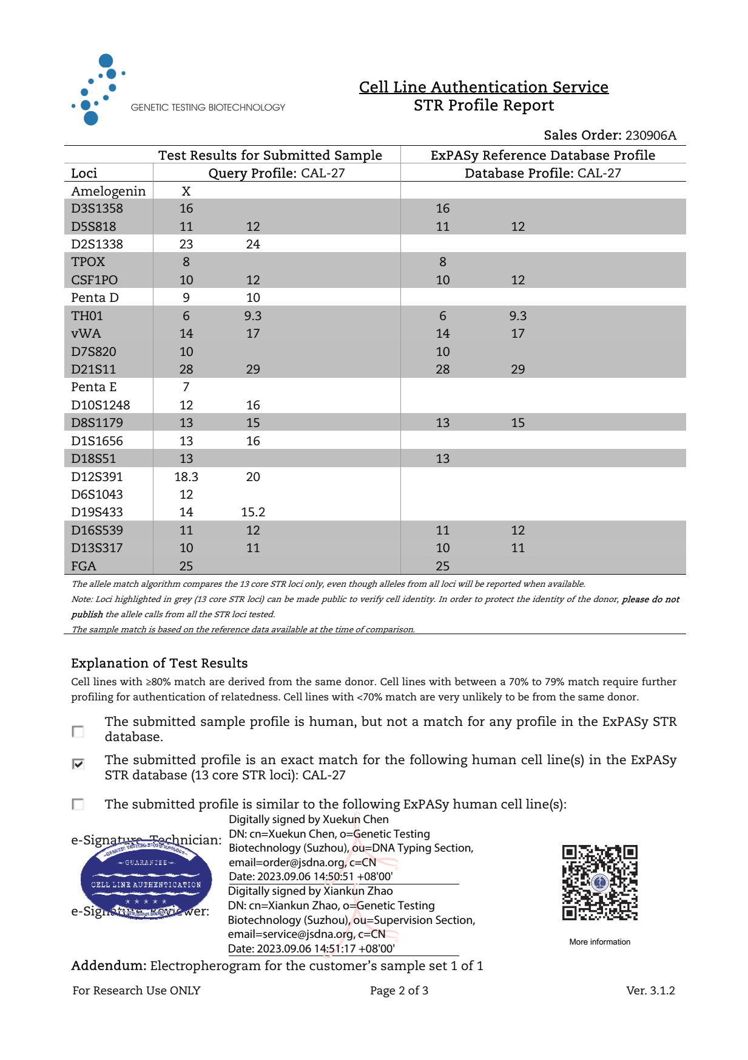
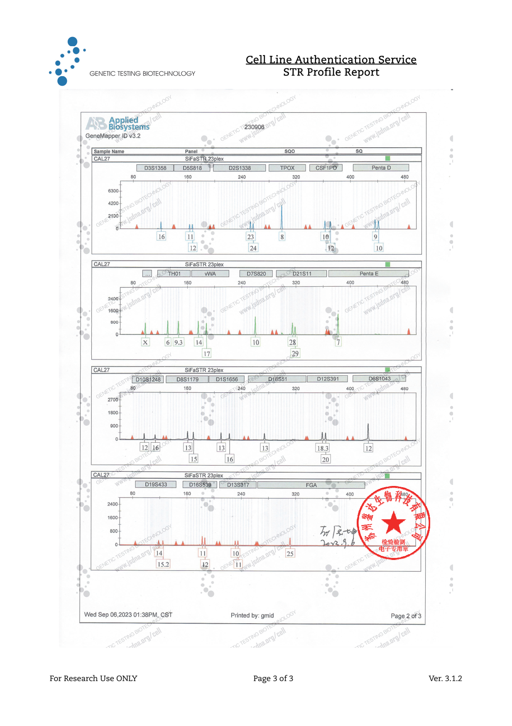

Supplementary File 2. All western-blot original images (non-cut) with molecular weight markers

