Supplementary material (max 6 pages) – All material reproduced with permission from World Medical Fund for Children
Supplementary Figure 1A: Difficult road conditions in rural areas of Malawi to deliver healthcare (photo taken by Michael Burt (WMF CEO), and reproduced with permission from World Medical Fund for Children)
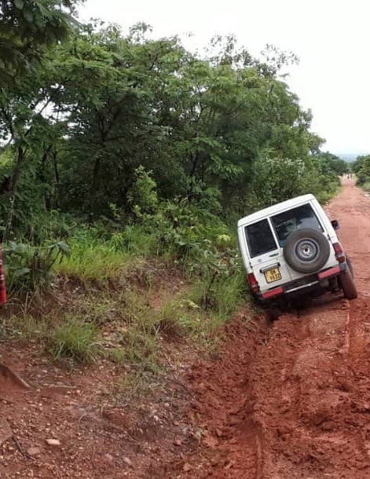
Supplementary Figure 1B: Difficult road conditions in rural areas of Malawi to deliver healthcare (photo taken by Michael Burt (WMF CEO) and reproduced with permission from World Medical Fund for Children)
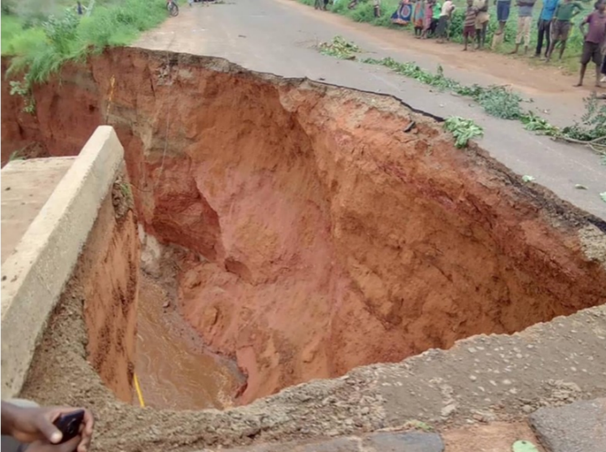
Rainy season destruction of roads makes them impassable to deliver healthcare
Supplementary Figure 2: Most travel for NGOs in Malawi is away from tarmac roads and through the bush (photo taken by Dr Faiz Kermani (WMF Trustee) and reproduced with permission from World Medical Fund for Children)
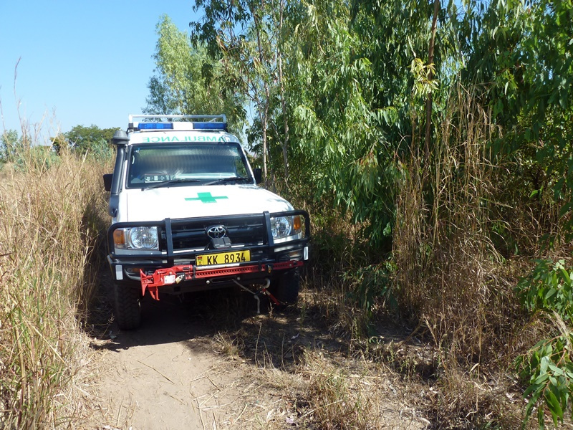

Supplementary Figure 3: Traditional Chief Mphonde’s letter to World Medical Fund (WMF) requesting additional healthcare services (reproduced with permission from Chief Mphonde)
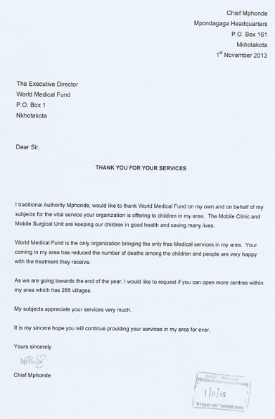

Supplementary Figure 4: Overview of the World Medical Fund (WMF) (reproduced with permission from World Medical Fund for Children)
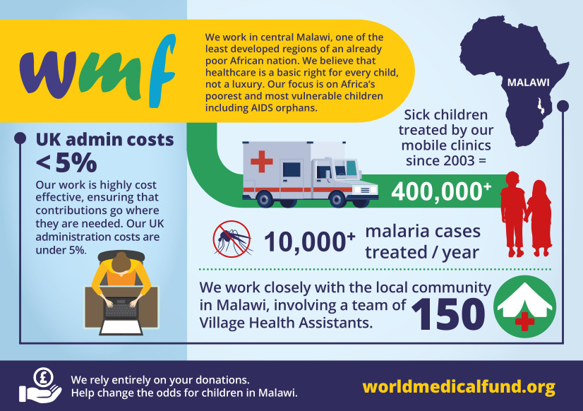
Supplementary Figure 5: Children and their families waiting for the mobile clinic (photo taken by Dr Faiz Kermani (WMF Trustee) and reproduced with permission from World Medical Fund for Children)
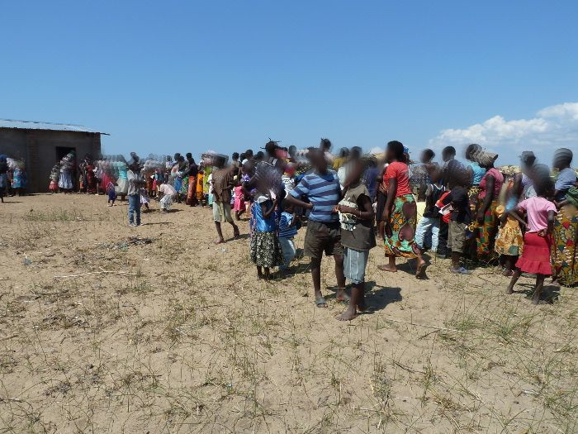
Legend: The Children’s Mobile Clinic; it provides the only access to healthcare in the villages far from the tarmac road in Malawi so the demand is immense
Supplementary Figure 6: Children and their families waiting for the mobile clinic (photo taken by Dr Faiz Kermani (WMF Trustee) and reproduced with permission from World Medical Fund for Children)
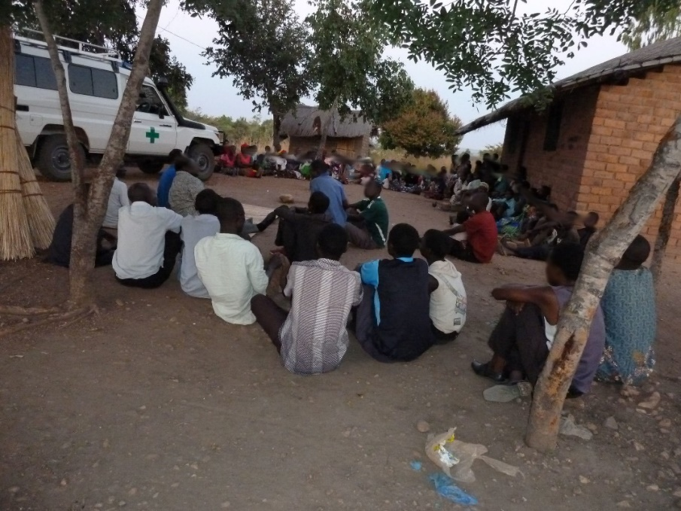

Supplementary Figure 7: The mobile clinic medical teams visit each village group on a 4-weekly schedule and cover a 140-kilometre distance across central Malawi (photo taken by Dr Faiz Kermani (WMF Trustee) and reproduced with permission from World Medical Fund for Children)
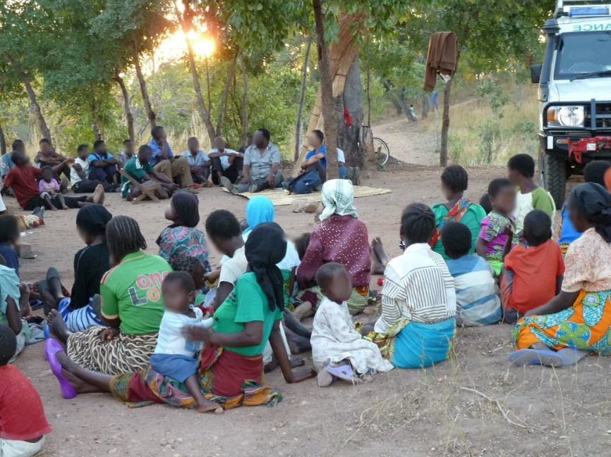
Supplementary Figure 8: Thandizo Transport Buddy scheme (reproduced with permission from World Medical Fund for Children)
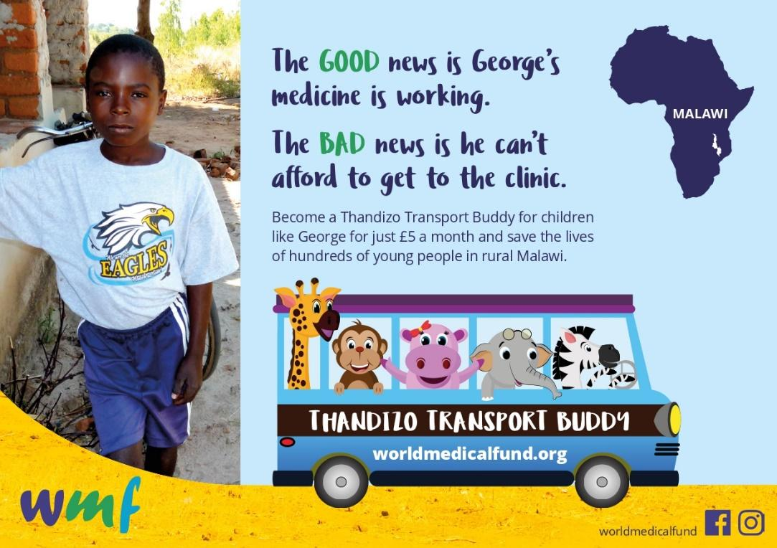

Supplementary Figure 9: WMF 5 steps to Health flyer (reproduced with permission from World Medical Fund for Children)
