Supplementary material

Supplementary Figure 1. Kaplan–Meier analysis of time to first asthma-related exacerbation post-treatmentª with FF/UMEC/VI.
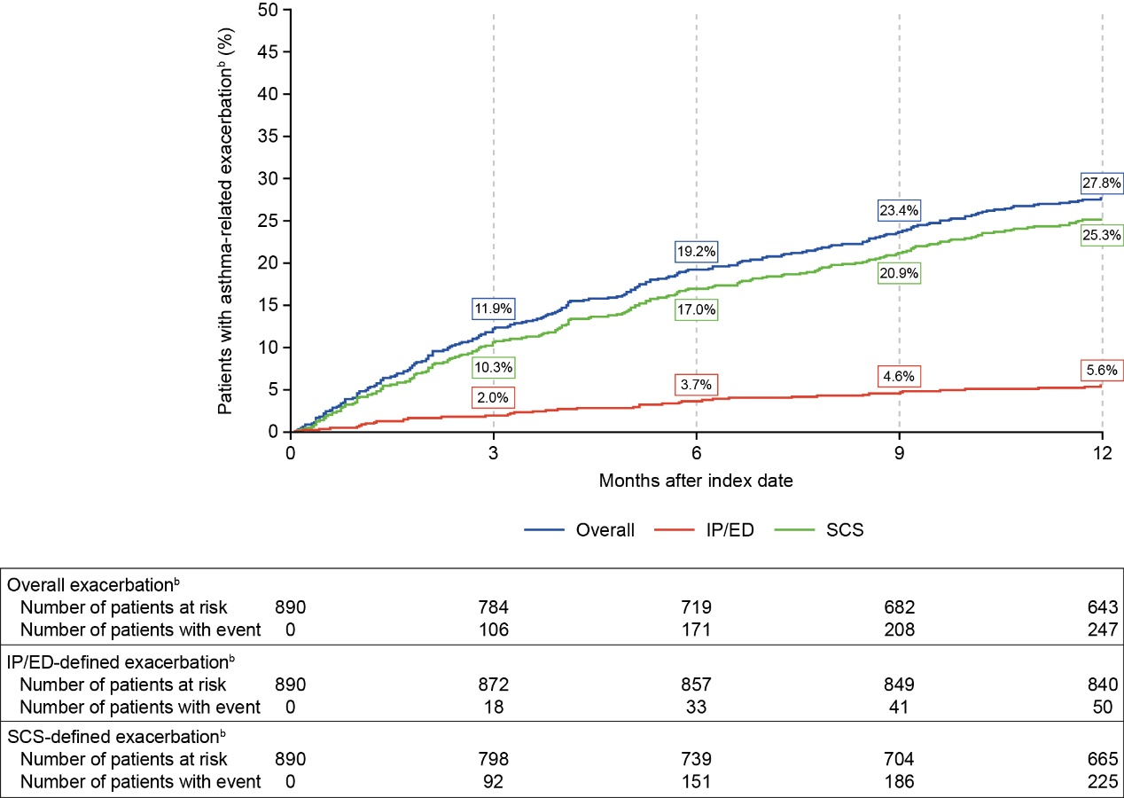
ªThe post-treatment period spanned from the day after the index date to 12 months after the index date (i.e., excluding the index date).
^{b}Overall asthma-related exacerbations included both SCS-defined and IP/ED-defined exacerbations. SCS-defined exacerbations were defined as an asthma-related ED visit or OP visit with an OCS or SCS dispensing/administration within ±5 days. IP/ED-defined exacerbations included hospitalization-defined and ED-defined exacerbations. Hospitalization-defined exacerbations were defined as an asthma-related hospitalization or asthma-related ED visit that results in a hospitalization within +1 day. ED-defined exacerbations were defined as an asthma-related ED visit. Asthma-related visits were identified as claims with a primary diagnosis of asthma.
ED: emergency department; FF, fluticasone furoate; IP: inpatient; SCS, systemic corticosteroid; UMEC, umeclidinium; VI, vilanterol.

