Supplementary files:
Figure S1: PCA score plot of QC samples in plasma
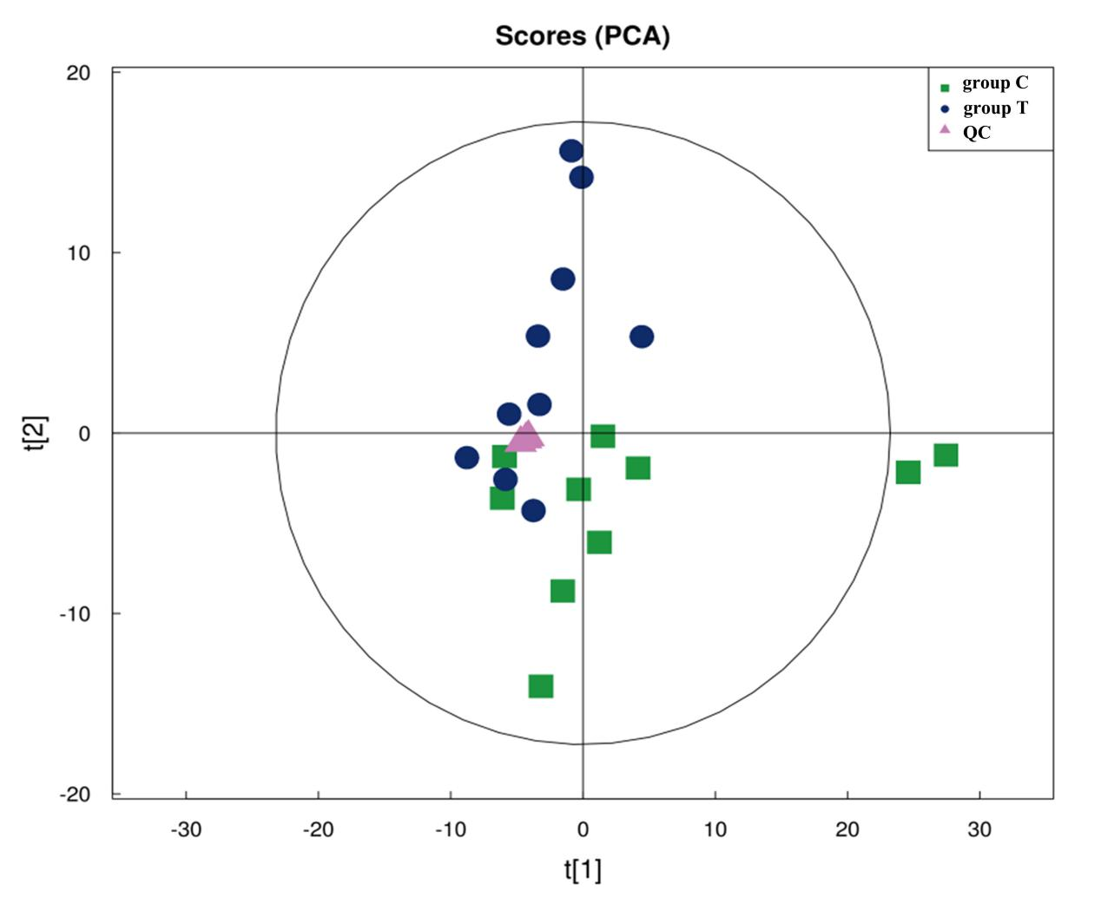

Figure S2: PCA score plot of QC samples in skin
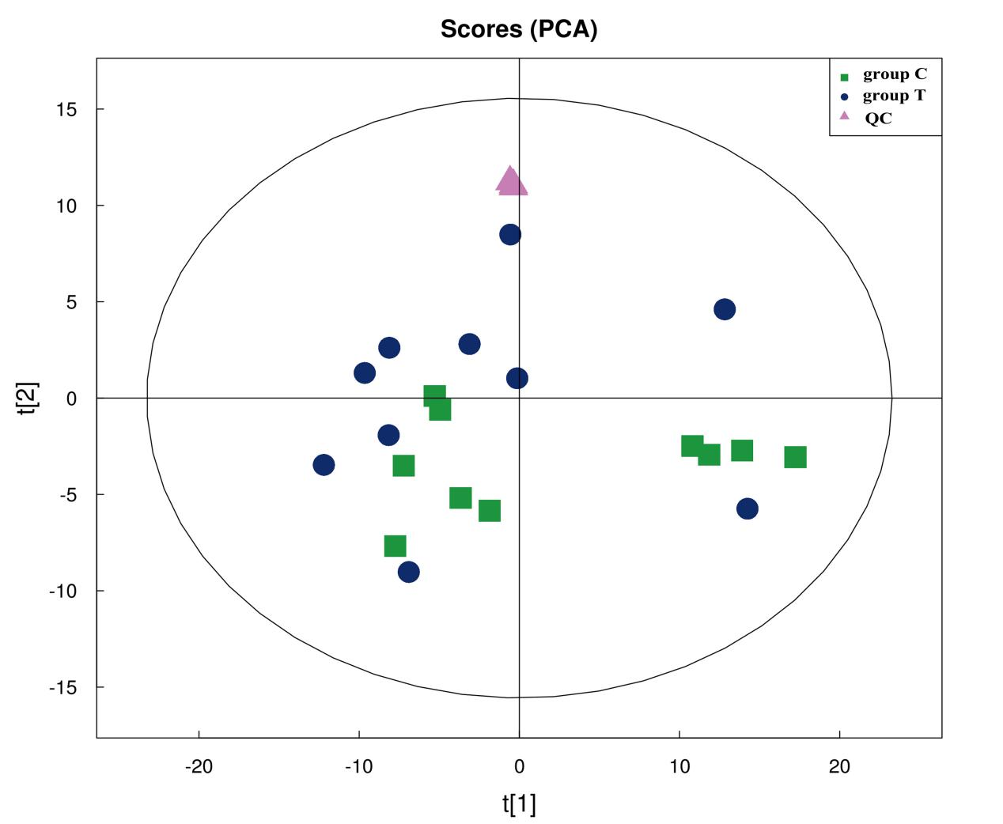

Table S1: The different metabolites in plasma

Name | ESI mode | VIP | Fold change | p-value | m/z | rt(s)
L-Norleucine | + | 2.203322213 | 1.521765078 | 0.000257083 | 173.1274 | 241.904
Urea | + | 1.731385043 | 0.804591873 | 0.000486587 | 61.03913 | 100.932
Anthranilic acid (Vitamin L1) | + | 5.400582541 | 0.595857752 | 0.000997195 | 138.05422 | 290.14
Lecithin | + | 3.716444981 | 0.675130406 | 0.001149495 | 832.58145 | 37.8085
Valine | + | 1.14815259 | 1.305096267 | 0.001432243 | 159.11171 | 265.997
Cyclohexylamine | + | 11.90757861 | 0.575692305 | 0.002706394 | 160.13284 | 387.148
Sarcosine | + | 1.259549809 | 1.744290139 | 0.003514357 | 131.08019 | 309.001
1-Myristoyl-sn-glycero-3-phosphocholine | + | 3.915663184 | 0.593400948 | 0.00354153 | 468.30693 | 198.373
Thioetheramide-PC | + | 12.24639863 | 0.691660608 | 0.004880259 | 758.56773 | 85.394
Dehydro-PAF (C) | + | 2.684498506 | 0.318037921 | 0.011190799 | 550.38235 | 167.68
Oxindole | + | 2.500242669 | 0.625644258 | 0.011349251 | 134.05947 | 28.558
Pipecolic acid | + | 4.339215916 | 1.346734573 | 0.017600648 | 171.11237 | 264.972
1-Stearoyl-sn-glycerol 3-phosphocholine | + | 5.613361329 | 0.198996268 | 0.018132509 | 568.33707 | 166.442
Phe-Tyr | + | 1.204079081 | 0.484857135 | 0.026837053 | 328.13748 | 300.218
2-Ethoxyethanol | + | 1.454772995 | 2.631203235 | 0.029652691 | 151.09498 | 64.034
Genistein | + | 1.356508966 | 0.320519845 | 0.036011836 | 271.05885 | 24.812
Tyramine | + | 2.009945171 | 0.716056979 | 0.043930867 | 120.07985 | 264.758
1-Stearoyl-2-arachidonoyl-sn-glycerol | + | 3.143214833 | 1.790428864 | 0.045019438 | 627.53121 | 105.379
D-galacturonic acid | － | 1.302244298 | 0.599756285 | 2.13199E-05 | 193.03478 | 387.345
Pentadecanoic Acid | － | 2.544388542 | 0.539394275 | 0.000114258 | 241.21682 | 48.872
Carnosine | － | 1.127867274 | 0.460016355 | 0.000273356 | 225.09848 | 421.793
Linoleic acid | － | 2.555517116 | 0.594911047 | 0.000673787 | 279.23227 | 100.901
Heptadecanoic acid | － | 1.747708569 | 0.633659084 | 0.001863261 | 269.24751 | 46.876
Indoxyl sulfate | － | 3.174872703 | 0.533374841 | 0.002727719 | 212.00172 | 49.469
Docosahexaenoic acid | － | 8.170901985 | 0.693698181 | 0.004336704 | 327.23225 | 46.276
myo-Inositol | － | 1.441552546 | 0.670651474 | 0.010317181 | 179.0557 | 392.475
Pyroglutamic acid | － | 2.006681911 | 0.752106189 | 0.012261638 | 128.03496 | 300.809
Gamma-Glutamylcysteine | － | 5.916001205 | 0.162709478 | 0.01615676 | 249.04921 | 113.6835
Dodecanoic acid | － | 2.307902696 | 1.306531025 | 0.01817019 | 199.16994 | 50.771
Phenylacetylglycine | － | 1.59240301 | 0.598806641 | 0.021713678 | 192.0658 | 190.202
L-Malate | － | 1.573369573 | 0.309994521 | 0.022258929 | 133.01366 | 425.683
3-Indolepropionic acid | － | 4.798324733 | 0.503535871 | 0.024821146 | 188.07152 | 105.493
Eicosapentaenoic Acid | － | 3.44808177 | 1.258230147 | 0.024844206 | 301.21655 | 46.226
DL-lactate | － | 2.909219373 | 1.614881235 | 0.026155656 | 89.02416 | 103.4775
2E-Eicosenoic acid | － | 3.94426103 | 1.272913247 | 0.030426323 | 309.27875 | 44.463
Cholic acid | － | 6.615070418 | 0.084087618 | 0.036836316 | 407.27918 | 223.633
Taurine | － | 3.727148337 | 0.835418279 | 0.040981588 | 124.0073 | 301.11
Deoxycholic acid | － | 2.527776503 | 0.427863832 | 0.046647932 | 391.28381 | 155.097

Table S2: The different metabolites in skin

Name | ESI mode | VIP | Fold change | p-value | m/z | rt(s)
Erucamide | + | 2.846173073 | 0.667271735 | 0.012600465 | 338.34019 | 3.837
Thioetheramide-PC | + | 11.28117702 | 1.148672208 | 0.014483681 | 758.56735 | 38.762
N-Docosanoyl-4-sphingenyl-1-O-phosphorylcholine | + | 1.711287572 | 0.793872678 | 0.014916396 | 809.64867 | 175.1005
Hypoxanthine | + | 16.39225778 | 1.302150606 | 0.02884754 | 137.0452 | 167.82
Creatinine | + | 1.813150649 | 1.176624119 | 0.036202661 | 114.06503 | 168.411
Glyceryl monolinoleate | + | 4.684927446 | 0.839457009 | 0.04216472 | 337.27263 | 31.748
Sphingosine | + | 4.892497056 | 1.417771855 | 0.048301493 | 300.28799 | 94.888

