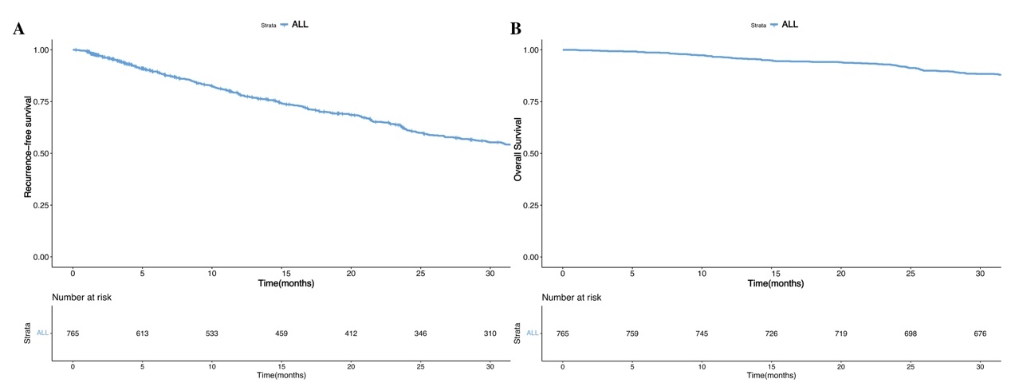
Supplementary figure 1. The Kaplan-Meier (K-M) survival curves for recurrence (A) and death (B) in the whole cohort.

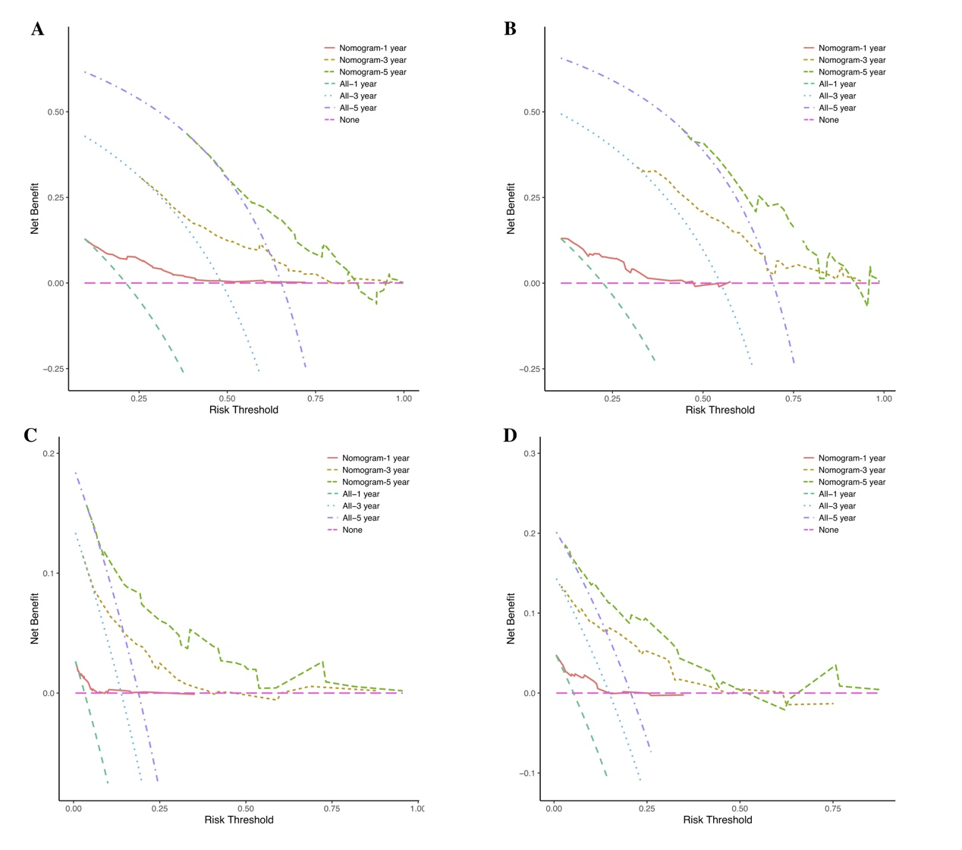
Supplementary figure 2. Decision curve analyses (DCA) curves of 1-, 3-, 5-year of recurrence-free survival (RFS) in the training (A) and validation (B) cohorts, and the DCA curves of overall survival (OS) in the training (C) and validation (D) cohorts.

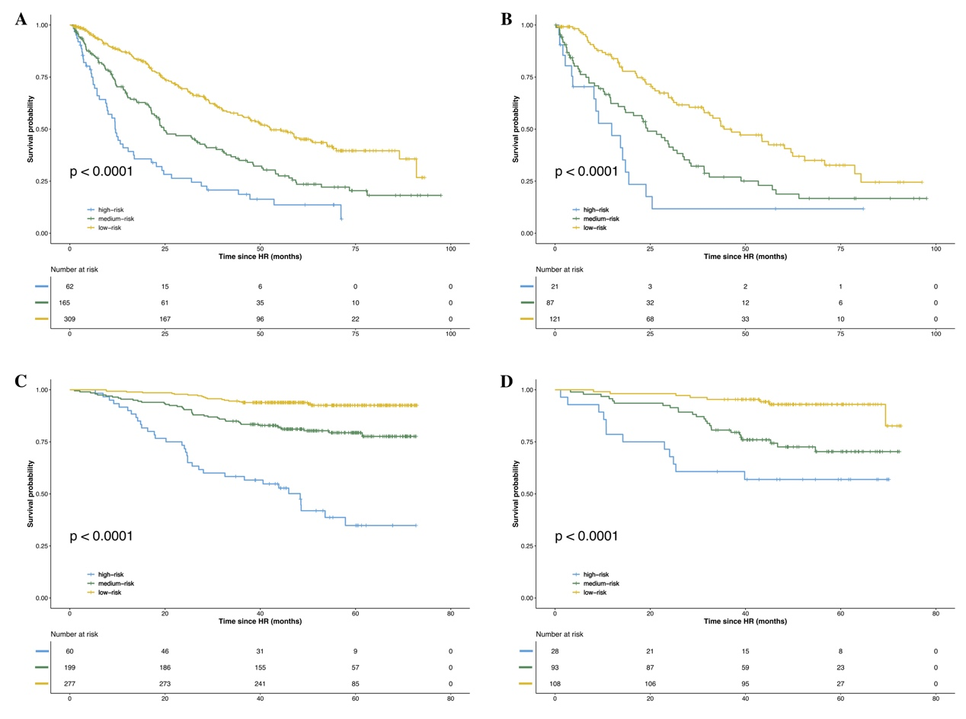
Supplementary figure 3. The Kaplan-Meier (K-M) survival curves for patients with different risks for recurrence in the training (A) and validation (B) cohorts, and the K-M survival curves for patients with different risks for death in the training (C) and validation (D) cohorts.

