Supplemental Information (Appendices)
APPENDIX A – E-MAIL TO ALL SUBJECTS
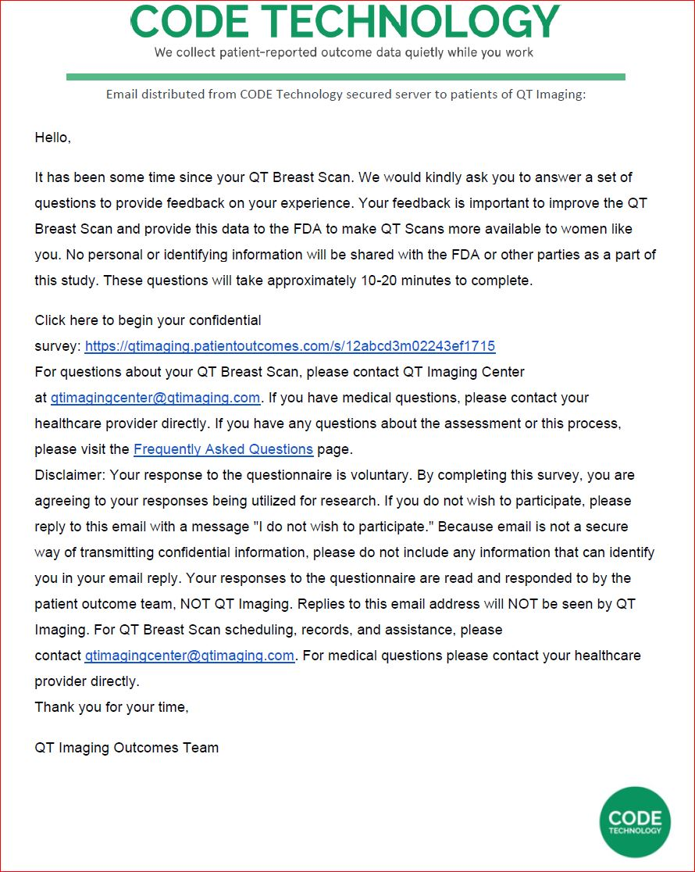
APPENDIX B – FAQ Script

FAQ Page Template- CODE Technology | QT Imaging

Instructions: this FAQ page will be linked in the patient emails.
_________________________________________________________________

Redirect Link: This is the webpage users will be sent to when they click your logo at the top of this FAQ page: https://www.qtimaging.com

Tracking Your QT Breast Scan Experience
After your QT Breast Scan, we will ask you to fill out a quick assessment about your experience. These "assessments" are far more than just a survey. They are rigorously tested, scientifically-validated measurement tools. These tools are called patient-reported outcomes (PROs), and they are one of the key methods QT Imaging uses to track patient’s experience with QT Breast Scans and using that information to obtain FDA approval to use the scan as a primary screening technology for breast cancer in young, high-risk women.

PROs essentially reflect the "voice of the patient", free from the input and interpretation of physicians and medical experts. We want to make sure your voice is heard, and your experience is tracked. To ensure the quality of our experience information, we partner with an independent 3rd-party company to collect PROs after your QT Breast Scan. This program allows our team to respond to you, the patient, and to create a patient-centered environment that supports continuous quality improvement. We greatly appreciate your participation in this process.

Frequently Asked Questions

- What are PRO assessments?
- How long will this take?
- What happens if I navigate away from the page during my assessment?
- What is the benefit of doing this online vs over the phone?
- Why can't I skip questions that clearly don't apply to me?
- Why do some of the questions seem repetitive?
- I already filled out an assessment for my mammogram. Do I need to go through these questions again?
- Why does this matter?
- Can I get a copy of my scan report?
- When did I last have a scan? / Am I due for another scan?
- Can I schedule another appointment for a QT Breast Scan?
- Will there be a QT Breast Scanner in other places in the US soon?
- Why is the center in Michigan/Arizona/Walnut Creek/San Jose now closed?
- What are the results of the clinical trial?
- Does the QT Breast Scan replace a mammogram? / Do I still have to get a mammogram if I have had a QT Breast Scan?
- When will the QT Breast Scan be approved as a screening device?
- I have questions for my surgeon and staff. Can I leave them as a comment in the assessment, or reply to the email\ message that contains the assessment link?
- Do people read my comments?
- Why do you use a 3rd-party company?
- Have a question we didn't answer? Contact our outcome team!

What are PRO assessments?
A patient-reported outcome (PRO) assessment is not just a typical "survey" — it is a set of statistically validated questions that have been rigorously tested through medical research. Patient Experience PROs are designed to measure your experience with your scan. These tools are used by medical providers around the world and are becoming the "gold standard" for evaluating patient experience.

How long will this take?
It usually takes about 10-20 minutes to complete a PRO assessment.

What happens if I navigate away from the page during my assessment?
If you navigate away from the page while you're taking your assessment, you'll have to start again at the beginning when you return to it. So please plan on finishing in one sitting.

What is the benefit of doing this online vs over the phone?
First and foremost: data quality. Eliminating any outside influence while completing the assessment improves the accuracy of your answers. Another benefit is time — almost all PRO questions are multiple choice, and when doing the assessment over the phone, all answer options must be read by the assessment administrator, even when the answer options are the same for many questions. On average, it takes patients 40% less time to complete an assessment online than over the phone.

Why can't I skip questions that clearly don't apply to me?
In order for the system to calculate a standardized score that can be compared to other patients who've undergone similar treatment, each question must be answered. Some questions or answer options may not seem relevant to your situation — but the good news is, there are no "trick" questions. So please try to answer all questions to the best of your ability. At the end of the assessment, you will be able to include your own comments with any additional information not previously covered that you feel may be beneficial for us to know.

Why do some of the questions seem repetitive?
The questions in each PRO assessment are designed to evaluate specific areas of your experience. Although some questions may seem repetitive, they are evaluating different aspects of the factors that affect your experience. Please answer all questions to the best of your ability.

I already filled out an assessment for my mammogram. Do I need to go through these questions again?
Yes. Since breast imaging exams continue to change, it's important to understand your experience for this type of exam.

Why does this matter?

This data will be used to determine how the QT Breast Scan experience compares to the standard mammogram experience.

Can I get a copy of my scan report?

If you were scanned while participating in a clinical trial, we are unable to provide a report from your QT Breast Scan as per the trial consent you signed. At that time the scanner was operating under a clinical trial and did not have FDA clearance. If you were scanned at one of our commercial centers, QT Breast Health or QT Imaging Center, please email QTimagingcenter@qtimaging.com to request a copy to be mailed to you.

When did I last have a scan? / Am I due for another scan?

Please contact Rachel at QTimagingcenter@qtimaging.com or call 415-842-7403 for that information.

Can I schedule another appointment for a QT Breast Scan?

We are currently open in Novato, California for appointments. Please call 415-842-7403 or email QTimagingcenter@qtimaging.com to request an appointment.

Will there be a QT Breast Scanner in other places in the US soon?

We would like there to be scanners in other locations, but do not have dates or locations confirmed at this time.

Why is the center in Michigan/Arizona/Walnut Creek/San Jose now closed?

Unfortunately, we had to close many of our centers due to the pandemic.

What are the results of the clinical trial?

Our recent publications of trial results are available on our website, www.qtimaging.com under the research and publications tab.

Does the QT Breast Scan replace a mammogram? / Do I still have to get a mammogram if I have had a QT Breast Scan?
As per our current FDA clearance, “The QT Ultrasound Breast Scanner is for use as an ultrasonic imaging system to provide reflection-mode and transmission-mode images of a patient’s breast. The device is not intended to be used as a replacement for screening mammography” FDA 510k K162372

When will the QT Breast Scan be approved as a screening device?
We are working with the FDA under our “Breakthrough Device Designation” to provide the clinical trial data we have accumulated to ask for expanded use. We do not know yet when this will be, but your participation in this survey will help move this technology toward that goal.

I have questions for my provider and staff. Can I leave them as a comment in the assessment, or reply to the email that contains the assessment link?
While all comments are appreciated, we recommend you contact your healthcare provider’s office directly with all comments or questions requiring immediate follow-up.

Do people read my comments?
QT Imaging staff will read your comments. Your comments help our staff improve the experience for all patients. Being able to explain in your own words is extremely beneficial and helps affect the way patients like you are treated in the future.

Why do you use a 3rd-party company?
Mainly to protect the integrity of the results collected from you. They also help organize the raw data so we can view your responses in context and compare them to what is typical for similar patients from across the country.

Have a question we didn't answer? Contact our outcome team!
For questions related to your PRO assessment, please contact the patient outcome team by email at qtimaging@patientoutcomes.com. For all scheduling, records, or medical questions and assistance, please contact your healthcare provider's office directly.
Thank you very much for your time and attention!

APPENDIX C - THE PRO INSTRUMENTS

The following questions are about your experience with your QT Breast Scan followed by the same or similar question regarding your experience with mammograms. If you have not had a mammogram, please answer the question with Not Applicable (N/A).
For the following questions, please click the answer that best matches your experience, then click Next Question. (On pages without any questions, like this one, click Next Question to continue.)

- Rate your level of discomfort during the QT Breast Scan
  - 0 – No Discomfort
  - 1
  - 2
  - 3
  - 4
  - 5
  - 6
  - 7
  - 8
  - 9
  - 10 – Worst Imaginable

- Rate your level of discomfort during a mammogram.
  - N/A – I have not had a mammogram
  - 0 – No Discomfort
  - 1
  - 2
  - 3
  - 4
  - 5
  - 6
  - 7
  - 8
  - 9
  - 10 – Worst Imaginable

- Rate your level of anxiety during the QT Breast Scan.
  - 0 – No Anxiety
  - 1
  - 2
  - 3
  - 4
  - 5
  - 6
  - 7
  - 8
  - 9
  - 10 – Worst Possible

- Rate your level of anxiety during a mammogram.
  - N/A – I have not had a mammogram
  - 0 – No Anxiety
  - 1
  - 2
  - 3
  - 4
  - 5
  - 6
  - 7
  - 8
  - 9
  - 10 – Worst Possible

- I will dread having another QT Breast Scan.
  - Strongly Agree
  - Agree
  - Neutral
  - Disagree
  - Strongly Disagree

- I will dread having another mammogram.
  - N/A – I have not had a mammogram
  - Strongly Agree
  - Agree
  - Neutral
  - Disagree
  - Strongly Disagree

- Having a QT Breast Scan made me feel embarrassed or uneasy.
  - Strongly Agree
  - Agree
  - Neutral
  - Disagree
  - Strongly Disagree

- Having a mammogram made me feel embarrassed or uneasy.
  - N/A – I have not had a mammogram
  - Strongly Agree
  - Agree
  - Neutral
  - Disagree
  - Strongly Disagree

- I am concerned that the QT Breast Scan will cause breast cancer.
  - Strongly Agree
  - Agree
  - Neutral
  - Disagree
  - Strongly Disagree

- I am concerned that a mammogram will cause breast cancer.
  - N/A – I have not had a mammogram
  - Strongly Agree
  - Agree
  - Neutral
  - Disagree
  - Strongly Disagree

- I am concerned that I received radiation from the QT Breast Scan.
  - Strongly Agree
  - Agree
  - Neutral
  - Disagree
  - Strongly Disagree

- I am concerned that I received radiation from a mammogram.
  - N/A – I have not had a mammogram
  - Strongly Agree
  - Agree
  - Neutral
  - Disagree
  - Strongly Disagree

- I am confident that I can receive multiple QT Breast Scans without additional radiation exposure.
  - Strongly Agree
  - Agree
  - Neutral
  - Disagree
  - Strongly Disagree

- After the QT Breast Scan, I had bruising, skin irritation, or soreness on or around my breast.
  - Strongly Agree
  - Agree
  - Neutral
  - Disagree
  - Strongly Disagree

- After a mammogram, I had bruising, skin irritation, or soreness on or around my breast.
  - N/A – I have not had a mammogram
  - Strongly Agree
  - Agree
  - Neutral
  - Disagree
  - Strongly Disagree

- I am concerned that my breast implants could be displaced or ruptured as a result of having a QT Breast Scan.
  - N/A – I do not have breast implants
  - Strongly Agree
  - Agree
  - Neutral
  - Disagree
  - Strongly Disagree

- I am concerned that my breast implants could be displaced or ruptured as a result of having a mammogram.
  - N/A – I have not had a mammogram
  - N/A – I do not have breast implants
  - Strongly Agree
  - Agree
  - Neutral
  - Disagree
  - Strongly Disagree

- I believe the QT Breast Scan results are accurate.
  - N/A - I did not receive results
  - Strongly Agree
  - Agree
  - Neutral
  - Disagree
  - Strongly Disagree

- I believe the mammogram results are accurate.
  - N/A – I have not had a mammogram
  - N/A - I did not receive results
  - Strongly Agree
  - Agree
  - Neutral
  - Disagree
  - Strongly Disagree

- I am more confident of my breast health after having a QT Breast Scan.
  - Strongly Agree
  - Agree
  - Neutral
  - Disagree
  - Strongly Disagree

- I am more confident of my breast health after having a mammogram.
  - N/A – I have not had a mammogram
  - Strongly Agree
  - Agree
  - Neutral
  - Disagree
  - Strongly Disagree

- Because I have dense breasts, I am more confident after having a QT Breast Scan.
  - N/A - I do not have dense breasts
  - Strongly Agree
  - Agree
  - Neutral
  - Disagree
  - Strongly Disagree

- Because I have dense breasts, I am more confident after having a mammogram.
  - N/A – I have not had a mammogram
  - N/A - I do not have dense breasts or do not know if I have dense breasts
  - Strongly Agree
  - Agree
  - Neutral
  - Disagree
  - Strongly Disagree

- The results of the QT Breast Scan were:
  - N/A - No results were provided
  - Unremarkable or benign findings – Recommended routine follow-up
  - Probable benign findings – Recommended short term follow-up
  - Suspicious findings – Recommended additional imaging and/or biopsy
  - Scan issues – Recommended re-scan
  - Other (require comment)

- The results of a mammogram were:
  - N/A – I have not had a mammogram
  - N/A - No results were provided
  - Unremarkable findings – Recommended routine follow-up
  - Probable benign findings – Recommended short term follow-up
  - Suspicious findings – Recommended additional imaging and/or biopsy
  - Technical issues with mammogram images
  - Other (require comment)

- Were you asked to have a follow-up QT Breast Scan for an abnormality after your initial scan?
  - Yes, the results were benign
  - Yes, the results were suspicious
  - No
  - Other (require comment)

- Were you asked to have a follow-up mammogram for an abnormality after your initial mammogram?
  - N/A – I have not had a mammogram
  - Yes, the results were benign
  - Yes, the results were suspicious
  - No
  - Other (require comment)

- Have you had a false-positive finding (a finding that turned out to be nothing) from a QT Breast Scan?
  - Yes
  - No

- Have you had a false-positive finding (a finding that turned out to be nothing) from a mammogram?
  - N/A – I have not had a mammogram
  - Yes
  - No

- I had additional out-of-pocket expenses because my QT Breast Scan results were false-positive (a finding that turned out to be nothing).
  - Yes
  - No

- I had additional out-of-pocket expenses because my mammogram results were false-positive (a finding that turned out to be nothing).
  - N/A – I have not had a mammogram
  - Yes
  - No

- Overall, my scan experience with the QT Breast Scan has been very satisfactory.
  - Strongly Agree
  - Agree
  - Neutral
  - Disagree
  - Strongly Disagree

- Overall, my experience with a mammogram has been very satisfactory.
  - N/A – I have not had a mammogram
  - Strongly Agree
  - Agree
  - Neutral
  - Disagree
  - Strongly Disagree

- I would recommend a QT Breast Scan to friends and family.
  - 0 – Very likely
  - 1
  - 2
  - 3
  - 4
  - 5
  - 6
  - 7
  - 8
  - 9
  - 10 – Very unlikely

- I would recommend a mammogram to friends and family.
  - N/A – I have not had a mammogram
  - 0 – Very Likely
  - 1
  - 2
  - 3
  - 4
  - 5
  - 6
  - 7
  - 8
  - 9
  - 10 – Very unlikely

- Compared to my experience with a mammogram my experience with the QT Breast Scan was ..
  - N/A – I have not had a mammogram
  - My experience with the QT Breast Scan was much better.
  - My experience with the QT Breast Scan was better.
  - My experience with the QT Breast Scan was as expected.
  - My experience with the QT Breast Scan was worse.
  - My experience with the QT Breast Scan was much worse.

