BRCA1 90 patients
BRCA2 79 patients
824 breast cancer patients received BRCA testing between 2016-2020 at 3 hospital
248 breast cancer patients confirmed to harboring BRCA mutation
203 breast cancer patients with BRCA mutation
169 early breast cancer patients with BRCA pathogenic or likely pathogenic mutation for analysis
Patients with no access to acquire pathological, surgical or treatment information and follow up information (n=45)
1.Patients with recurrent or metastatic breast cancer (n=4)
2.Patients harboring benign /likely benign/VUS BRCA mutation (n=30)

Figure S1. Flowchart of patient selection.

Table S1 BRCA1 and BRCA2 recurrent mutations
Gene | Exon | cDNA | protein | No.of patient
BRCA1 | 3 | c.132C>T | p.Cys44Cys | 2
 | 7 | c.376C>T | p.Gln126Ter | 2
 | 7 | c.441+2T>A | Splicing | 2
 | 11 | c.1214C>G | p.Ser405Ter | 2
 | 11 | c.1465G>T | p.Glu489Ter | 3
 | 11 | c.1600C>T | p.Gln534Ter | 2
 | 11 | c.2138C>G | p.Ser713Ter | 2
 | 11 | c.3916_3917del | p.Leu1306fs | 2
 | 11 | c.4065_4068del | p.Asn1355fs | 4
 | 16 | c.4801A>T | p.Lys1601Ter | 3
 | 17 | c.4987-5T>C | Splicing | 2
 | 24 | c.5470_5477del | p.Ile1824fs | 11
 | 24 | c.5521del | p.Ser1841fs | 3
BRCA2 | 10 | c.1298dup | p.Asn433fs | 2
 | 10 | c.1310_1313del | p.Lys437fs | 3
 | 11 | c.2059_2063del | p.Asp687fs | 2
 | 11 | c.4440T>G | p.Tyr1480Ter | 2
 | 11 | c.5576_5579del | p.Ile1859fs | 2
 | 11 | c.5851_5854del | p.Ser1951fs | 2
 | 11 | c.6699_6702dup | p.Met2235fs | 2
 | 20 | c.8517C>A | p.Tyr2839Ter | 2
 | 22 | c.8951C>G | p.Ser2984Ter | 2
 | 23 | c.9117+1G>A | Splicing | 2

Table S2. Events at a median follow-up of 33 months
 | Total  （n=169） | BRCA1  （n=90） | BRCA2  （n=79）
First recurrence
Locoregional only | 12 | 8 | 4
Distant only | 10 | 6 | 4
Combined | 1 | 0 | 1
Contralateral invasive breast cancer | 26 | 13 | 13
Second primary cancer | 7 | 4 | 5
Ovarian cancer | 6 | 2 | 4
Thyroid cancer | 1 | 0 | 1
Location of distant recurrence
Lung | 4 | 3 | 1
Bone | 5 | 1 | 4
Liver | 2 | 2 | 0
Brain | 1 | 1 | 0
Ovarian and oviduct | 1 | 1 | 0

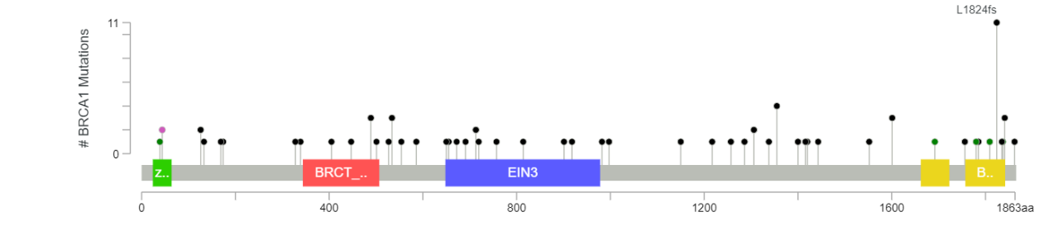
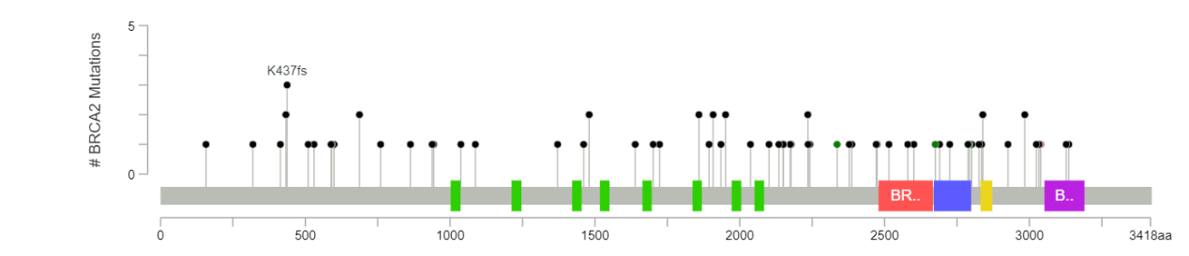
Figure S2. Lollipop plots showing the distribution and frequency of BRCA1 and BRCA2 mutation.

