Addendum Measuring adherence to pulmonary rehabilitation: a prospective validation study of the Dutch version of the Rehabilitation Adherence Measure for Athletic Training (RAdMAT-NL)

Additional file 1: Flowchart
Additional file 2: Characteristics physiotherapists

Additional file 1: Flowchart
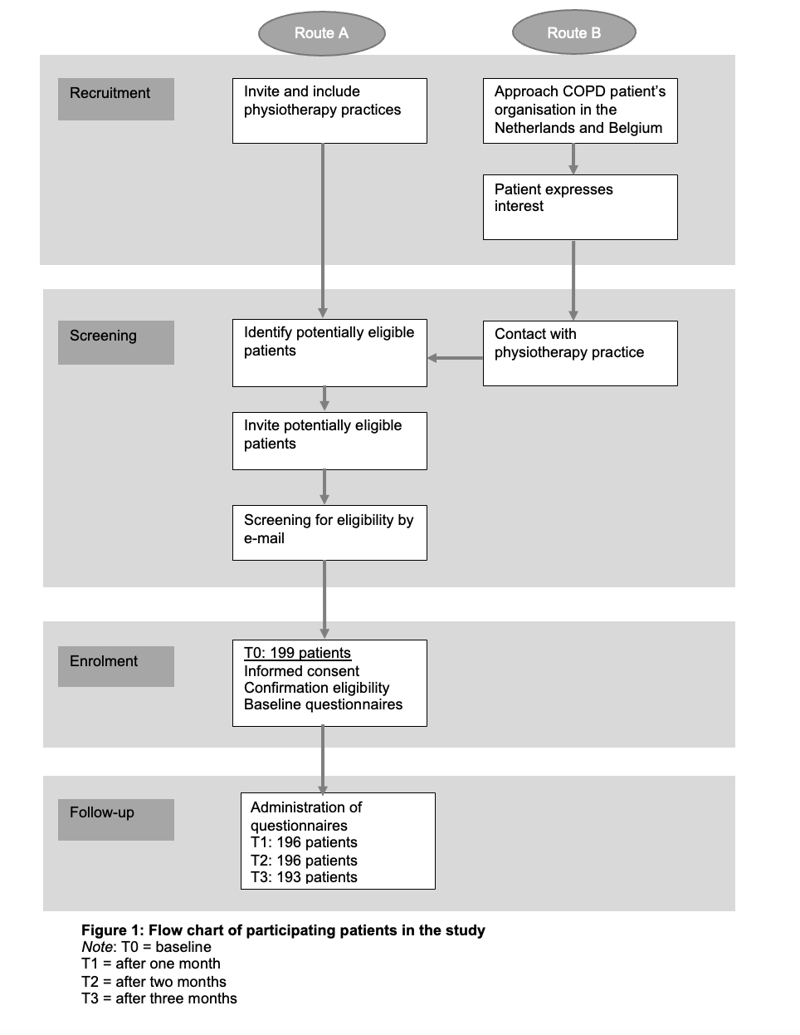

Additional file 2: Characteristics physiotherapists (n = 53)

Demographic characteristics
Male gender (%) | 54.7
Age (%)  - < 25 years  - 26-35 years  - 36-45 years  - 46-55 years  - 56-65 years  - > 65 years | 0  28.3  37.7  15.1  18.9  0
Completed Master’s degree (%)  - Yes  - No, but currently working on it  - No | 37.7  3.8  58.5
Years of professional experience  - < 5 years  - 6-15 years  - 16-25 years  - > 25 years | 11.3  34.0  35.8  18.9

