Supporting Information
Carrier-Free Binary Self-Assembled Nanomedicines Originated from Traditional Herb Medicine with Multifunction to Accelerate MRSA-Infected Wound Healing by Antibacterial, Anti-Inflammation and Promoting Angiogenesis
Jihui Lu¹, Zhijia Wang¹, Desheng Cai¹, Xiaoyu Lin¹, Xuemei Huang¹, Zhihua Yuan¹, Yaozhi Zhang¹, Haimin Lei^{1∗}, Penglong Wang^{1∗}
School of Chinese Pharmacy, Beijing University of Chinese Medicine, Beijing 102488, China
∗ Correspondence: Penglong Wang, School of Chinese Pharmacy, Beijing University of Chinese Medicine, Beijing 102488, China, E-mail addresses: wpl581@126.com. Haimin Lei, School of Chinese Pharmacy, Beijing University of Chinese Medicine, Beijing 102488, China, E-mail addresses: hm_lei@126.com.

Proton Nuclear Magnetic Resonance Spectroscopy of ¹H-NMR
¹H-NMR spectra were recorded on an Avance IIIHD 400 MHz spectrometer (Bruker, America) with tetramethylsilane as an internal standard
GA: ¹H-NMR (400 MHz, DMSO-d₆, δ): 12.21 (s, 1H, 1-COOH), 9.17 (s, 2H, 3-H, 5-H), 8.82 (s, H, 3-H), 6.92 (s, 2H, 2-H, 6-H).
BBR: ¹H-NMR (400 MHz, DMSO-d₆, δ): 9.91 (s, 1H, 8-H), 8.97 (s, 1H, 13-H), 8.19 (d, J = 9.2 Hz, 1H, 11-H), 8.01 (d, J = 8.0 Hz, 1H, 12-H), 7.79 (s, 1H, 1-H), 7.08 (s, 1H, 4-H), 6.18 (s, 2H, 15-CH₂), 4.95 (t, J = 6.0 Hz, 2H, 6-CH₂), 4.10 (s, 3H, 9-OCH₃), 4.07 (s, 3H, 10-OCH₃), 3.21 (t, J = 6.0 Hz, 2H, 5-CH₂).
GA-BBR NPs: ¹H-NMR (400 MHz, DMSO-d₆, δ): 9.88 (s, 1H, 8-H, BBR), 8.91 (s, 1H, 13-H, BBR), 8.18 (d, J = 9.2 Hz, 1H, 11-H, BBR), 7.98 (d, J = 8.0 Hz, 1H, 12-H, BBR), 7.78 (s, 1H, 1-H, BBR), 7.08 (s, 1H, 4-H, BBR), 6.84 (s, 4H, 2-H, 6-H, GA), 6.17 (s, 2H, 15-CH₂, BBR), 4.95 (t, J = 6.0 Hz, 2H, 6-CH₂, BBR), 4.10 (s, 3H, 9-OCH₃, BBR), 4.07 (s, 3H, 10-OCH₃, BBR), 3.21 (t, J = 6.0 Hz, 2H, 5-CH₂, BBR).

Table S1. Primers used in this study.
Gene | Forward Primer (5′-->3′) | Reverse primer (5′-->3′)
rpsF | ACGCCCAAACATTGAGGAAG | CGTTGGAATTCGTCAGTAGCT
rplC | CTTTTGTAGCTGGCGACGTT | TGTTTCCACCCATACGTCCT
rplN | CAACTCTGGTGCTCGTGAAG | GTGGGCCTTTGTCATCACG
rplX, | TCGCAGGTAAAGACAAAGGT | CATGGATTGCTGCCTCTGTT
rpsC | AAACCGTGCTTCATTCCGTC | ATCGATGTCAGCACGTAACG
rpmC | ATGAAAGCTAAGGAAATTAG | TTTCATTCCGATTAGTTATT
rpsH | CGTGTTTATGCAAAAGCTAGCG | TGCGATAATTTCTCCACCAACA

Table S2. Self-assembly occurs. √: Occurs ×: No occurs
Compound | Gallic acid | 3-Hydroxybenzoic acid | 4-Hydroxybenzoic acid | 3,5-Dihydroxybenzoic acid | Pyrogallol
Structure
Self-assembly occurs | √ | × | × | × | ×

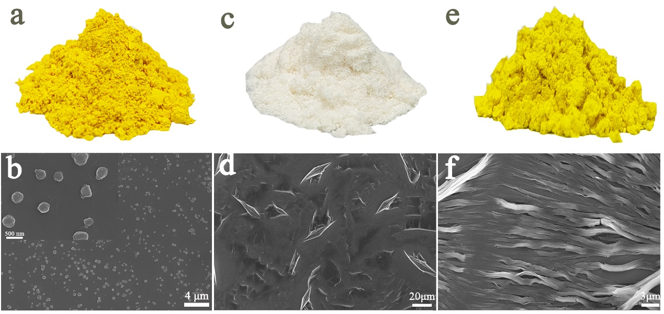
Figure S1. The morphology of monomers. (a) Powder of GA-BBR NPs. (b) FESEM image of GA-BBR NPs. (c) Monomer powder of GA. (d) FESEM image of GA. (e) Monomer powder of BBR. (f) FESEM image of BBR

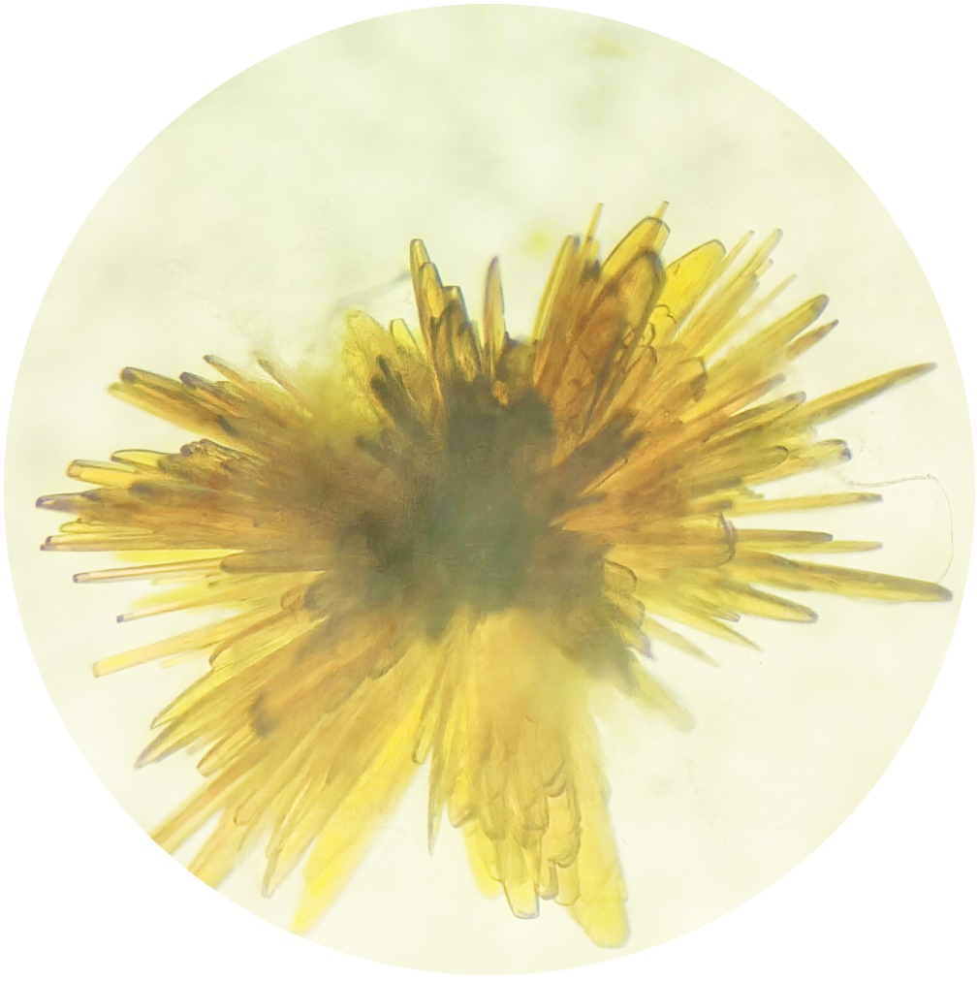
Figure S2. The flower-shaped crystal of GA-BBR NPs.

Table S3. Crystal data and structure refinement for GA-BBR NPs (CCDC: 2208520).
Name | GA-BBR NPs
Chemical composition | C₂₁₆H₁₉₅N₈O₈₀
Formula mass | 4182.79
Crystal system | Monoclinic
Space group | P 21
Unit cell dimensions | a=9.320 (2) Å  α=90 °  b=20.966 (6) Å  β=91.636 (9)°  c=47.181 (12)Å  γ=90 °
Volume | 9216 (4) Å³
Z | 2
Density | 1.507 mg/m³
Absorption coefficient | 0.116 mm⁻¹
F (000) | 4374
Theta range for data collection | 1.939 to 22.473 °
Index ranges | -10<=h<=10, -22<=k<=22, -50<=l<=50
Refinement method | Full-matrix least-squares on F²
Goodness-of-fit on F² | 0.918

Figure S3. Bacteriostatic rates of GA, BBR, GA-BBR NPs and GA/BBR mixture at different concentrations in vitro. All dates were presented as the mean ± SD, *P < 0.05, ***P < 0.001 (n = 3).

Figure S4. Antibacterial mechanism study. (a) GA VS Control differentially expressed genes (DEGs) in volcanic map. (b) Venn diagram of the DEGs in GA-BBR NPs and GA. (c) KEGG annotation statistics GA VS Control. (d) - (f) GO terms between GA-BBR NPs, BBR and GA.
Table S4. Gene Ontology analysis of GA-BBR NPs
GO term | category | Number of Unigenes
translation | biological process | 30
obsolete pathogenesis | biological process | 9
regulation of transcription | biological process | 9
integral component of membrance | cellular component | 61
plasma membrance | cellular component | 23
ribosome | cellular component | 23
cytoplasm | cellular component | 21
cytosolic large ribosomal subunit | cellular component | 18
cytosol | cellular component | 13
integral component plasma membrane | cellular component | 9
cytosolic small ribosomal subunit | cellular component | 8
extracellular region | cellular component | 8
large ribosomal subunit | cellular component | 8
structural constituent of ribosome | molecular function | 30
rRNA binging | molecular function | 23
ATP binging | molecular function | 13
DNA binging | molecular function | 9
hydrolase activity | molecular function | 8
RNA binging | molecular function | 7
tRNA binging | molecular function | 7

Table S5. Gene Ontology analysis of BBR
GO term | category | Number of Unigenes
translation | biological process | 15
arginine biosynthetic process | biological process | 5
nitrate assimilation | biological process | 5
phosphoenolpyruvate-dependent sugar phosphotransferase system | biological process | 5
'de novo' IMP biosynthetic process | biological process | 4
integral component of membrance | cellular component | 45
plasma membrance | cellular component | 23
cytoplasm | cellular component | 19
ribosome | cellular component | 13
cytosolic large ribosomal subunit | cellular component | 9
integral component plasma membrane | cellular component | 8
cytosol | cellular component | 7
extracellular region | cellular component | 6
cytosolic small ribosomal subunit | cellular component | 5
structural constituent of ribosome | molecular function | 15
rRNA binging | molecular function | 14
DNA binging | molecular function | 10
ATP binging | molecular function | 9
metal ion binging | molecular function | 8
transmembrane transporter activity | molecular function | 6

Table S6. Gene Ontology analysis of GA
GO term | category | Number of Unigenes
translation | biological process | 15
obsolete pathogenesis | biological process | 14
negative regulation of transcription, DNA-templated | biological process | 7
transmembrane transport | biological process | 7
nickel cation transport | biological process | 4
integral component of membrance | cellular component | 53
plasma membrance | cellular component | 27
cytoplasm | cellular component | 18
ribosome | cellular component | 15
cytosolic large ribosomal subunit | cellular component | 9
extracellular region | cellular component | 9
structural constituent of ribosome | molecular function | 15
DNA binging | molecular function | 12
rRNA binging | molecular function | 11
ATP binging | molecular function | 9
hydrolase activity | molecular function | 7
transcription cis-regulatory region binding | molecular function | 7
DNA-binding transcription factor activity | molecular function | 6
metal ion binging | molecular function | 6
transmembrane transporter activity | molecular function | 6

Figure S5. Transcriptional analysis. (a) Expression difference analysis statistics. (b) Volcano plot showing differentially expressed genes (DEGs). (c) KEGG enrichment analysis (d) GO annotation analysis.

