Table S1 Key hyper-parameters of the ML models.
Male
Model | Hyper-parameter | value
RF | max_depth | 2
 | n_estimators | 45
XGBoost | max_depth | 8
 | n_estimators | 10
 | subsample | 0.8
 | learning_rate | 0.01
LR | C (penalty coefficient) | 1
SVM | C (penalty coefficient) | 1
 | gamma | 0.07
KNN | neighbors | 8
DT | max_depth | 3
 | min_samples_split | 2
 | min_samples_leaf | 1
Female
Model | Hyper-parameter | value
RF | max_depth | 3
 | n_estimators | 25
XGBoost | max_depth | 4
 | n_estimators | 20
 | subsample | 0.6
 | learning_rate | 0.01
LR | C (penalty coefficient) | 1
SVM | C (penalty coefficient) | 1
 | gamma | 0.07
KNN | neighbors | 8
DT | max_depth | 3
 | min_samples_split | 2
 | min_samples_leaf | 1

Abbreviations: RF, random forest; XGBoost, extreme gradient boost; LR, logistic regression; SVM, support vector machine; KNN, k-nearest neighbors; DT, decision tree.

Table S2 Baseline characteristics of the male study population.
Variable | Training dataset (n=177) |  |  | Validation dataset (n=75)
Variable | Decreased BMD Group  (n= 114) | Normal BMD Group  (n=63) | P value | Decreased BMD Group  (n=41) | Normal BMD Group  (n=34) | P value
Age (years) | 60.5 (55.0, 68.8) | 59.0 (53.5,65.5) | 0.107 | 60.0 (55.0,66.0) | 56.5 (52.3, 63.8) | 0.301
Diabetes duration (months) | 120.0  (60.0,180.0) | 120.0  (36.0,180.0) | 0.912 | 60.0  (36.0,120.0) | 96.0  (24.0, 120.0) | 0.785
Smoking, n (%) | 53.0 (46.5%) | 23.0 (36.5%) | 0.199 | 19.0 (46.3%) | 16.0 (47.1%) | 0.951
Drinking, n (%) | 30.0 (26.3%) | 29.0 (46.0%) | 0.008 | 10.0 (24.4%) | 13.0 (38.2%) | 0.196
SBP (mmHg) | 137.0 ± 17.9 | 135.1 ± 17.9 | 0.487 | 136.1 ± 16.1 | 133.5 ± 16.7 | 0.496
DBP (mmHg) | 82.4 ± 10.8 | 82.8 ± 11.3 | 0.821 | 84.1±9.1 | 83.2 ± 11.7 | 0.709
ALT (U/L) | 16.3 (11.7,22.5) | 19.5 (14.6,28.9) | 0.020 | 18.0 (12.8,25.5) | 17.7 (12.0, 27.5) | 0.790
AST (U/L) | 16.9 (14.0,21.5) | 19.1 (16.2,22.9) | 0.011 | 18.0 (14.0,22.4) | 18.4 (15.2, 22.6) | 0.482
TBIL (μmol/L) | 12.0 (8.2,15.8) | 12.6 (9.7,15.8) | 0.417 | 11.7 (9.4,15.6) | 11.8 (9.8, 15.7) | 0.911
ALP (U/L) | 75.0 (61.0,91.8) | 68.0 (56.5,77.5) | 0.012 | 76.0 (64.0,91.0) | 69.0 (57.3, 81.8) | 0.099
UA (μmol/L) | 283.4  (241.6,344.9) | 344.7  (297.9,384.6) | <0.001 | 308.3  (272.0,353.0) | 354.0  (287.5, 407.5) | 0.068
Ca (mmol/L) | 2.3 (2.2,2.3) | 2.3 (2.2,2.4) | 0.055 | 2.3 (2.2,2.3) | 2.3 (2.2, 2.4) | 0.638
TC (mmol/L) | 4.4 (3.7,5.1) | 4.4 (3.9,5.1) | 0.786 | 4.4 ± 0.7 | 4.5 ± 0.9 | 0.408
TG (mmol/L) | 1.5 (1.0,2.2) | 1.9 (1.2,2.6) | 0.150 | 1.5 (1.1,2.0) | 1.7 (1.2, 2.6) | 0.203

Table S2 (continued)
Variable | Training dataset (n=177) |  |  | Validation dataset (n=75)
Variable | Decreased BMD Group  (n= 114) | Normal BMD Group  (n=63) | P value | Decreased BMD Group  (n=41) | Normal BMD Group  (n=34) | P value
HDL (mmol/L) | 1.0 (0.9,1.2) | 1.0 (0.8,1.3) | 0.889 | 1.0 (0.9,1.2) | 1.0 (0.8, 1.1) | 0.016
LDL (mmol/L) | 2.5 (2.1,3.2) | 2.5 (2.0,3.1) | 0.302 | 2.5 ± 0.6 | 2.5 ± 0.6 | 0.837
TG/HDL | 1.5 (1.0,2.5) | 1.8 (0.9,3.0) | 0.302 | 1.5 (1.0,2.0) | 2.0 (1.1, 2.8) | 0.039
FT3 (pmol/L) | 4.4 (4.2,4.9) | 4.5 (4.1,4.9) | 0.792 | 4.5 (4.2,4.9) | 4.4 (4.1, 4.9) | 0.561
FT4 (pmol/L) | 16.9 (15.2,18.0) | 17.4 (15.9,18.7) | 0.088 | 17.5 (15.7,19.0) | 17.3 (16.0, 18.6) | 0.466
TSH (μIU/ml) | 1.7 (1.1,2.3) | 2.2 (1.6,3.0) | 0.002 | 2.1 (1.3,2.7) | 2.0 (1.5, 2.4) | 0.705
HbA1c (%) | 9.2 (7.6,11.1) | 8.3 (7.4,11.0) | 0.328 | 9.0 (7.5,10.8) | 8.6 (7.4, 10.7) | 0.807
FCP (mmol/L) | 522.6  (349.6,662.2) | 543.5  (390.6,813.8) | 0.405 | 517.7  (433.3,760.9) | 516.1  (389.8, 751.3) | 0.812
FPG (mmol/L) | 8.1 (6.5,10.4) | 8.2 (6.6,10.2) | 0.625 | 8.1 (6.3,9.7) | 8.3 (6.5, 10.4) | 0.729
HOMA-IR | 3.1(2.4,3.7) | 3.2 (2.6,4.0) | 0.320 | 3.1(2.7,3.6) | 2.9 (2.6, 3.6) | 0.970
HOMA-islet | 29.1 (17.0,48.9) | 33.5 (16.5,50.1) | 0.784 | 35.9 (20.8,57.8) | 35.8 (19.6, 50.9) | 0.852
TyG index | 0.4 ± 0.4 | 0.5 ± 0.3 | 0.388 | 0.5(0.4,0.6) | 0.4 (0.2, 0.6) | 0.192
PINP (ng/ml) | 35.3 (29.1,47.4) | 31.5 (22.7,40.6) | 0.021 | 39.2 (29.7,48.8) | 31.6 (26.6, 40.6) | 0.082
CTX (pg/ml) | 398.6  (279.8,528.5) | 282.1  (220.2,379.2) | <0.001 | 418.9  (348.4,584.4) | 298.2  (223.1, 455.1) | 0.036

Table S2 (continued)
Variable | Training dataset (n=177) |  |  | Validation dataset (n=75)
Variable | Decreased BMD Group  (n= 114) | Normal BMD Group  (n=63) | P value | Decreased BMD Group  (n=41) | Normal BMD Group  (n=34) | P value
PTH (pg/ml) | 37.1  (28.6,43.3) | 39.3  (26.5,47.3) | 0.545 | 40.7  (32.0,54.2) | 36.8  (27.4, 46.2) | 0.282
eGFR (ml/min/1.73 min²) | 104.9  (87.8,113.9) | 99.4 (85.0,112.8) | 0.228 | 104.1  (89.1,112.7) | 103.7  (91.3, 115.7) | 0.983
DN, n (%) | 30 (26.3%) | 18 (28.6%) | 0.747 | 10 (24.4%) | 6 (17.7%) | 0.478
DR, n (%) | 20 (17.5%) | 14 (22.2%) | 0.449 | 7 (17.1%) | 8 (23.5%) | 0.487
CVD, n (%) | 78(68.4%) | 40(63.5%) | 0.505 | 36(87.8%) | 14(41.2%) | <0.001
DPN, n (%) | 77(67.5%) | 35 (55.6%) | 0.113 | 27 (65.9%) | 18 (52.9%) | 0.256
ASMI (kg/m²) | 7.3 ± 0.7 | 7.6 ± 0.7 | 0.008 | 7.4 (7.0,7.8) | 7.8 (7.5, 8.4) | 0.002
BFM (kg) | 16.2 ± 5.7 | 18.8 ± 6.2 | 0.005 | 17.3 ± 4.8 | 19.5 ± 5.5 | 0.075
FFM (kg) | 50.5 ± 6.1 | 53.4 ± 5.9 | 0.003 | 49.7  (47.4, 53.7) | 55.1  (50.4, 60.2) | 0.002
SMM (kg) | 27.9 ± 3.6 | 29.6 ± 3.5 | 0.002 | 27.5  (25.9, 30.0) | 30.7  (27.9, 33.7) | 0.001
BMI (kg/m²) | 23.1 (20.9,25.1) | 24.3 (22.6,26.3) | 0.008 | 23.6 ± 2.4 | 25.3 ± 3.2 | 0.011
PBF (%) | 23.8 ± 6.0 | 25.5 ± 6.1 | 0.074 | 27.1  (21.8, 28.7) | 24.6  (21.8, 30.6) | 0.663
WHR | 0.91 ± 0.06 | 0.94 ± 0.07 | 0.008 | 0.92 ± 0.05 | 0.94 ± 0.06 | 0.063
FFMI (kg/m²) | 17.4 (16.4,18.8) | 17.8 (16.9,18.9) | 0.072 | 17.6 ± 1.3 | 18.7 ± 1.8 | 0.004
FMI (kg/m²) | 5.6 ± 2.0 | 6.4 ± 2.1 | 0.024 | 6.0 ± 1.7 | 6.6 ± 2.0 | 0.140
PhA | 5.2 (4.8,5.7) | 5.4 (4.9,5.8) | 0.456 | 5.2 (4.9, 5.7) | 5.4 (5.2, 6.0) | 0.036

Notes: Bold values represented a P value less than 0.05 with statistical significance.
Abbreviations: BMD, bone mineral density; SBP, systolic blood pressure; DBP, diastolic blood pressure; ALT, alanine transaminase; AST, aspartate aminotransferase; TBIL, total bilirubin; ALP: alkaline phosphatase; UA, uric acid; Ca, calcium; TC, total cholesterol; TG, triglyceride; HDL, high-density lipoprotein; LDL, low-density lipoprotein; FT3, free triiodothyronine; FT4, free thyroxine; TSH, thyroid stimulating hormone; HbA1c, glycated hemoglobin A1c; FCP, fasting C-peptide; FPG, fasting plasma glucose; HOMA-IR, homeostasis model assessment for insulin resistance; HOMA-islet, homeostasis model assessment for islet beta-cell function; TyG index, triglyceride-glucose index; PINP: N-terminal propeptide of type I procollagen; CTX:C-terminal telopeptide of type I collagen; PTH, parathyroid hormone; eGFR, estimated glomerular filtration rate; DN, diabetic nephropathy; DR, diabetic retinopathy; CVD, cardiovascular disease; DPN, diabetic peripheral neuropathy; ASMI: appendicular skeletal muscle mass index; BFM, body fat mass; FFM, fat-free mass; SMM, skeletal muscle mass; BMI, body mass index; PBF, percentage of body fat; WHR, waist-to-hip ratio; FFMI, fat-free mass index; FMI, fat mass index; PhA, phase angle

Table S3 Baseline characteristics of the female study population.
Variable | Training dataset (n=139) |  |  | Validation dataset (n=59)
Variable | Decreased BMD Group  (n=103) | Normal BMD Group  (n=36) | P value | Decreased BMD Group  (n=47) | Normal BMD Group  (n=12) | P value
Age (years) | 66.0 (57.0, 73.0) | 55.5 (52.0, 58.8) | <0.001 | 65.0 (60.0, 72.0) | 55.5 (52.3, 68.5) | 0.032
Diabetes duration (months) | 120.0  (36.0, 204.0) | 78.0  (12.0, 156.0) | 0.251 | 72.0  (24.0, 120.0) | 90.0  (36.0, 174.0) | 0.519
Drinking, n (%) | 2.0 (1.9%) | 0 (0.0%) | 0.400 | 1.0 (2.1%) | 0 (0.0%) | 0.610
SBP (mmHg) | 138.0  (124.0, 149.0) | 142.0  (124.3, 152.0) | 0.475 | 144.1 ± 16.3 | 135.6 ± 15.6 | 0.111
DBP (mmHg) | 78.0 (72.0, 85.0) | 83.5 (74.3, 89.8) | 0.099 | 81.5 ± 11.1 | 79.9 ± 8.5 | 0.650
ALT (U/L) | 15.3 (11.2, 26.8) | 17.2 (14.6, 28.8) | 0.119 | 16.1 (11.9, 25.0) | 18.8 (15.3, 21.9) | 0.323
AST (U/L) | 18.5 (15.8, 25.7) | 18.3 (15.2, 25.5) | 0.874 | 20.0 (16.8, 26.0) | 17.5 (16.0, 21.5) | 0.413
TBIL (μmol/L) | 10.5 (8.4, 14.1) | 9.3 (7.8, 11.7) | 0.053 | 10.0 (8.3, 13.1 | 7.3 (6.5, 10.5) | 0.034
ALP (U/L) | 84.0  (68.0, 100.0) | 75.0  (66.0, 89.0) | 0.067 | 85.1 ± 23.7 | 66.1 ± 16.7 | 0.011
UA (μmol/L) | 293.3 ± 94.7 | 325.4 ± 100.4 | 0.087 | 297.7 ± 83.4 | 329.6 ± 70.6 | 0.229
Ca (mmol/L) | 2.3 ± 0.1 | 2.3 ± 0.1 | 0.022 | 2.3 ± 0.1 | 2.4 ± 0.1 | 0.173
TC (mmol/L) | 4.7 (4.0, 5.4) | 4.8 (4.1, 5.8) | 0.434 | 4.6 (4.1, 5.7) | 4.1 (3.7, 5.1) | 0.081
TG (mmol/L) | 1.5 (1.1, 2.3) | 1.8 (1.4, 2.3) | 0.136 | 1.8 (1.1, 3.1) | 1.8 (1.5, 2.2) | 0.925

Table S3 (continued)
Variable | Training set (n=139) |  |  | Validation set (n=59)
Variable | Decreased BMD Group  (n=103) | Normal BMD Group  (n=36) | P value | Decreased BMD Group  (n=47) | Normal BMD Group  (n=12) | P value
HDL (mmol/L) | 1.1 (1.0, 1.3) | 1.1 (0.9, 1.3) | 0.445 | 1.1 (0.9, 1.3) | 1.1 (0.9, 1.3) | 0.554
LDL (mmol/L) | 2.7 (2.2, 3.5) | 2.8 (2.4, 3.4) | 0.634 | 2.6 (2.2, 3.1) | 2.3 (1.8, 3.1) | 0.220
TG/HDL | 1.2 (0.9, 2.2) | 1.6 (1.2, 2.3) | 0.146 | 1.6 (0.8, 3.2) | 1.8 (1.3, 2.5) | 0.678
FT3 (pmol/L) | 4.2 ± 0.5 | 4.1 ± 0.5 | 0.518 | 4.2 (3.9, 4.5) | 4.2 (3.8, 4.4) | 0.691
FT4 (pmol/L) | 16.4 (15.3, 18.0) | 16.9 (15.7, 17.6) | 0.651 | 15.9 (14.9, 18.3) | 15.6 (14.0, 17.3) | 0.651
TSH (μIU/ml) | 2.3 (1.4, 3.4) | 1.9 (1.3, 3.6) | 0.840 | 1.8 (1.4, 3.1) | 2.0 (1.3, 2.9) | 0.792
HbA1c (%) | 9.0 (7.4, 11.1) | 9.9 (7.4, 10.5) | 0.939 | 9.4± 2.4 | 8.5 ± 1.8 | 0.191
FCP (mmol/L) | 613.8  (403.3, 797.9) | 699.3  (508.1, 828.5) | 0.203 | 460.0  (351.8, 740.0) | 827.0  (652.8, 1028.8) | 0.003
FPG (mmol/L) | 8.5 (6.7, 11.5) | 8,1 (6.4, 11.0) | 0.442 | 7.7 (6.3, 10.5) | 7.2 (5.9, 9.5) | 0.474
HOMA-IR | 3.3 (2.6, 4.3) | 3.5 (2.9, 4.1) | 0.679 | 3.1 (2.4, 4.0) | 3.9 (2.8, 5.1) | 0.060
HOMA-islet | 28.5 (18.1, 49.7) | 36.8 (21.0, 59.9) | 0.145 | 37.4 (19.0, 68.9) | 58.3 (44.3, 92.9) | 0.032
TyG index | 0.7 ± 0.4 | 0.6 ± 0.3 | 0.458 | 0.5 (0.3, 0.8) | 0.7 (0.4, 0.9) | 0.244
PINP (ng/ml) | 47.4 (31.6, 64.5) | 35.7 (24.2, 55.6) | 0.019 | 48.8 ± 19.5 | 37.4 ± 8.1 | 0.053
CTX (pg/ml) | 474.1  (306.1, 683.5) | 316.5  (228.5, 557.8) | 0.012 | 450.7  (333.5, 729.2) | 360.7  (220.7, 508.4) | 0.033

Variable | Training dataset (n=139) |  |  | Validation dataset (n=59)
Variable | Decreased BMD Group  (n=103) | Normal BMD Group  (n=36) | P value | Decreased BMD Group  (n=47) | Normal BMD Group  (n=12) | P value
PTH (pg/ml) | 39.3 (29.0, 49.3) | 30.3 (24.7, 44.0) | 0.095 | 37.8 (31.7, 43.2) | 30.1 (26.1, 41.0) | 0.203
eGFR (ml/min/1.73 min²) | 93.5  (80.9, 101.0) | 99.5  (87.2, 103.0) | 0.193 | 94.8  (87.9, 101.5) | 94.2  (81.5, 104.2) | 0.895
DN, n (%) | 43.0 (41.7%) | 13.0 (36.1%) | 0.553 | 16.0 (34.0%) | 3.0 (25.0%) | 0.550
DR, n (%) | 27.0 (26.2%) | 10.0 (27.8%) | 0.855 | 7.0 (14.9%) | 2.0 (16.7%) | 0.879
CVD, n (%) | 66.0 (64.1%) | 15.0 (41.7%) | 0.019 | 32.0 (68.1%) | 7.0 (58.3%) | 0.524
DPN, n (%) | 51.0 (49.5%) | 11.0 (30.6%) | 0.049 | 14.0 (29.8%) | 5.0 (41.7%) | 0.432
ASMI (kg/m2) | 6.1 (5.7, 6.4) | 6.5 (5.9, 7.2) | 0.001 | 6.0 ± 0.5 | 6.5 ± 0.5 | 0.006
ICW (kg) | 17.4 ± 1.8 | 19.1 ± 2.4 | <0.001 | 17.0 ± 1.7 | 18.9 ± 2.0 | 0.001
BFM (kg) | 19.0 (15.8, 23.8) | 23.1 (19.9, 28.6) | 0.001 | 19.8 ± 5.7 | 21.9 ± 4.8 | 0.252
FFM (kg) | 38.8 ± 4.1 | 42.4 ± 5.5 | <0.001 | 37.8 ± 3.6 | 42.1 ± 4.4 | 0.001
SMM (kg) | 20.7 ± 2.4 | 23.0 ± 3.2 | <0.001 | 20.2 ± 2.2 | 22.7 ± 2.6 | 0.001
BMI (kg/m2) | 23.2 (21.1, 25.3) | 25.2 (23.1, 27.2) | 0.003 | 23.6 ± 2.7 | 24.8 ± 2.7 | 0.167
PBF (%) | 33.5 ± 6.6 | 36.1 ± 5.1 | 0.034 | 34.2 (28.7, 37.1) | 33.3 (30.1, 38.8) | 1.000
WHR | 0.92 ± 0.06 | 0.95 ± 0.06 | 0.003 | 0.91 ± 0.06 | 0.93 ± 0.05 | 0.540
FFMI (kg/m2) | 15.4 (14.8, 16.0) | 16.2 (15.2, 17.2) | 0.009 | 15.5 ± 1.0 | 16.3 ± 1.3 | 0.012
FMI (kg/m2) | 7.7 (6.2, 9.8) | 8.8 (7.6, 10.6) | 0.007 | 8.1 ± 2.3 | 8.5 ± 1.9 | 0.582
PhA | 4.6 ± 0.5 | 4.8 ± 0.5 | 0.025 | 4.6 ± 0.5 | 4.8 ± 0.6 | 0.369
Table S3 (continued)

Notes: Bold values represented a P value less than 0.05 with statistical significance.
Abbreviations: BMD, bone mineral density; SBP, systolic blood pressure; DBP, diastolic blood pressure; ALT, alanine transaminase; AST, aspartate aminotransferase; TBIL, total bilirubin; ALP: alkaline phosphatase; UA, uric acid; Ca, calcium; TC, total cholesterol; TG, triglyceride; HDL, high-density lipoprotein; LDL, low-density lipoprotein; FT3, free triiodothyronine; FT4, free thyroxine; TSH, thyroid stimulating hormone; HbA1c, glycated hemoglobin A1c; FCP, fasting C-peptide; FPG, fasting plasma glucose; HOMA-IR, homeostasis model assessment for insulin resistance; HOMA-islet, homeostasis model assessment for islet beta-cell function; TyG index, triglyceride-glucose index; PINP: N-terminal propeptide of type I procollagen; CTX:C-terminal telopeptide of type I collagen; PTH, parathyroid hormone; eGFR, estimated glomerular filtration rate; DN, diabetic nephropathy; DR, diabetic retinopathy; CVD, cardiovascular disease; DPN, diabetic peripheral neuropathy; ASMI: appendicular skeletal muscle mass index; ICW, intracellular water; BFM, body fat mass; FFM, fat-free mass; SMM, skeletal muscle mass; BMI, body mass index; PBF, percentage of body fat; WHR, waist-to-hip ratio; FFMI, fat-free mass index; FMI, fat mass index; PhA, phase angle

Table S4 Univariate and multivariate analysis of factors associated with a BMD decrease in the male patients.
Variable | Univariate logistic regression |  | Multivariate logistic regression
Variable | OR (95% CI) | P value | OR (95% CI) | P value
Age | 1.032 (0.995, 1.073) | 0.097
Diabetes duration | 1.000 (0.997, 1.004) | 0.872
Smoking | 1.511 (0.808, 2.867) | 0.200
Drinking | 0.419 (0.218, 0.798) | 0.008 | 0.357(0.171,0.745) | 0.006
SBP | 1.006 (0.989, 1.024) | 0.485
DBP | 0.997 (0.969, 1.025) | 0.820
ALT | 0.987 (0.966, 1.008) | 0.217
AST | 0.987 (0.959, 1.015) | 0.352
TBIL | 0.989 (0.934, 1.048) | 0.692
ALP | 1.022 (1.007, 1.040) | 0.009 | 1.028(1.008,1.049) | 0.007
UA | 0.992 (0.988, 0.996) | <0.001 | 0.992(0.988,0.996) | <0.001
Ca | 0.067 (0.004, 0.997) | 0.055
TC | 1.020 (0.768, 1.363) | 0.891
TG | 0.851 (0.677, 1.066) | 0.159
HDL | 0.828 (0.258, 2.076) | 0.751
LDL | 1.255 (0.952, 1.825) | 0.205
TG/HDL | 0.917 (0.776, 1.077) | 0.288
FT3 | 0.953 (0.591, 1.523) | 0.839
FT4 | 0.920 (0.807, 1.045) | 0.200
TSH | 0.831 (0.654, 1.029) | 0.103
HbA1c | 1.059 (0.924, 1.220) | 0.414
FCP | 1.000 (0.998, 1.001) | 0.426
FPG | 0.967 (0.892, 1.049) | 0.411
HOMA-IR | 0.898 (0.898, 0.682) | 0.443
HOMA-islet | 0.997 (0.989, 1.006) | 0.525
TyG index | 0.678 (0.277, 1.626) | 0.386
PINP | 1.029 (1.006, 1.056) | 0.018
CTX | 1.003 (1.001, 1.005) | 0.001

Table S4 (continued)
Variable | Univariate logistic regression |  | Multivariate logistic regression
Variable | OR (95% CI) | P value | OR (95% CI) | P value
PTH | 0.994 (0.974, 1.015) | 0.556
eGFR | 1.009 (0.993, 1.026) | 0.249
DN | 0.893 (0.452, 1.796) | 0.747
DR | 0.745 (0.348, 1.625) | 0.450
CVD | 1.246 (0.648, 2.376) | 0.506
DPN | 1.665 (0.883, 3.142) | 0.114
ASMI | 0.533 (0.324, 0.848) | 0.010 | 0.534(0.309,0.922) | 0.024
PFFM | 75.281 (0.533, 12722.702) | 0.091
PSMM | 15.976 (0.011, 35779.225) | 0.466
SMM | 0.874 (0.796, 0.954) | 0.003
BMI | 0.872 (0.872, 0.778) | 0.013
PBF | 0.954 (0.905, 1.004) | 0.076
Inbody Score | 1.025 (0.973, 1.081) | 0.354
BMR | 0.996 (0.994, 0.999) | 0.004
WHR | 0.001 (0.000, 0.173) | 0.010
TBW/FFM | 1.453 (0.449, 4.779) | 0.534
FFMI | 0.825 (0.670, 1.008) | 0.064
FMI | 0.839 (0.715, 0.977) | 0.026
PhA | 0.846 (0.542, 1.309) | 0.454

Notes: Bold values represented a P value less than 0.05 with statistical significance.
Abbreviations: BMD, bone mineral density; OR, odds ratio; CI, confidence interval; SBP, systolic blood pressure; DBP, diastolic blood pressure; ALT, alanine transaminase; AST, aspartate aminotransferase; TBIL, total bilirubin; ALP: alkaline phosphatase; UA, uric acid; Ca, calcium; TC, total cholesterol; TG, triglyceride; HDL, high-density lipoprotein; LDL, low-density lipoprotein; FT3, free triiodothyronine; FT4, free thyroxine; TSH, thyroid stimulating hormone; HbA1c, glycated hemoglobin A1c; FCP, fasting C-peptide; FPG, fasting plasma glucose; HOMA-IR, homeostasis model assessment for insulin resistance; HOMA-islet, homeostasis model assessment for islet beta-cell function; TyG index, triglyceride-glucose index; PINP, N-terminal propeptide of type I procollagen; CTX, C-terminal telopeptide of type I collagen; PTH, parathyroid hormone; eGFR, estimated glomerular filtration rate; DN, diabetic nephropathy; DR, diabetic retinopathy; CVD, cardiovascular disease; DPN, diabetic peripheral neuropathy; ASMI, appendicular skeletal muscle mass index; PFFM, percentage of fat-free mass; PSMM, percentage of skeletal muscle mass; SMM, skeletal muscle mass; BMI, body mass index; PBF, percentage of body fat; BMR, basal metabolic rate; WHR, waist-to-hip ratio; FFMI, fat-free mass index; FMI, fat mass index; PhA, phase angle

Table S5 Univariate and multivariate analysis of factors associated with a BMD decrease in the female patients.
Variable | Univariate logistic regression |  | Multivariate logistic regression
Variable | OR (95% CI) | P value | OR (95% CI) | P value
Age | 1.162 (1.087, 1.242) | <0.001 | 1.216(1.111,1.331) | <0.001
Diabetes duration | 1.002 (0.998, 1.006) | 0.238
SBP | 0.994 (0.975, 1.012) | 0.488
DBP | 0.976 (0.944, 1.008) | 0.134
ALT | 0.990 (0.972, 1.007) | 0.243
AST | 0.994 (0.967, 1.023) | 0.693
TBIL | 1.098 (0.992, 1.214) | 0.070
ALP | 1.015 (0.999, 1.032) | 0.073
UA | 0.997 (0.993, 1.001) | 0.091
Ca | 0.026 (0.001, 0.627) | 0.025 | 0.026 (0.000,1.739) | 0.089
TC | 0.843 (0.636, 1.117) | 0.234
TG | 0.938 (0.825, 1.067) | 0.329
HDL | 1.512 (0.395, 5.785) | 0.546
LDL | 0.855 (0.569, 1.285) | 0.452
TG/HDL | 0.985 (0.936, 1.036) | 0.553
FT3 | 1.275 (0.613, 2.651) | 0.515
FT4 | 0.986 (0.832, 1.168) | 0.869
TSH | 0.939 (0.729, 1.210) | 0.628
HbA1c | 1.000 (0.844, 1.186) | 0.997
FCP | 0.999 (0.998, 1.000) | 0.225
FPG | 1.072 (0.962, 1.195) | 0.206
HOMA-IR | 1.049 (0.815, 1.349) | 0.711
HOMA-islet | 0.993 (0.985, 1.002) | 0.117
TyG index | 1.516 (0.509, 4.516) | 0.455
PINP | 1.023 (1.003, 1.043) | 0.027 | 1.044 (1.014,1.075) | 0.003
CTX | 1.002 (1.000, 1.004) | 0.031

Table S5 (continued)
Variable | Univariate logistic regression |  | Multivariate logistic regression
Variable | OR (95% CI) | P value | OR (95% CI) | P value
PTH | 1.012 (0.986, 1.038) | 0.370
eGFR | 0.992 (0.971, 1.014) | 0.476
DN | 1.268 (0.578, 2.779) | 0.553
DR | 0.924 (0.394, 2.164) | 0.855
CVD | 2.497 (1.150, 5.422) | 0.021
DPN | 2.229 (0.994, 4.998) | 0.052
ASMI | 0.346 (0.190, 0.632) | 0.001
PFFM | 750.153 (3.130, 179763.390) | 0.018
PSMM | 85.089 (0.042, 174448.734) | 0.253
ICW | 0.673 (0.550, 0.823) | <0.001 | 0.497(0.320,0.771) | 0.002
ECW | 0.578 (0.426, 0.783) | <0.001
BFM | 0.921 (0.873, 0.973) | 0.003
BMI | 0.876 (0.793, 0.969) | 0.010 | 1.389(0.953,2.204) | 0.088
PBF | 0.936 (0.879, 0.996) | 0.037 | 0.787(0.645,0.960) | 0.018
Inbody Score | 1.041 (0.973, 1.113) | 0.242
WHR | 0.000 (0.000, 0.061) | 0.005
TBW/FFM | 1.283 (0.224, 7.336) | 0.779
FFMI | 0.697 (0.529, 0.919) | 0.010
PhA | 0.434 (0.206, 0.916) | 0.028

Notes: Bold values represented a P value less than 0.05 with statistical significance.
Abbreviations: BMD, bone mineral density; OR, odds ratio; CI, confidence interval; SBP, systolic blood pressure; DBP, diastolic blood pressure; ALT, alanine transaminase; AST, aspartate aminotransferase; TBIL, total bilirubin; ALP: alkaline phosphatase; UA, uric acid; Ca, calcium; TC, total cholesterol; TG, triglyceride; HDL, high-density lipoprotein; LDL, low-density lipoprotein; FT3, free triiodothyronine; FT4, free thyroxine; TSH, thyroid stimulating hormone; HbA1c, glycated hemoglobin A1c; FCP, fasting C-peptide; FPG, fasting plasma glucose; HOMA-IR, homeostasis model assessment for insulin resistance; HOMA-islet, homeostasis model assessment for islet beta-cell function; TyG index, triglyceride-glucose index; PINP, N-terminal propeptide of type I procollagen; CTX, C-terminal telopeptide of type I collagen; PTH, parathyroid hormone; eGFR, estimated glomerular filtration rate; DN, diabetic nephropathy; DR, diabetic retinopathy; CVD, cardiovascular disease; DPN, diabetic peripheral neuropathy; ASMI, appendicular skeletal muscle mass index; PFFM, percentage of fat-free mass; PSMM, percentage of skeletal muscle mass; ICW, intracellular water; ECW, extracellular water; BFM, body fat mass; BMI, body mass index; PBF, percentage of body fat; WHR, waist-to-hip ratio; FFMI, fat-free mass index; PhA, phase angle

Table S6 The comparison of six machine learning models in the male patients.
Model | Training dataset |  |  |  |  | Testing dataset
 | Accuracy | AUC | Recall | precision | F1-score | Accuracy | AUC | Recall | precision | F1-score
LR | 0.69 | 0.75 | 0.82 | 0.71 | 0.76 | 0.72 | 0.87 | 0.81 | 0.79 | 0.76
RF | 0.72 | 0.81 | 0.86 | 0.73 | 0.79 | 0.64 | 0.75 | 0.81 | 0.74 | 0.68
XGBoost | 0.89 | 0.97 | 0.96 | 0.88 | 0.92 | 0.68 | 0.80 | 0.81 | 0.76 | 0.72
SVM | 0.62 | 0.74 | 0.99 | 0.62 | 0.76 | 0.68 | 0.87 | 1.00 | 0.80 | 0.67
DT | 0.74 | 0.81 | 0.74 | 0.82 | 0.78 | 0.80 | 0.75 | 0.81 | 0.84 | 0.87
KNN | 0.76 | 0.81 | 0.76 | 0.83 | 0.79 | 0.72 | 0.80 | 0.75 | 0.77 | 0.80
Notes: Bold values represented the model with the best performance.
Abbreviations: AUC, area under the curve; LR, logistic regression; RF, random forest; XGBoost, extreme gradient boost; SVM, support vector machine; DT, decision tree; KNN, k-nearest neighbors.

Table S7 The comparison of six machine learning models in the female patients.
Model | Training dataset |  |  |  |  | Testing dataset
 | Accuracy | AUC | Recall | precision | F1-score | Accuracy | AUC | Recall | precision | F1-score
LR | 0.85 | 0.87 | 0.93 | 0.88 | 0.90 | 0.85 | 0.87 | 1.00 | 0.90 | 0.82
RF | 0.85 | 0.95 | 1.00 | 0.83 | 0.91 | 0.80 | 0.87 | 1.00 | 0.88 | 0.78
XGBoost | 0.88 | 0.95 | 0.97 | 0.88 | 0.92 | 0.85 | 0.88 | 1.00 | 0.90 | 0.82
SVM | 0.76 | 0.84 | 1.00 | 0.76 | 0.87 | 0.70 | 0.77 | 1.00 | 0.82 | 0.70
DT | 0.87 | 0.88 | 0.99 | 0.86 | 0.92 | 0.80 | 0.85 | 0.93 | 0.87 | 0.81
KNN | 0.83 | 0.85 | 0.91 | 0.87 | 0.89 | 0.70 | 0.60 | 0.93 | 0.81 | 0.72
Notes: Bold values represented the model with the best performance.
Abbreviations: Abbreviations: AUC, area under the curve; LR, logistic regression; RF, random forest; XGBoost, extreme gradient boost; SVM, support vector machine; DT, decision tree; KNN, k-nearest neighbors.

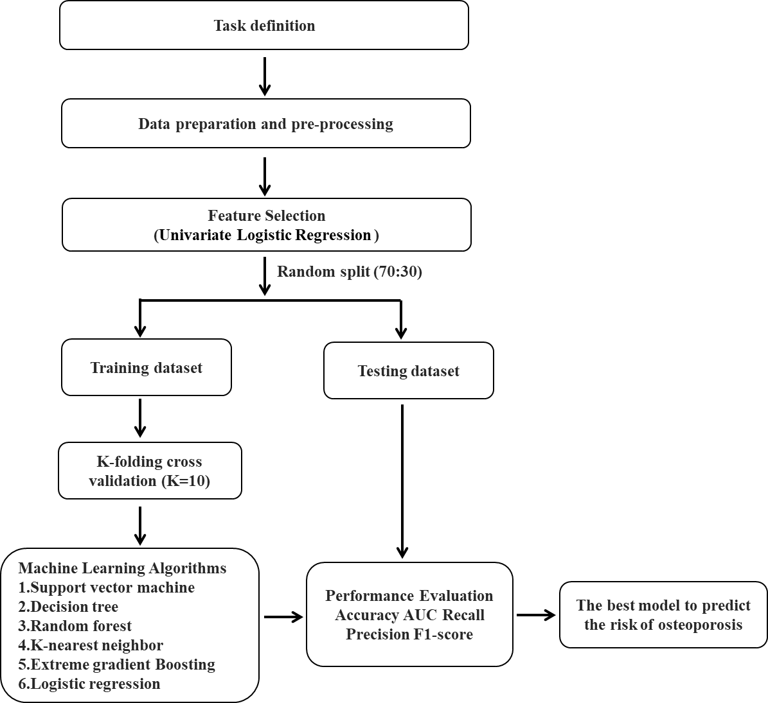
Figure S1 The process of developing machine learning algorithms.
Abbreviation: AUC, area under the curve.

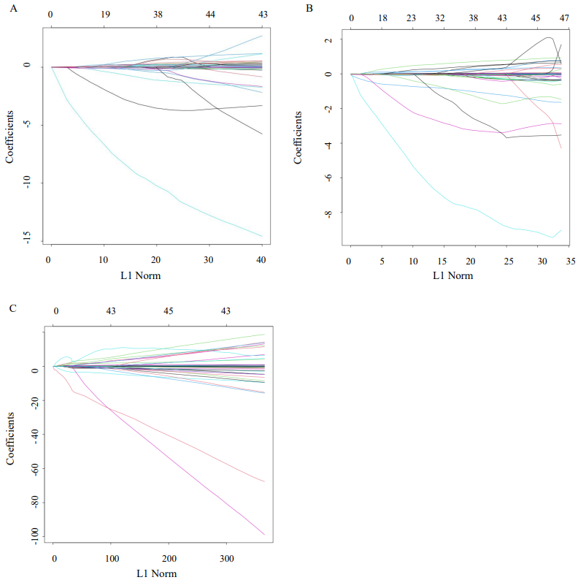

Figure S2 LASSO feature selection models.
Notes: (A) LASSO coefficient profiles of all 53 features in the total study population. (B) LASSO coefficient profiles of all 53 features in the male patients. (C) LASSO coefficient profiles of all 53 features in the female patients.
Abbreviation: LASSO, least absolute shrinkage and selection operator.
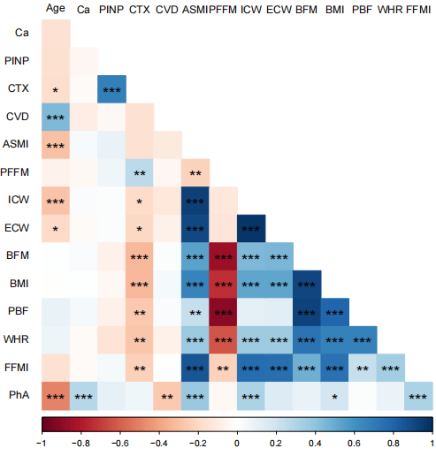
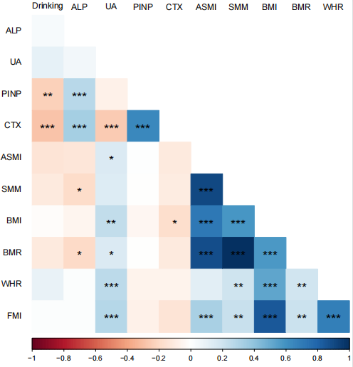
A
B
Figure S3 The Spearman’s correlation analysis heat maps.
Notes: The Spearman’s correlation analysis heat map in the training datasets of male (A) and female patients (B). The colors of the squares in the heat map represent r values ranging from -1 to 1 according to the Spearman’s correlation analysis. * P < 0.05, ** P < 0.01, *** P < 0.001.
Abbreviations: ALP, alkaline phosphatase; UA, uric acid; PINP: N-terminal propeptide of type I procollagen; CTX:C-terminal telopeptide of type I collagen; ASMI, appendicular skeletal muscle mass index; SMM, skeletal muscle mass; BMI, body mass index; BMR, basal metabolic rate; WHR, waist-to-hip ratio; FMI, fat mass index; Ca, calcium; CVD, cardiovascular disease; PFFM, percentage of fat-free mass; ICW, intracellular water; ECW, extracellular water; BFM, body fat mass; PBF, percentage of body fat; FFMI, fat-free mass index; PhA, phase angle
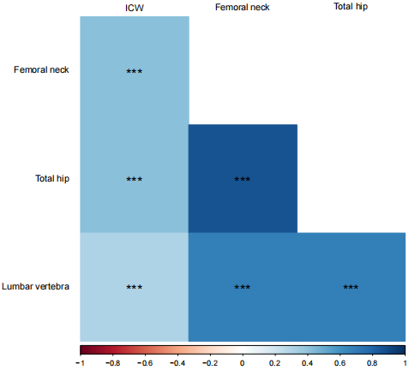
Figure S4 The Spearman’s correlation analysis heat map illustrates the correlation between ICW and BMD at different measured sites in the female patients.
Notes: The colors of the squares in the heat map represent r values ranging from -1 to 1 according to the Spearman’s correlation analysis. *** P < 0.001.
Abbreviations: ICW, intracellular water; BMD, bone mineral density.

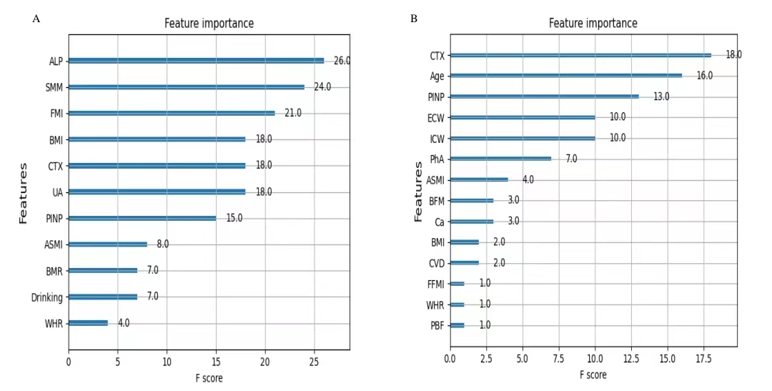

Figure S5 The importance scores of the features by XGBoost algorithm.
Notes: The importance scores of the features are calculated by XGBoost in the male (A) and female patients (B).
Abbreviations: ALP, alkaline phosphatase; SMM, skeletal muscle mass; FMI, fat mass index; BMI, body mass index; CTX, C-terminal telopeptide of type I collagen; UA, uric acid; PINP, N-terminal propeptide of type I procollagen; ASMI, appendicular skeletal muscle mass index; BMR, basal metabolic rate; WHR, waist-to-hip ratio; ECW, extracellular water; ICW, intracellular water; PhA, phase angle; BFM, body fat mass; Ca, calcium; CVD, cardiovascular disease; FFMI, fat-free mass index; PBF, percentage of body fat.

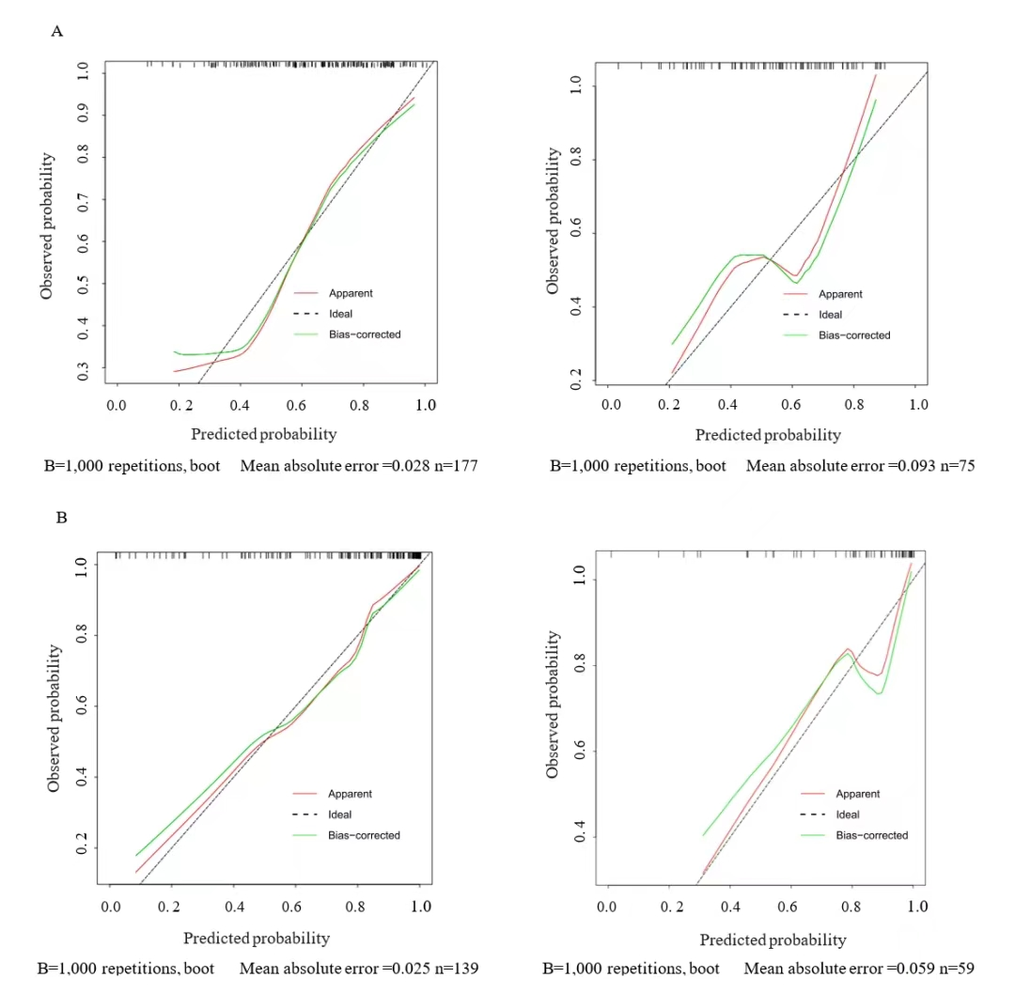
Figure S6 Calibration curves of the nomogram.
Notes: Calibration curves of the nomogram in the male (A) and female patients (B) (left, training datasets, right, testing datasets).
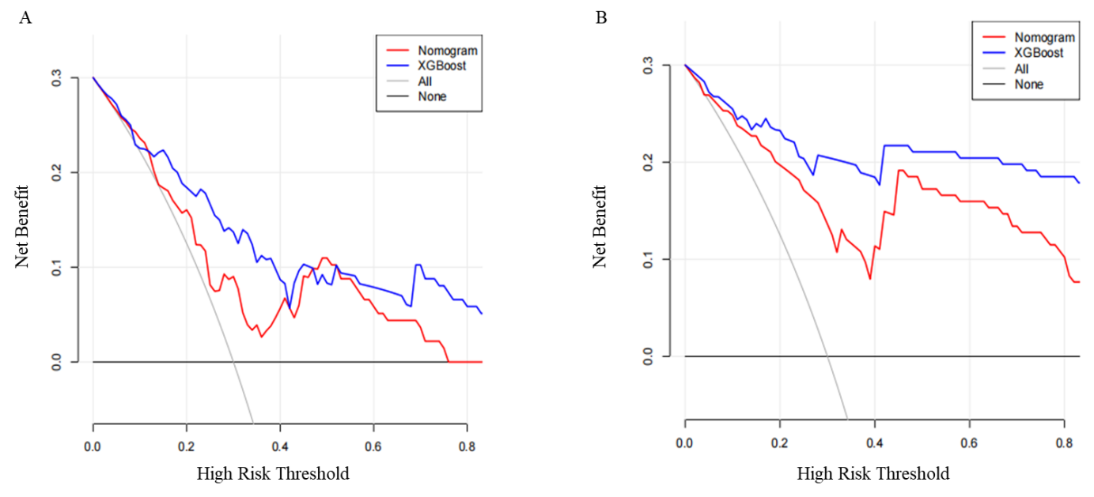
Figure S7 Comparison of DCA.
Notes: Comparison of DCA between the nomogram and XGBoost models in the testing datasets of male (A) and female patients (B).
Abbreviations: DCA, decision curve analysis; XGBoost, extreme gradient boost.

