Online supplement
Lung fibroblasts from chronic obstructive pulmonary disease subjects have a deficient gene expression response to cigarette smoke extract compared to healthy.

Martin Ryde, Nicole van der Burg, Carin Larsson, Anna-Karin Larsson-Callerfelt, Gunilla Westergren -Thorsson, Leif Bjermer, Ellen Tufvesson

Table S1. Gene lists that changed expression significantly (p < 0.05) from baseline to after CSE stimulation within healthy only, COPD only and within both. Statistics: Wilcoxon signed rank test.
 | Healthy |  | Both |  | COPD
# | Down | Up | Down | Up | Down | Up
1  2  3  4  5  6  7  8  9  10  11  12  13  14  15  16  17  18  19  20  21  22  23  24  25  26  27  28  29  30  31  32  33  34  35  36  37  38  39  40  41  42  43  44  45  46  47  48  49  50  51  52  53  54  55  56  57  58  59  60  61  62  63  64  65  66  67  68  69  70  71  72  73  74  75  76  77  78  79  80  81  82  83  84  85  86  87  88  89  90  91  92  93  94  95  96  97  98  99  100  101  102  103  104  105  106  107  108  109  110  111  112  113  114  115  116  117 | ACSL4  ADAM17  ADAM9  AKR1B10  ANAPC1  AP1G1  APLP2  ATF4  ATG101  ATG2B  BRAF  CBL  CD36  CD44  CDKN1A  CFLAR  CKAP4  CREB3  CREBBP  CRK  CRKL  CSNK1E  CSNK2A1  CSNK2B  CTBP2  CTNNB1  CUL3  CXCL8  DAXX  DERL1  E2F4  ERO1A  FAP  FGF2  FNIP2  FRS2  GREM1  GSK3B  HADHA  HDAC4  HTRA2  IL11  IL1R1  IL6ST  ITGA1  JAK1  JAK2  KAT6A  KRAS  LATS1  LATS2  LEPR  LOX  LRP6  MAP2K1  MAPK1  MAPK8  MAPK9  MECP2  MEF2A  MET  MFAP3  MKI67  MOB1B  NCK2  NID1  NOL7  NPC1  NUMB  OGT  PANX1  PDE3B  PIK3C3  PIK3CA  PIK3CB  PPARA  PPM1A  PPP2CA  PRDX1  PRKAB2  PRKDC  PROS1  PSMB1  PSMC3  PSMD13  PTK2  PTPN1  PTPN12  RAC1  RAP1B  RAPGEF1  RAPGEF2  RELA  RELB  RNF111  ROCK2  RORA  SEC61B  SIRT1  SKI  SMAD4  SMURF1  SNAI2  SOS1  SRC  STAT3  TBC1D4  TGFB1  TGFBR1  TGFBR2  TJP2  TRAF6  UBE2D2  UBE4B  XBP1  YWHAG  ZFYVE16 | ATOX1  CASP8  CAT  CCS  COL1A1  COL1A2  COL6A3  COX6B1  COX7C  DEPDC5  EGR1  FABP5  GNG2  HADH  HIKESHI  HSD11B1  HSD17B4  LDLRAP1  LGALS3  LIPA  LOXL1  LOXL4  LRP1  MASP1  MMUT  NDUFA1  NDUFB5  NDUFB8  PGM1  PRKAG1  RPLP0  S100A4  SERPINF1  SIL1  SREBF1  SSR4  STAT5A  TCF7L2  TXN2 | AMOTL1  ANGPTL4  APC  ARHGAP35  ATP7A  BRPF3  CASP3  CASP4  CDH2  CHUK  CREB1  CSNK1A1  CSNK1G3  CUL1  DIAPH1  DUSP7  ERC1  GNB4  GNPTAB  GRB10  HCFC1  IQGAP1  ITGB1  ITPR2  KMT2D  MAML1  MAP3K1  NF1  NOTCH2  PIK3R4  PPARD  PRKACA  PRKACB  PSMB7  PTPN11  RNF152  SEC24C  SEH1L  SELENOS  SMAD2  SP1  SP3  SPOPL  STK4  SUGT1  TBL1XR1  TJP1  UQCRFS1  XIAP  YWHAB | ISG15 | ATF7IP  CHMP4B  DOCK1  EP300  FURIN  IRS1  MAML2  PDGFRB  SERPINE1  SMAD3  SSR2  UBE2N | CTSD  ERP29  JAG1  JUN  LAMTOR4  NR1H2  PLTP

Table S2. Gene lists of genes that significantly changed expression levels from baseline to after CSE stimulation that formed the same Enrichr cluster (Positive regulation of transcription by RNA polymerase II) for healthy and COPD. Genes are separated by increased or decreased expression from baseline to after CSE stimulation. Table includes unique genes of the same cluster GO terms (p < 0.01) in the comparing group.
Cluster |  | Gene list of cluster
 |  | Decreased | Increased
Healthy-RPII | RPII transcription | ATF4, CHUK, CREB1, CREB3, CREBBP, CTBP2, CTNNB1, E2F4, FGF2, GREM1, HCFC1, HDAC4, IL11, KAT6A, KMT2D, LRP6, MAML1, MET, MEF2A, NCK2, OGT, PPARA, PPARD, PRKDC, PSMC3, RELA, RNF111, RORA, SIRT1, SKI, SMAD2, SMAD4, SREBF1, STAT3, SP1, SP3, TGFB1, TRAF6, TBL1XR1, XBP1 | EGR1, TCF7L2
COPD-RPII | RPII transcription | CHUK, CREB1, EP300, HCFC1, KMT2D, MAML1, MAML2, PPARD, SERPINE1, SMAD2, SMAD3, SP1, SP3, TBL1XR1 | JAG1, JUN, NR1H2

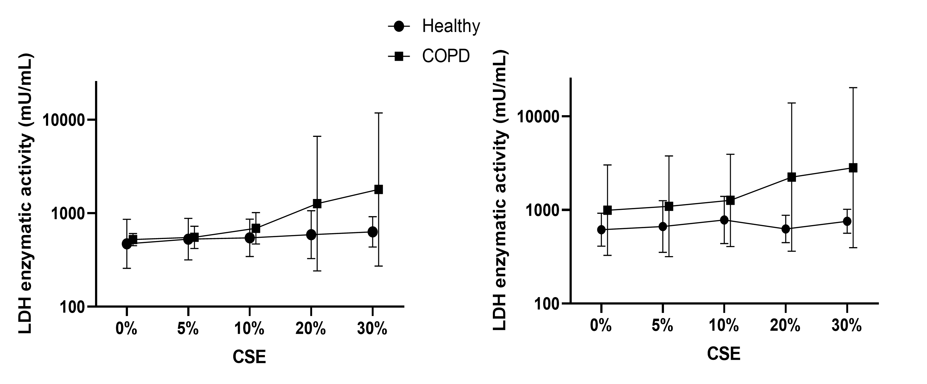
Figure S1. Investigation of the cell cytotoxic in lung fibroblasts from healthy and COPD subjects after exposure to 0%, 5%, 10%, 20% or 30% CSE for (A) 4 and (B) 8 hours, measured as lactase dehydrogenase (LDH) in the cell supernatant.
Figure S2. Number of genes with more than 50% of subjects having more than 23 transcript counts (background threshold), the maximum being 480 genes. Dotted line indicates median for each group.
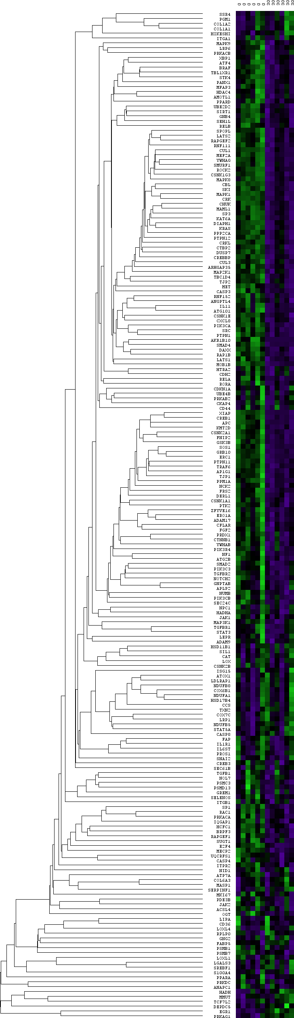
Figure S3. Heatmap of genes that changed expression significantly (p < 0.05) from baseline to after CSE stimulation within healthy only. Statistics: Wilcoxon signed rank test
Figure S4. Heatmap of genes that changed expression significantly (p < 0.05) from baseline to after CSE stimulation within COPD only. Statistics: Wilcoxon signed rank test
Healthy
Baseline CSE
Figure S5. Heatmap of genes that changed expression significantly (p < 0.05) from baseline to after CSE stimulation within both healthy and COPD. Statistics: Wilcoxon signed rank test
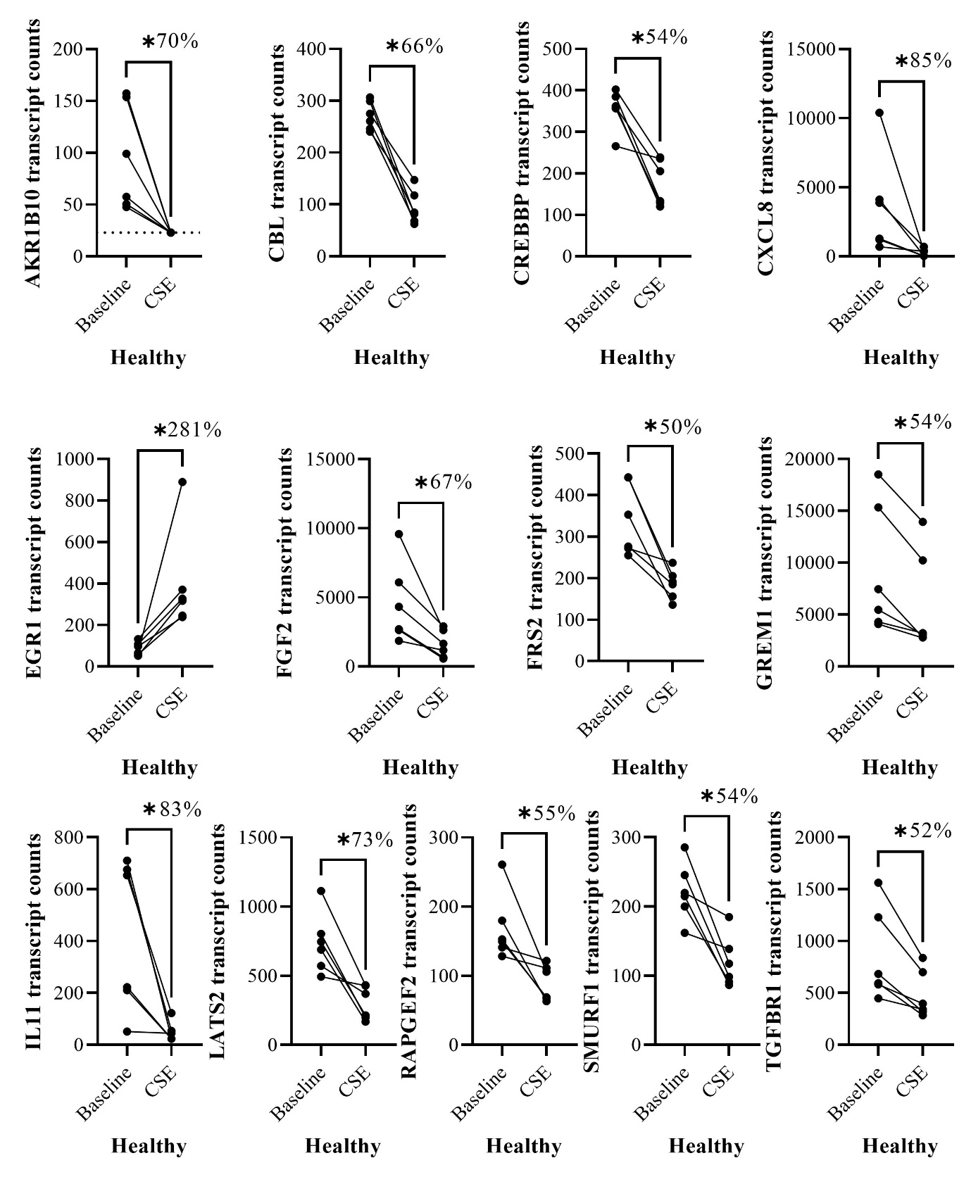Figure S6. Plots of genes from Figure 3G with more than 50% median of the paired differences in transcript counts between baseline and after CSE stimulation and more than 25% coefficient of variation. Statistics: Wilcoxon rank test.
Figure S7. Bar graph of the top 10 enriched pathways based on (A) the genes that had significant differences in expression of lung fibroblasts from baseline to after CSE stimulation in both healthy and COPD and (B) all the 480 genes above background threshold.

