ORIGINAL RESEARCH

Multifunctional AuPt Nanoparticles for Synergistic Photothermal and Radiation Therapy
Han Tang^{1*}, Ji Chen ^{2, *}, Lu He Qi ³, Meng Lyu ⁴, Hong Quan ¹, Zhi Jie Tan ^{1,}

¹ Key Laboratory of Artificial Micro- and Nano-Structures of Ministry of Education, School of Physics and Technology, Wuhan University, Wuhan, China; ² Department of Radiation and Medical Oncology, Hubei Key Laboratory of Tumor Biological Behaviors, Hubei Cancer Clinical Study Center, Zhongnan Hospital of Wuhan University, Wuhan, China; ³ School of Resource and Environmental Sciences, Wuhan University, Wuhan, China; ⁴ Department of Gastrointestinal Surgery, Shenzhen People's Hospital (The Second Clinical Medical College, Jinan University, the First Affiliated Hospital, Southern University of Science and Technology), Shenzhen, Guangdong, China.

*These authors contributed equally to this work

Correspondence:
Hong Quan
School of Physics and Technology, Wuhan University, Wuhan, Hubei Province, China

Email: 00007962@whu.edu.cn
Zhi Jie Tan
School of Physics and Technology, Wuhan University, Wuhan, Hubei Province, China
Email: zjtan@whu.edu.cn

Calculation of photothermal conversion efficiency

Photothermal conversion efficiency ($Ƞ$) detailed calculation was given as following：

$Ƞ=\frac{hS\left(T_{max}-T_{surr}\right)-Q_{Dis}}{I\left(1-{10}^{A_{808}}\right)}$ (1)
where h is the heat transfer coefficient, S is the surface area of the container. $\left(T_{max}-T_{surr}\right)$ is the elevated temperature after laser radiation. The light absorption of 100 μg/ml material at 808nm (A₈₀₈) is 0.570. The laser power I is 1 W. Q_{Dis}=5.4×10⁻⁴ I. In order to gain hS, a dimensionless parameter $θ$ is introduced as followed:
$θ=\frac{T-T_{sur}}{T_{Max}-T_{sur}}$ (2)
A sample system time constant${ τ}_{s}$ can be calculated as equation
$t={-τ}_{s}\ln{(θ)}$ (3)

$S={M_{i}C_{i}}/{τ_{s}}$ (4)
where $M_{i}$ and $C_{i}$ are the mass and specific heat capacity of the solution, respectively. The ln(θ)-t scatter plot is plotted based on the experiments and fitted to obtain the fitting coefficient $τ_{s}$, which leads to the calculation of hS. Finally, the photothermal conversion$(Ƞ)$ of material AF was calculated to be 46.84%.

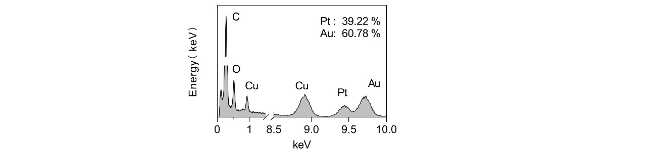

Figure.S1 EDX image of AuPt.

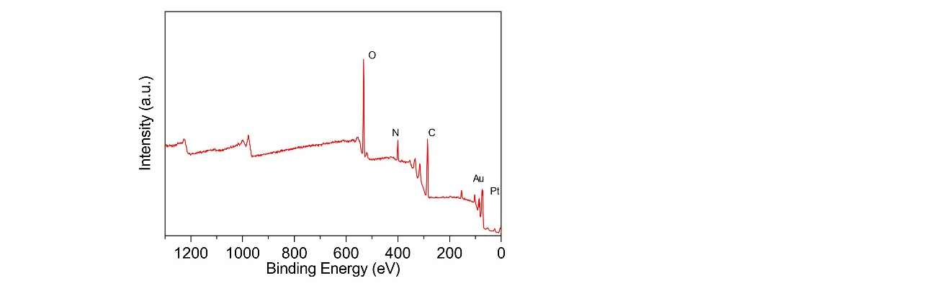

Figure.S2 Survey XPS spectrum.

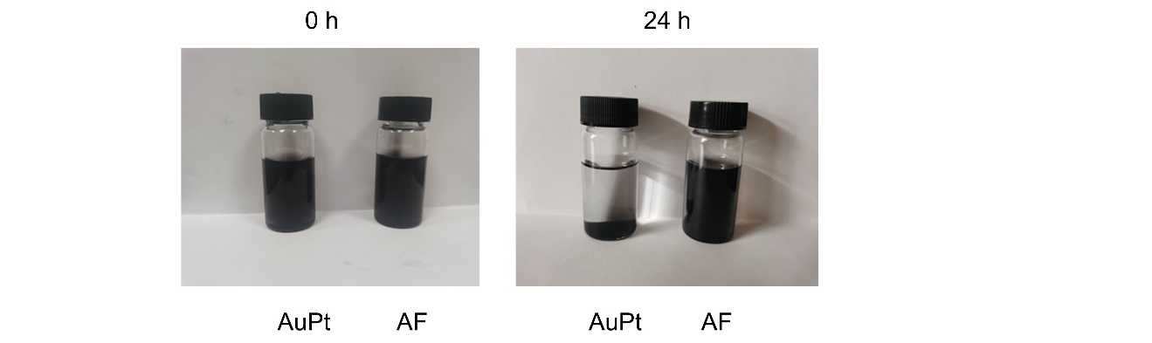

Figure.S3 Dispersion of AF and AuPt in PBS after 0h and 24 h.

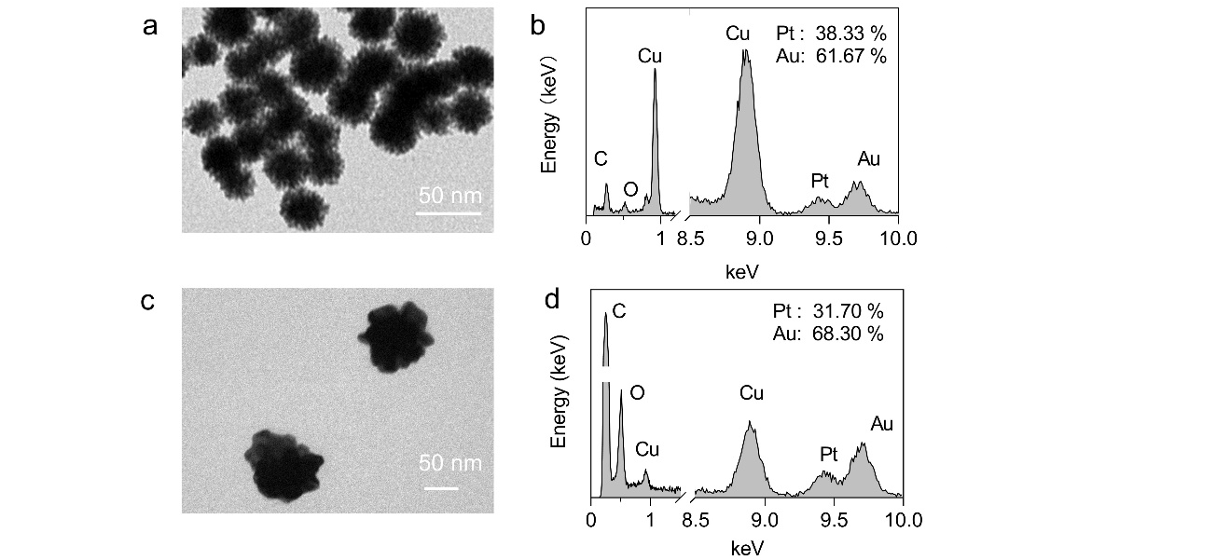

Figure.S4 (a,b) TEM and EDX image of AuPt (30 nm). (c,d) TEM and EDX image of AuPt (100 nm).

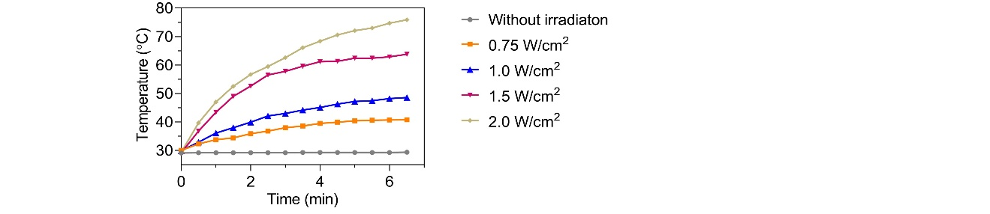

Figure.S5 Photothermal heating curves of AF with different energy laser.

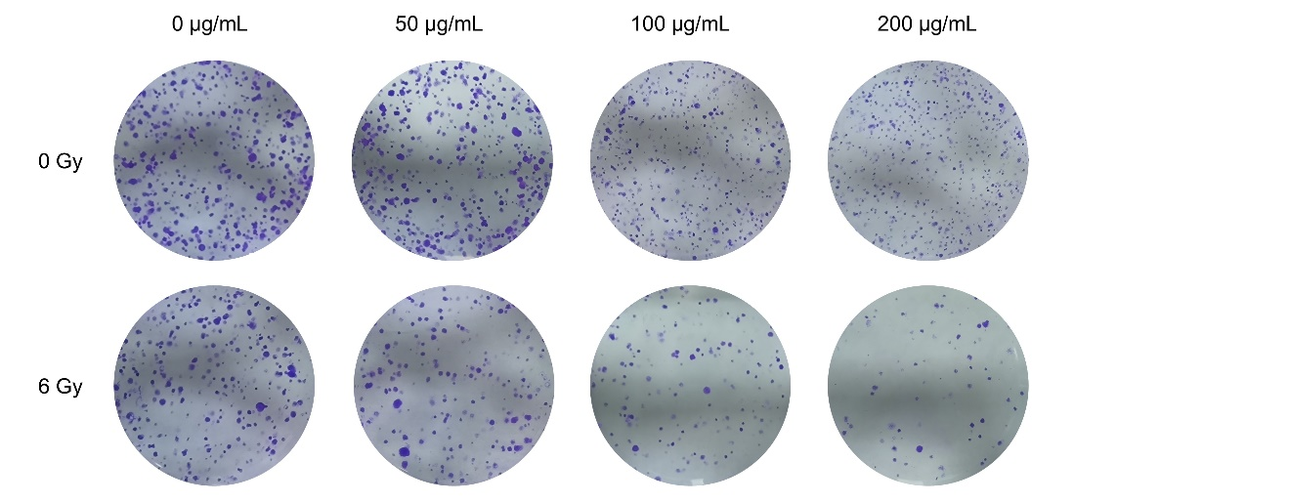

Figure.S6 Colony formation images under different concentrations of AF and irradiation.

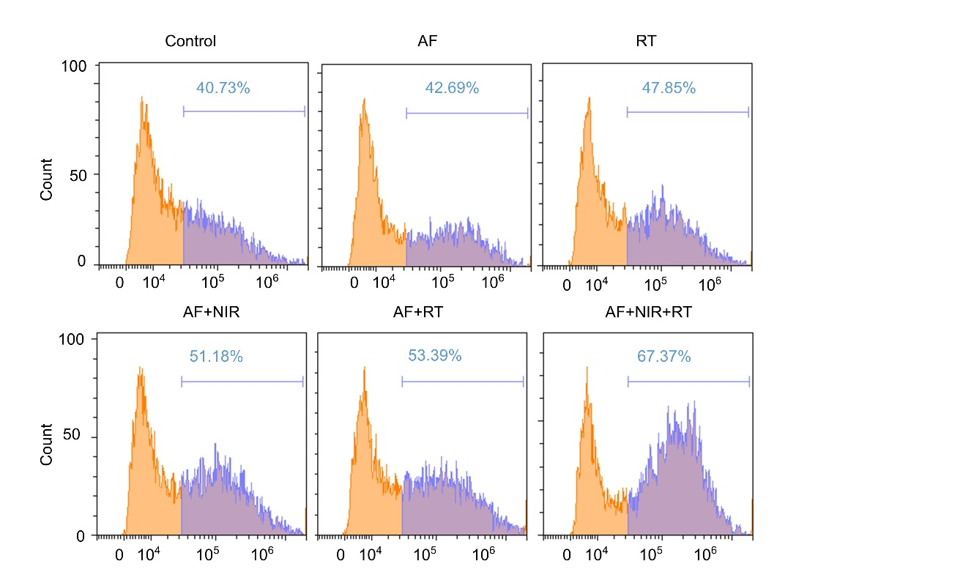

Figure.S7 Changes in intracellular ROS content after different treatments.
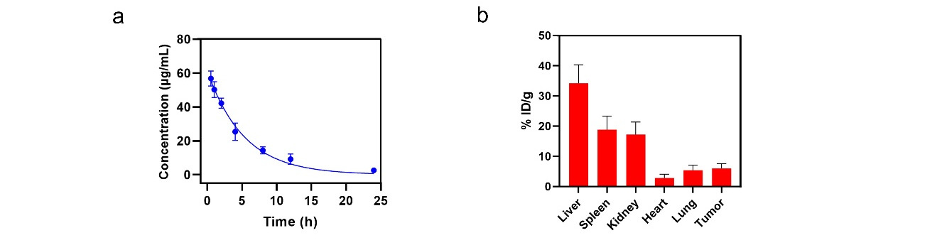
Figure.S8 (a) Pharmacokinetics of AF in blood after injection (0,1,2,4,8,12 and 24h) (b) The distribution of AF in various organs (heart, liver, spleen, lungs, and kidneys) and tumors of mice

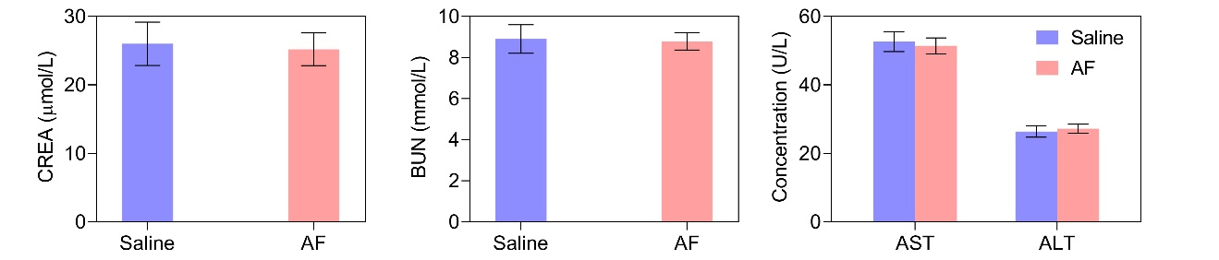

Figure.S9 Blood routine tests (CREN, BUN, AST and ALT) for AF and control groups.

