Supplementary Material

Supplementary Figures and Tables

Supplementary Figures

Supplementary Figure S1 Sensitivity analysis of FMWT
Notes: (A)Sensitivity analysis of FMWT between the true-acupuncture group and the model group. (B)Sensitivity analysis of FMWT between the true-acupuncture group and the sham-acupuncture group.
Abbreviation: FMWT, facial mechanical withdrawal threshold.
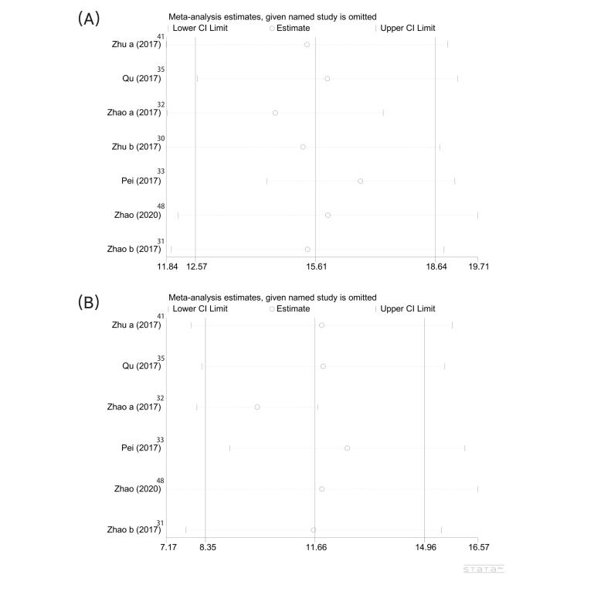

Supplementary Figure S2 Sensitivity analysis of PMWT
Notes: (A)Sensitivity analysis of PMWT between the true-acupuncture group and the model group. (B)Sensitivity analysis of PMWT between the true-acupuncture group and the sham-acupuncture group.
Abbreviation: PMWT, paw mechanical withdrawal threshold.
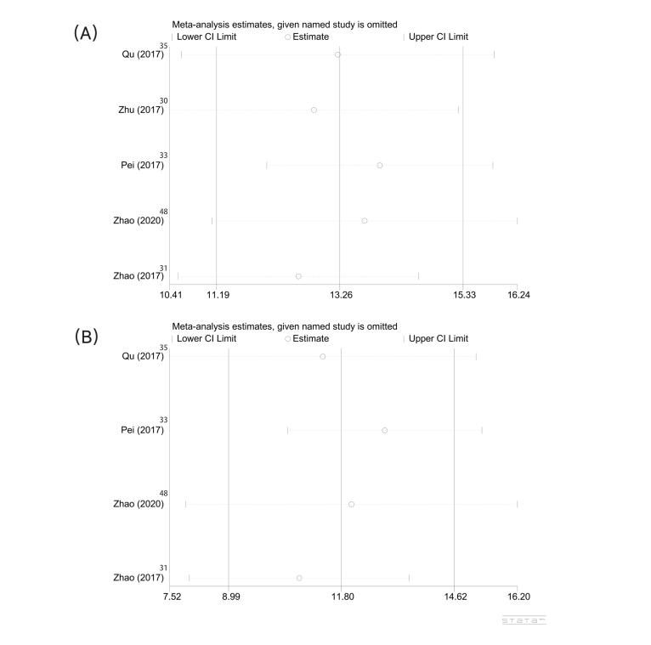
Supplementary Figure S3 Sensitivity analysis of 50%FMWT
Notes: (A)Sensitivity analysis of 50%FMWT between the true-acupuncture group and the model group. (B)Sensitivity analysis of 50%FMWT between the true-acupuncture group and the sham-acupuncture group.
Abbreviation: 50% FMWT, 50% facial mechanical withdrawal threshold.
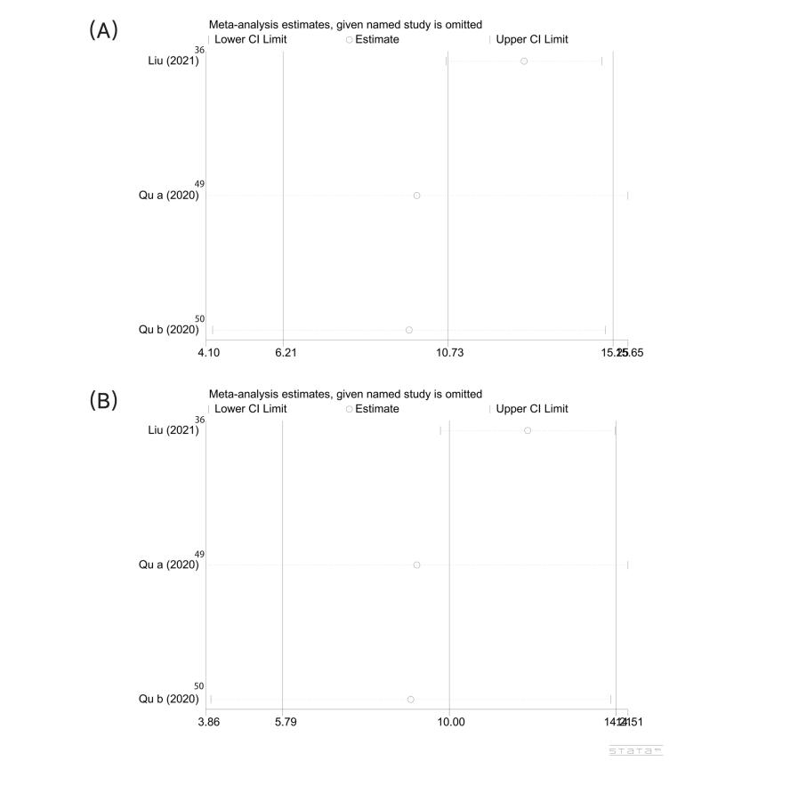
Supplementary Figure S4 Sensitivity analysis of 50%PMWT
Notes: (A)Sensitivity analysis of 50%PMWT between the true-acupuncture group and the model group. (B)Sensitivity analysis of 50%PMWT between the true-acupuncture group and the sham-acupuncture group.
Abbreviation: 50% PMWT, 50% facial mechanical withdrawal threshold.
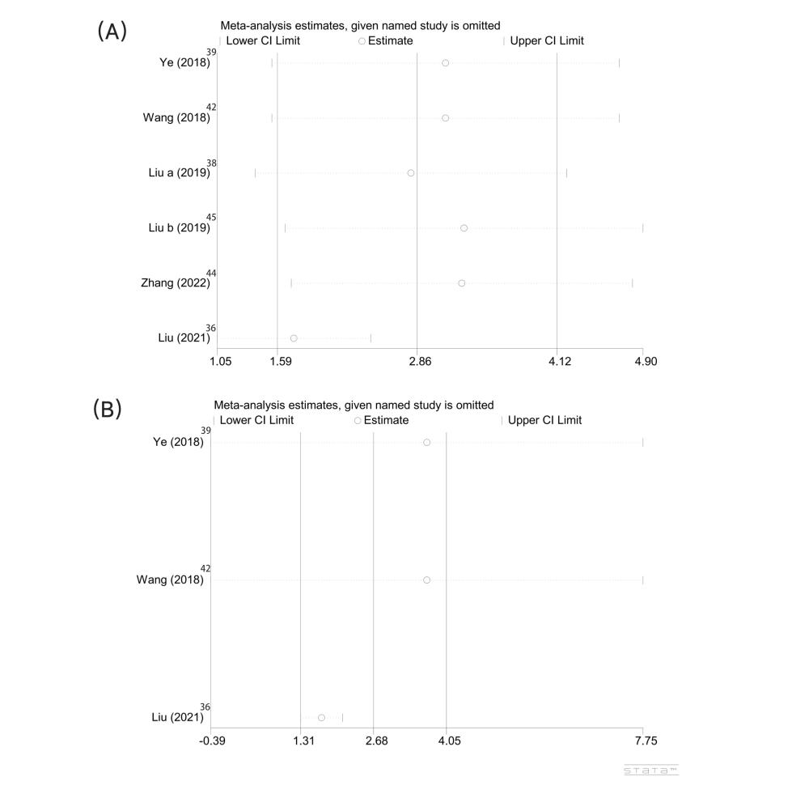
Supplementary Figure S5 Sensitivity analysis of CGRP
Abbreviation: CGRP, calcitonin gene related peptide.
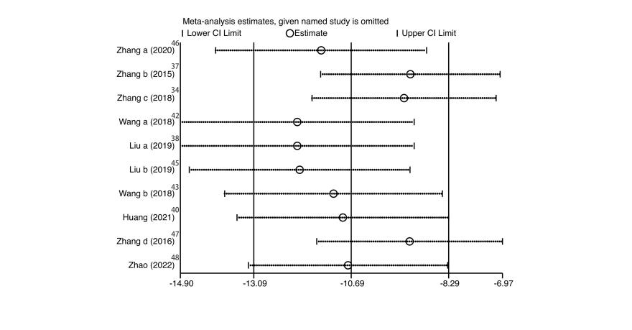
Supplementary Figure S6 Assessment of Publication Bias
Notes: (A)Funnel plot results of publication bias assessments. (B)Results by Begg's test and Egger's test.
Abbreviation: WMD, weighted mean difference.
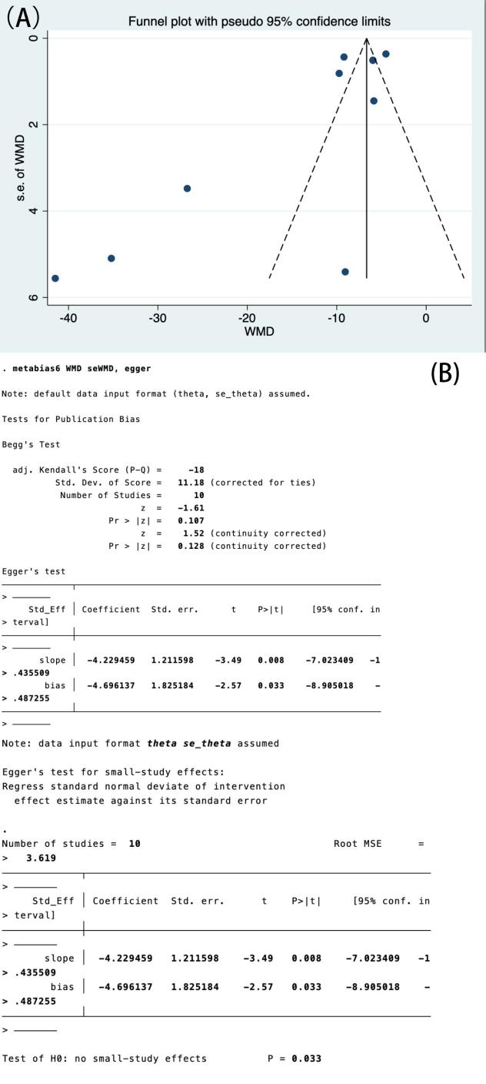

Supplementary Tables
Table S1 Subgroup analysis of acupuncture for FMWT between TA group and Model group
Abbreviation: WMD, weighted mean difference; TA, true acupuncture; FMWT, facial mechanical withdrawal threshold
Subgroup variables | No. of studies | Pooled WMD (95%CI) | Measure of heterogeneity |  |  | Weight (%) | P value
Subgroup variables | No. of studies | Pooled WMD (95%CI) | Statistic | P | I² | Weight (%) | P value
Acupoints selection
CB20+GB34 | 4 | 16.51(12.83, 20.19) | 16.04 | 0.001 | 81.3% | 55.69 | <0.0001
GB20+SJ5 | 1 | 17.44(14.38, 20.50) | 0.00 | - | - | 14.68 | <0.0001
GB20 | 2 | 13.12(6.15, 20.09) | 10.83 | 0.001 | 90.8% | 29.63 | <0.0001
Sessions
3 weeks | 3 | 16.66(14.72, 18.60) | 1.69 | 0.429 | 0.00% | 40.06 | <0.0001
7 weeks | 3 | 15.93(8.52, 23.35) | 36.89 | 0.000 | 94.6% | 44.07 | <0.0001
5 weeks | 1 | 13.90(11.74, 16.05) | 0.00 | - | - | 15.87 | <0.0001
Duration of each treatment
10min | 3 | 16.66(14.72, 18.60) | 1.69 | 0.429 | 0.00% | 40.06 | <0.0001
15min | 4 | 15.36(10.51, 20.11) | 36.96 | 0.000 | 91.9% | 59.94 | <0.0001
Risk of bias
5 | 3 | 15.85(13.56, 18.14) | 4.51 | 0.105 | 55.7% | 45.63 | <0.0001
6 | 2 | 15.70(12.28, 19.11) | 1.15 | 0.284 | 13.0% | 24.20 | <0.0001
4 | 1 | 21.50(18.27, 24.73) | 0.00 | - | - | 14.43 | <0.0001
7 | 1 | 9.70(7.43,11.96) | 0.00 | - | - | 15.74 | <0.0001
Table S2 Subgroup analysis of acupuncture for FMWT between TA group and SA group
Abbreviation: WMD, weighted mean difference; TA, true acupuncture; SA, sham acupuncture; FMWT, facial mechanical withdrawal threshold.
Subgroup variables | No. of studies | Pooled WMD (95%CI) | Measure of heterogeneity |  |  | Weight (%) | P value
Subgroup variables | No. of studies | Pooled WMD (95%CI) | Statistic | P | I² | Weight (%) | P value
Acupoints selection
CB20+GB34 | 4 | 12.80(18.33, 17.26) | 27.71 | 0.000 | 89.32% | 65.48 | <0.0001
GB20 | 2 | 9.36(4.98, 13.74) | 4.67 | 0.031 | 78.6% | 34.52 | <0.0001
Sessions
3 weeks | 2 | 10.49(7.70, 13.28) | 0.04 | 0.839 | 0.00% | 29.42 | <0.0001
7 weeks | 3 | 12.81(5.28,20.33) | 45.02 | 0.000 | 95.6% | 51.67 | <0.0001
5 weeks | 1 | 10.74(9.16, 12.32) | 0.00 | - | - | 18.91 | <0.0001
Duration of each treatment
10min | 2 | 10.49(7.70, 13.28) | 0.04 | 0.839 | 0.00% | 29.42 | <0.0001
15min | 4 | 12.22(7.74, 16.70) | 45.18 | 0.000 | 93.4% | 70.58 | <0.0001
Risk of bias
5 | 2 | 10.72(9.30, 12.14) | 0.00 | 0.967 | 0.00% | 35.52 | <0.0001
6 | 2 | 11.31(8.31, 14.32) | 0.32 | 0.574 | 0.00% | 28.83 | <0.0001
4 | 1 | 19.29(16.39, 22.19) | 0.00 | - | - | 17.15 | <0.0001
7 | 1 | 7.38(5.45,9.31) | 0.00 | - | - | 18.51 | <0.0001

Table S3 Subgroup analysis of acupuncture for PMWT between TA group and Model group
Abbreviation: WMD, weighted mean difference; TA, true acupuncture; PMWT, paw mechanical withdrawal threshold.
Subgroup variables | No. of studies | Pooled WMD (95%CI) | Measure of heterogeneity |  |  | Weight (%) | P value
Subgroup variables | No. of studies | Pooled WMD (95%CI) | statistic | P | I² | Weight (%) | P value
Acupoints selection
CB20+GB34 | 2 | 12.44(10.36, 14.52) | 0.47 | 0.495 | 0.00% | 42.61 | <0.0001
GB20+SJ5 | 1 | 15.04(11.74, 18.34) | 0.00 | - | - | 19.50 | <0.0001
GB20 | 2 | 13.00（7.03, 18.97) | 6.11 | 0.013 | 83.6% | 37.88 | <0.0001
Sessions
3 weeks | 2 | 14.26(11.87, 16.65) | 0.45 | 0.502 | 0.00% | 38.10 | <0.0001
7 weeks | 2 | 13.00(7.03,18.97) | 6.11 | 0.013 | 83.6% | 37.88 | <0.0001
5 weeks | 1 | 11.89(9.28, 14.50) | 0.00 | - | - | 24.02 | <0.0001
Duration of each treatment
10min | 2 | 14.26(11.87, 16.65) | 0.45 | 0.502 | 0.00% | 38.10 | <0.0001
15min | 3 | 12.64(9.33, 15.95) | 6.76 | 0.034 | 70.4% | 61.90 | <0.0001
Risk of bias
5 | 2 | 14.79(12.26, 17.31) | 1.16 | 0.282 | 13.7% | 38.86 | <0.0001
6 | 2 | 13.30(10.23, 16.36) | 2.15 | 0.143 | 53.5% | 43.52 | <0.0001
7 | 1 | 9.89(6.24,13.53) | 0.00 | - | - | 17.62 | <0.0001

Table S4 Subgroup analysis of acupuncture for PMWT between TA group and SA group
Abbreviation: WMD, weighted mean difference; TA, true acupuncture; SA: sham acupuncture; PMWT, paw mechanical withdrawal threshold.
Subgroup variables | No. of studies | Pooled WMD (95%CI) | Measure of heterogeneity |  |  | Weight (%) | P value
Subgroup variables | No. of studies | Pooled WMD (95%CI) | Statistic | P | I² | Weight (%) | P value
Acupoints selection
CB20+GB34 | 2 | 11.76(9.77, 13.76) | 1.03 | 0.311 | 2.5% | 53.27 | <0.0001
GB20 | 2 | 11.42(4.10, 18.75) | 8.57 | 0.003 | 88.3% | 46.73 | <0.0001
Sessions
3 weeks | 1 | 13.10(9.84, 16.36) | 0.00 | - | - | 24.61 | <0.0001
7 weeks | 2 | 11.42(4.10,18.75) | 8.57 | 0.003 | 88.3% | 46.73 | <0.0001
5 weeks | 1 | 10.99(8.53, 13.45) | 0.00 | - | - | 28.66 | <0.0001
Duration of each treatment
10min | 1 | 13.10(9.84, 16.36) | 0.00 | - | - | 24.61 | <0.0001
15min | 3 | 11.34(7.52, 15.17) | 8.98 | 0.011 | 77.7% | 75.39 | <0.0001
Risk of bias
6 | 2 | 14.12(11.86, 16.38) | 0.73 | 0.394 | 0.00% | 49.78 | <0.0001
7 | 1 | 7.59(3.70, 11.49) | 0.00 | - | - | 21.56 | <0.0001
5 | 1 | 10.99(8.53,13.45) | 0.00 | - | - | 28.66 | <0.0001

Table S5 Subgroup analysis of acupuncture for 50%PMWT between TA group and Model group
Abbreviation: WMD, weighted mean difference; TA, true acupuncture; 50%PMWT, 50% paw mechanical withdrawal threshold.
Subgroup variables | No. of studies | Pooled WMD (95%CI) | Measure of heterogeneity |  |  | Weight (%) | P value
Subgroup variables | No. of studies | Pooled WMD (95%CI) | Statistic | P | I² | Weight (%) | P value
Acupoints selection
CB20+GB34+SJ5 | 5 | 1.74(1.05, 2.44) | 38.66 | 0.000 | 89.7% | 85.43 | <0.0001
GB20+GB34 | 1 | 9.29(7.92, 10.67) | 0.00 | - | - | 14.57 | <0.0001
Sessions
1 week | 4 | 1.92(1.07, 2.77) | 34.75 | 0.000 | 91.4% | 68.35 | <0.0001
8 weeks | 1 | 1.05(0.52,1.57) | 0.00 | - | - | 17.08 | <0.0001
4 weeks | 1 | 9.29(7.92, 10.67) | 0.00 | - | - | 14.47 | <0.0001
Duration of each treatment
30min | 5 | 1.74(1.05, 2.44) | 38.66 | 0.000 | 89.7% | 85.43 | <0.0001
15min | 1 | 9.29(7.92, 10.67) | 0.00 | - | - | 14.57 | <0.0001
Risk of bias
6 | 6 | 2.86(1.59, 4.12) | 158.13 | 0.000 | 96.8% | 100.00 | <0.0001

Table S6 Subgroup analysis of acupuncture for CGRP between TA group and Model group
Abbreviation: WMD, weighted mean difference; TA, true acupuncture; CGRP, calcitonin gene related peptide.
Subgroup variables | No. of studies | Pooled WMD (95%CI) | Measure of heterogeneity |  |  | Weight (%) | P value
Subgroup variables | No. of studies | Pooled WMD (95%CI) | Statistic | P | I² | Weight (%) | P value
Acupoints selection
CB20+SJ5 | 3 | 0.62(-32.82, 34.06) | 55.55 | 0.000 | 96.4% | 27.39 | 0.021
GB20 | 1 | -41.48(-52.37, -30.59) | 0.00 | - | - | 7.98 | <0.0001
GB20+GB34+SJ5 | 3 | -5.42(-6.47, -4.38) | 8.11 | 0.017 | 75.3% | 33.95 | <0.0001
GB20+DU20+PC6+LR3 | 2 | 9.28(8.63, 9.92) | 0.34 | 0.542 | 0.00% | 22.58 | <0.0001
GB20+GB34 | 1 | -9.05(-19.64, 1.55) | 0.00 | - | - | 8.11 | 0.094
Sessions
5 weeks | 4 | -1.81(-26.03, 22.40) | 111.94 | 0.000 | 97.3% | 35.50 | 0.883
1 weeks | 4 | -7.12(-9.63,-4.60) | 50.55 | 0.000 | 94.1% | 41.92 | <0.0001
8 weeks | 2 | 9.28(8.63, 9.92) | 0.37 | 0.542 | 0.00% | 22.58 | <0.0001
Duration of each treatment
20min | 1 | -5.85(-8.69, 2-3.01) | 0.00 | - | - | 11.03 | <0.0001
30min | 8 | -3.13(-9.46, 3.21) | 1390.94 | 0.000 | 99.5% | 80.86 | 0.333
15min | 1 | -9.05(-19.64,1.55) | 0.00 | - | - | 8.11 | 0.094
Risk of bias
5 | 3 | -18.38(-38.69, 1.92) | 38.50 | 0.000 | 94.8% | 27.12 | 0.076
6 | 6 | -4.05(-10.85, 2.75) | 1274.25 | 0.000 | 99.6% | 64.90 | 0.243
7 | 1 | 43.33(32.46,54.21) | 0.00 | - | - | 7.99 | <0.0001
Blood collection sites
Apex cordis | 1 | -5.85(-8.69, -3.01) | 0.00 | - | - | 11.96 | <0.0001
Jugular vein | 4 | -28.08(-40.30, -15.86) | 20.29 | 0.000 | 85.2% | 18.16 | <0.0001
Abdominal aorta | 3 | -5.42(-6.47,-4.38) | 8.11 | 0.017 | 75.3% | 42.25 | <0.0001
Abdominal veins | 2 | -9.31(-13.09,-8.29) | 191.50 | 0.000 | 0.0% | 27.64 | <0.0001

