Supplementary Material

Umbilical cord stem cell lysate: A new biologic injectate for the putative treatment of acute temporomandibular joint inflammation
7

Christopher K. Ward, Rita G. Gill, Robert S. Liddell, John E Davies

A note on Lysate Composition
The cell lysate employed herein is highly complex since it contains the complete contents of the cells following homogenization and 0.22 micron filtration. The lysate includes cell membrane particles, of varying size and shape, from both plasma and other cell membrane bound organelles, cell cytoplasmic content and, in addition, secretory products from the final 24 hour of cell culture.
Mass spectrometry was used to identify the protein composition of the both the perivascular tissue and the lysate derived therefrom, although it should be emphasized that both would also contain cell membrane lipids and the carbohydrate moieties of glycoproteins and proteoglycans. The mass spectrometry was conducted using a Orbitrap Fusion Lumos Tribrid mass spectrometer (ThermoFisher Scientific, USA) at the SPARC Molecular Analysis at the Hospital for Sick Children, Toronto.

Of the 18124 genes in the background data set, 666 were available in the Biological process database as shown, in part, in Table S1.
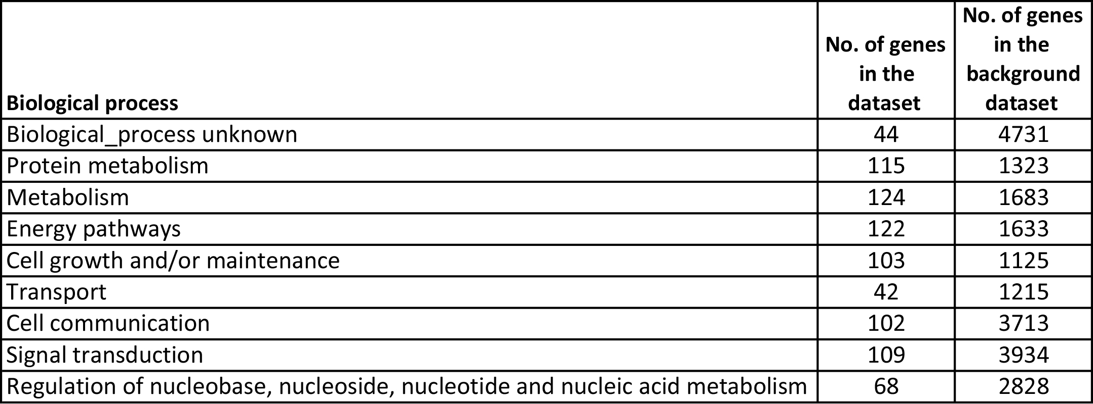
TABLE S1: Broad categorization of genes according to their biologic process. The remaining 1291 genes in the background data set represented 82 further biologic process categories.¹

From the gene set, of the 900 proteins of interest (POI) derived from perivascular tissue preparations, 204 whose relative abundance was comparable over 10 cord donors could be categorized as related to antioxidant, angiogenic, anti-inflammatory and both definitive and possible immune activities as shown in Fig S1 below:-
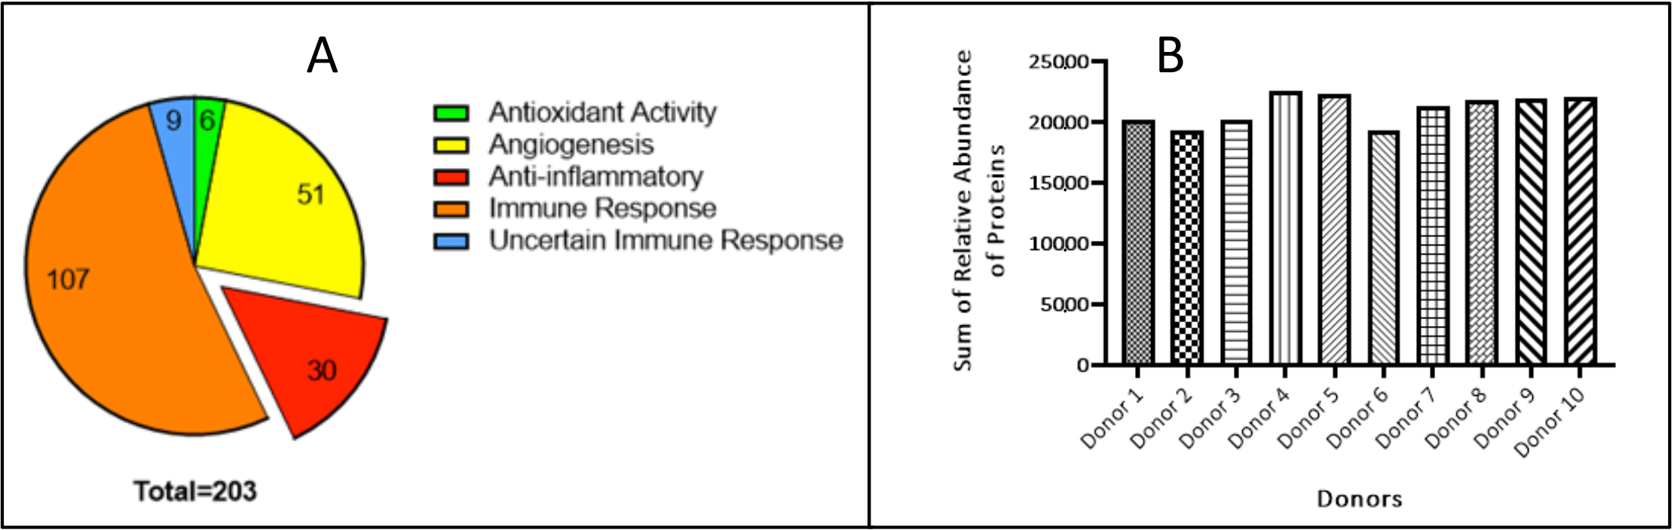
Figure S1: (A) Mass spectrometry data of the >200 proteins of interest from perivascular preparations and (B) A comparison of the sum of relative abundance of the same proteins from10 donor cord-derived preparations.²

The resultant lysate is therefore highly complex in both range of particle sizes, and molecular composition. In this preliminary study no attempt was made to equate the anti-inflammatory function of the lysate to either the 900 POI or the 204 characterized as above.

References
- Data courtesy of Tissue Regeneration Therapeutics Inc., Toronto.
- Gill R G, Umbilical Cord Derivatives Abrogate Carrageenan-Induced Inflammation. MSc Thesis, (2020) University of Toronto. Available at https://tspace.library.utoronto.ca/handle/1807/103642.

